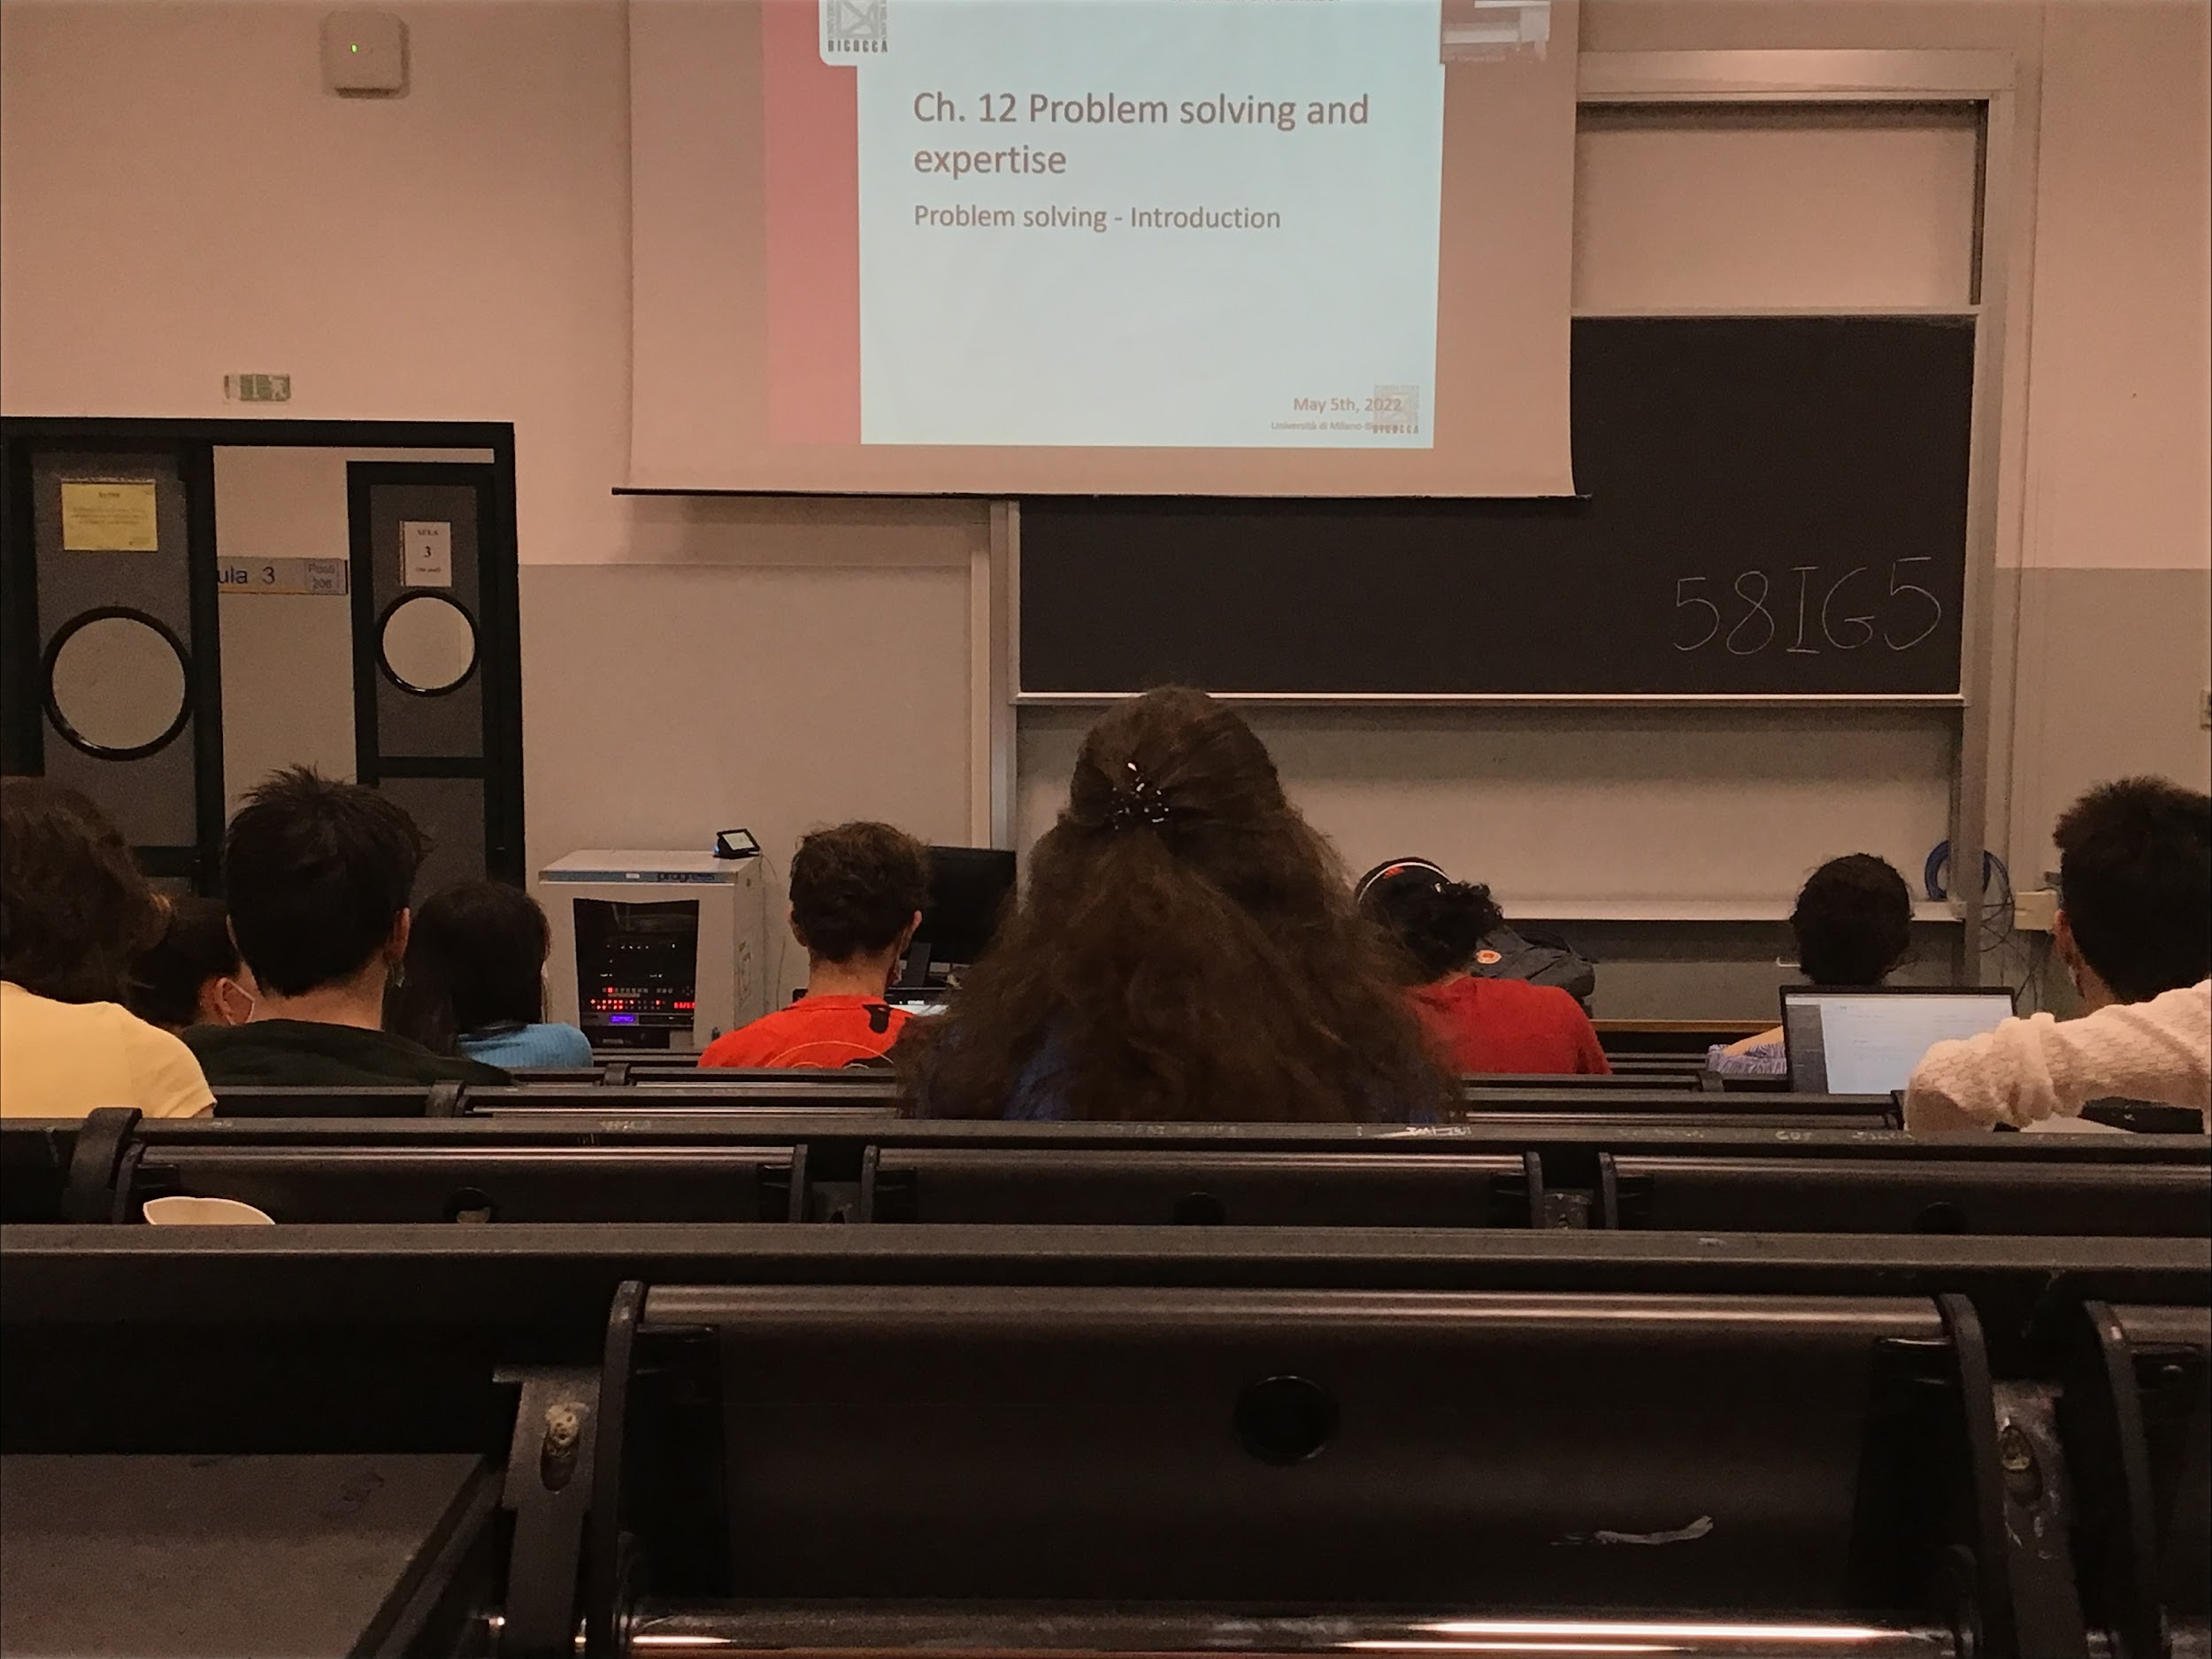

Problem solving

2 big classes

* **Well defined problems**: there is a clear solutions (chess)
* **Ill defined problems**: no clear goal, more difficult to solve

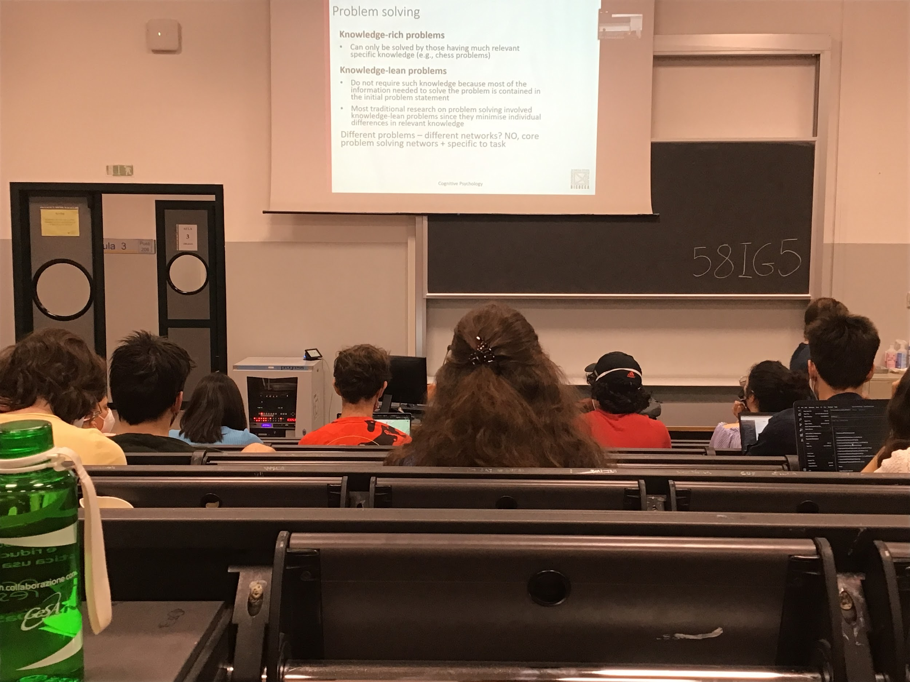

* **Knowledge-rich problem**: knowledge is required
* **Knowledge-lean problems**: knowledge is not necessary (a minimum knowledge like language is required) but don’t need to be an expert in some topic to solve this problem

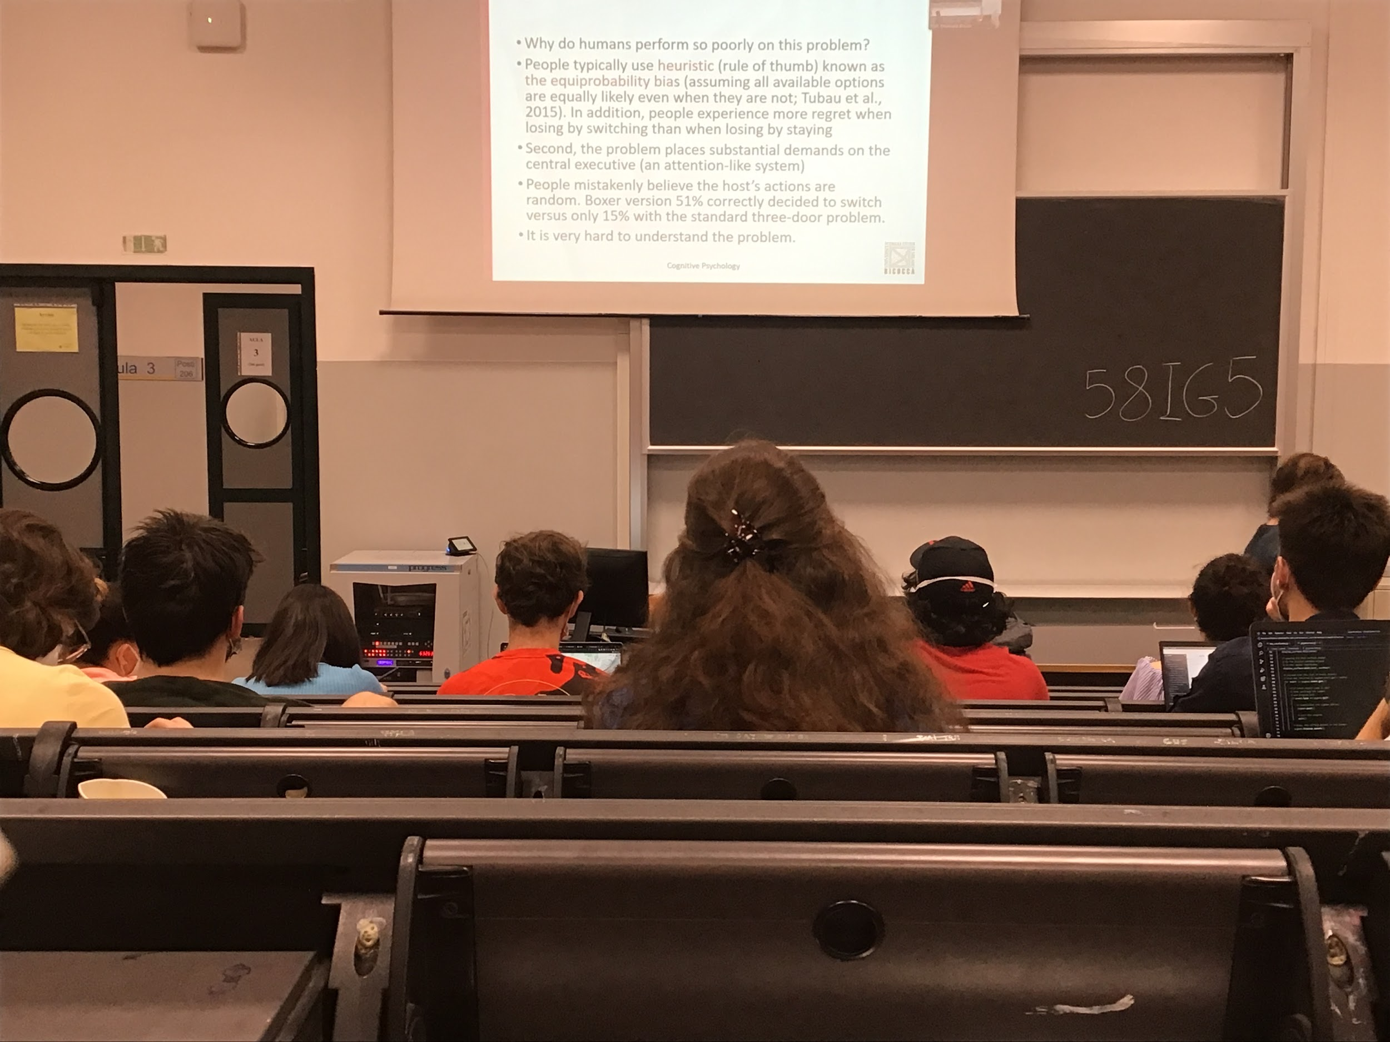

People when try to solve the problem uses heuristic: something to come to the solution fast, not looking for all the alternatives, **probably not choosing the best answer but try to get it fast**

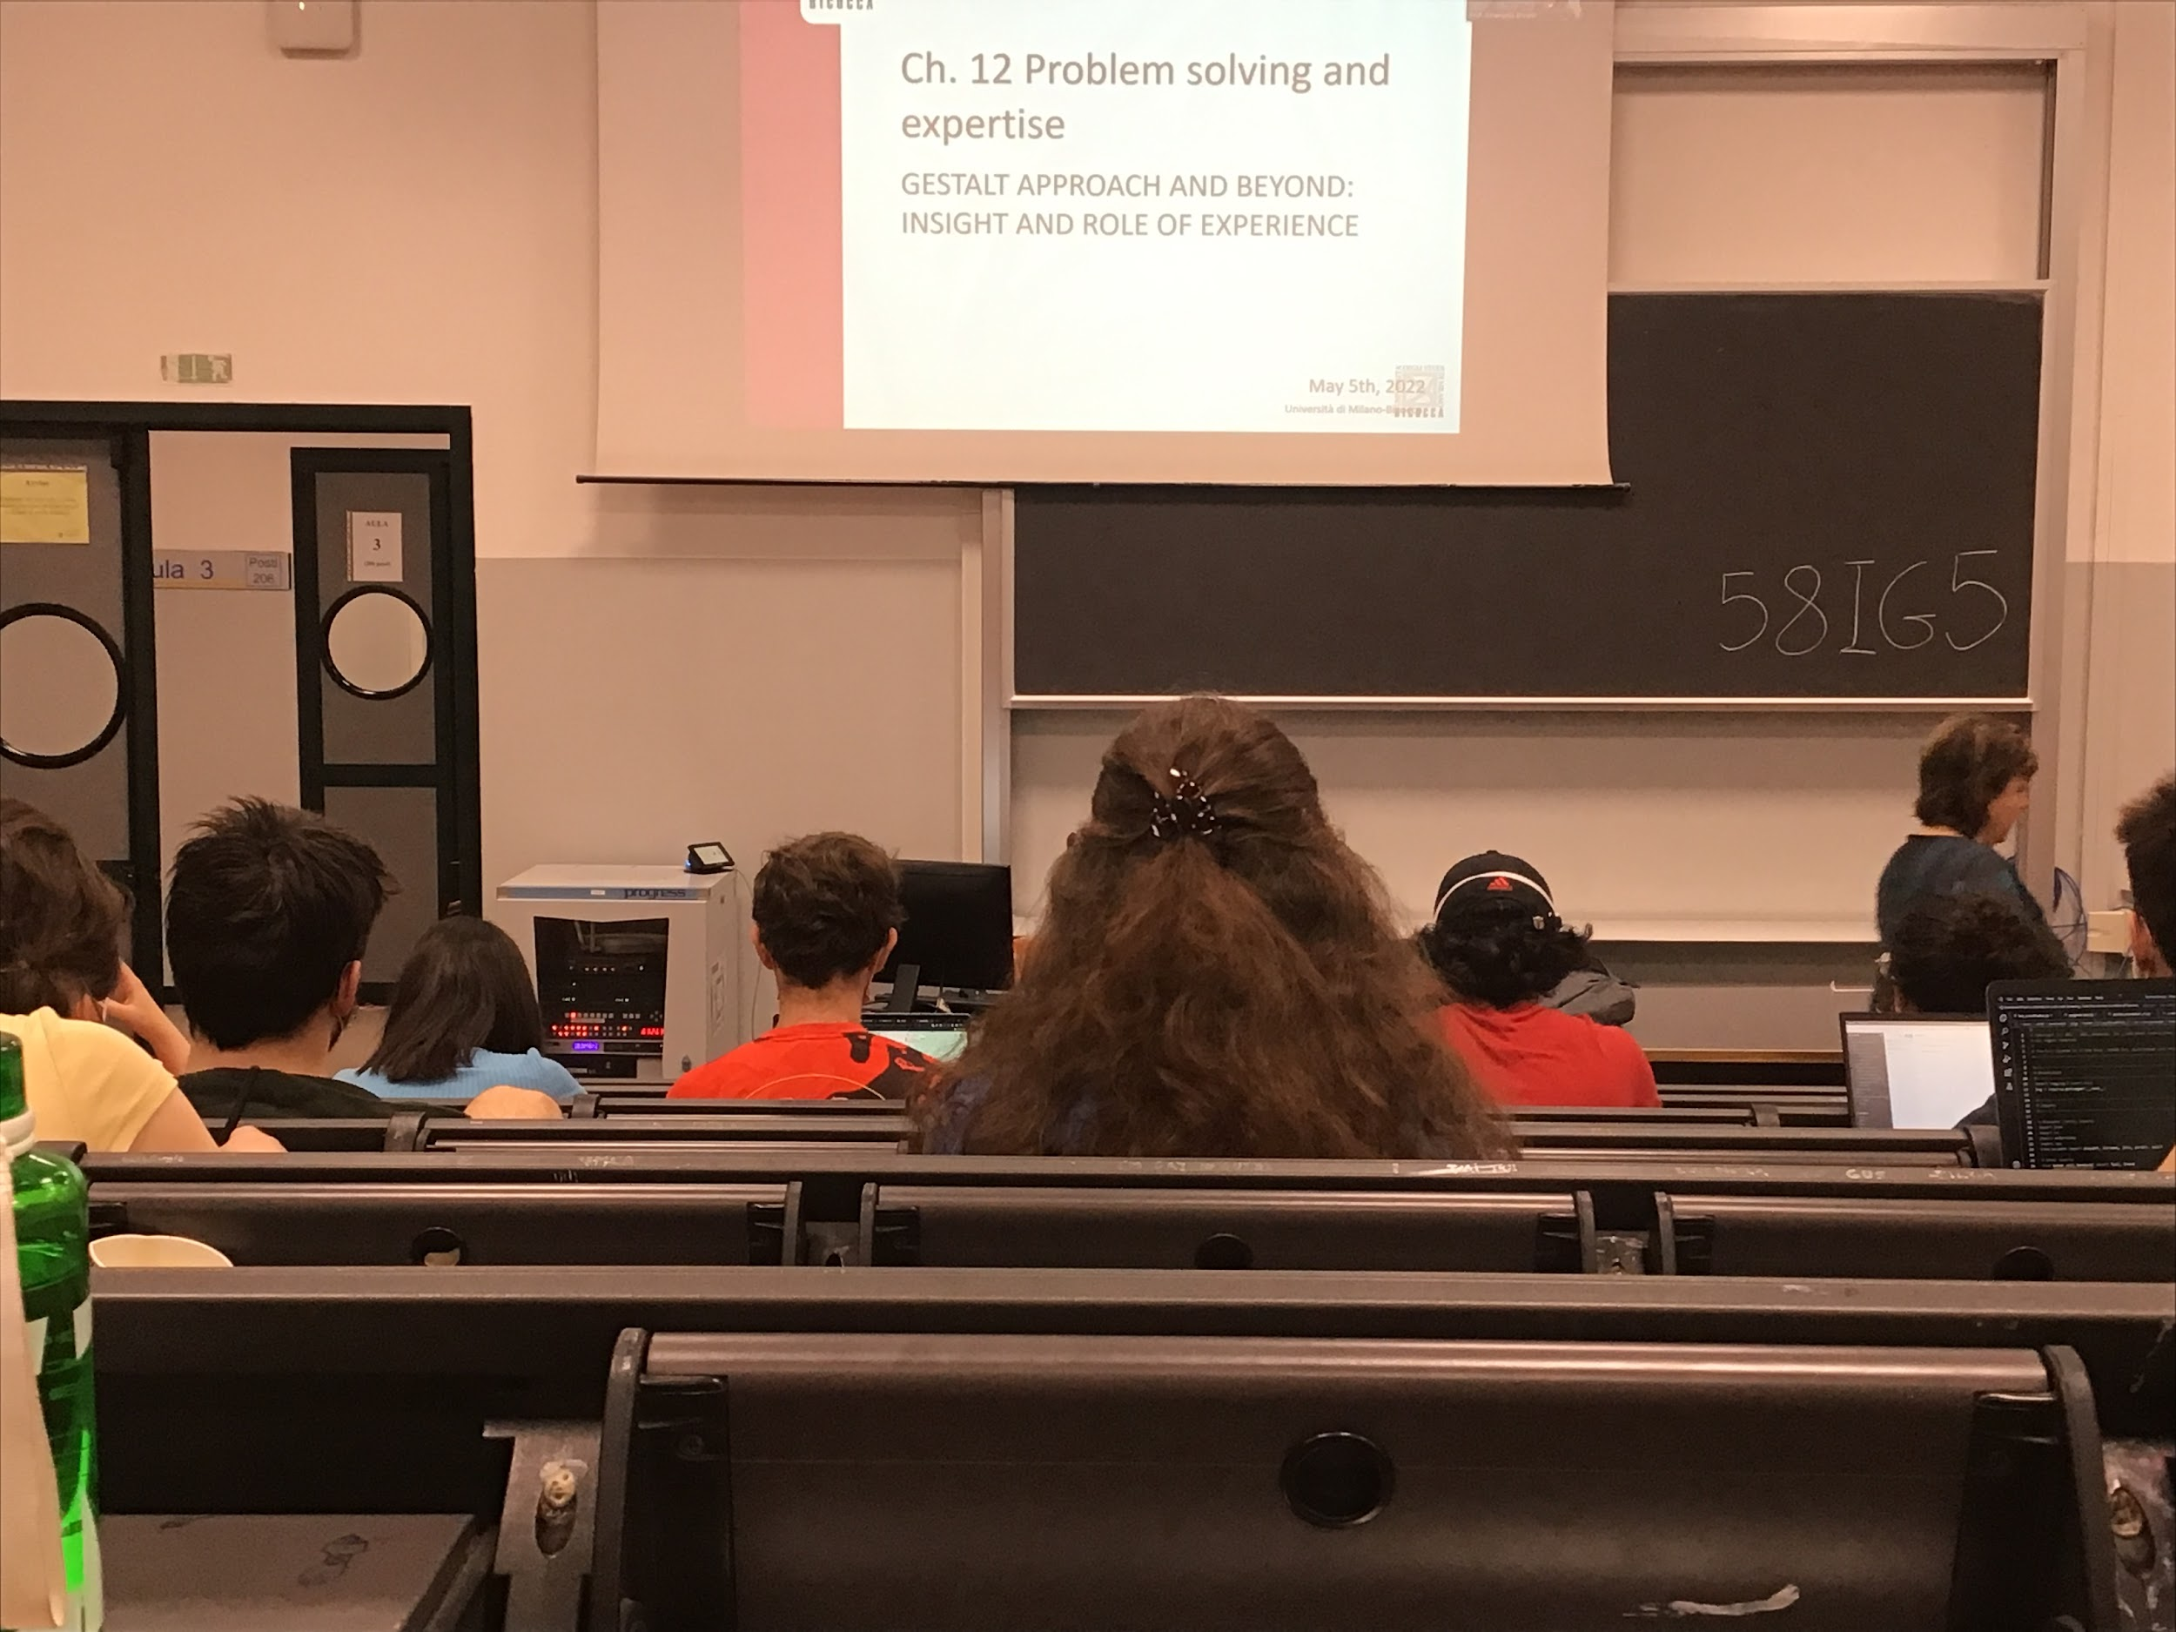

How we answer problems using some kind of intuition

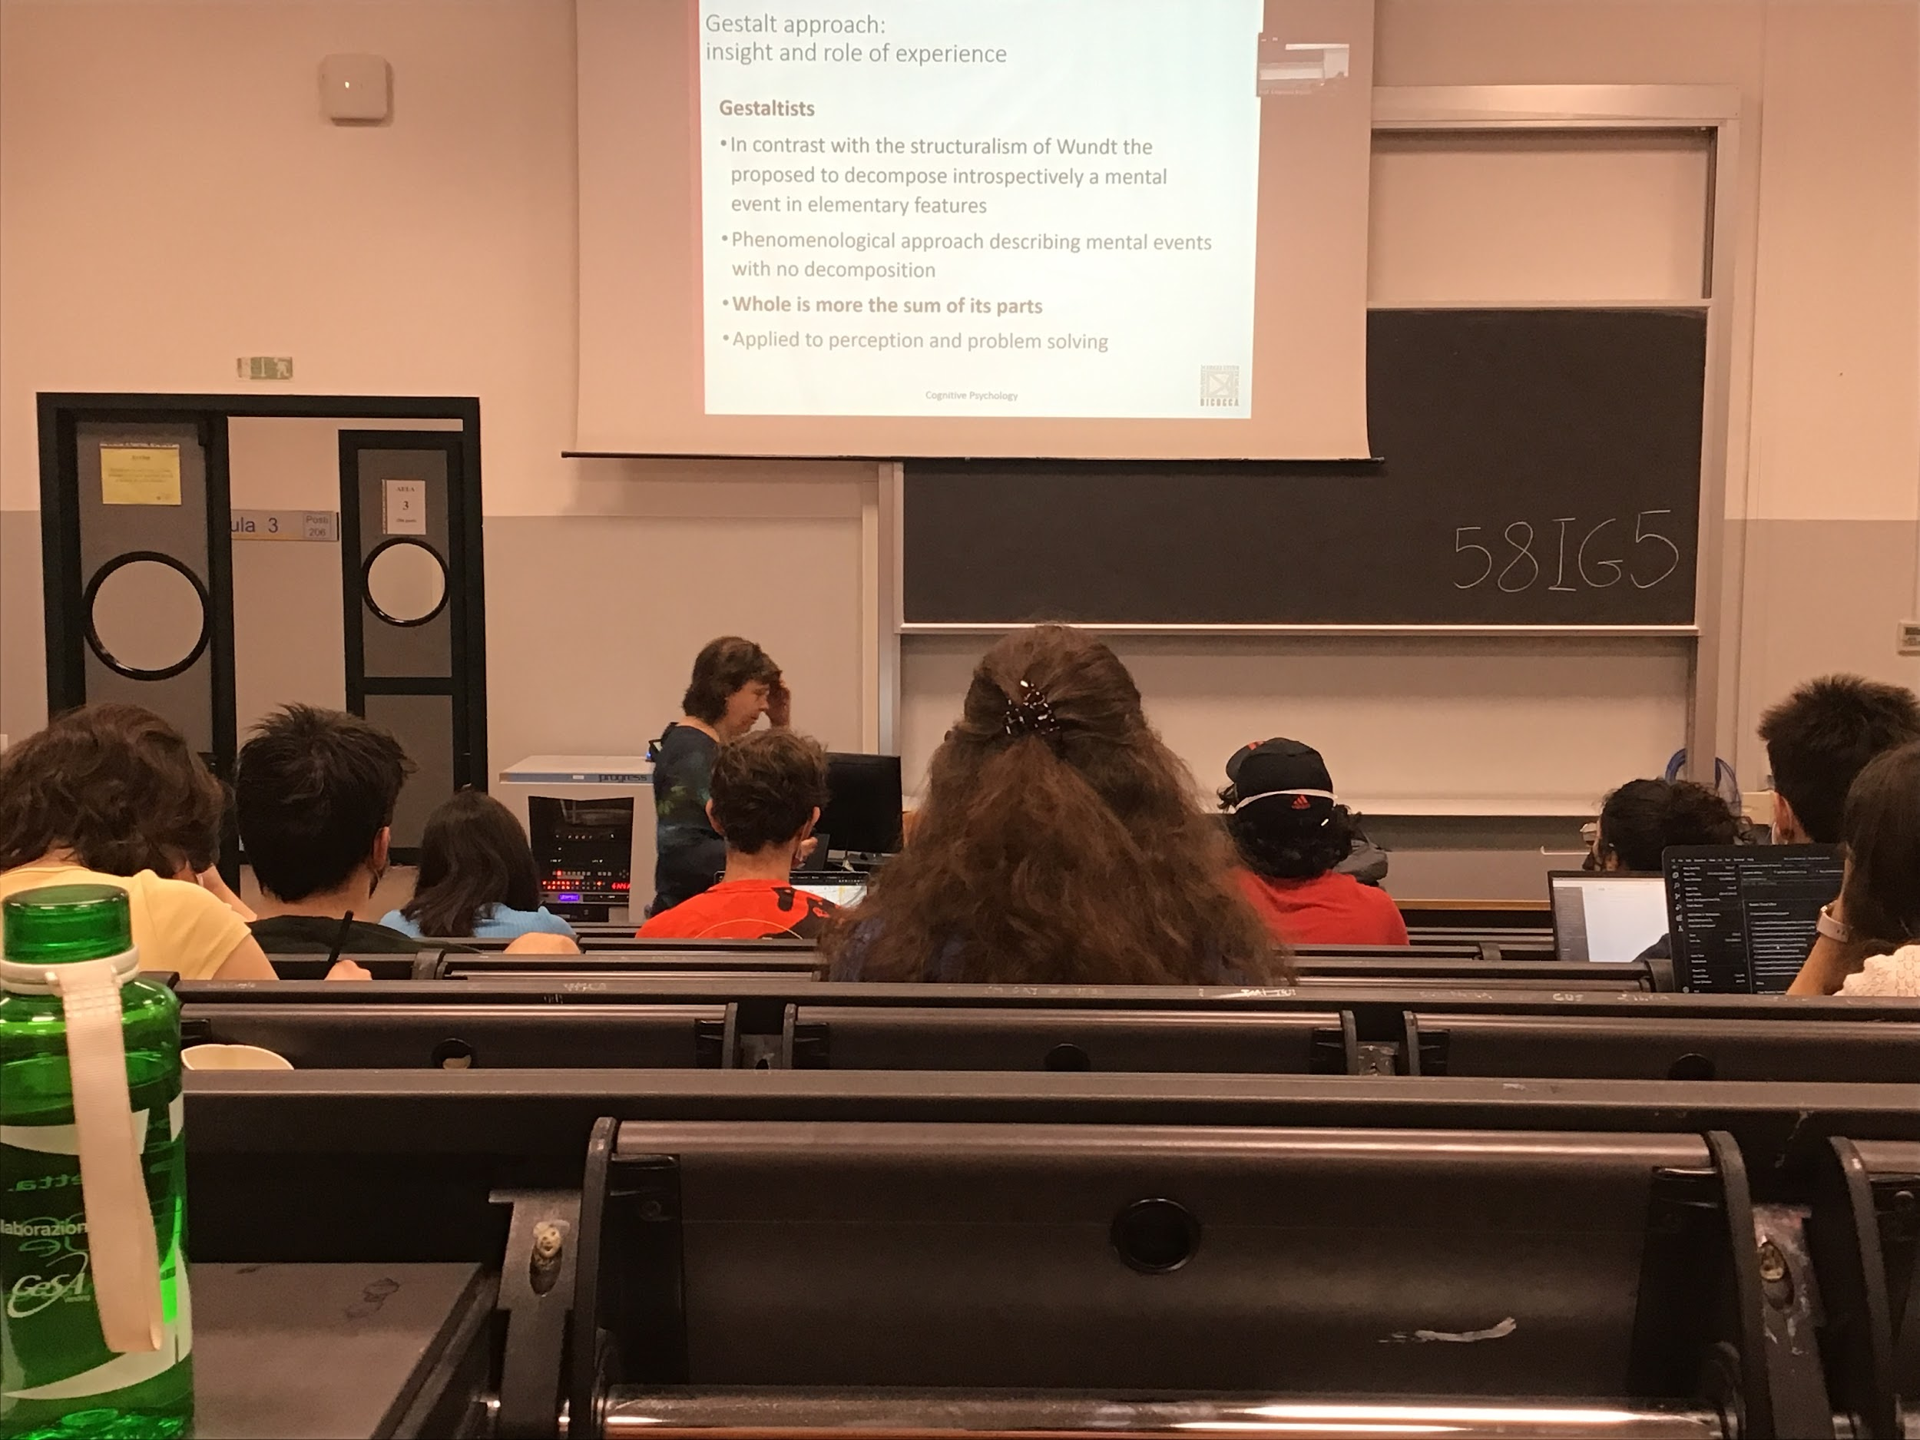

It is not important to decompose things in that parts (even in perception), **what you see is more than the sum of the parts**

Sometimes we find a solution of a problems that is not just putting together the different evidence

We have to try to understand what is happening in the mind for a global point of view

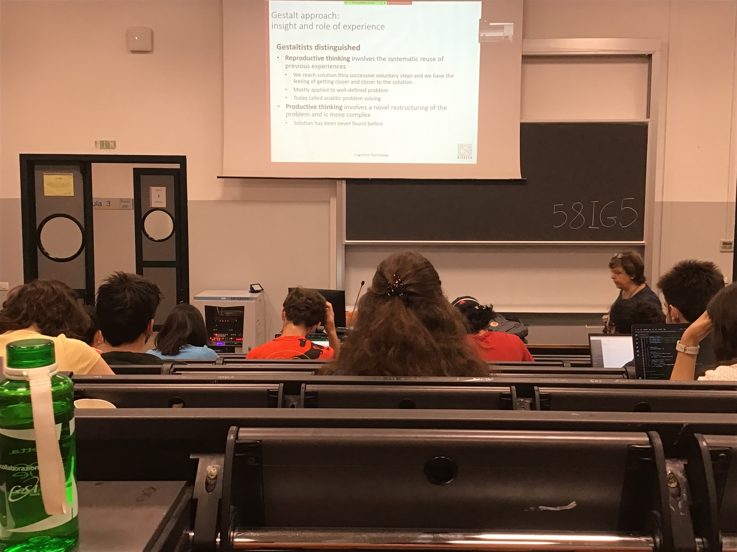

* Reproductive thinking: we apply information from previous experience to solve a problem we have now. Our experience influences our interpretation of what we see, sometimes to reach a solution of a well define problem we can apply information that we learned before, knowledge that we have (like for chess, we re-apply the same problems, is **analytical problem solving**, we go step by step and apply rules to solve a problem)
* Productive thinking: problems that we never encountered before, we can not use experience because it is a new problem. We try to look at the problem from different view point and reconsidered the different aspect of the problem and restructuring, we produce a new solution

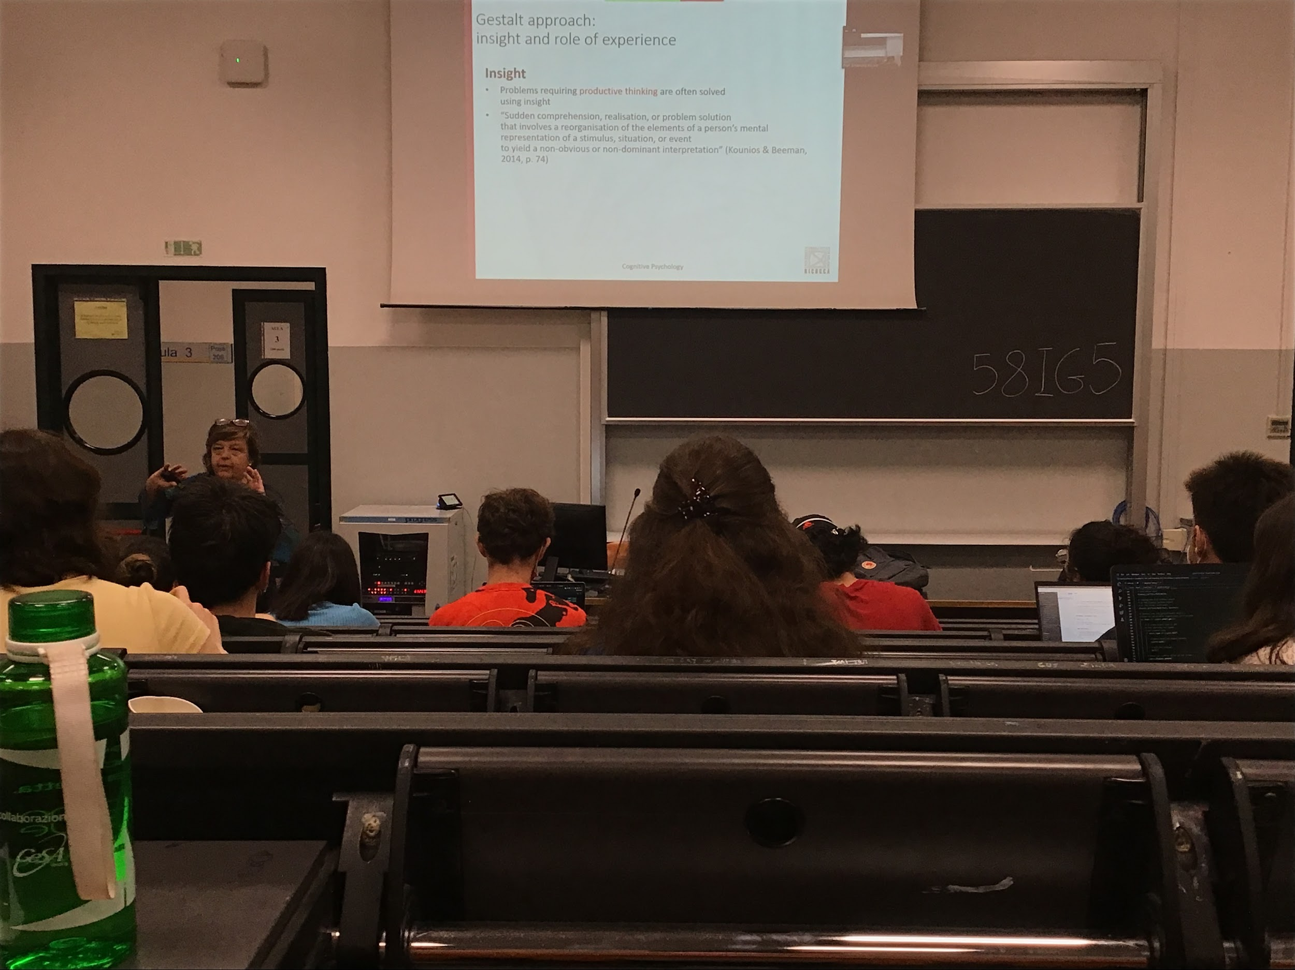

Productive thinking: when we have to find a new solution to a problem never faced before, different ways to get to the solution

* Insight: at a certain moment, all of a sudden you know the solution of the problem, the solution appears immediately in front of us. We can not choose to have an insight, the solutions, we don’t know how we got there

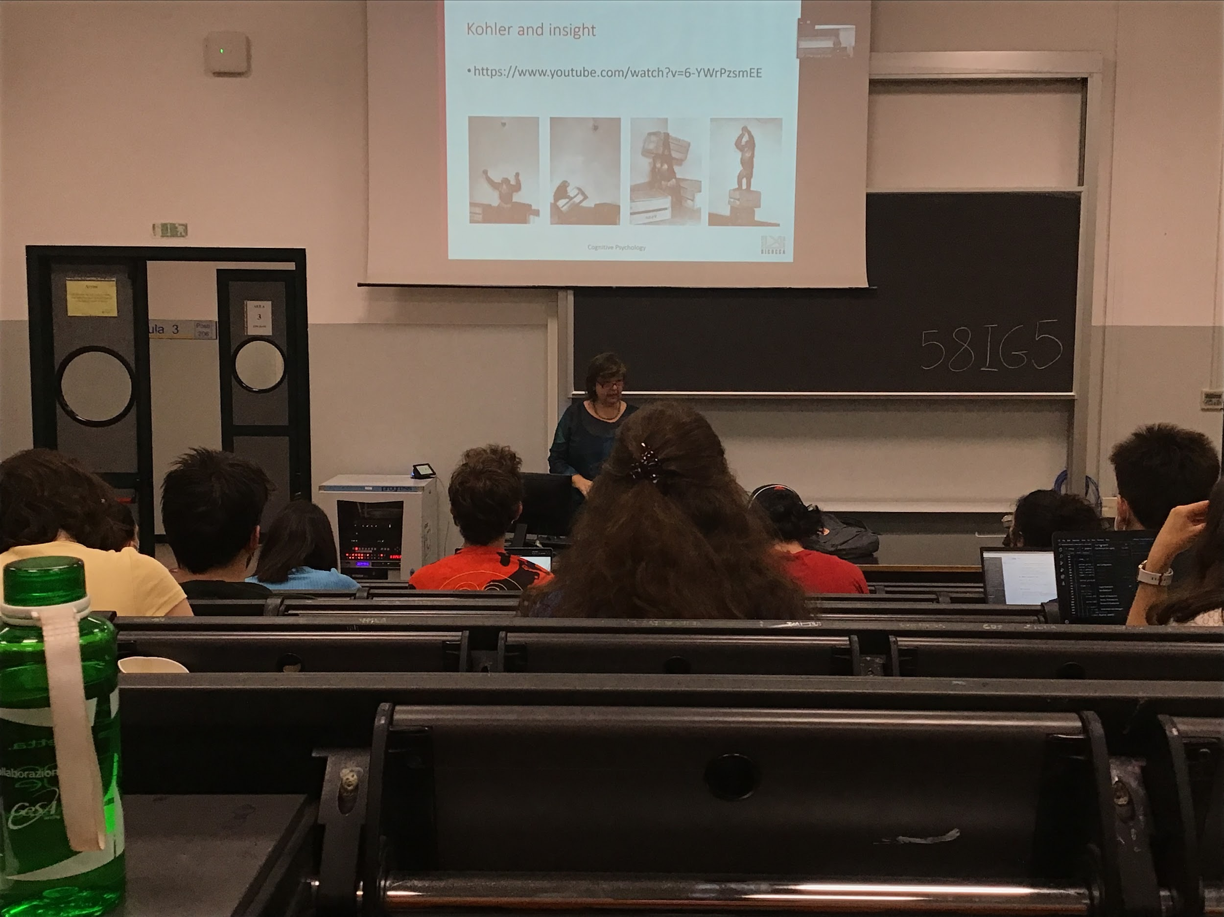

Try to see how insight develops: when the solution is not in our brain you can come out with the solution without reasoning, what to show that this can be done also by animals

Video: [Chimpanzee Insight (Kohler Study Footage)](https://youtu.be/6-YWrPzsmEE)

Kohler: one of the first that talked about insight

There is no way to reach it, a new problem. At the end of the movie there was a collaboration between two monkeys and they shared the food

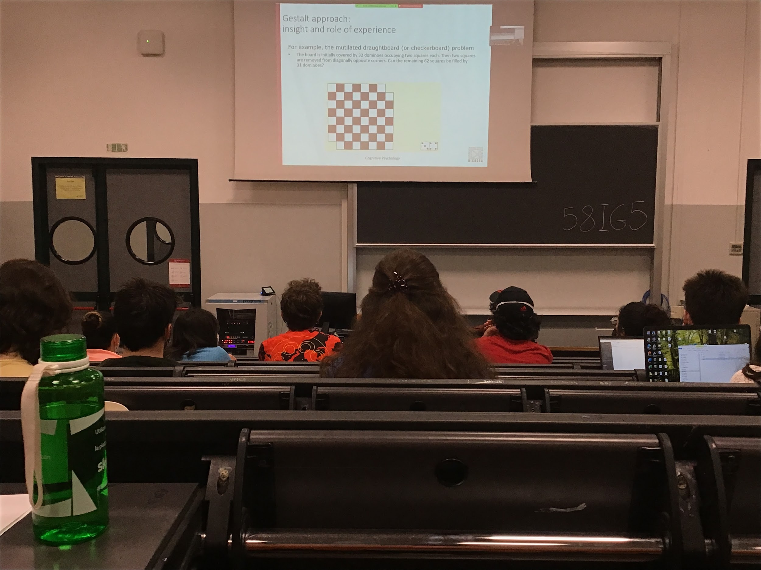

32 black and white dominos

If I take away the two corners can I rearrange the dominos to fill the chessboard?

Can be easily solve with insight, it is not possible, you removed two blacks it can not be filled with black and white dominos

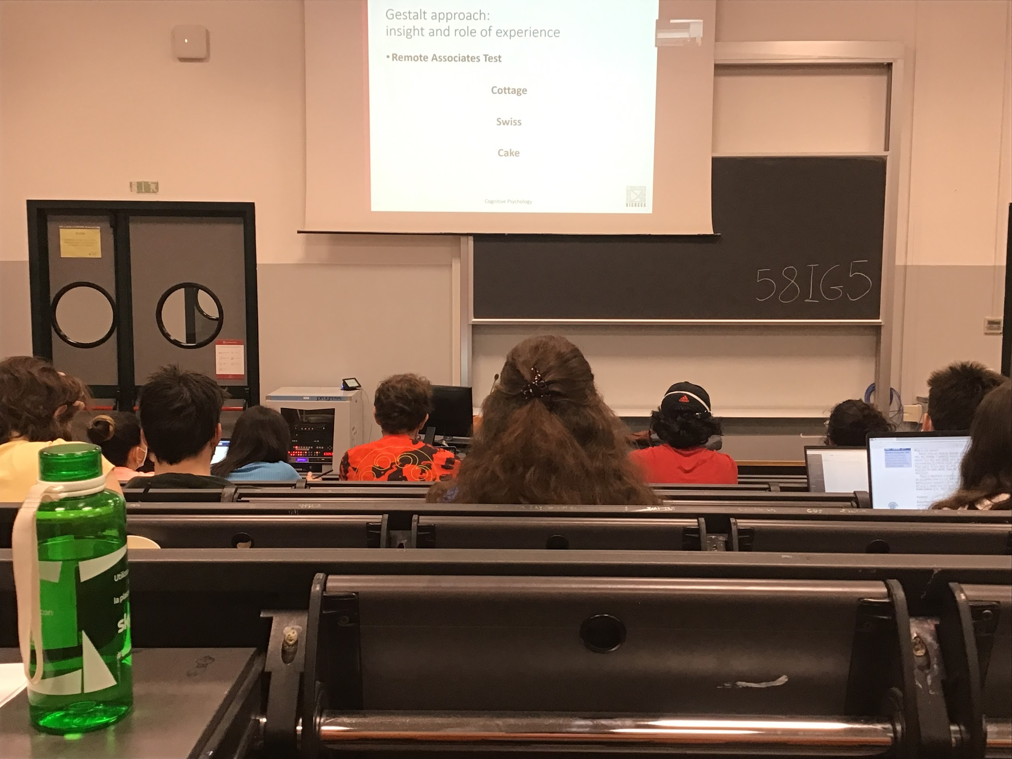

To study insight we need to use insight problems, are problems that are very well defined and that are easily checked, you need to find a word that made a compound word

You test a lot of different possibilities and there are a % of these combinations that at a certain point you feel you got an insight. All of a sudden you see the right solution. The remote associate test does not always produce an insight solution, but sometimes it does

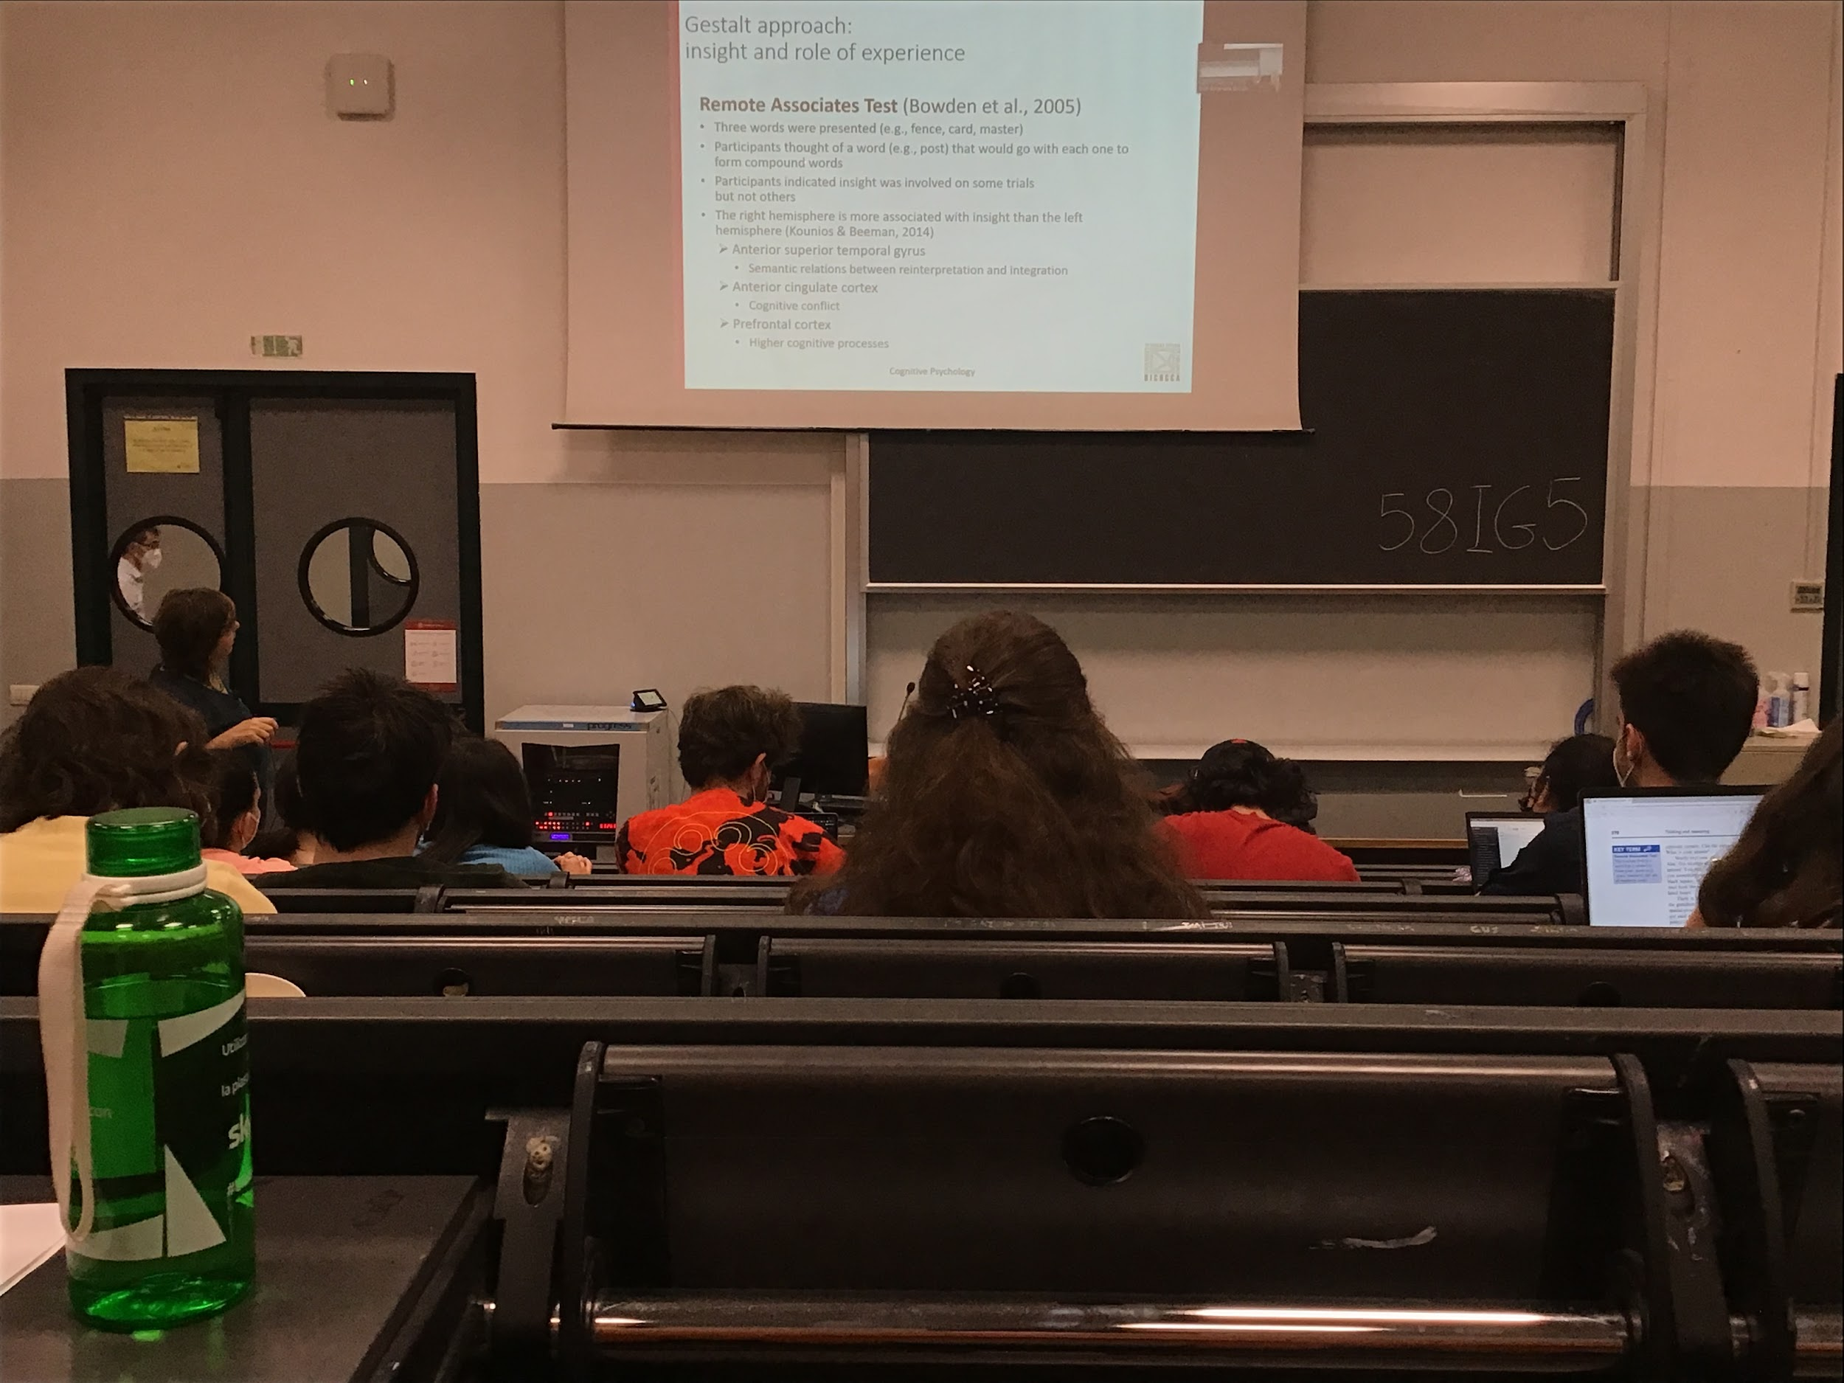

Not all productive thinking is associated with insight

Right hemisphere more associated with insight then the left

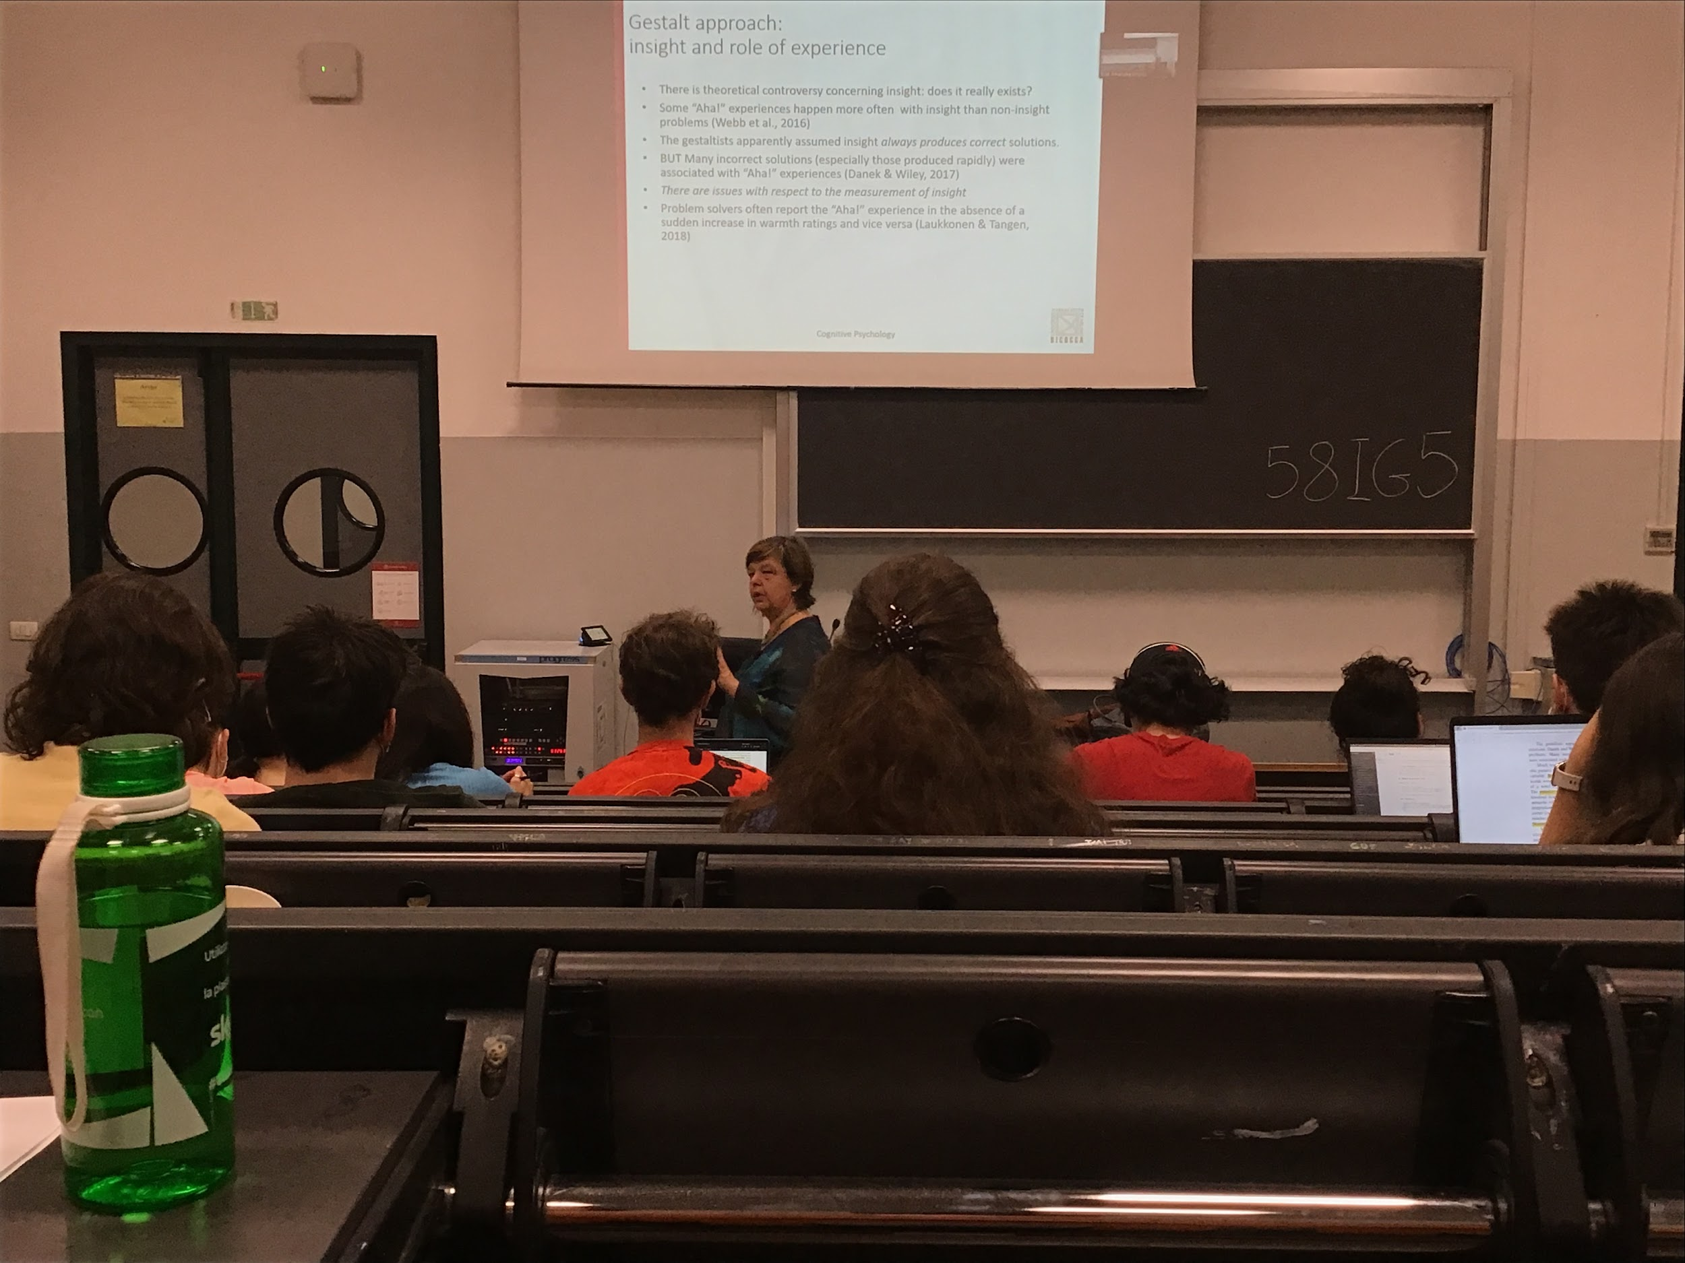

There are insight problems and no-insight problems

It is a big controversy

People try to say that maybe insight does no really exists

Also gestalt it says that insight always gives the correct answer, but it is not always true

A lot of debate on how insight comes

We agree that this type of problem solution does exist is, not clear the condition on which it comes out

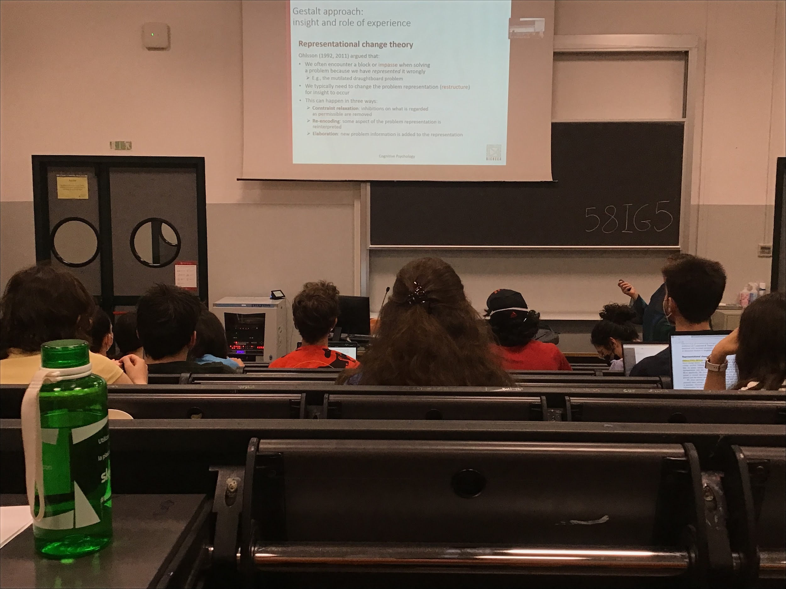

Ohlsson: representational change theory, when we are facing a problem and we need to find a solution, at the beginning we are very activity, there are situation in which we do not find the solution and we reach an impasse, it is a block, we don’t see others alternatives

When we are at this point the only solution is to restructure the problem, try to think in a different way, it help find the solution

According to Ohlsson, to get an insight experience we need to reach an impasse and to have a restructure. **When we restructure there is an insight experience**

How does this restructure happen? There are 3

1. You relax the constraint. At the beginning you think that some things are allowed and some not, now you need to open your mind for more options
2. Re-encoding: think of the problem in a completely different way, reprogram using a different definition
3. Elaboration: add some information that we not had before to be able to solve the problem

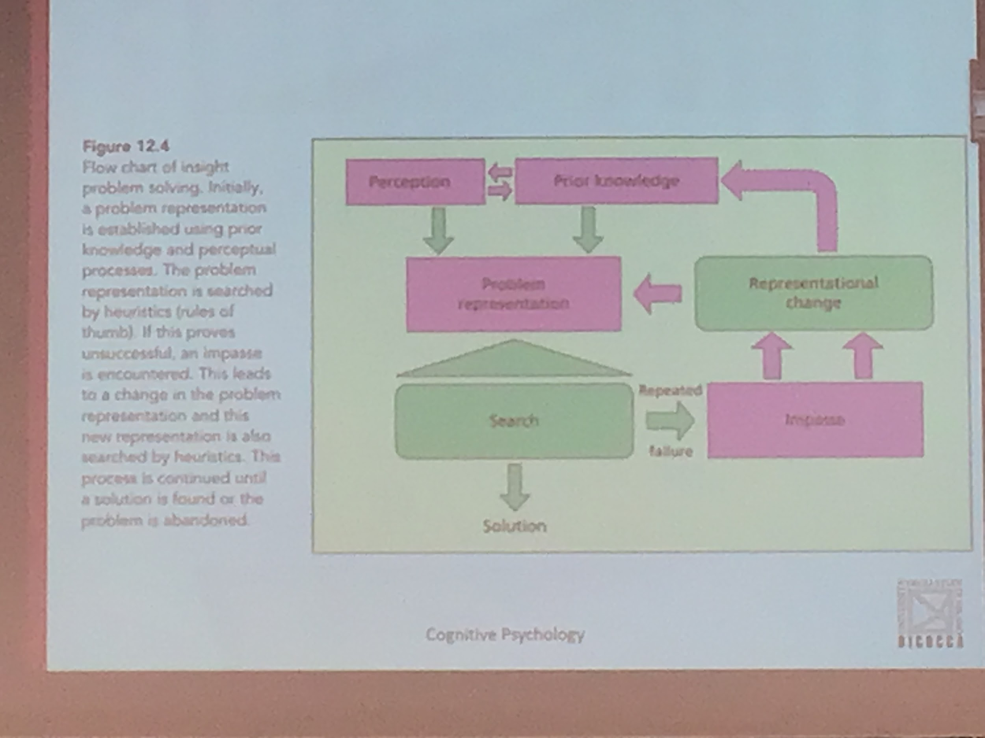

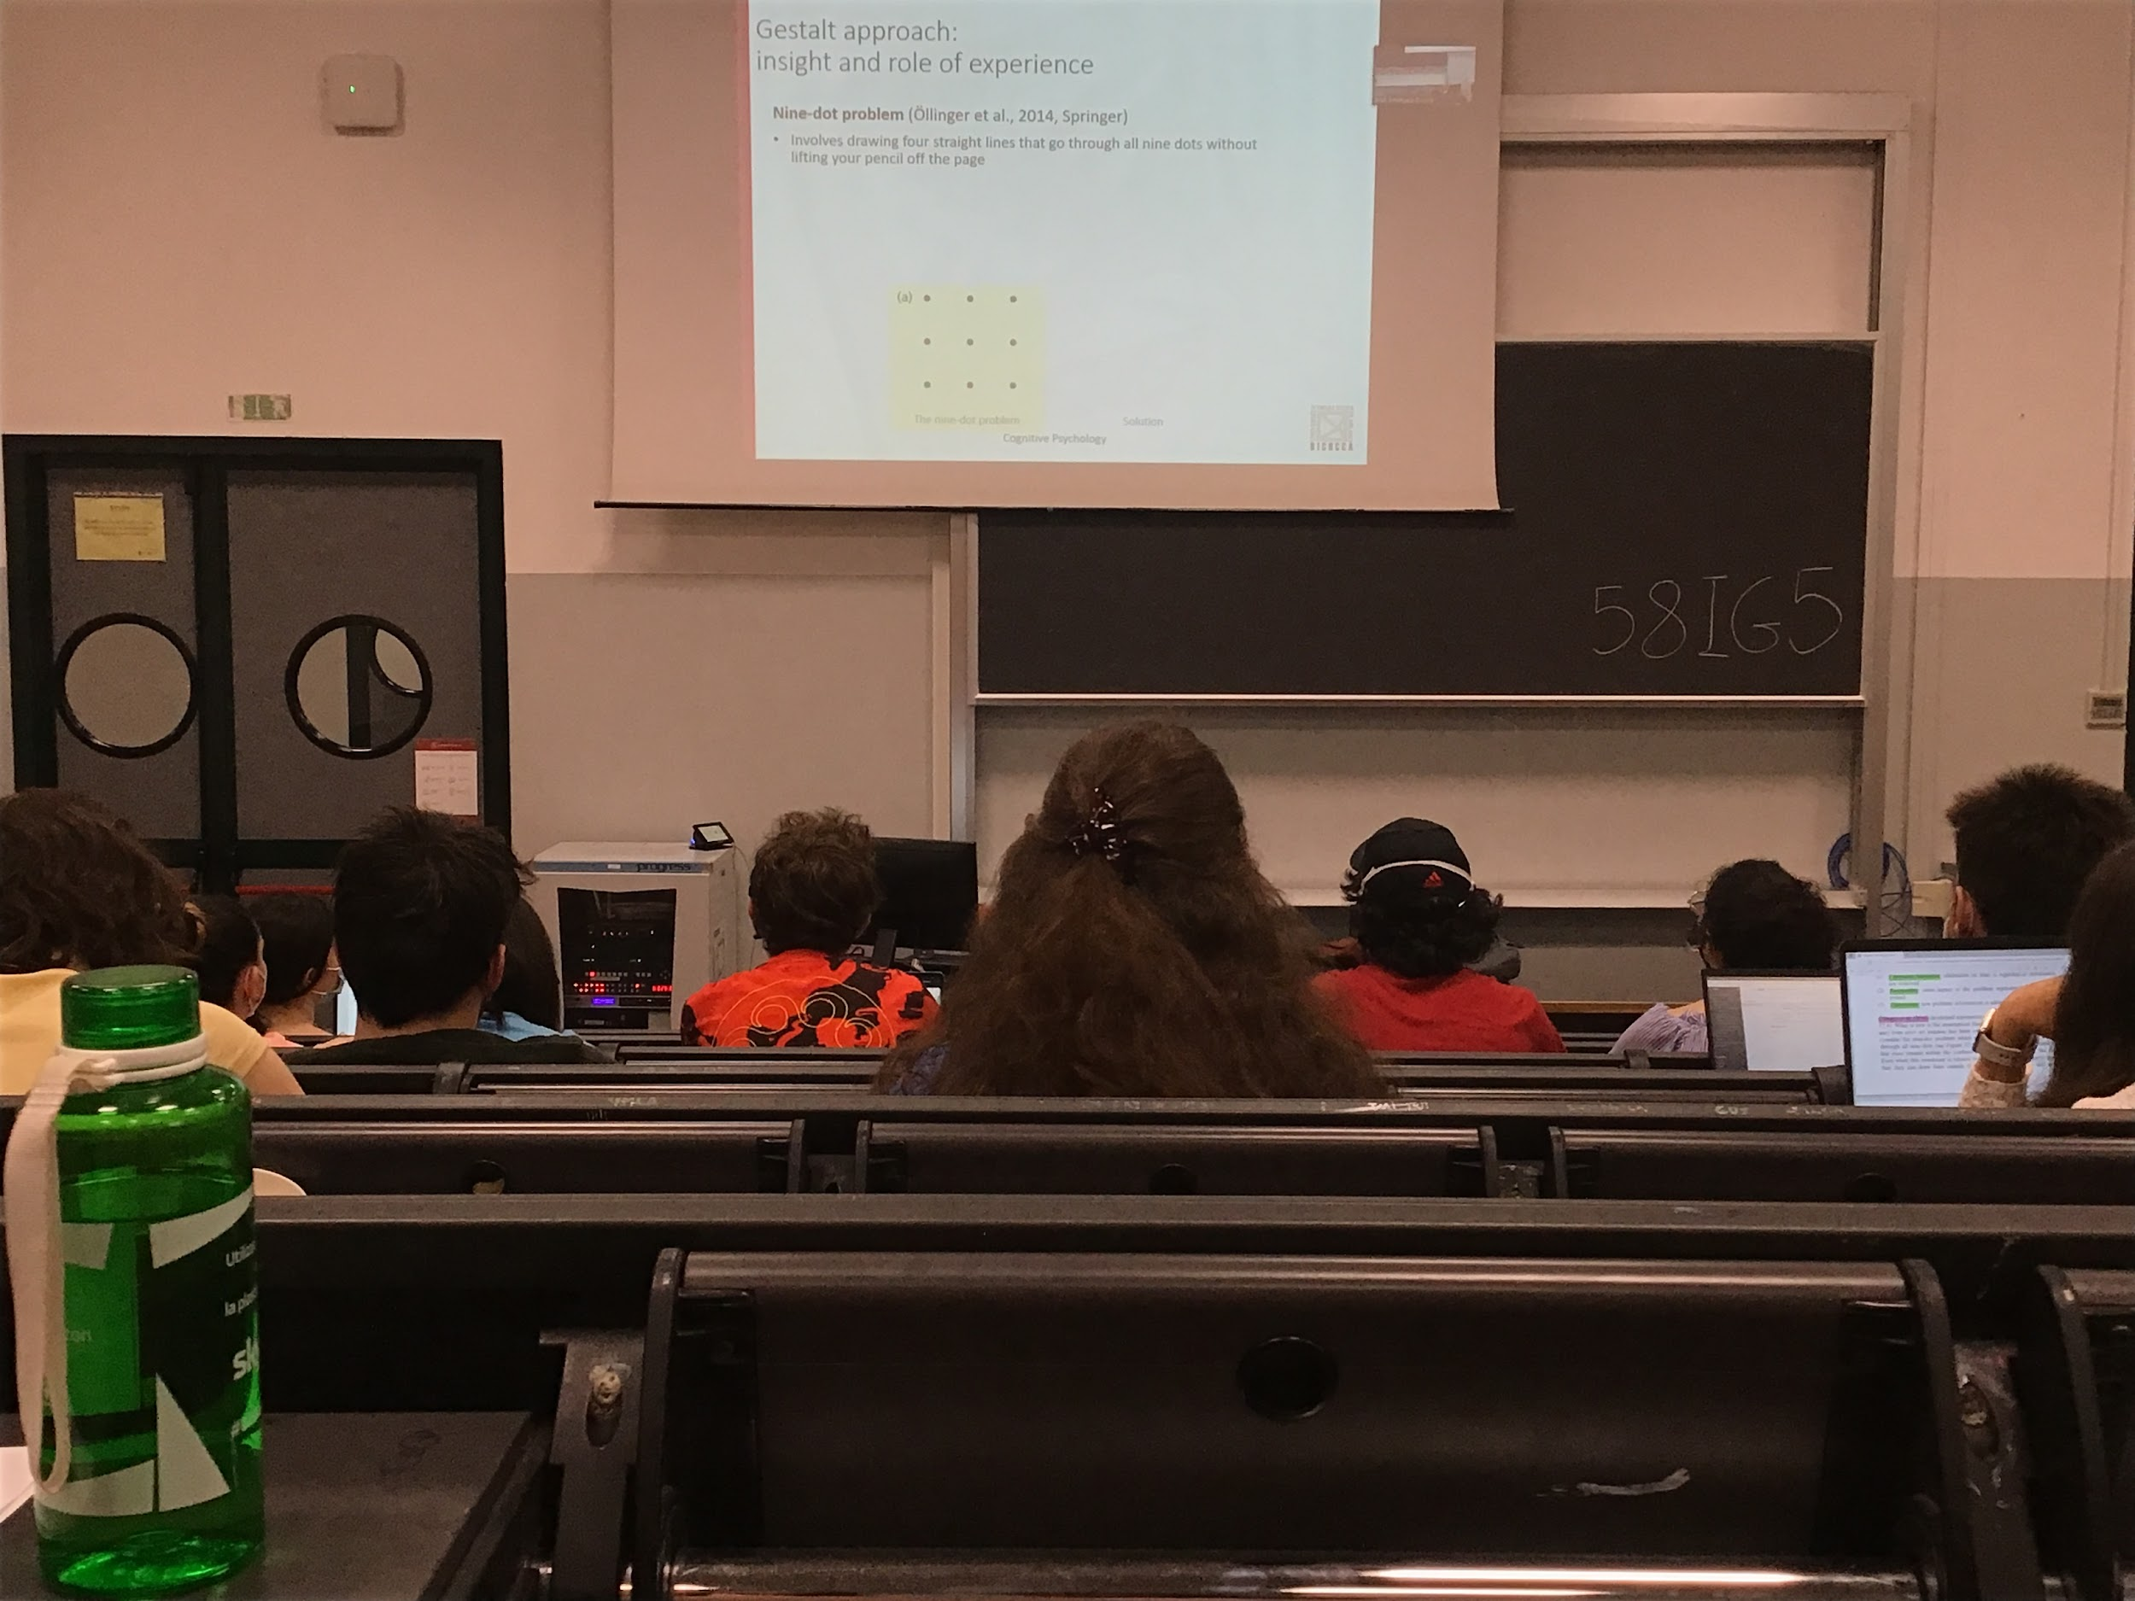

9 dot problem

Relax a constraint that you added by yourself

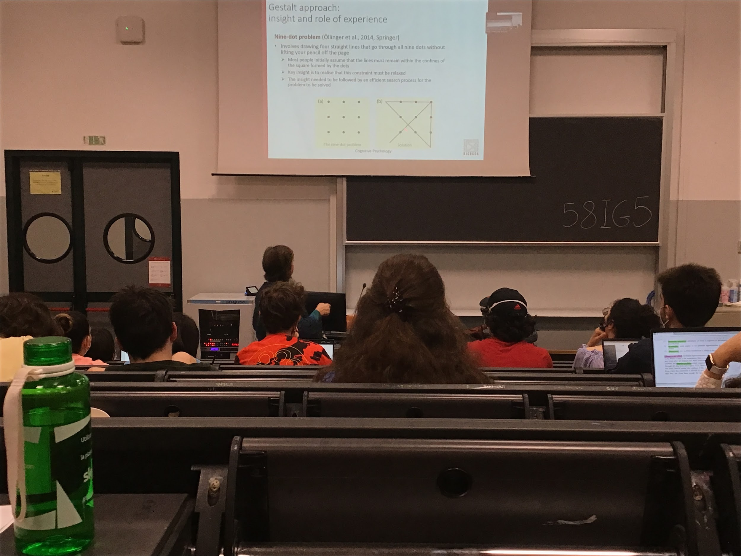

Restructure

You really have to relax the constraint

We need a problem with an impasse

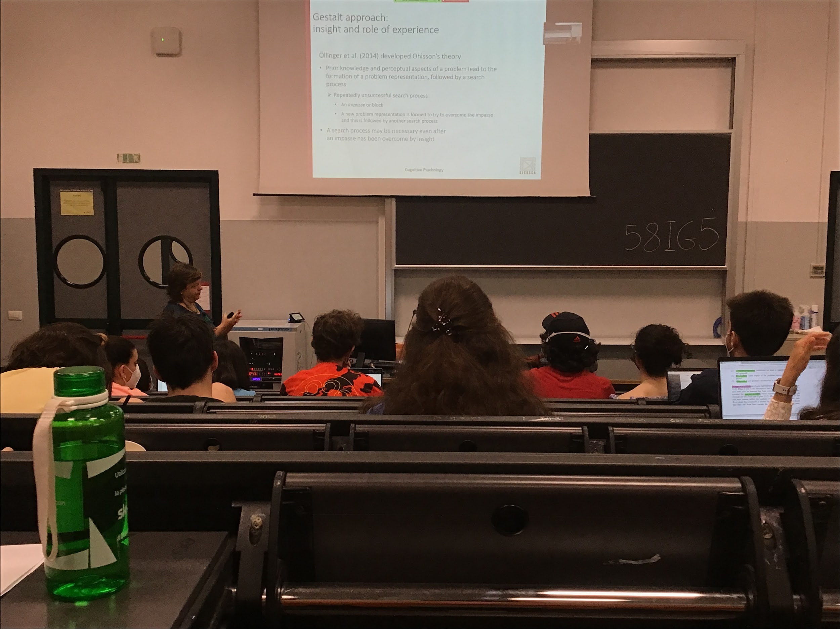

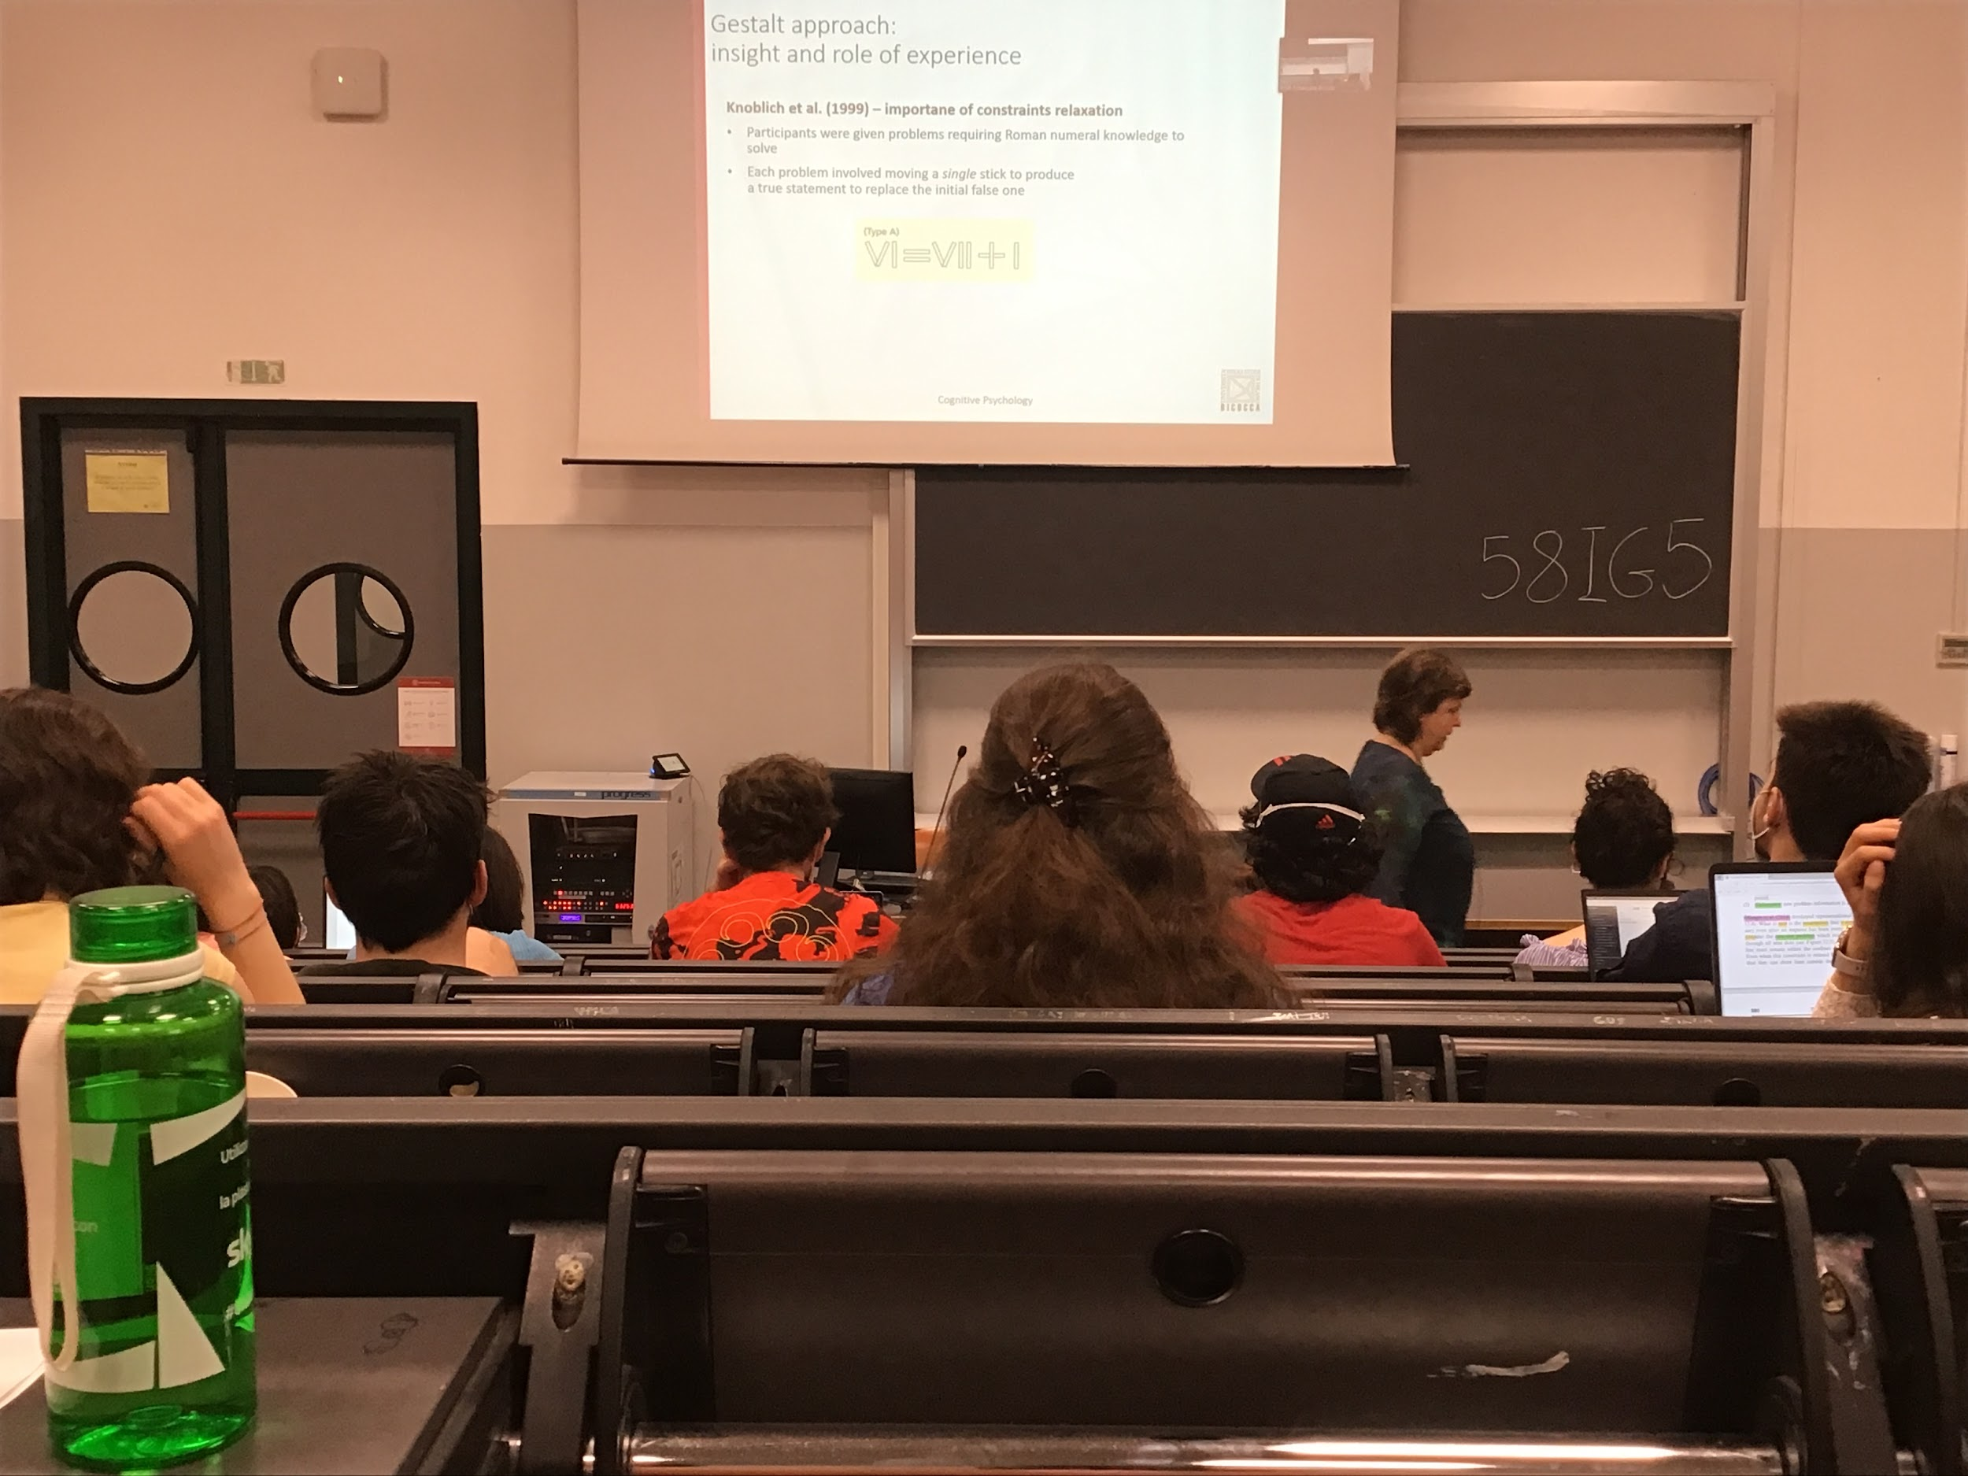

Need to move 1 stick to produce a true statement to replace the initial false one

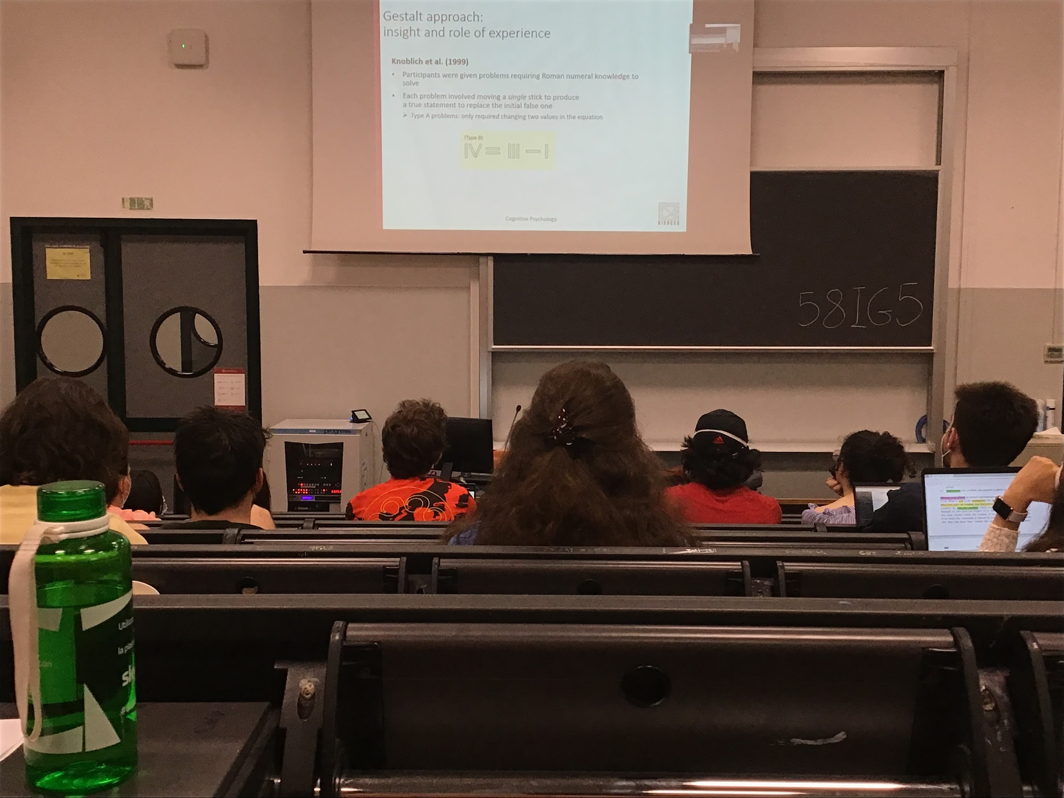

Usually we think that we need to change the numbers, while instead we change the operators, much harder for people to relax the constraints. People spend more time watching (use eye movement) about the numbers and not the operator

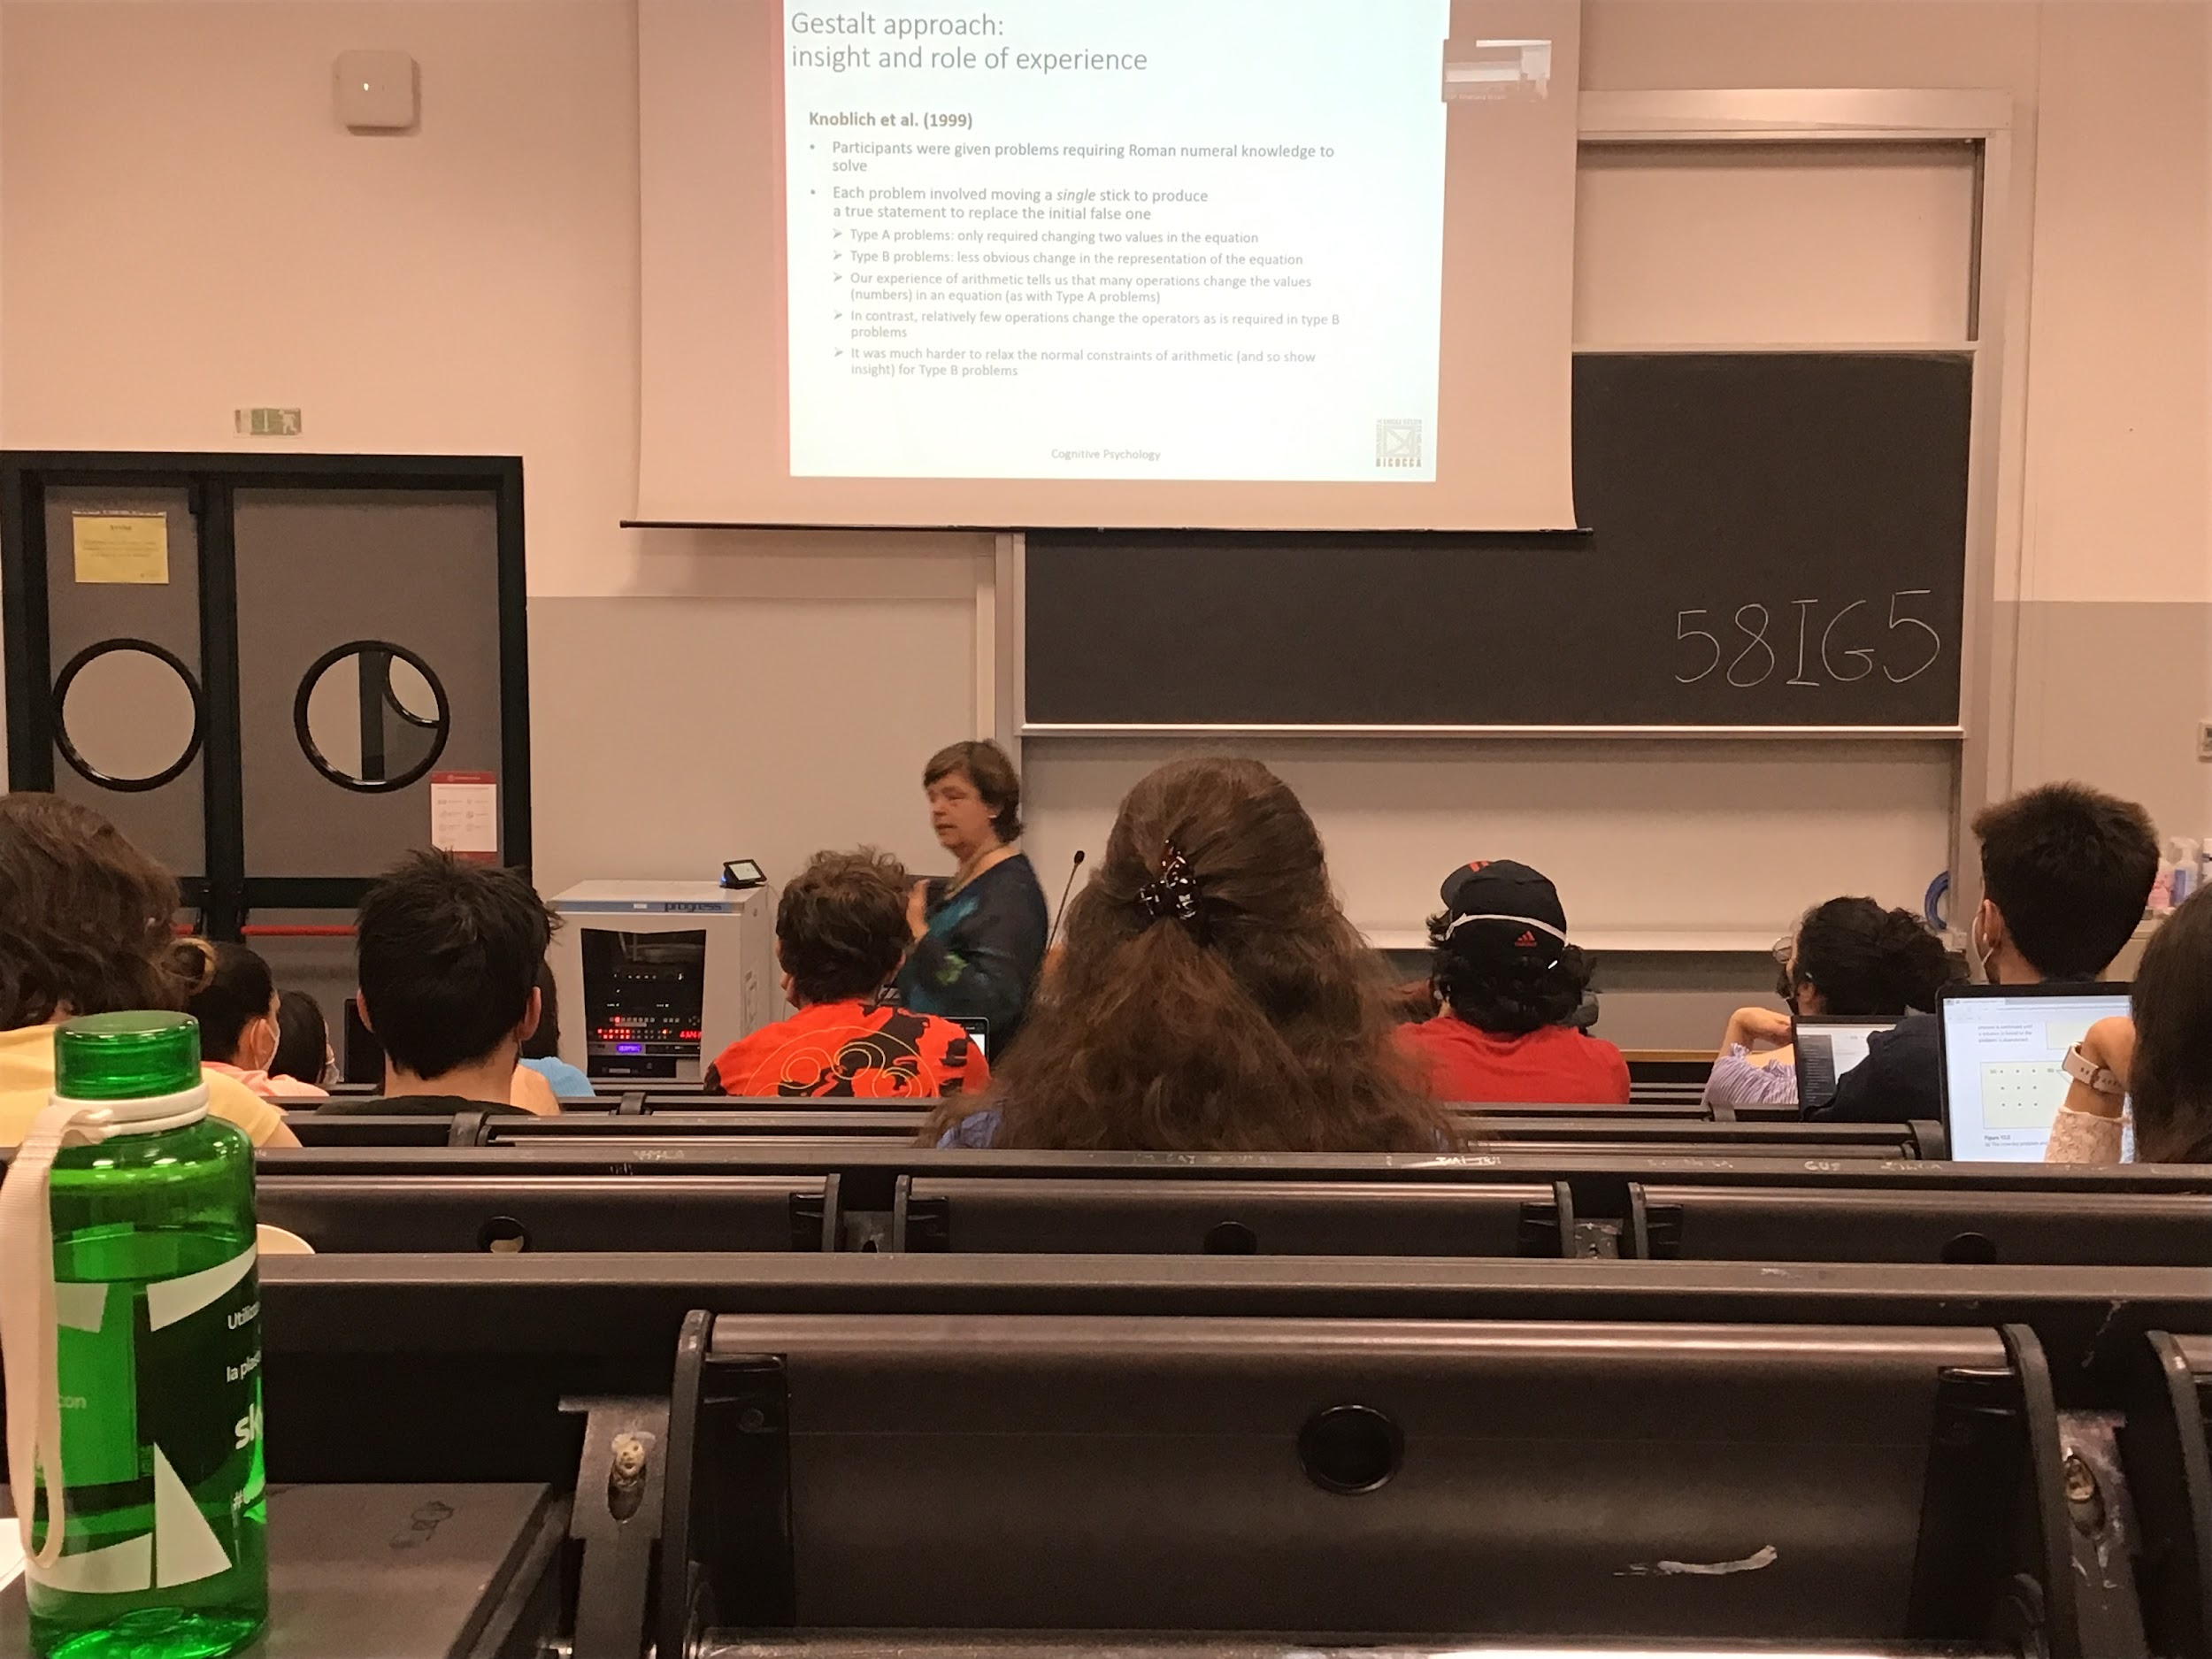

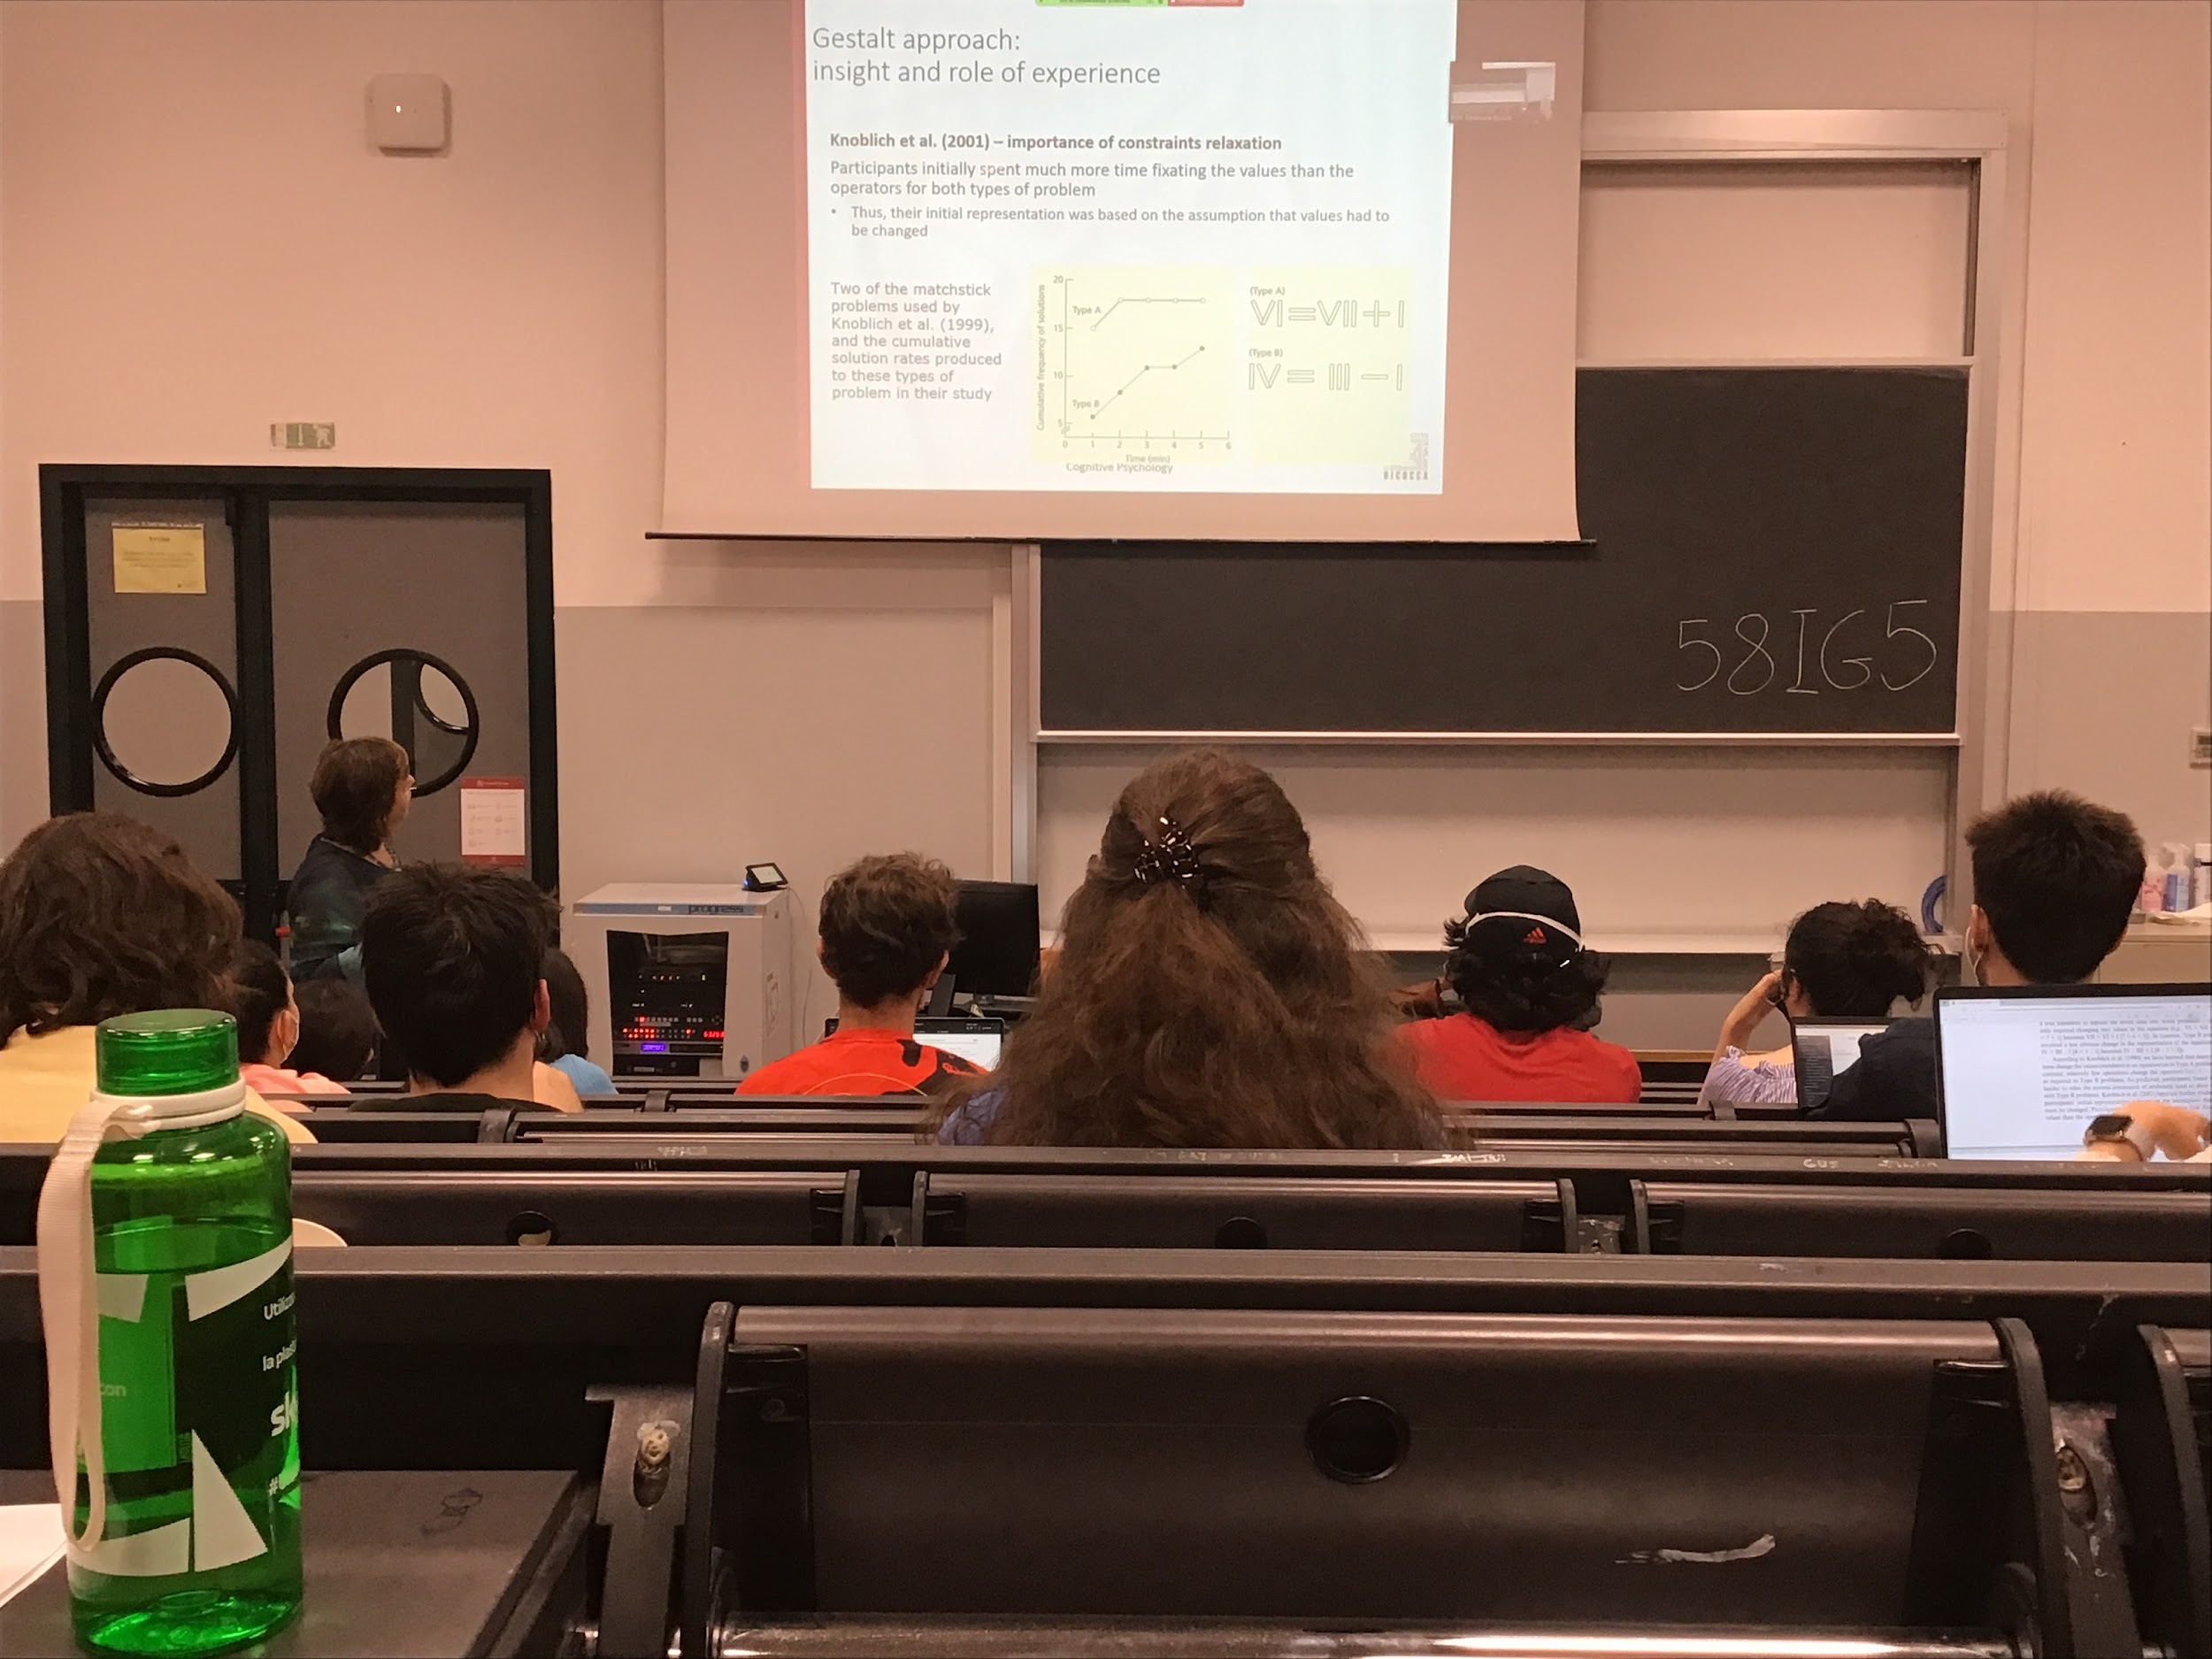

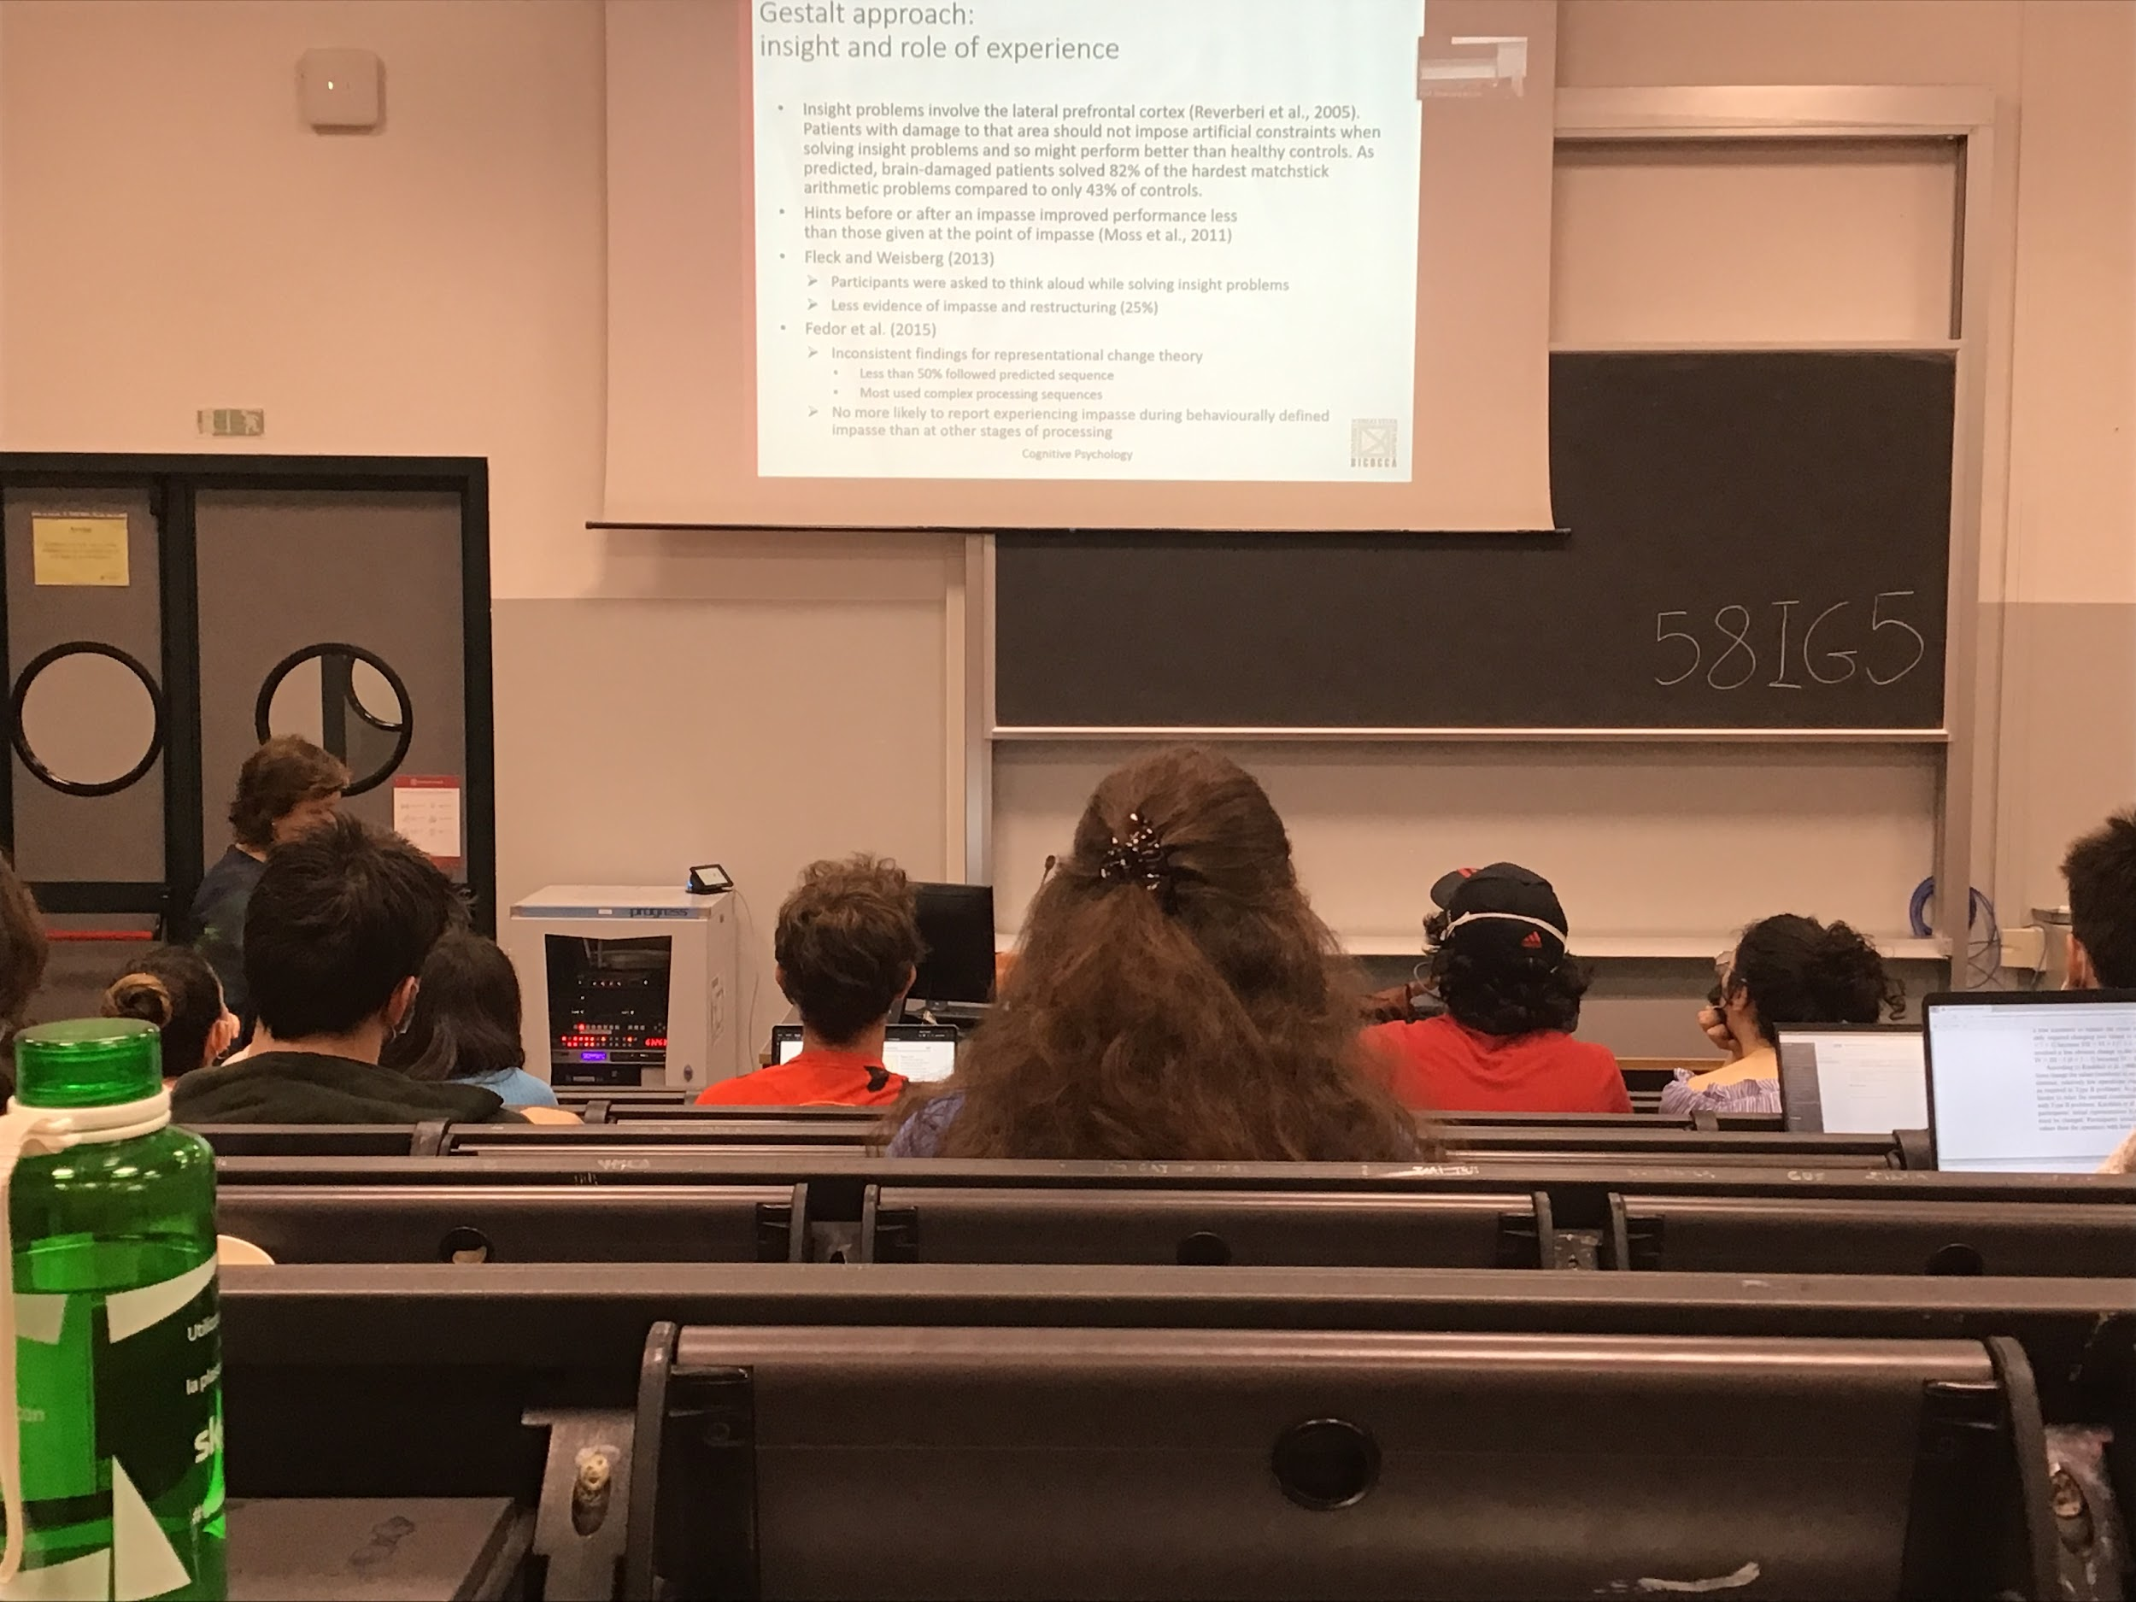

Insight problem involve lateral prefrontal cortex

Patients with damage to that area perform better, they do not use to much constraints

If I give a hint right before or after the impasse I produces more effects, your solutions comes out much faster

One of the approaches that people uses the thinking at loud paradigm, what you to tell me what is coming in your mind all the time

Data is not much in favor of the idea of impasse and restructuring, because one thing is being conscious and aware of what you are doing and being able to express it

Finding against this theory: fedeog idea, the behavior should follow a predicted sequences, but it did not

There is still a debate between impasse and restructure

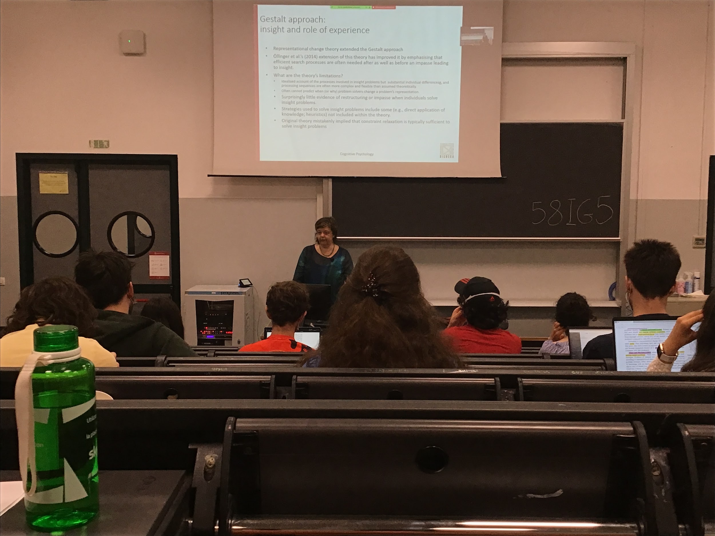

Theory did extend the Gerald approach

It build o the gestalt a more complex I’ve theory

There are some limitations of the theory: not explaining the large individual differences, there are different % of insight reports, some people report a lot of insights, some report very few insights. The theory does not explain why we have individual differences. Not all the times can predict when people are restructure

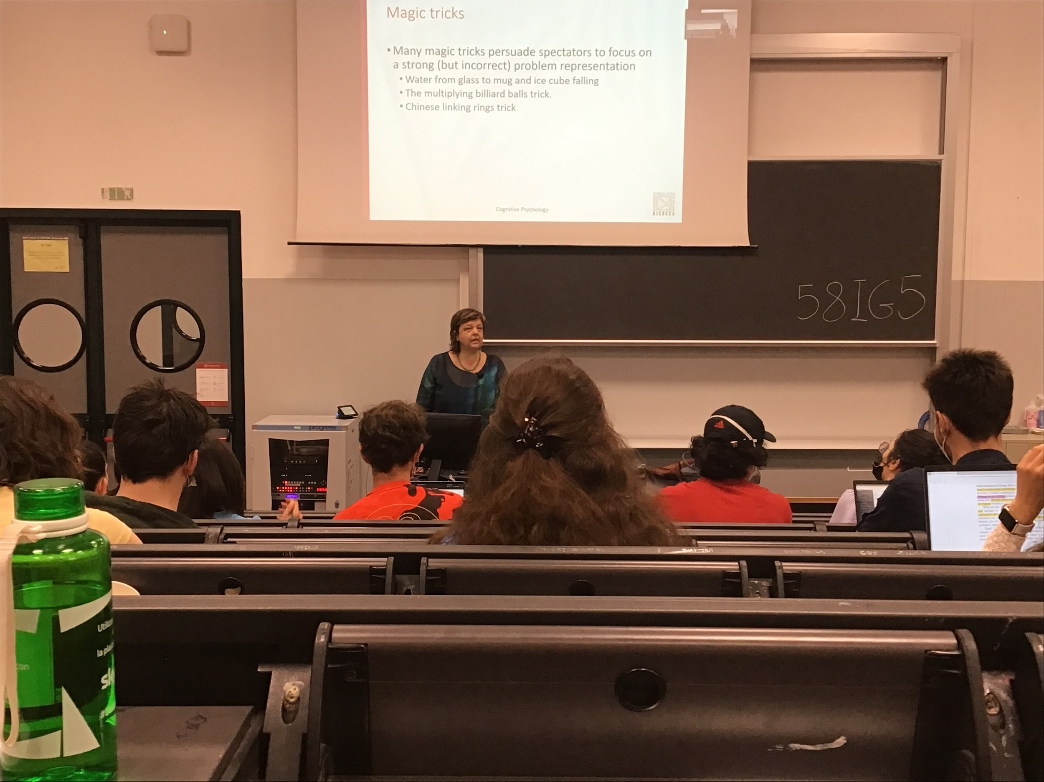

Idea of restructuring

People very often focus on incorrect problem representation by taking advantage of magicians, they try to misguide you to have a different representation of the problem from the one that actually is

When you have a glass of water and a mag and show that it is empty

You don’t see it, even if you know it you don't realize it and create a empty representation of the mug

We build representation of the environment around that is very strong and is very difficult to restructure

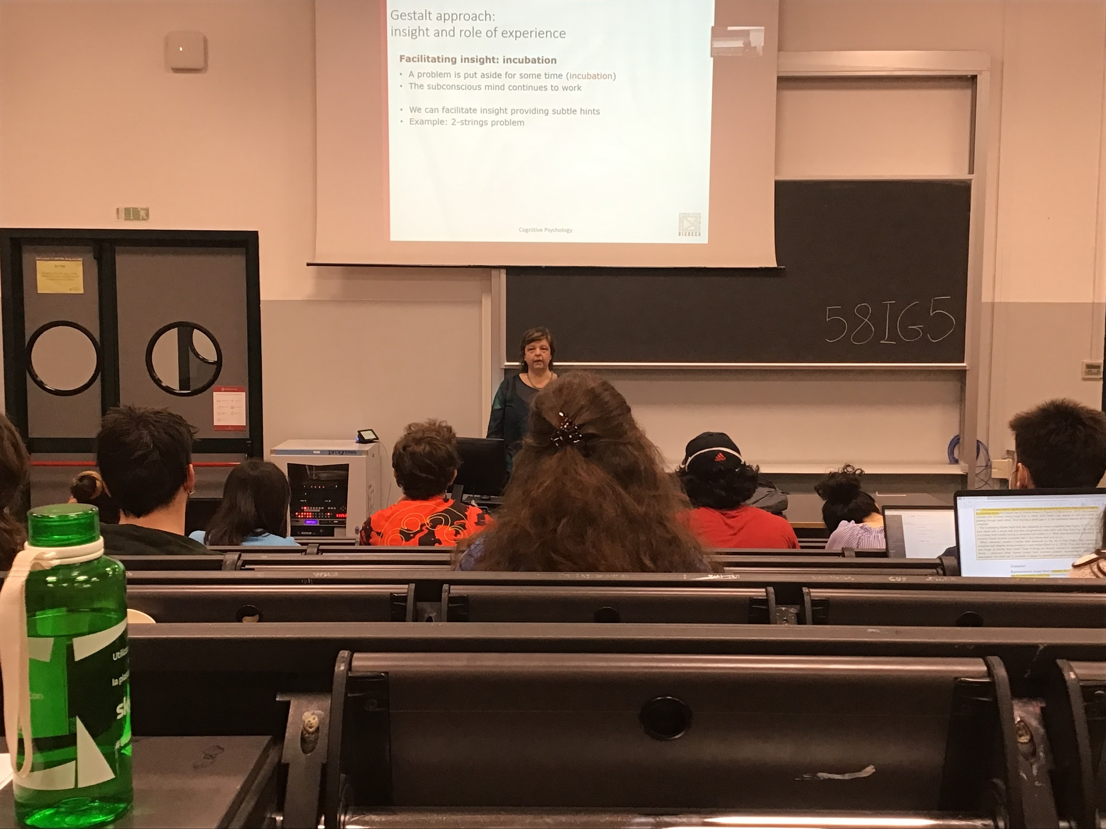

One way to facilitate insight is to allow incubator, don’t think about the problem for a while

**Incubator**: just **think at something else**, we are not aware but the mind keep thinking about the problem

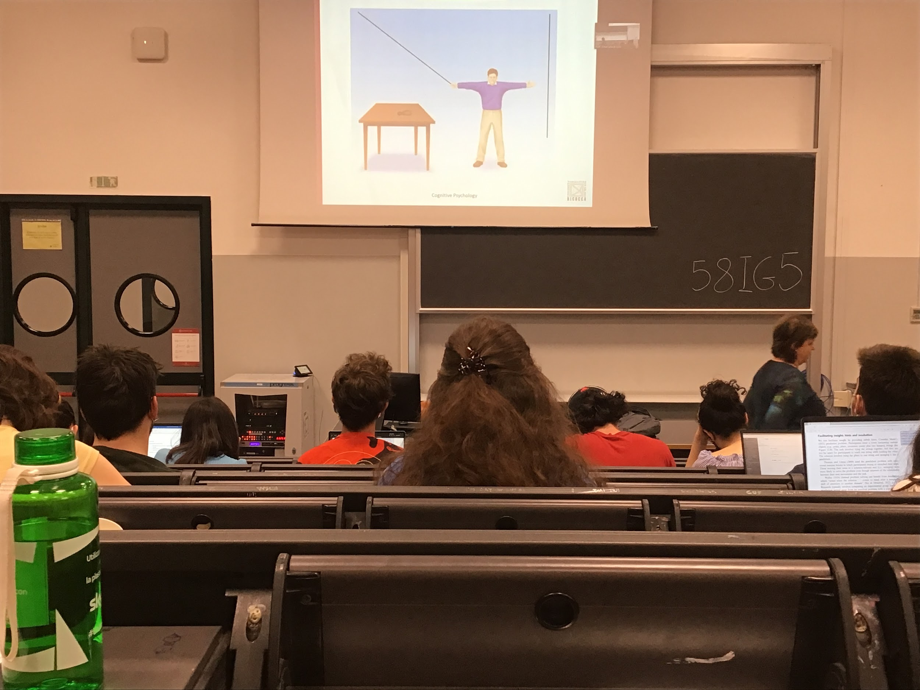

Make it swing by adding the pliers

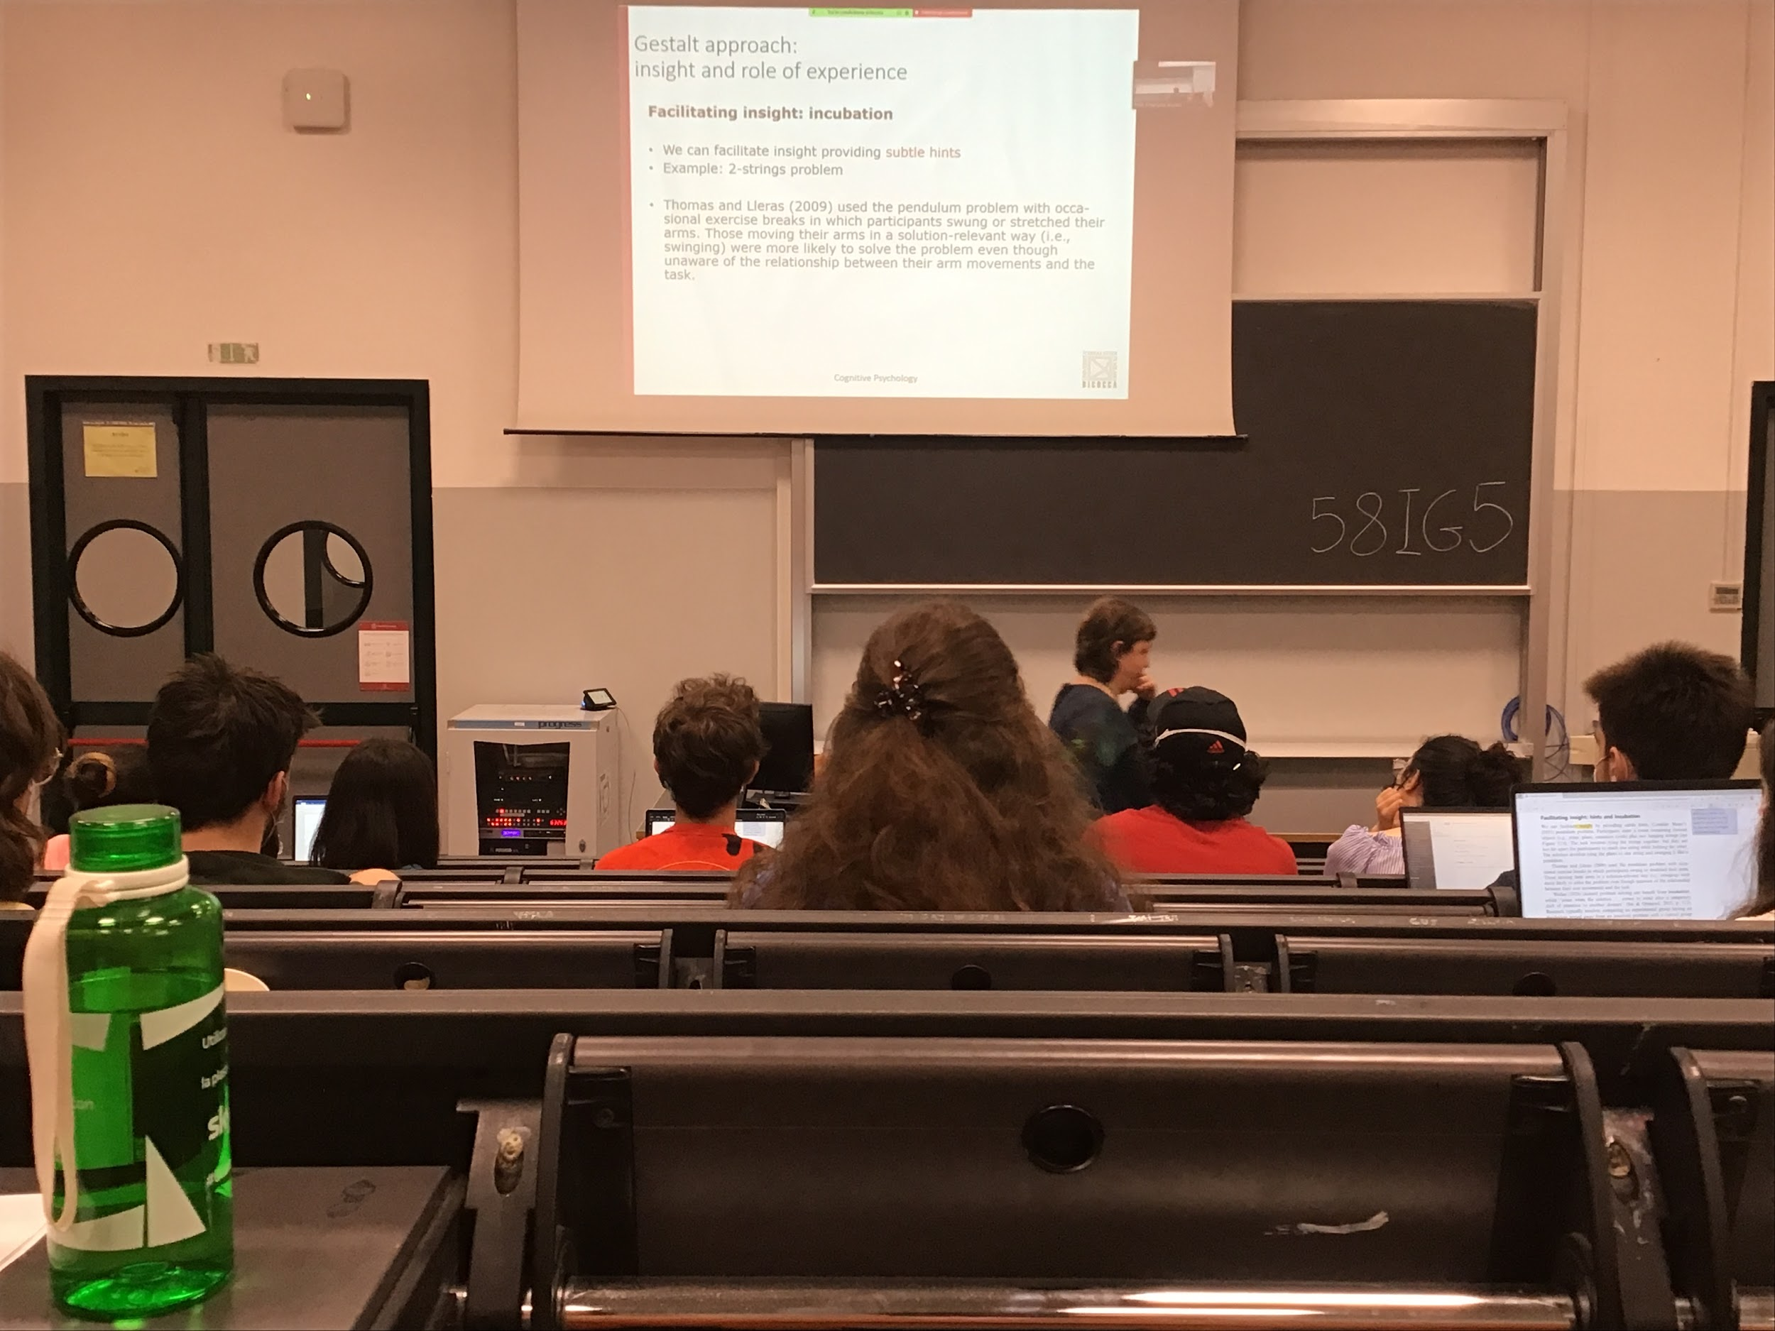

You can also provides hints that facilitates the solution

People in the room you tell them the problem and before you start doing the problem do some exercise, if you are asked to wing your arms, people who did swinging thinked much more about the solution much faster

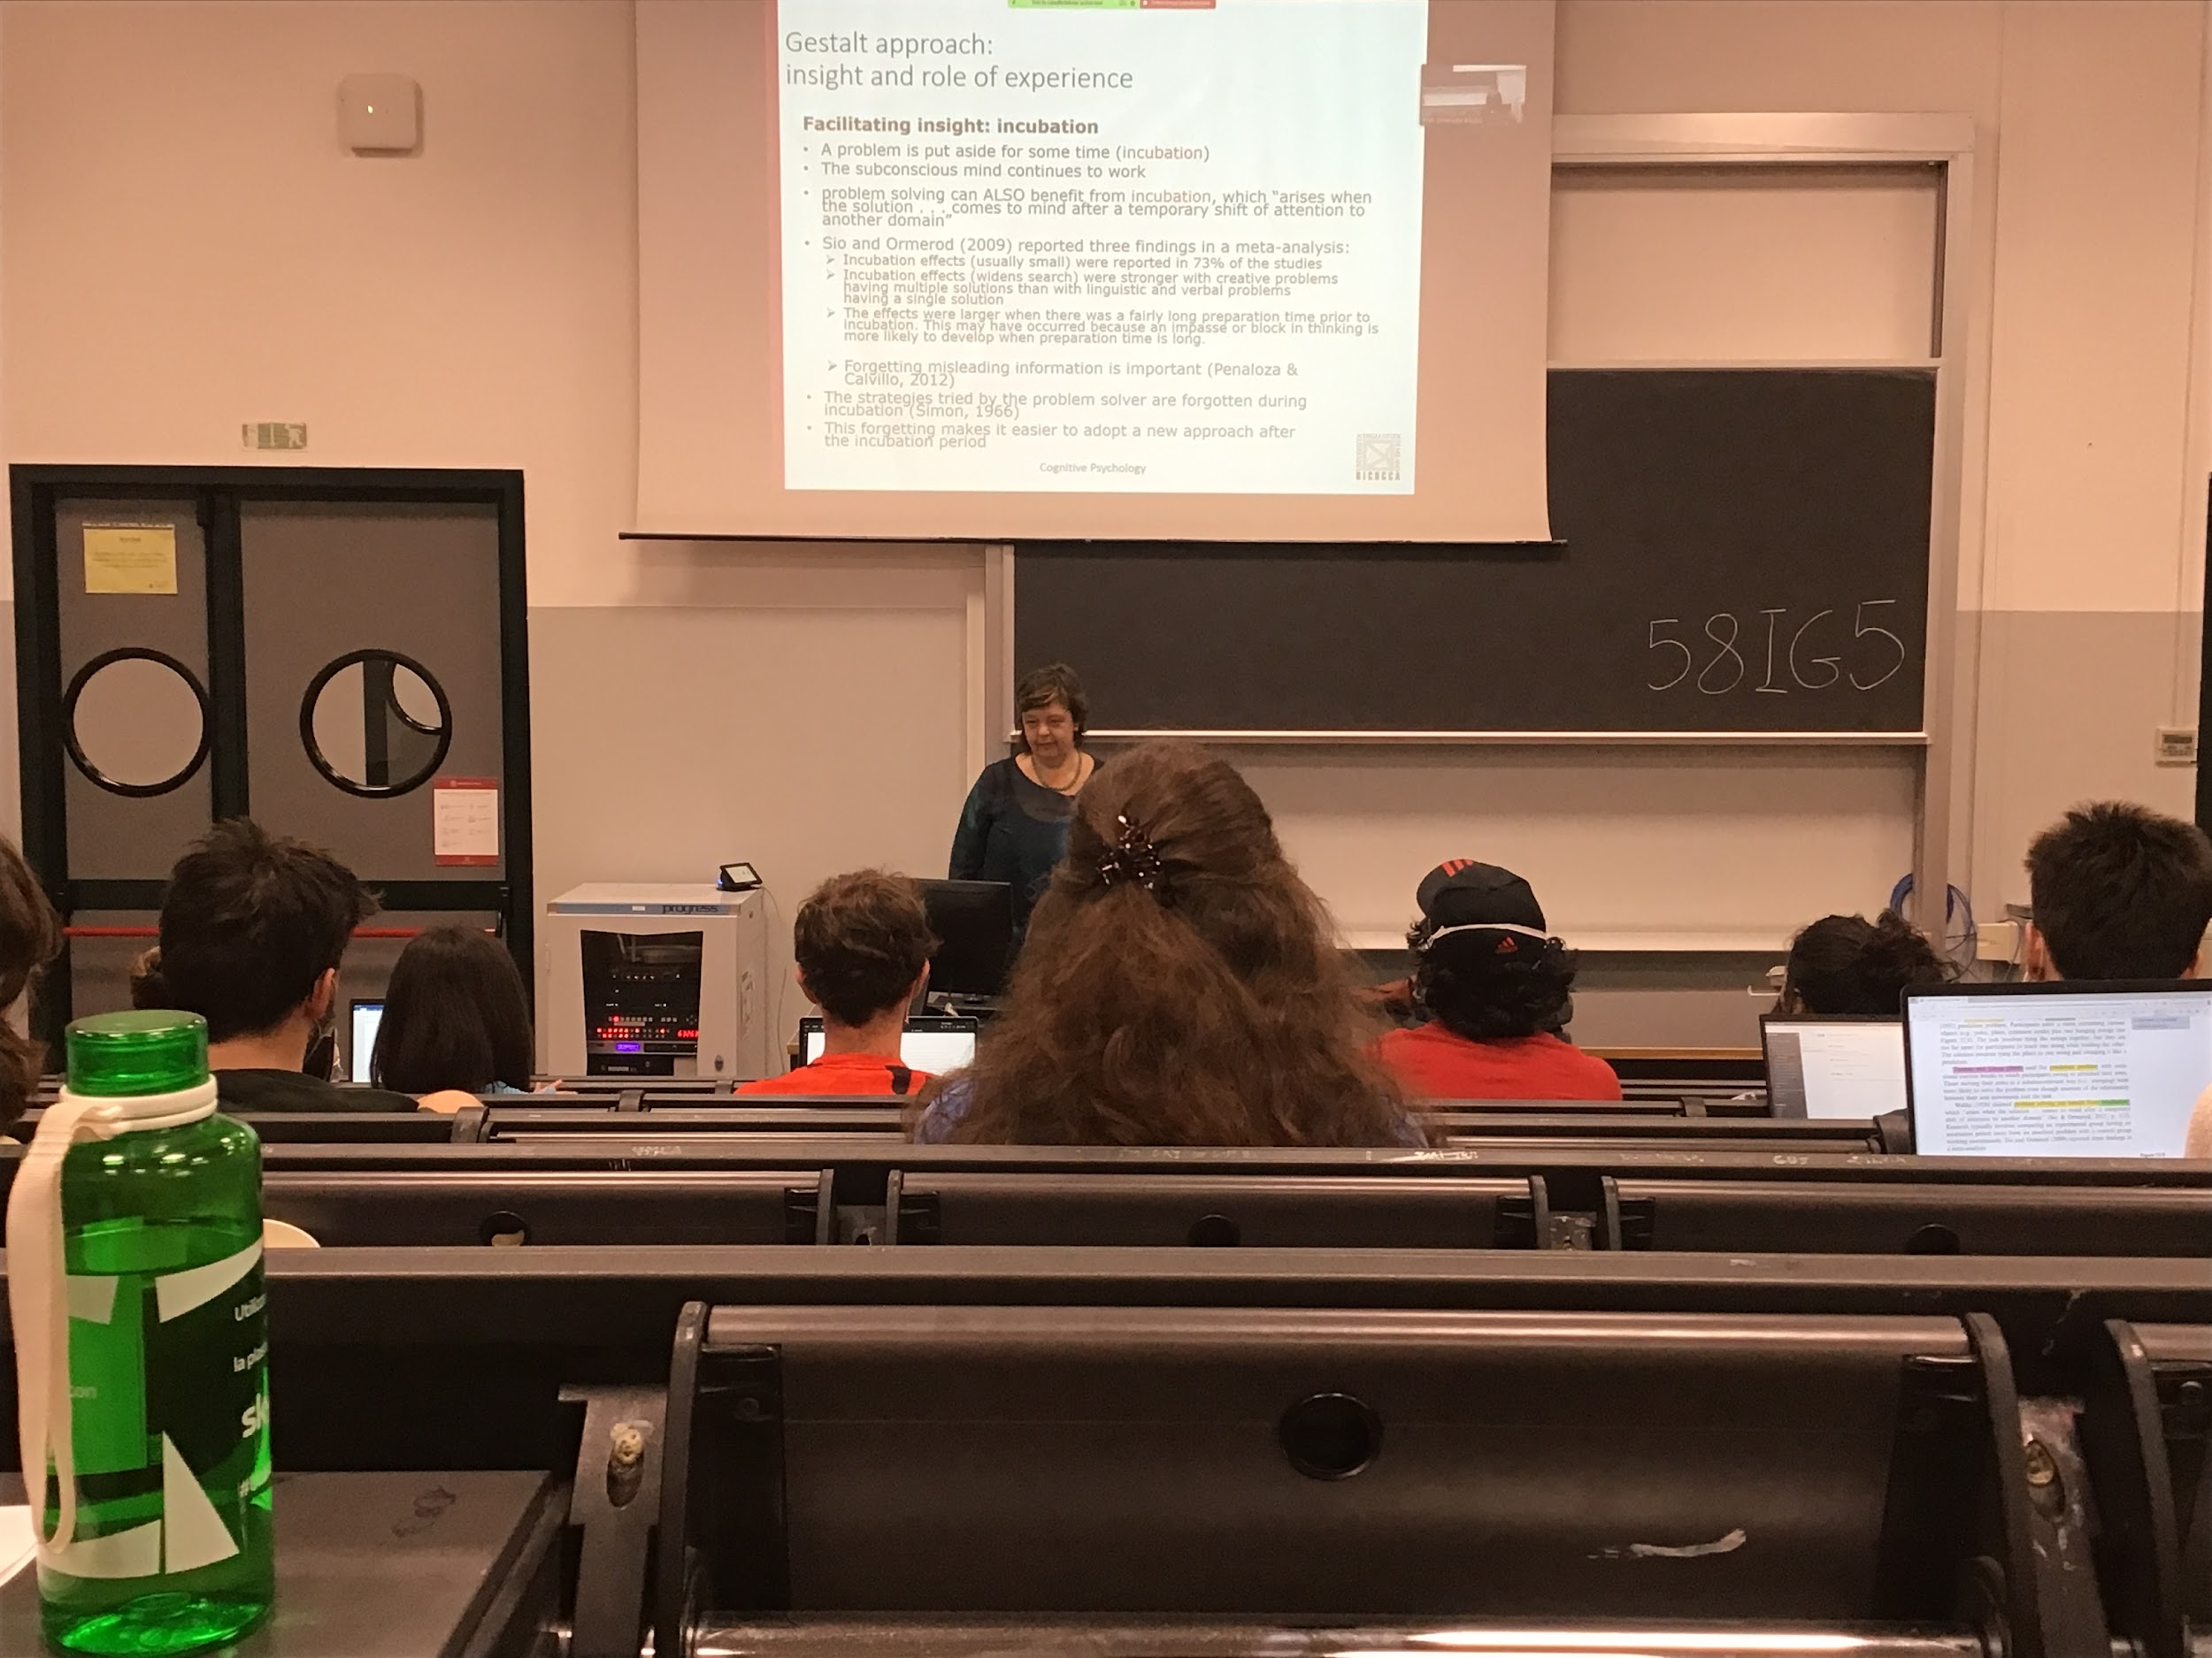

Incubation also works, leaving people to think about the solution and to think to something else, the incubation effect is found in small doses in a lot of test

Incubation does work, it stronger with problem that have multiple solutions

During incubation you forget about what you tried and is clearing up the problem and forgetting about all your trials and you can find a new solution

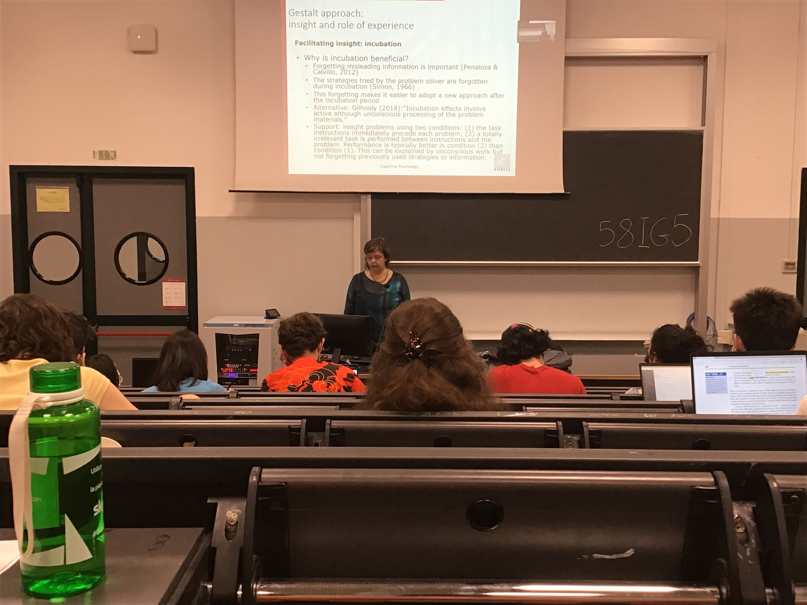

Incubation period let you relax your hypothesis and find out your solution, it helps you find a new approach and help you use your subconscious

To show that incubuitions works two test

1. give you the instruction and ask you to solve the problem now
2. give you instructions, make you do something else, then you solve the problem

You are much faster at solving the problem when you do something else before the problem as if your brain was thinking about the problem and reorganizing the information

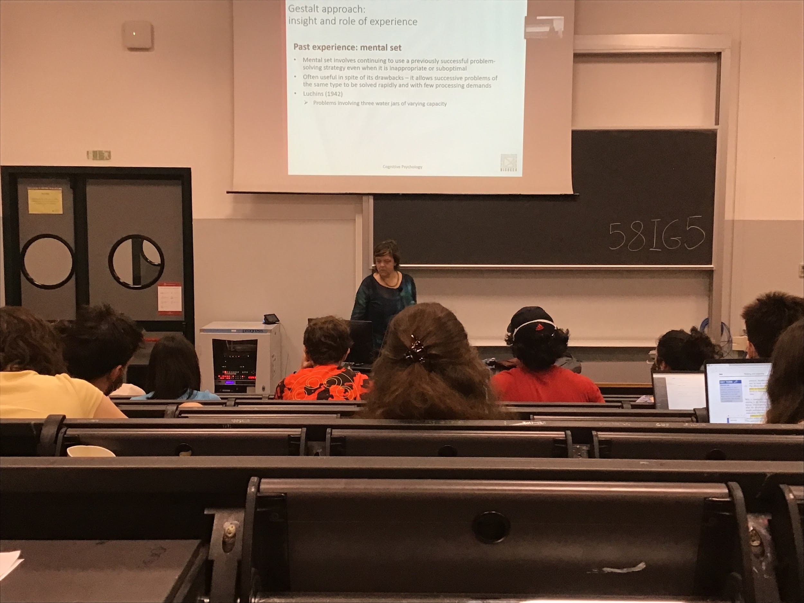

**Audio 2**

**Previous experience**

Our past experiences influence our perception and our problem solving

One idea that is important when we talk about previous experience is the **mental set**: we are mentally set in some convidionts given by the past experience, for us a way to solve a problem is to keep using previous solutions that have been demonstrated to be useful in some situations

Reuse strategies that earlier where good strategy for solving a problem, we use mental set even when it is not optimal

There are situations in which re-apply the solution used before implies taking longer time and not givinign the right solution, but the mental set forces us to do in in any case

We use the mental set because many times it helps us to find the correct solution in a easy way

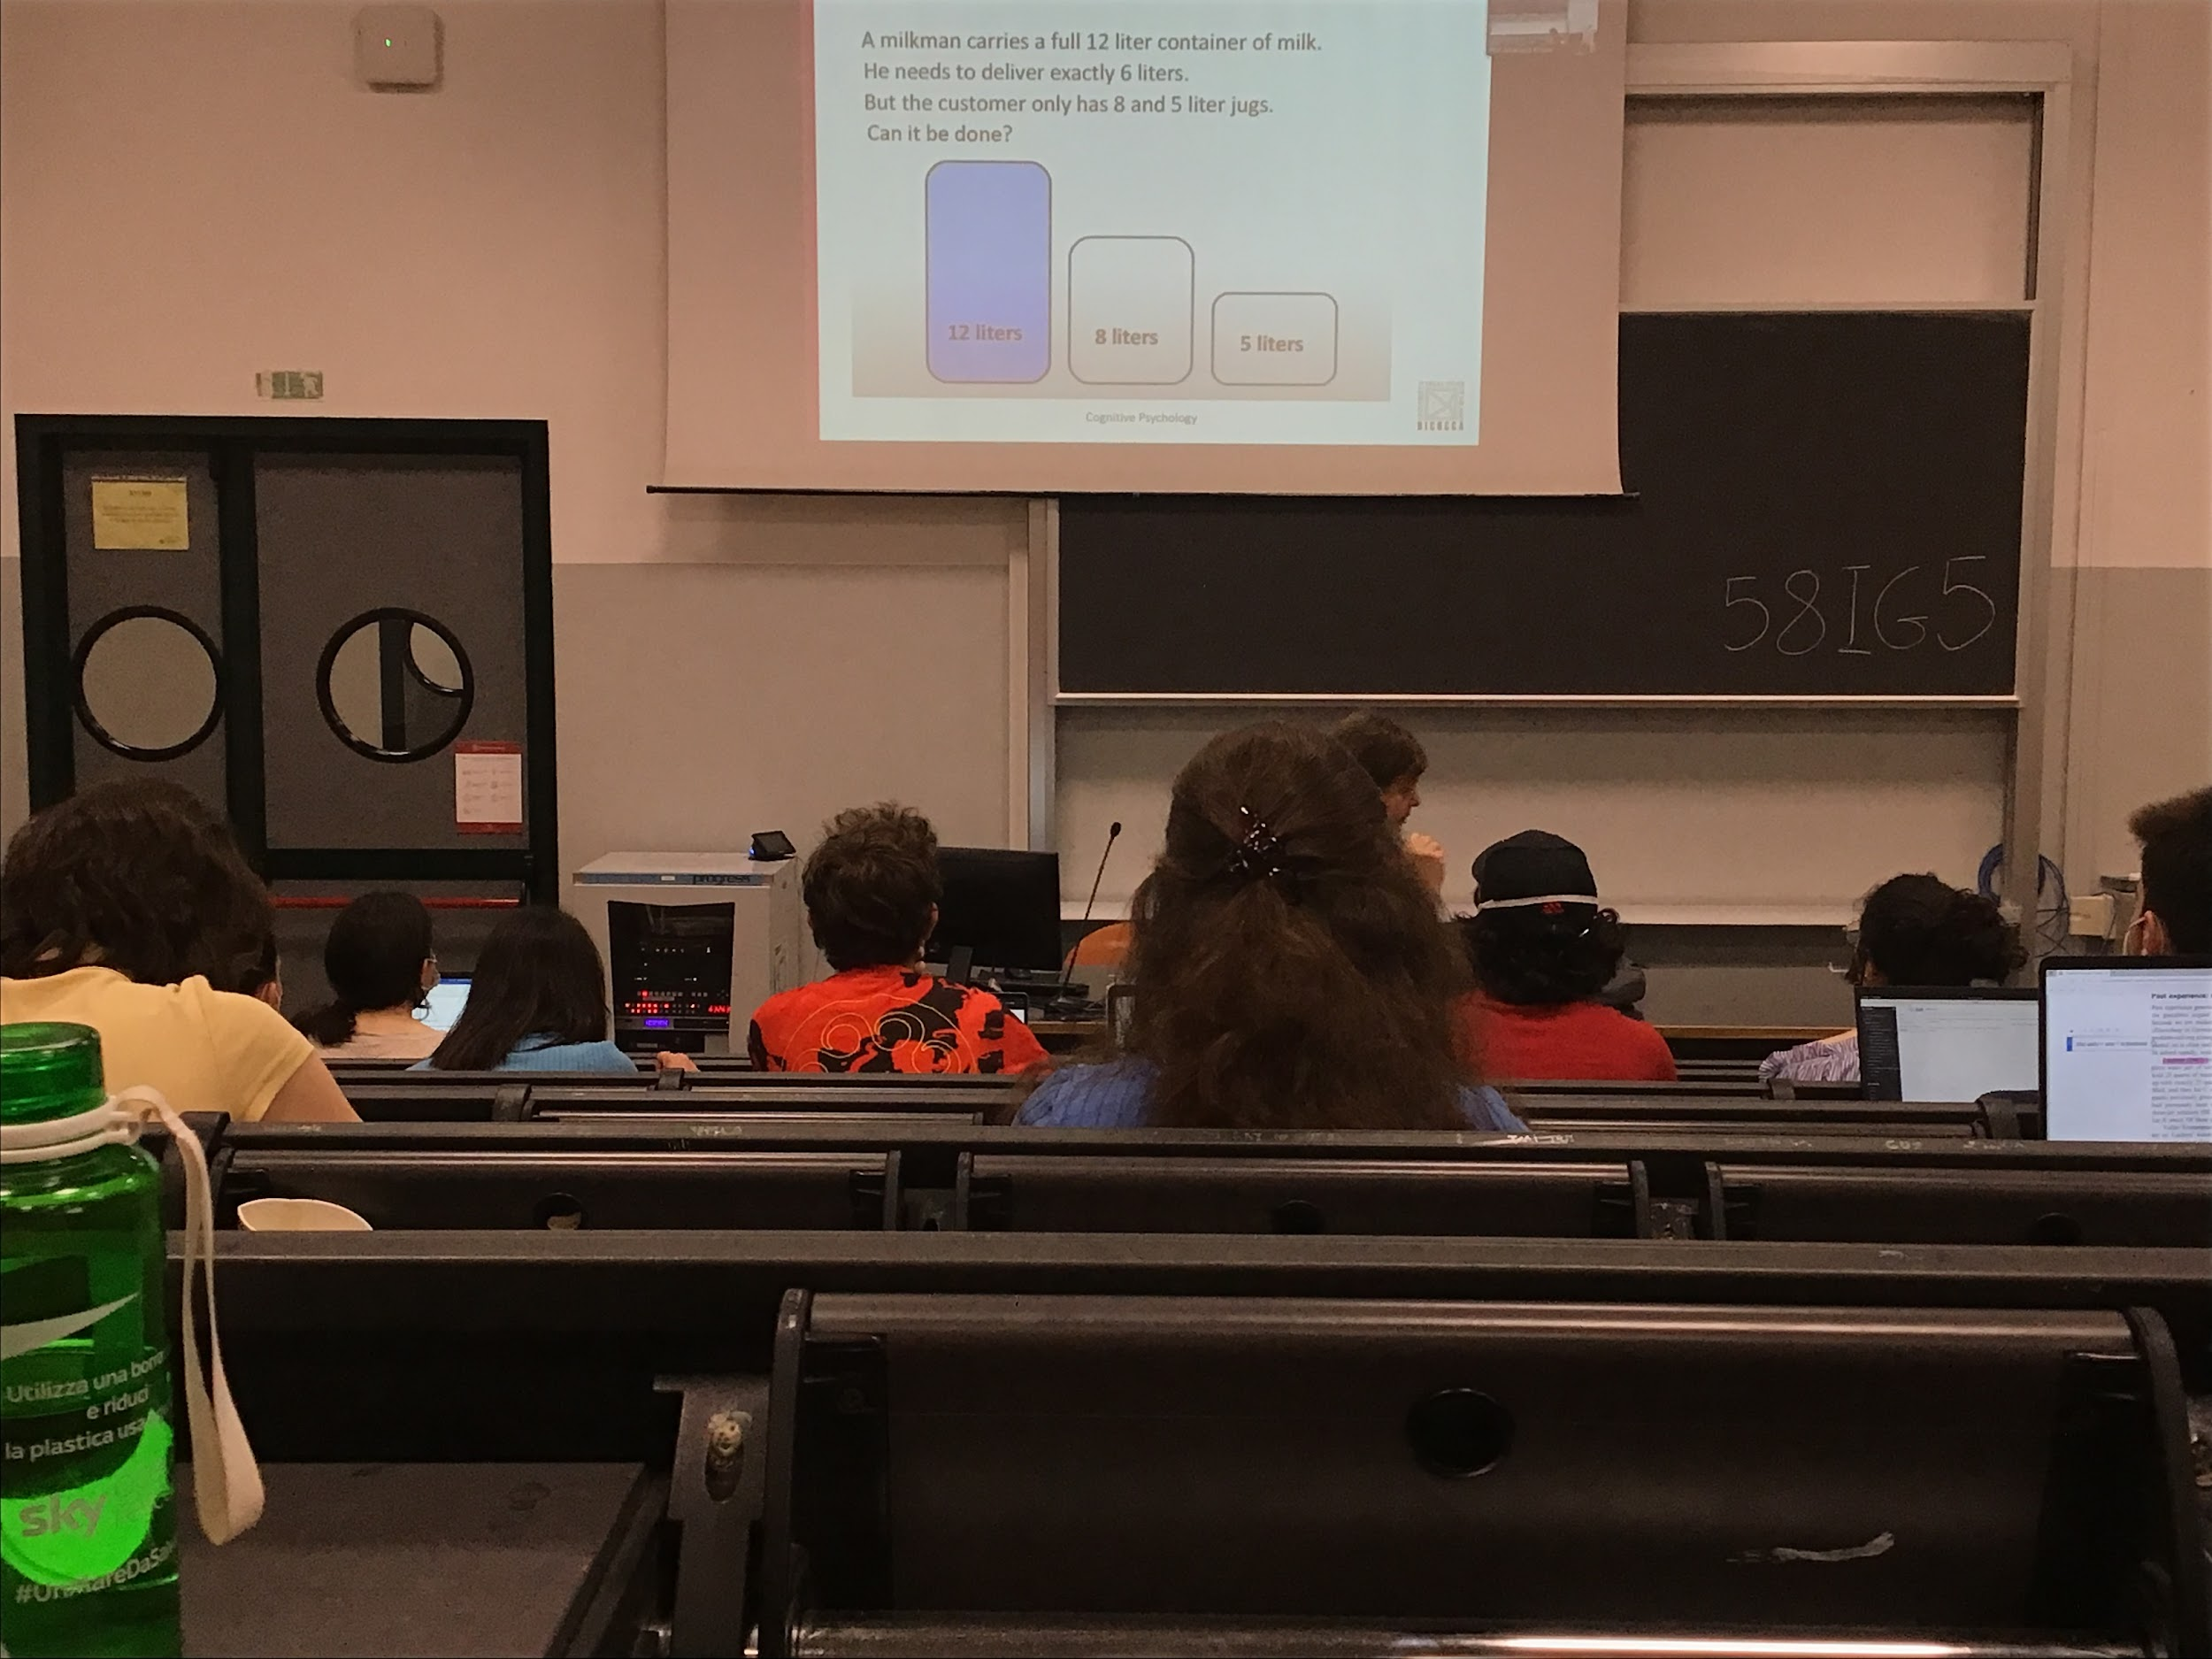

The problem used is the 3 giars problem

We need to deliver to somebody 6 litres, how do we do it

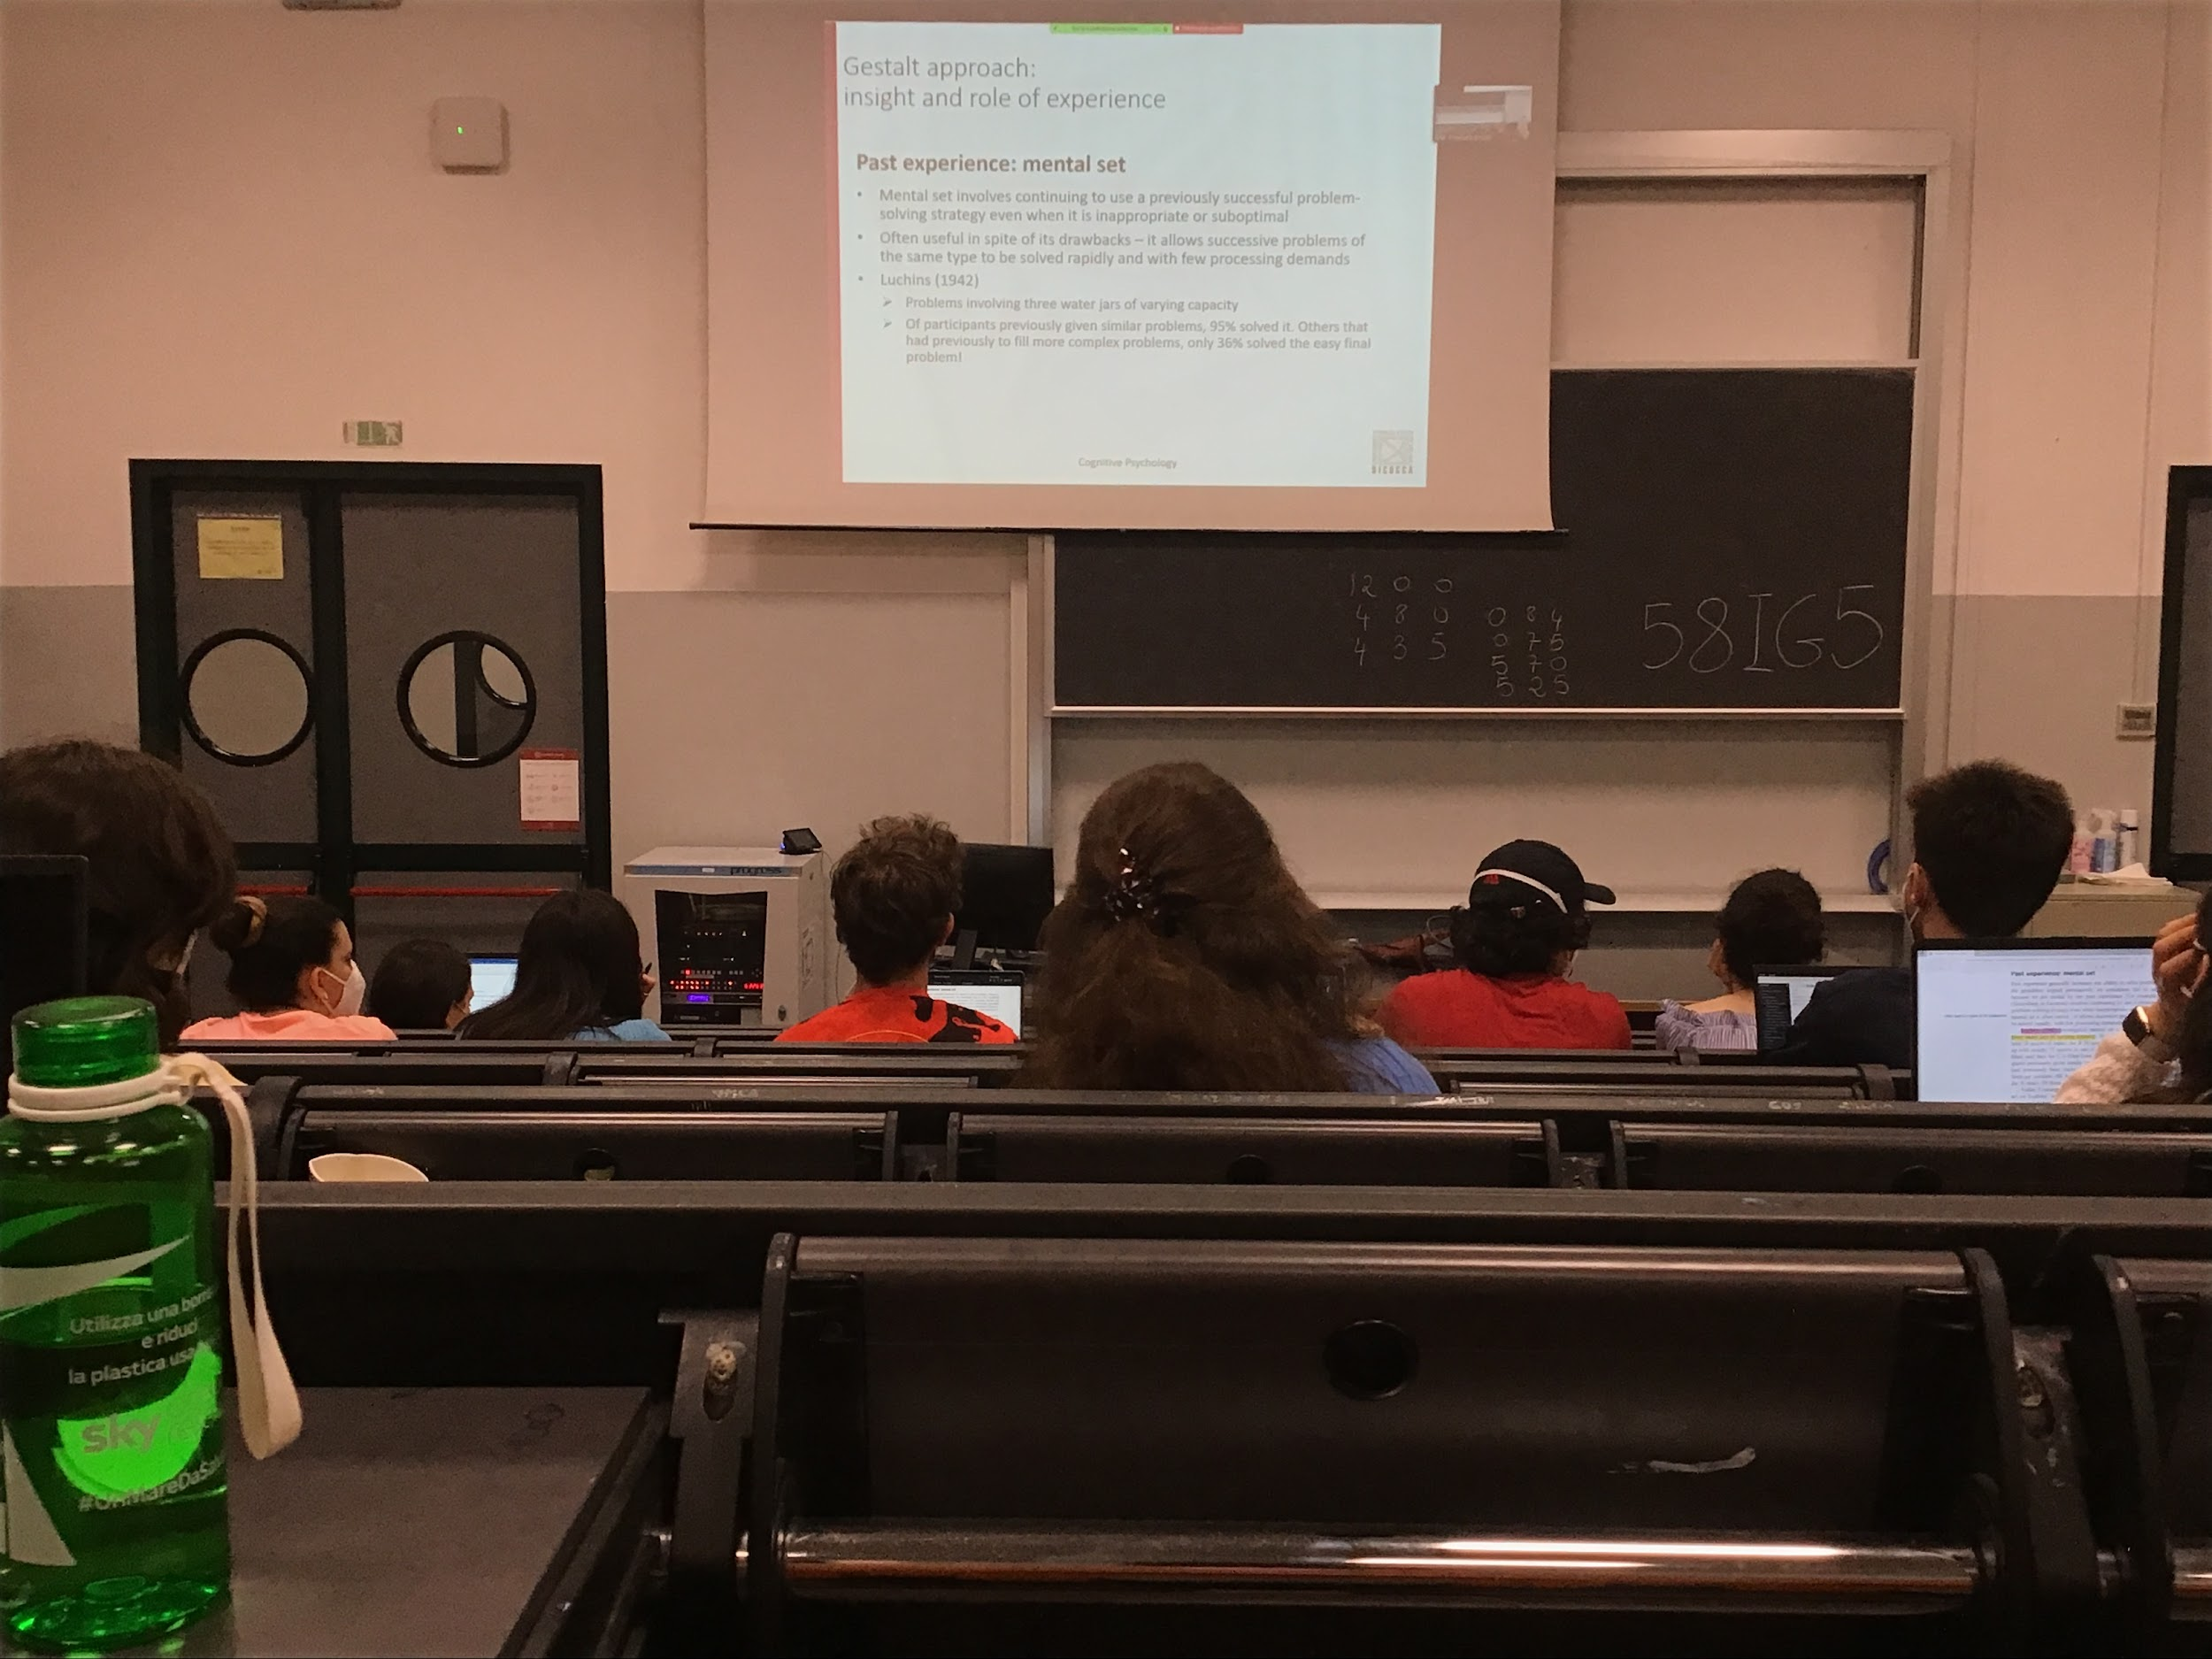

Even I a make a much easier problem the sequence is the same

If I give you a easier problem you try to use the old solution

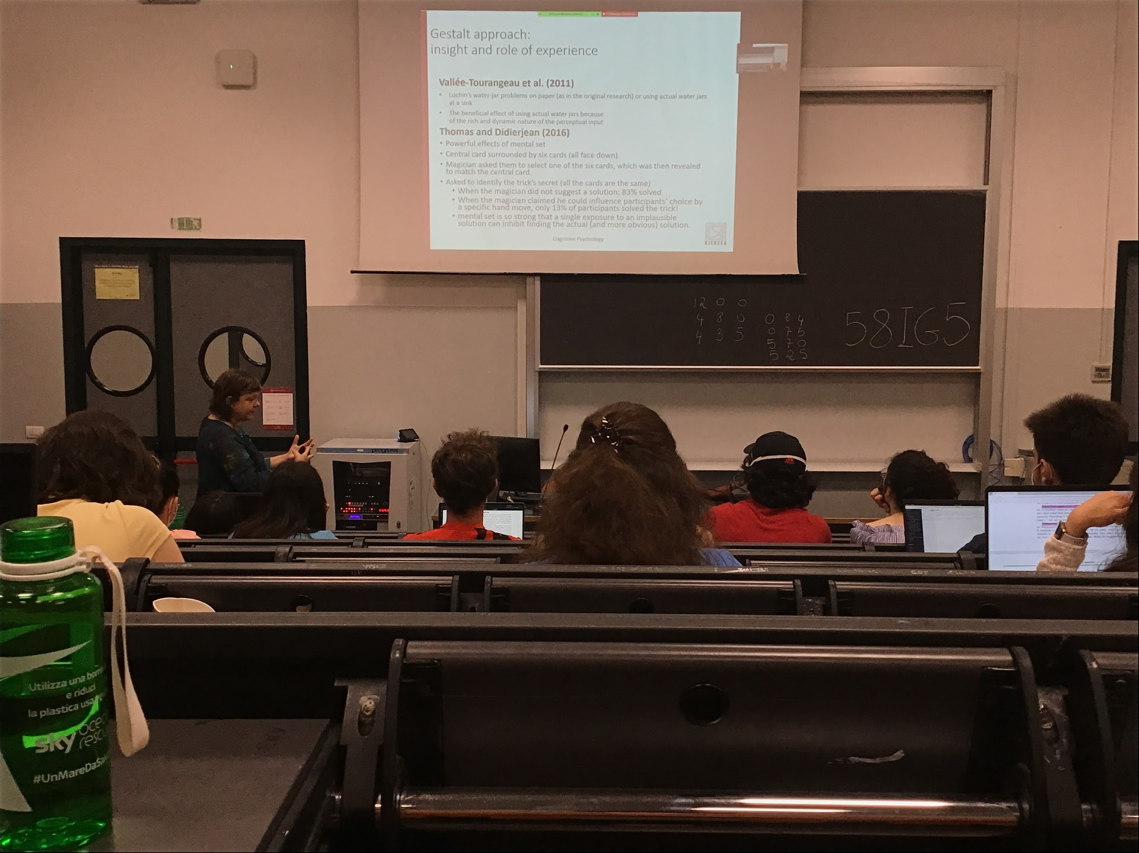

Your system try to take advnge of what you learned, even in the situation where there is no point. There is a different effect if you are doing the same problem with real giars, you are much better of at non using the mind set when you are doing in practice with real water/milk

Les forced on the mental set. This effect is very strong

It is very strong and can influence negatlety our behavior

But is important, the mental set is influenced by experience

When you use chess experts and you give them some board position and ask to solve the problem, you see that most of time they use a way that is familiar for them because it is easier because is the way that they usually do it. Even if in that situation there is a faster solution

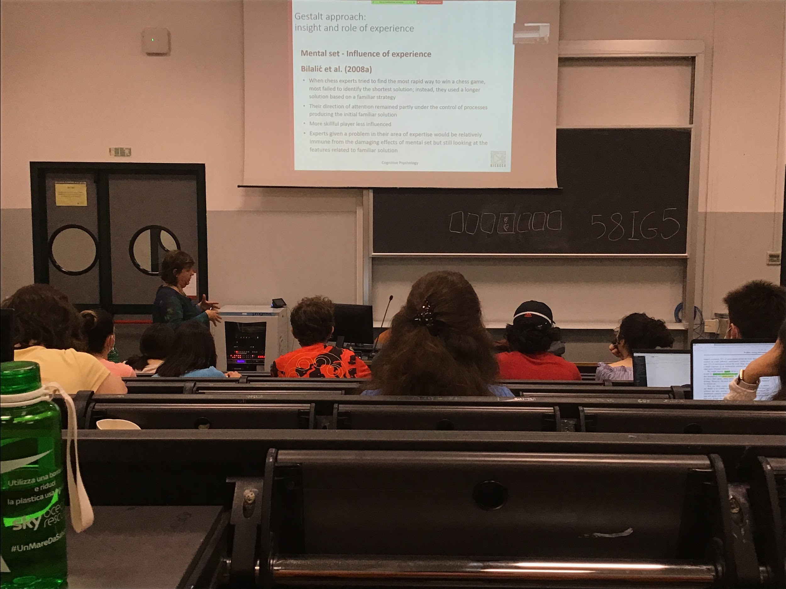

Influences of the mental set that sometime is wrong but most of the time is right

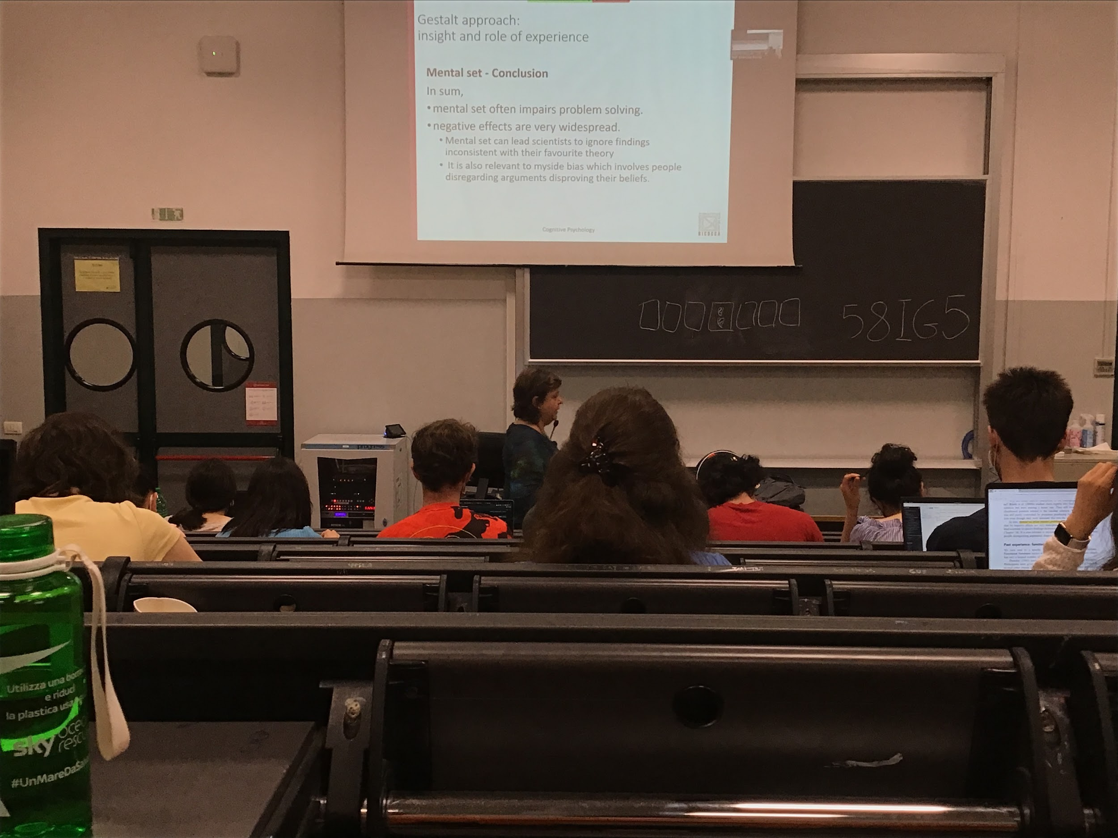

This mental set often impairs problem solving

Refuse to accept demonstration or data that shows that you are wrong. You keep your con convictions

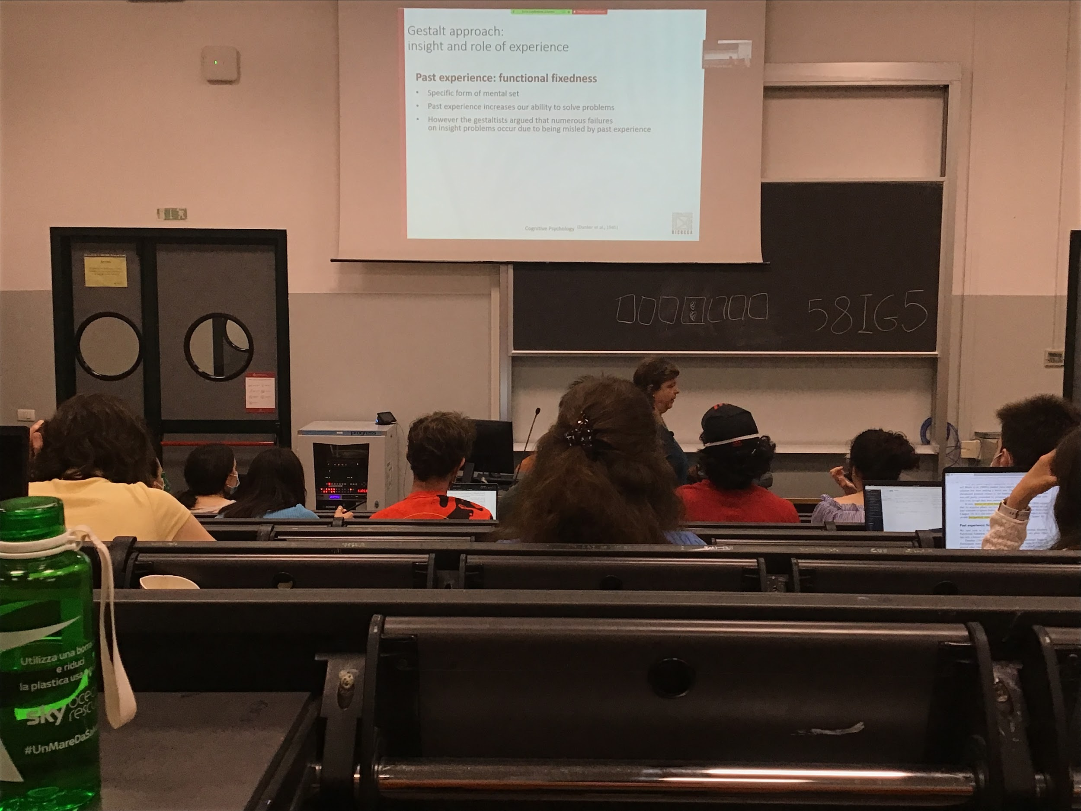

Function fixdness (a specific example of mental set and past experience): we are convinced that specific objects are used only for one function (like the two cords problems)

In that problem you need to switch and try to think about objects using different functions to relax the constraints. Past experience associate with objects different functions and so it is difficult to get away from this function and to think about something else

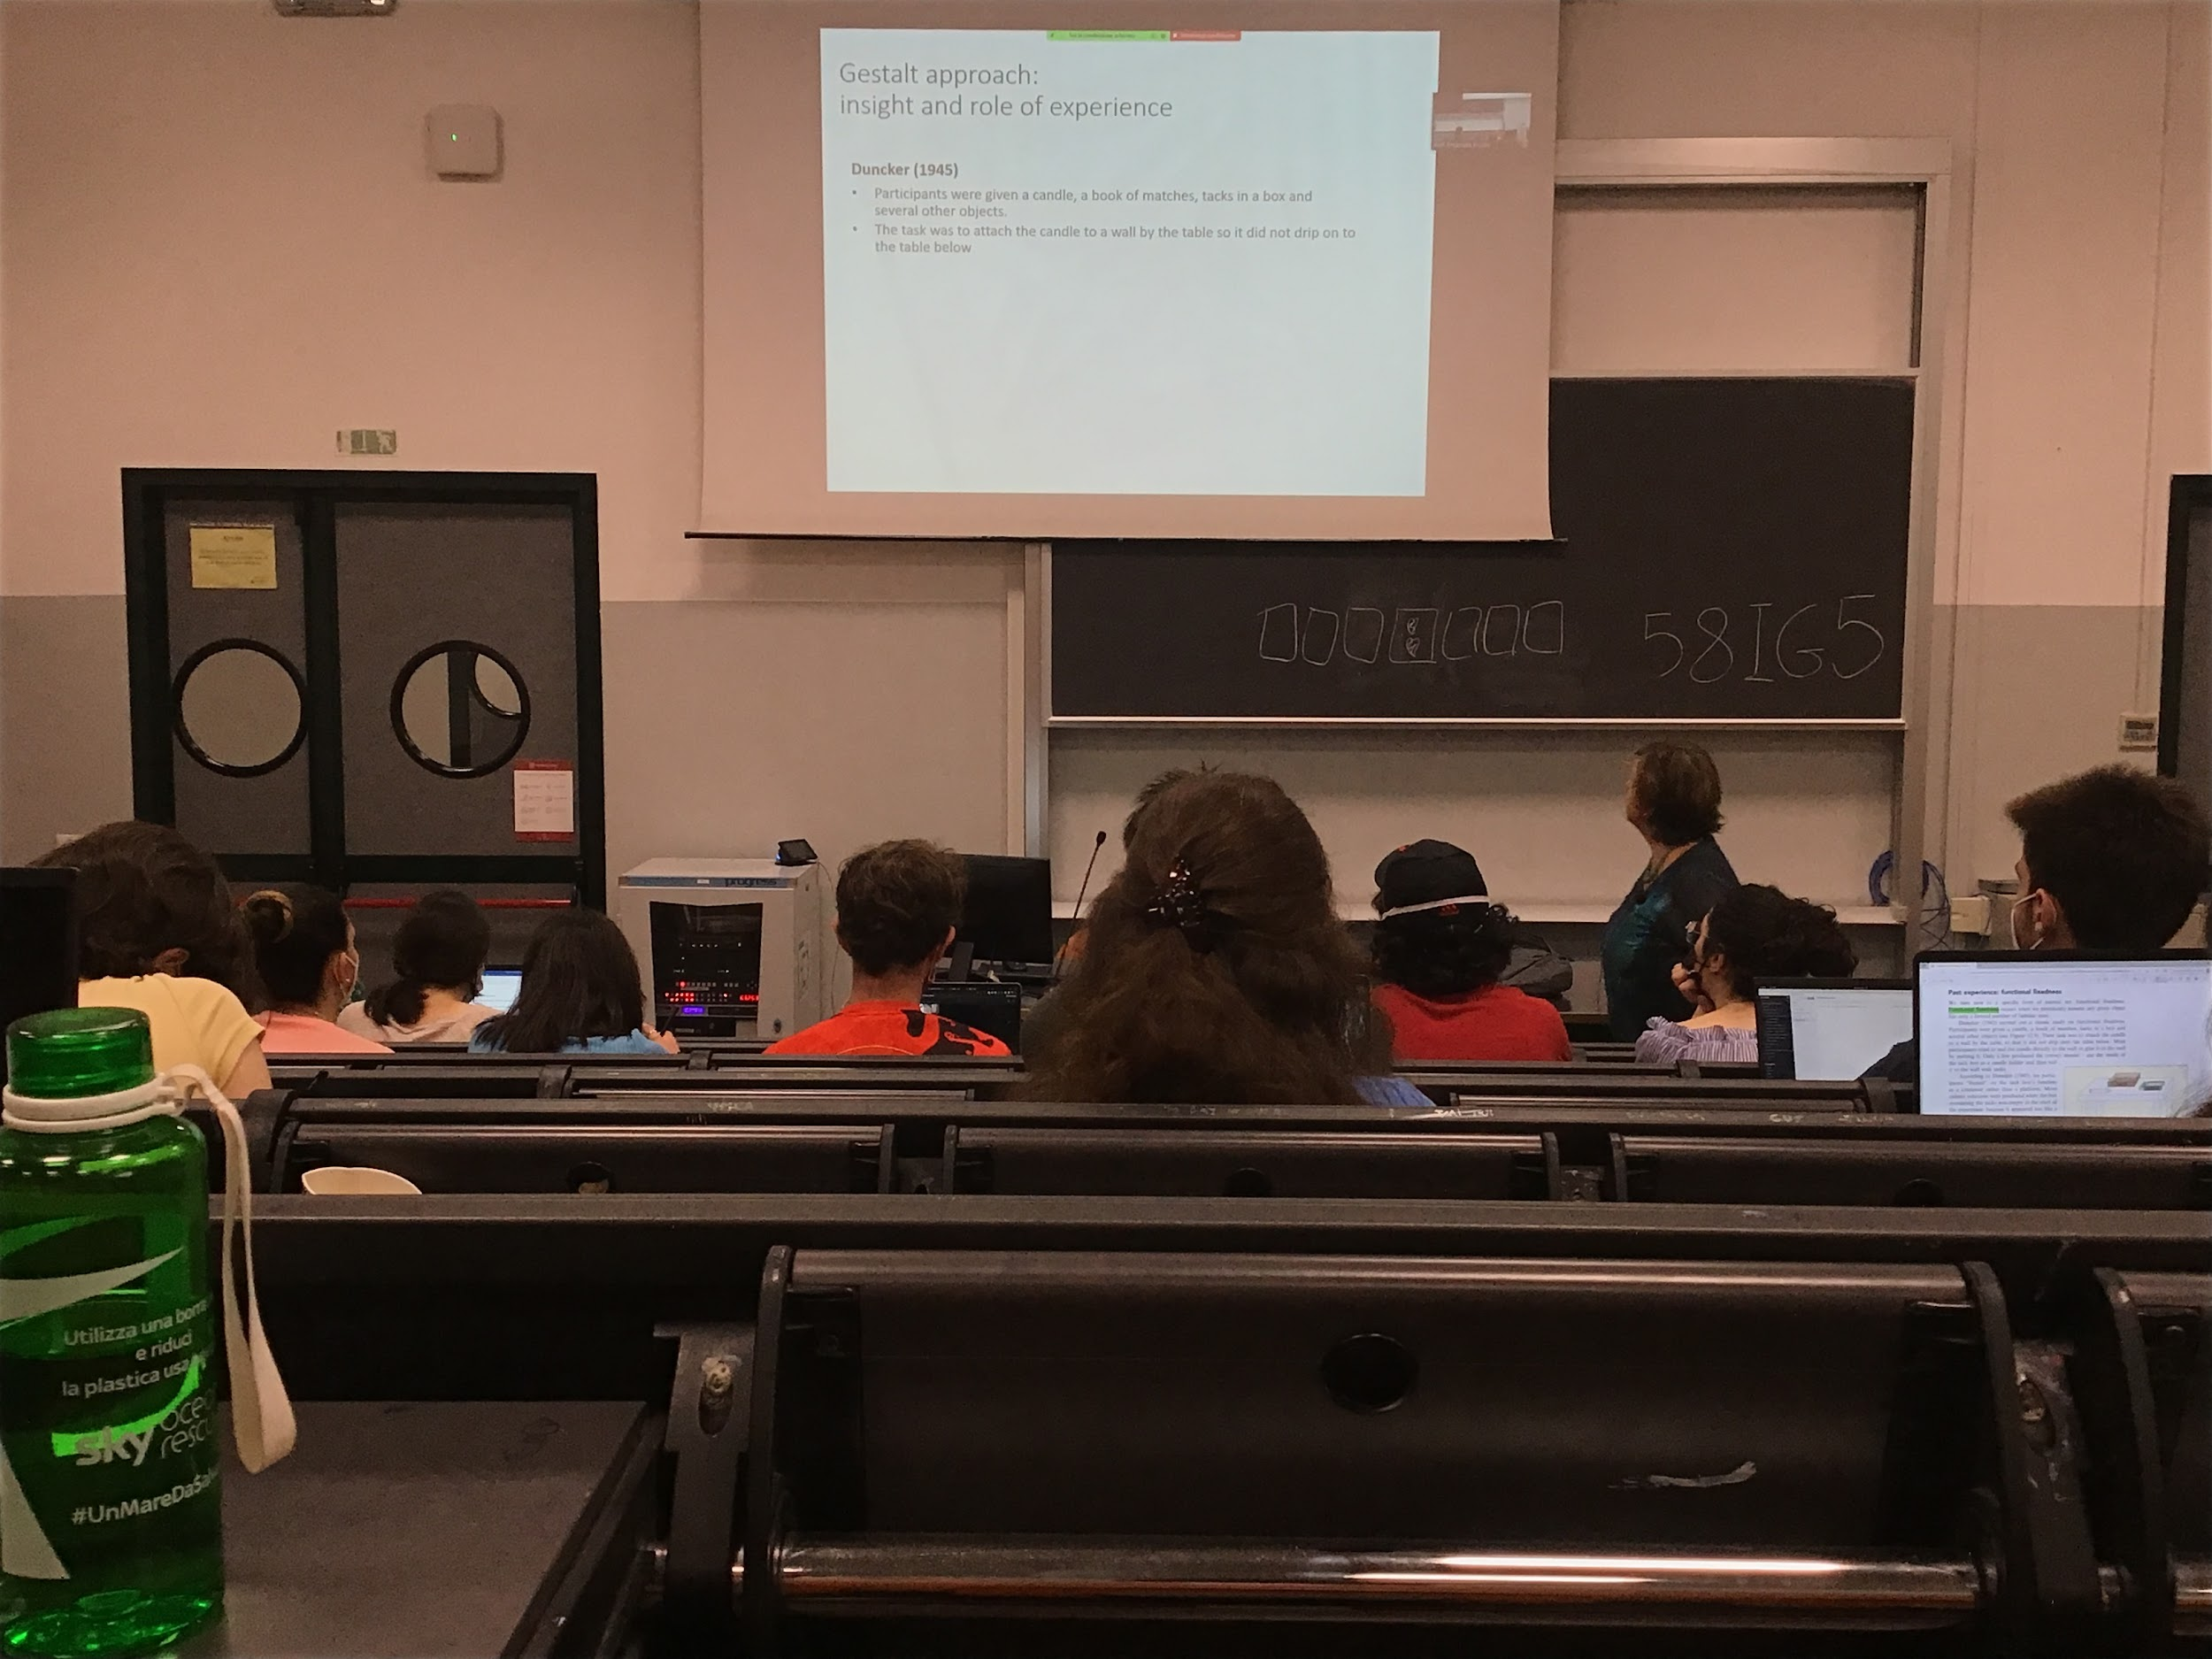

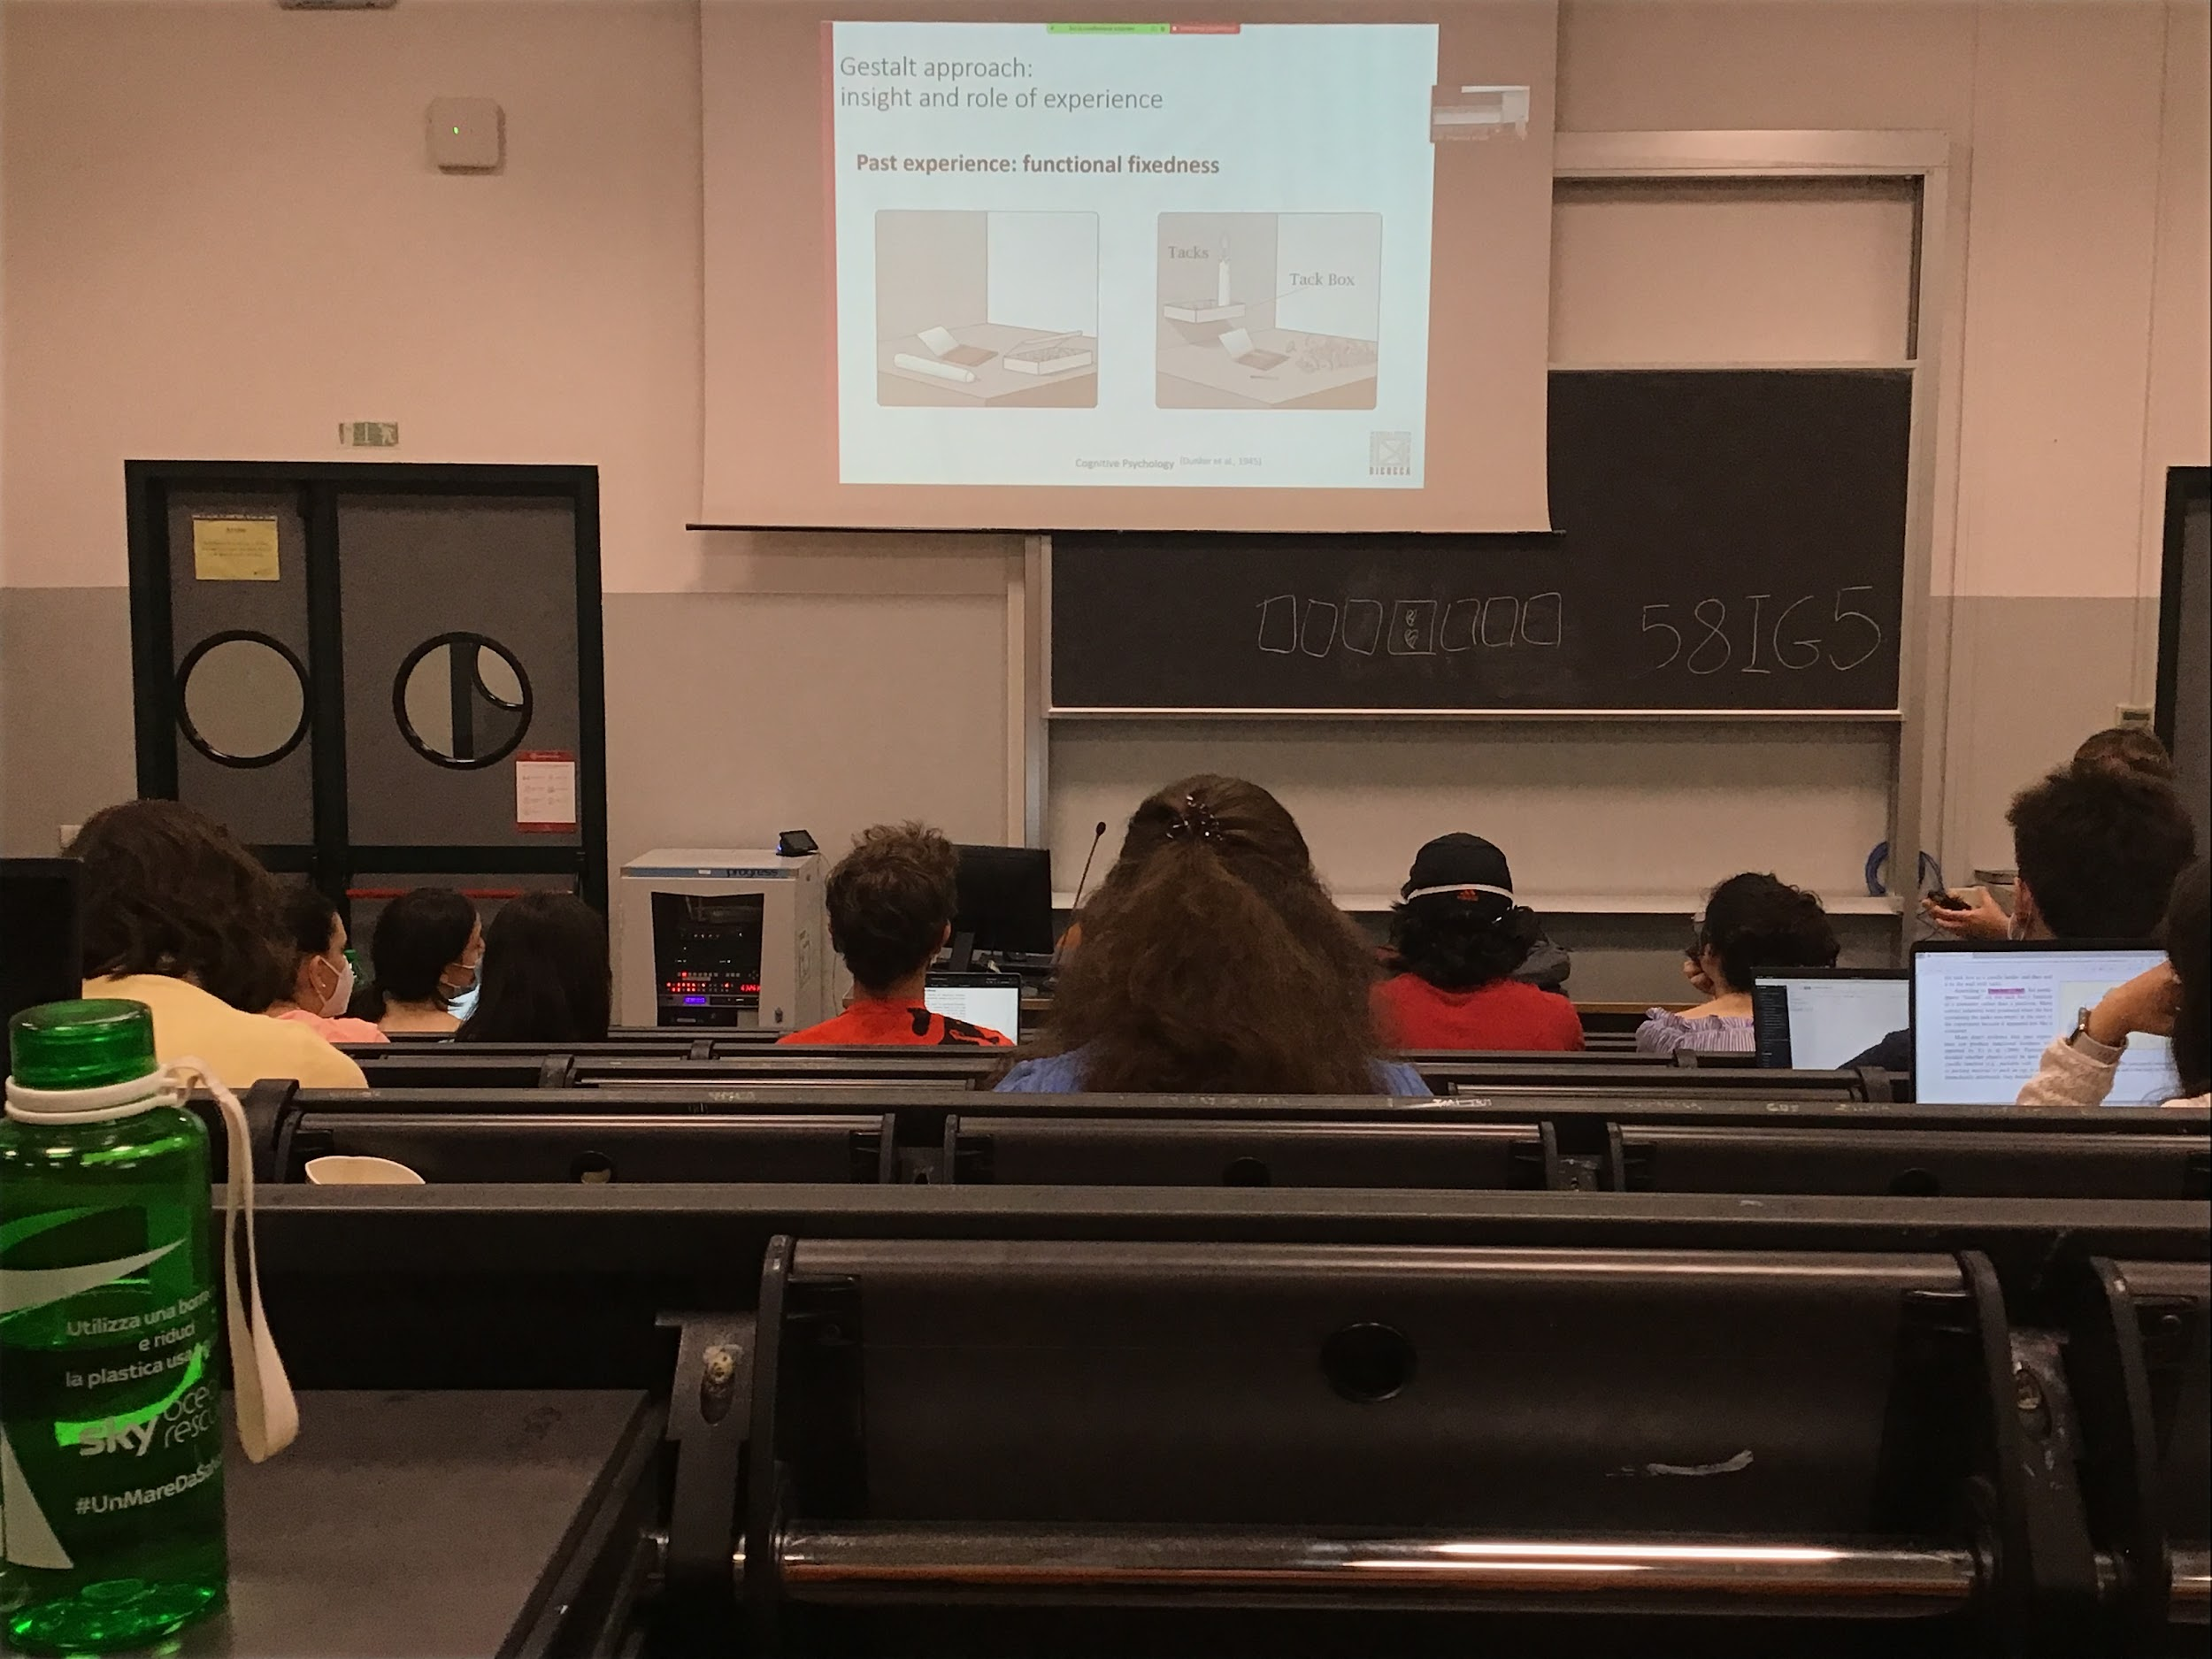

I give you a cable, a bock of matches, tacks in a box and others objects

You have to attach the candle on a wall so that the candle does not drip on the table below

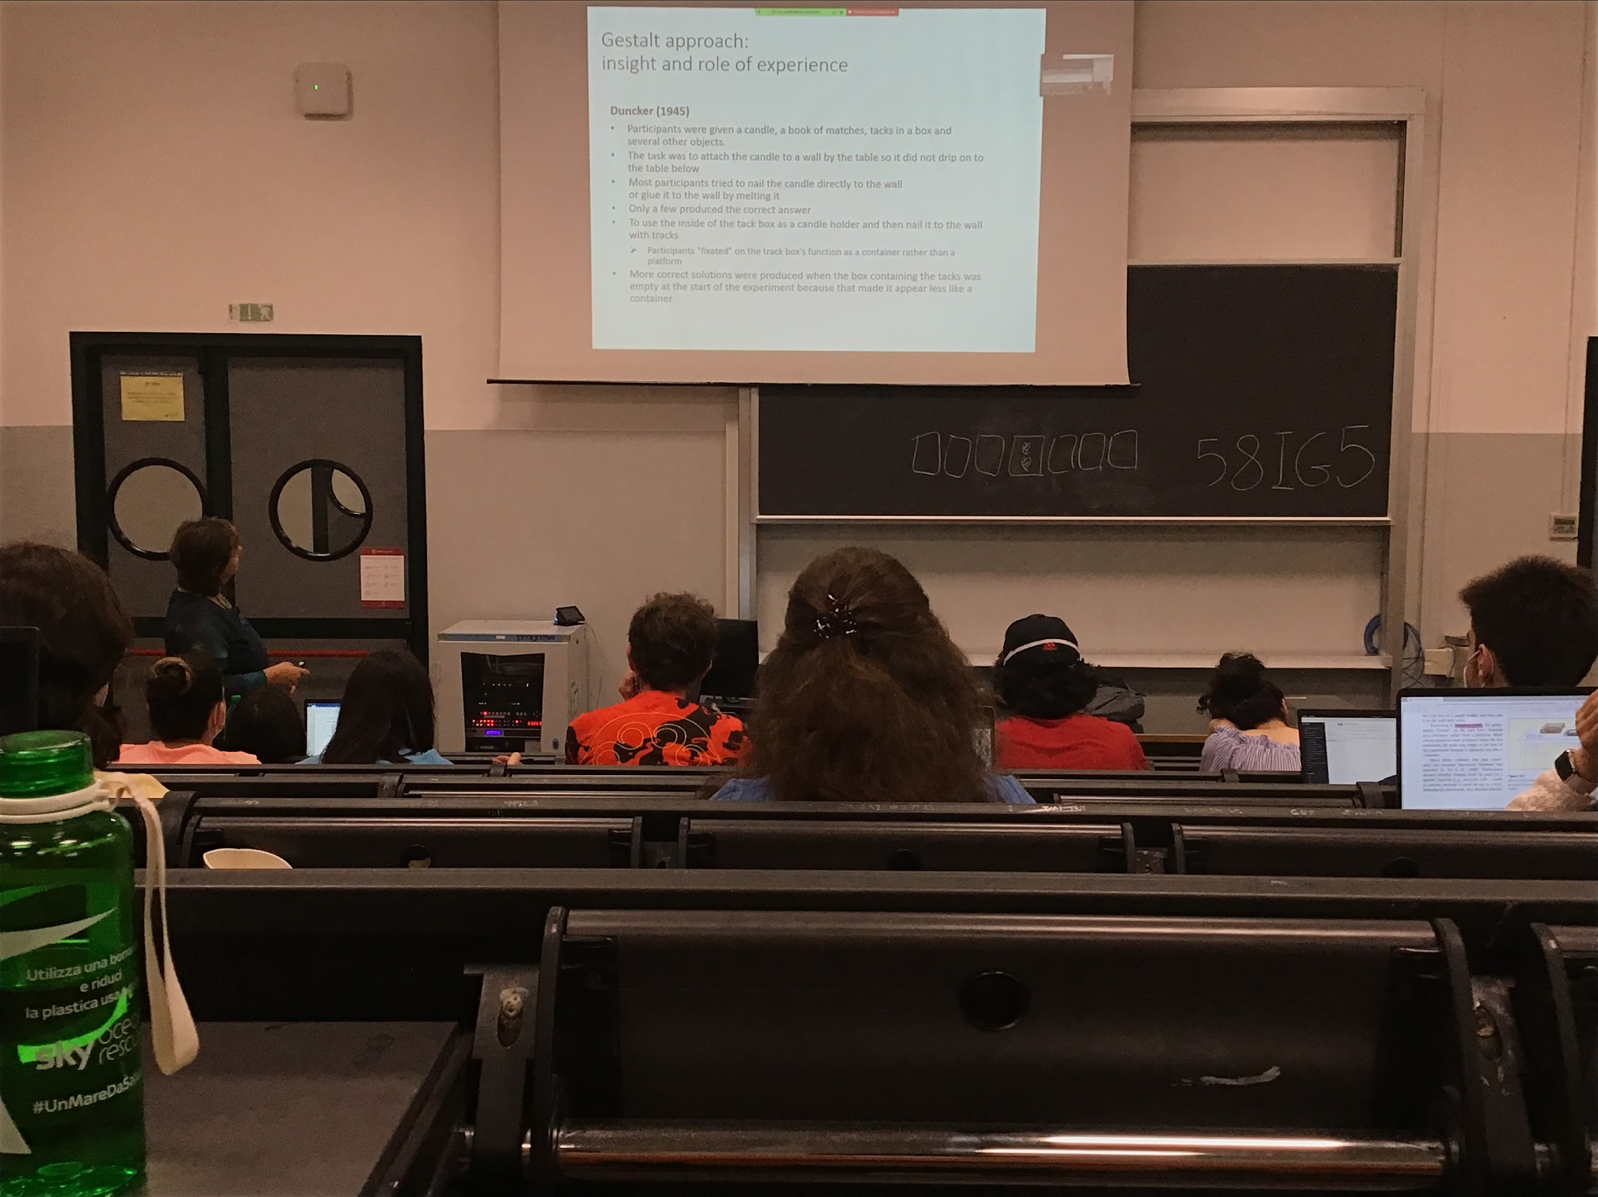

The problem is th functional fictness. You think that the box is simply a container rather than a platform

You don’t have to use the obejcts for the functions they are thought of

If you have on the table an empty box is much easier for the people to solve the problem and to think to put the candle in the box

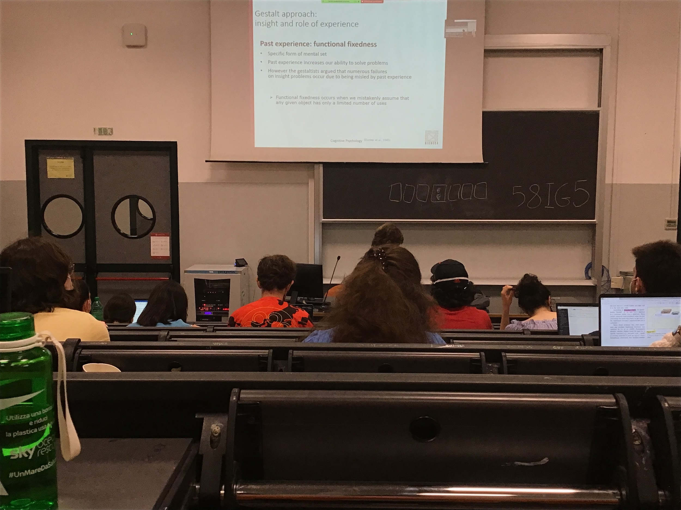

We use functional fixdness: you think that the box is simply a container

It very important for our survival, important to understand what an object is used for

It I something that helps a lot during a daily life, but sometimes have an opposte effect

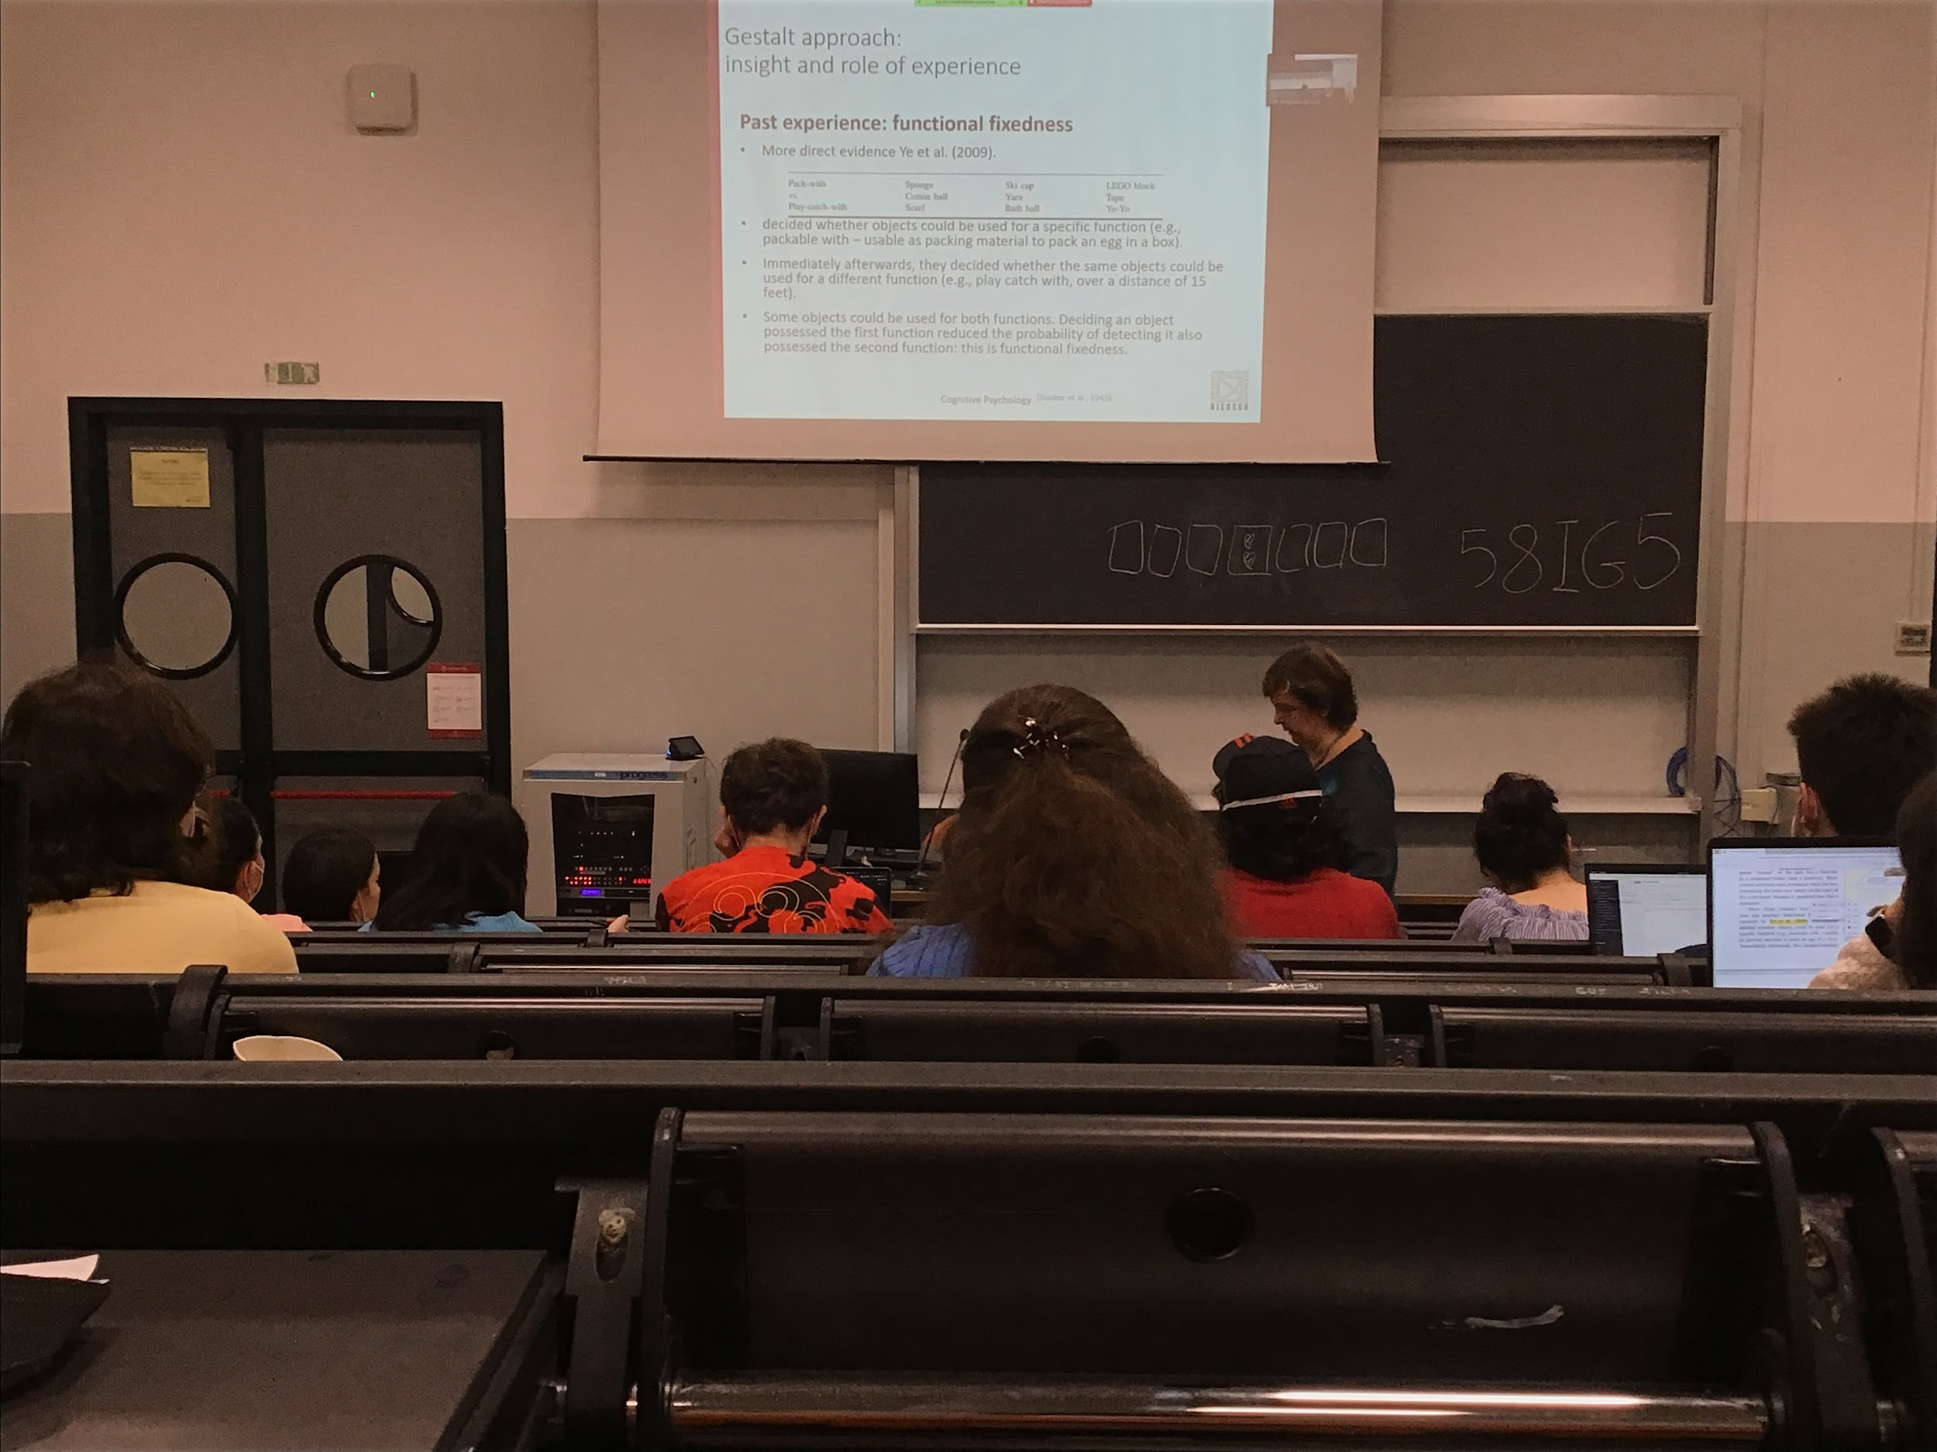

Experiment:

I give you name of the objects and you have to decide which object can be used for a specific function

If they can be used to pack a box of eggs without breaking the egg. You answer *yes* or *no*

Immediately after I ask you if I can use the same objects for a different function (play catch with it). Some objects can be use for both functions people have more difficulty in answering the second question

As if activating the first function block that object in that category

Past experience does influence a lot our behaviour when we have to do problem solving, we are not so strict about it, some people are more flexible

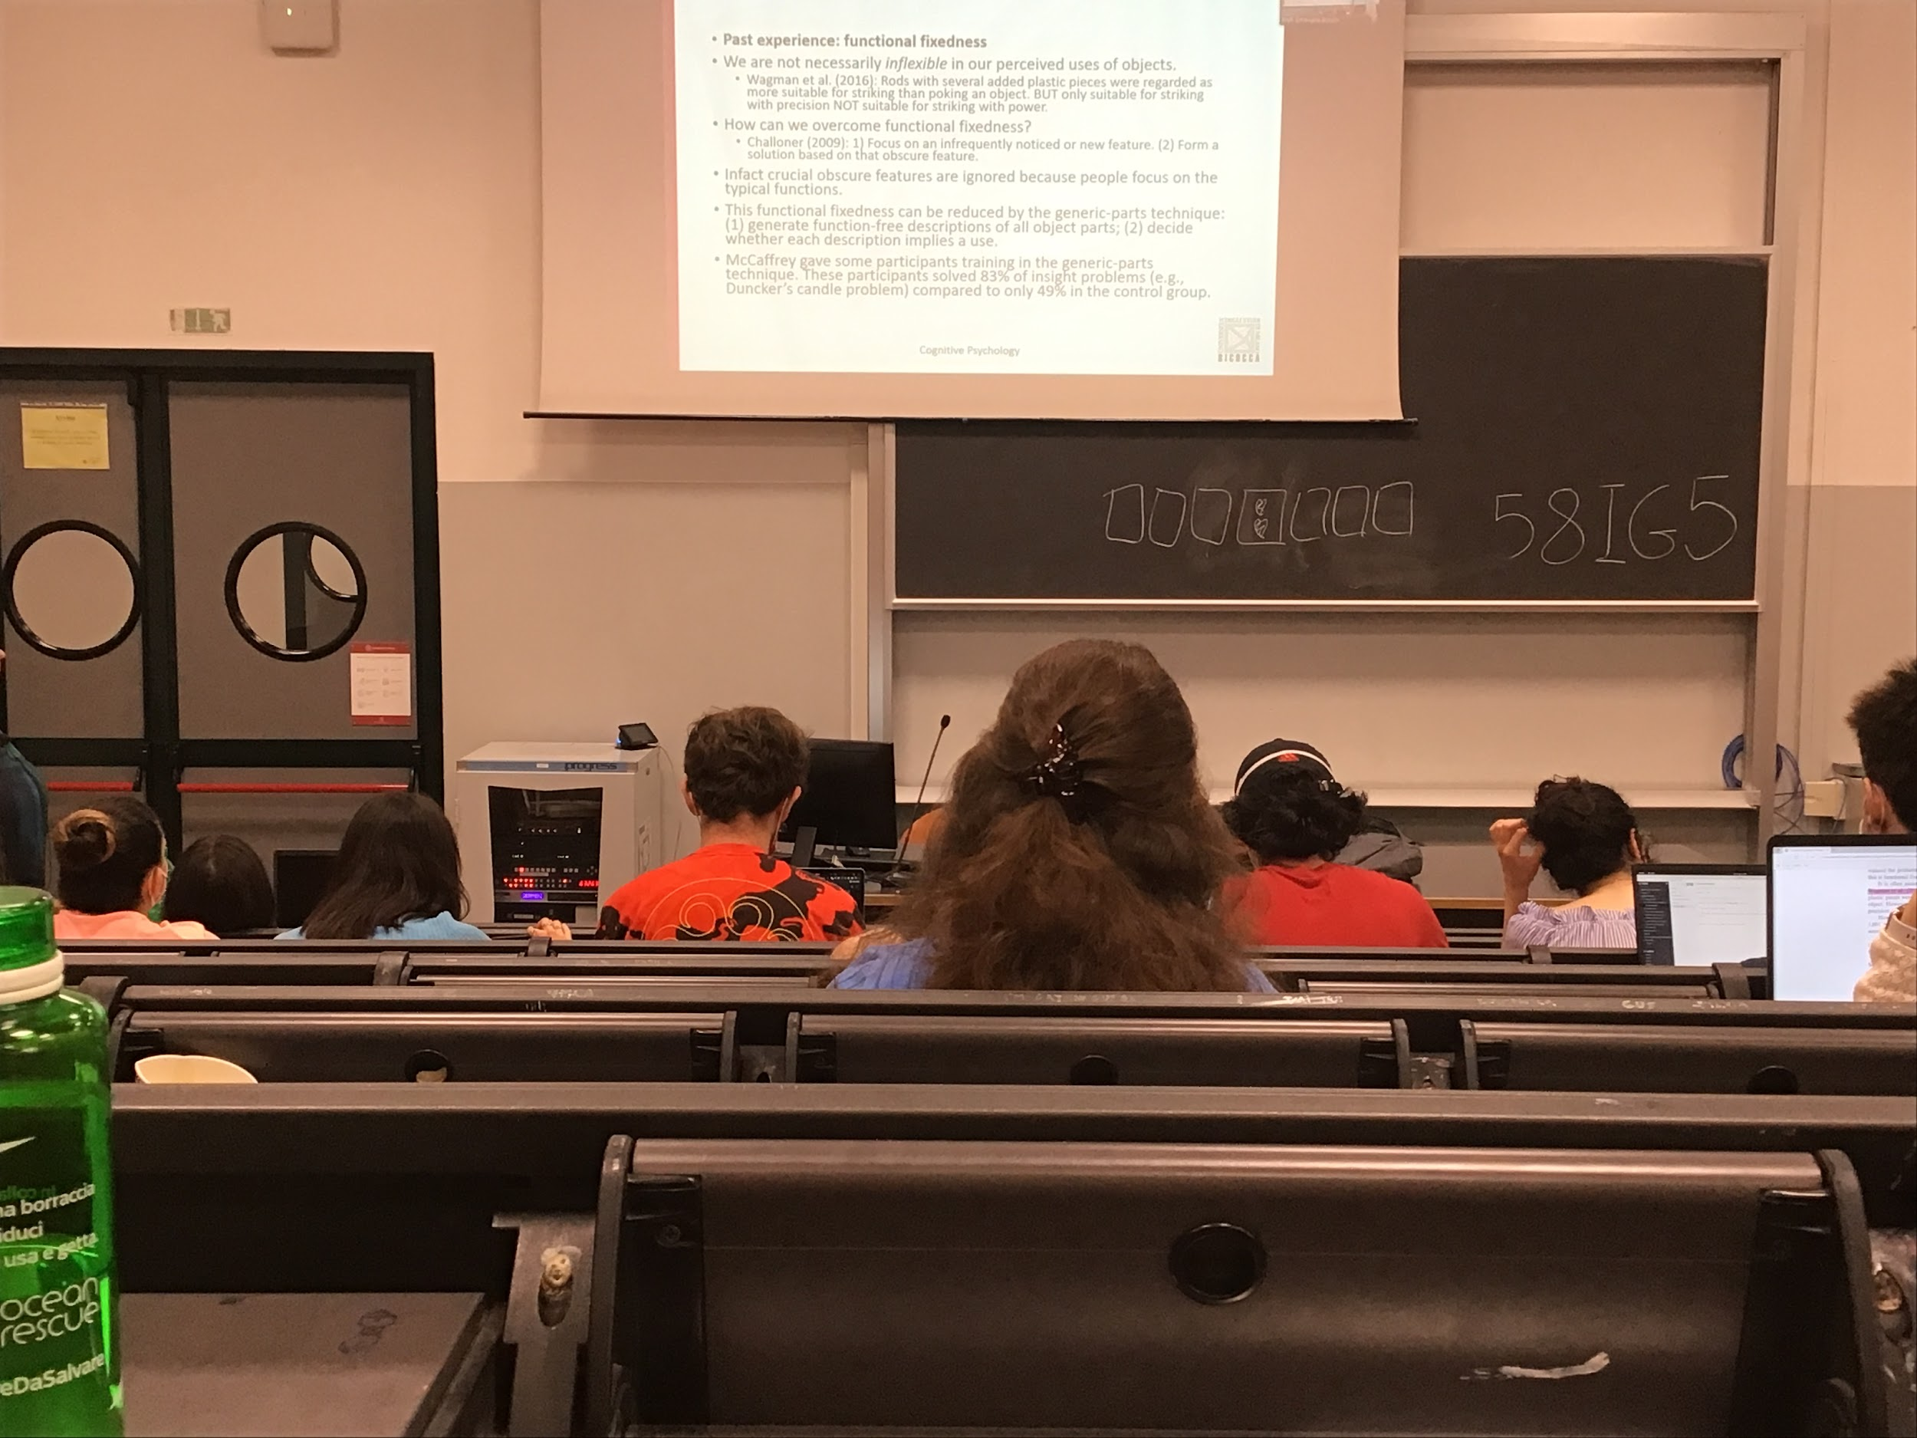

We can overcome this problem, if we know that this is a problem we can look at the objects and try to see if they have features that usually we don’t use that we can take advantage of it

Usually we focus on typical functions

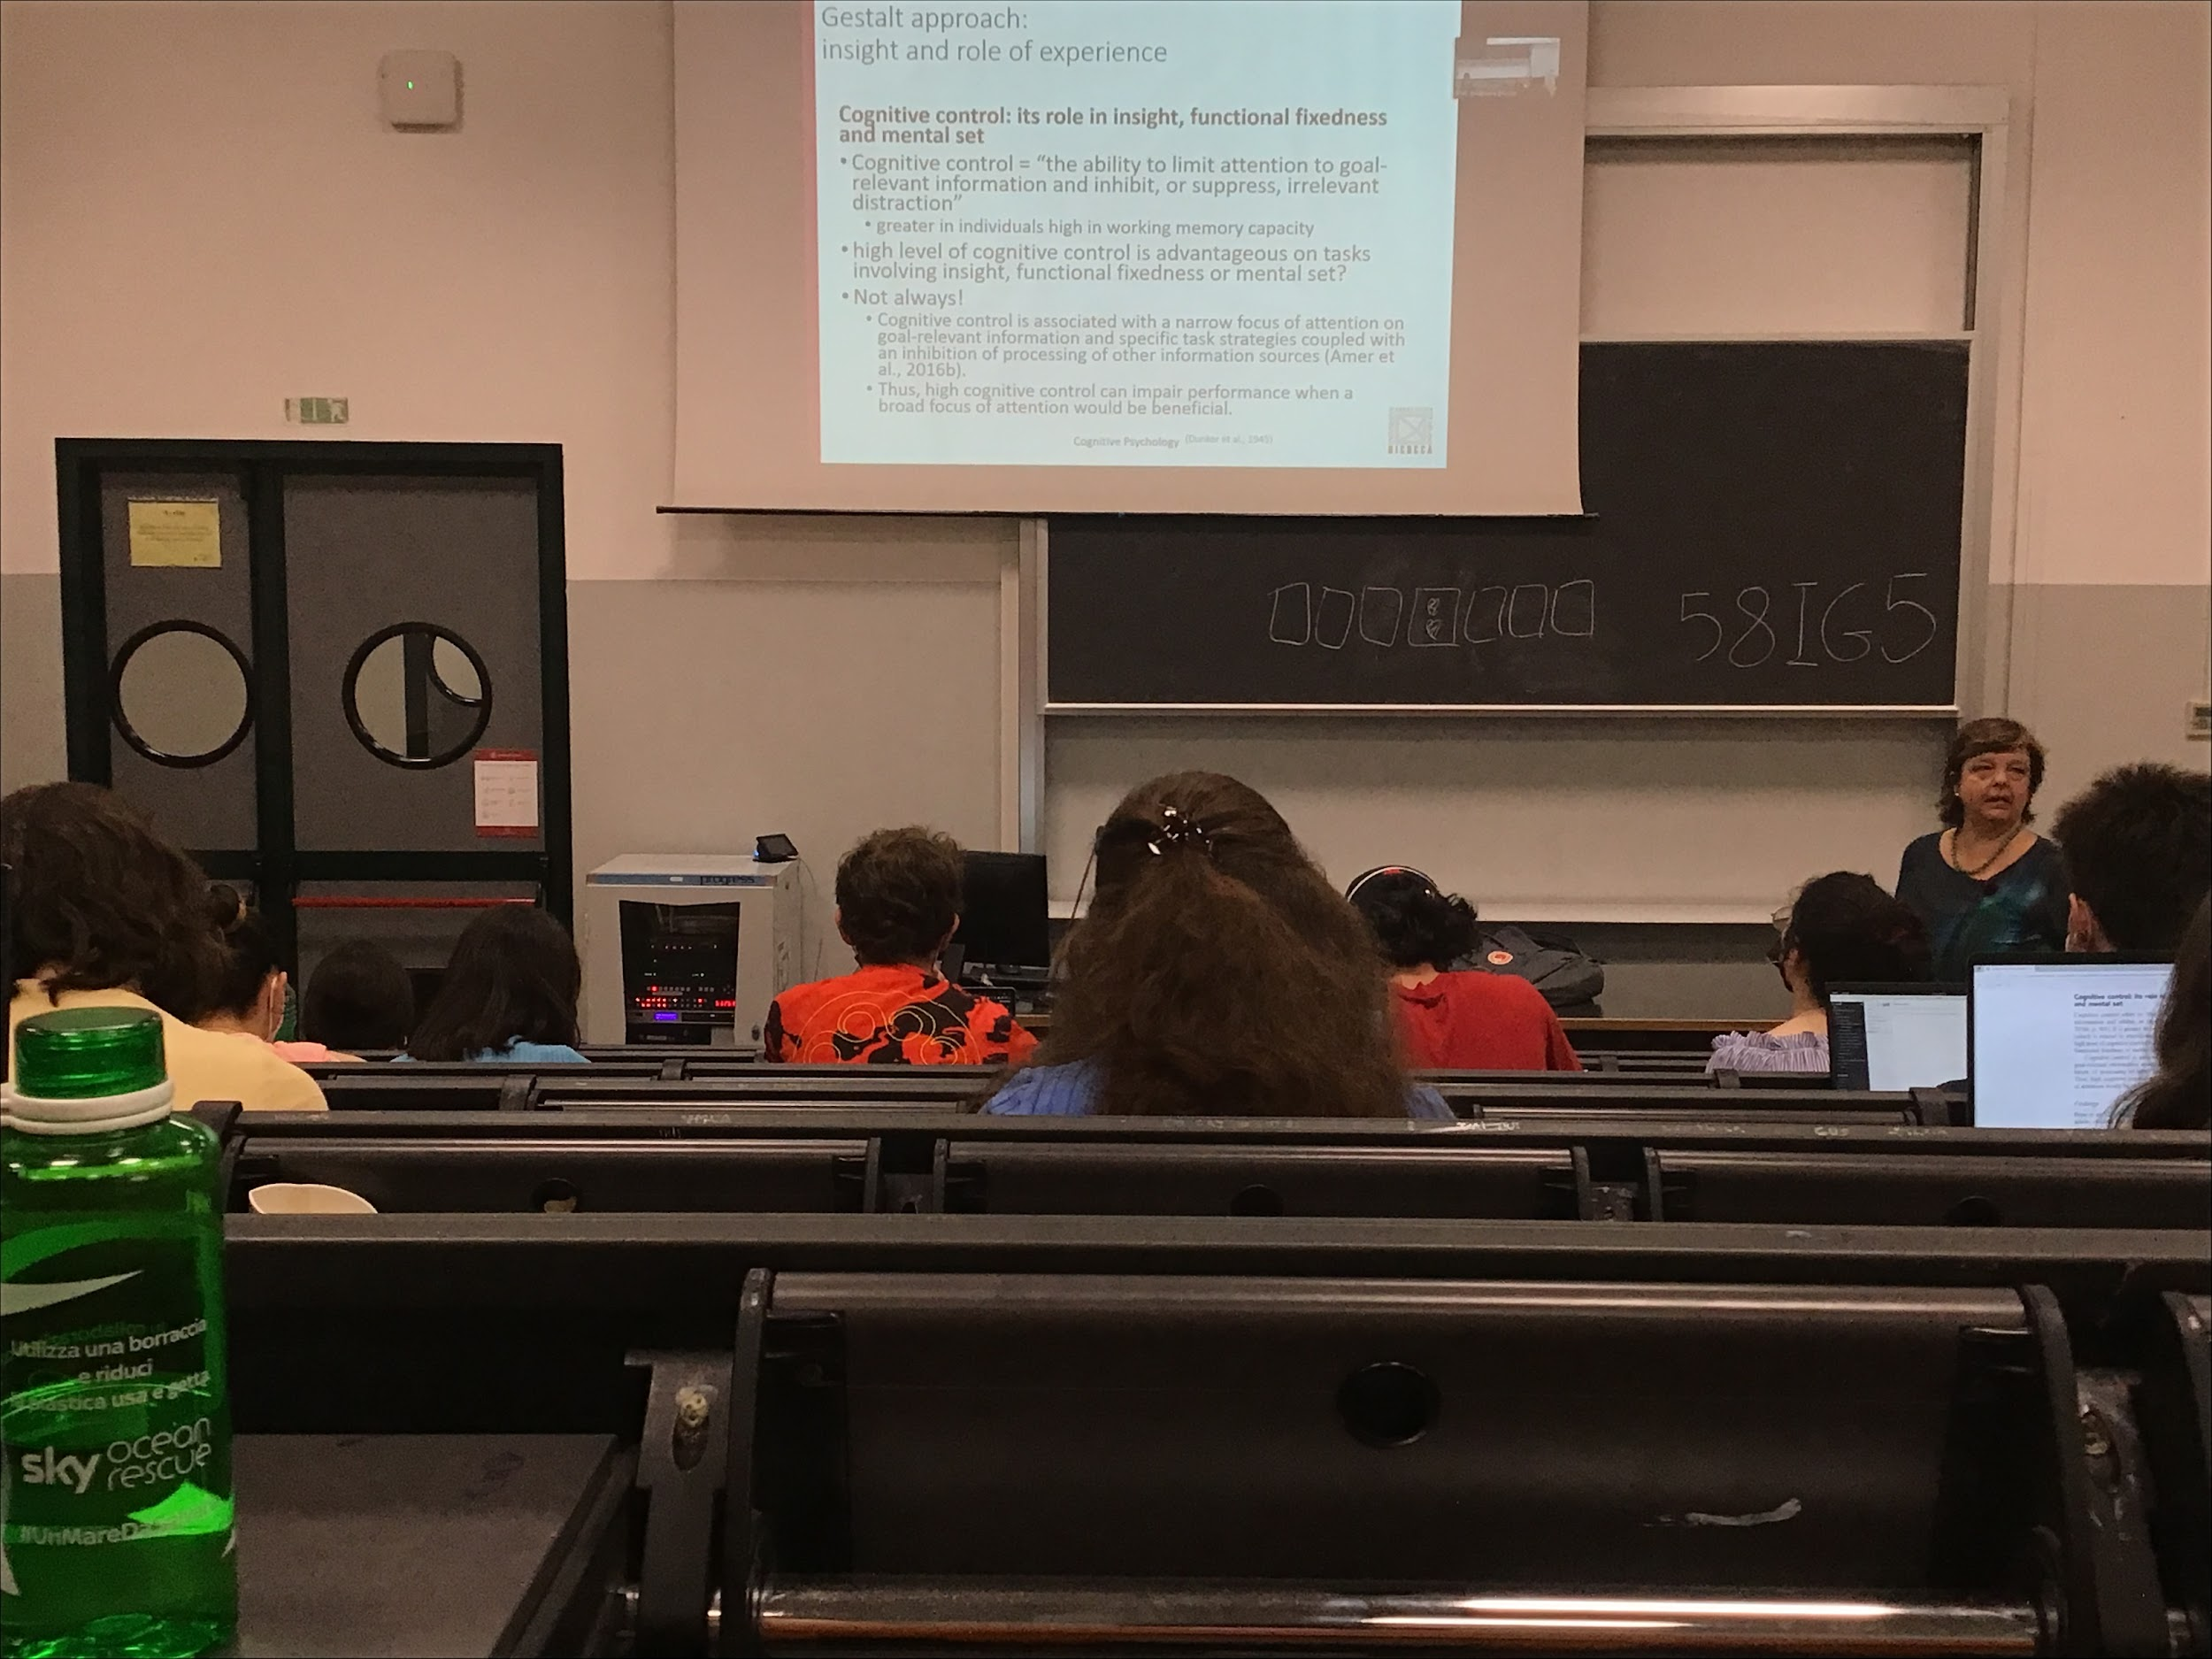

Different people have different level of working memory

Higher working memory capacity implies that we can perform some tasks better

We can control what we put in working memory to help us perform better in the tasks. Isolate the information that is important for that specific task and no inhibit irrelevant information

Higher cognitive control people should always be better at performing the task involving insight, but this is not true

People with high cognitive control are much better in restricting options: choosing the relevant information with respect to the irrelevant information, the real solution we obtain be relaxing the constraints and being more open with our mind help us to find solutions that are nor obvious. High cognitive control can impair performance in situation were it is important to have a border apporach

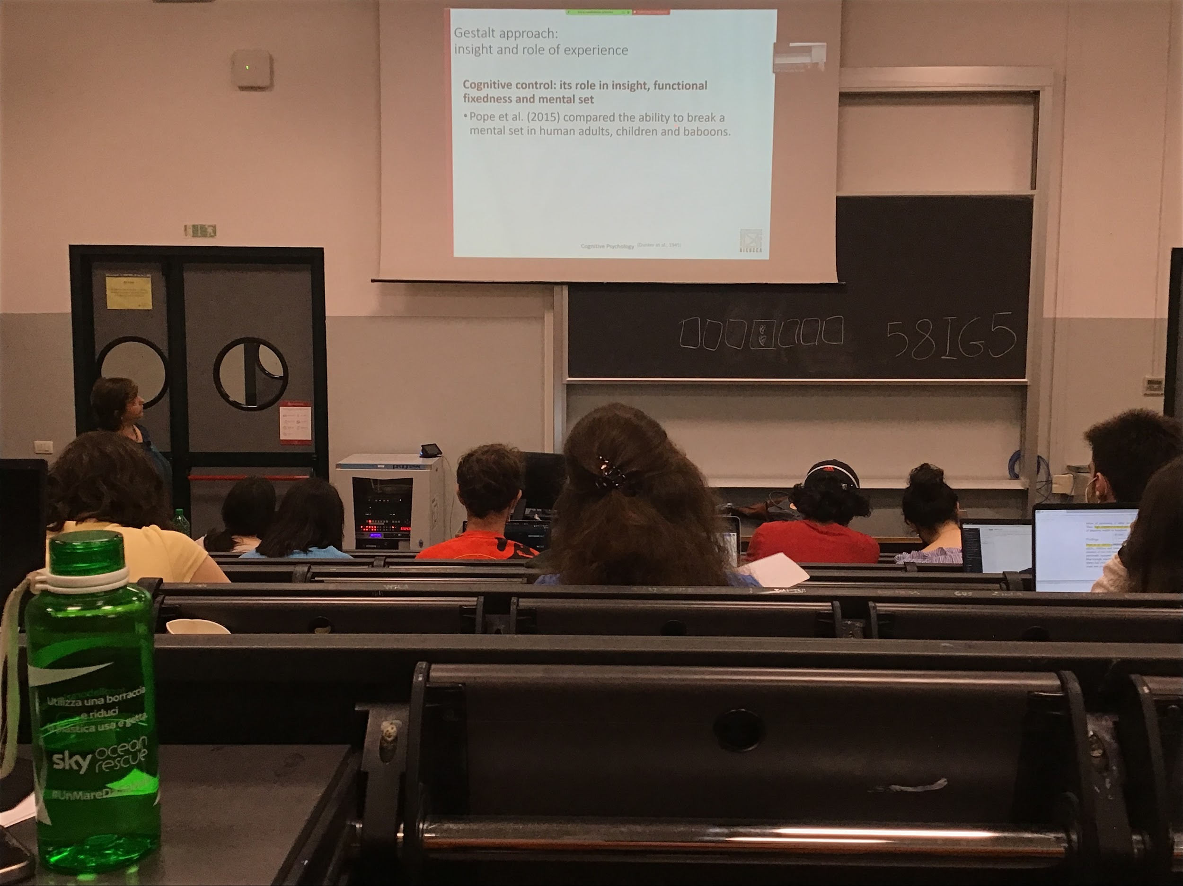

Pope compared the ability to to break a mental set in humans adults, children and baboons

When you have to solve some insight problems sometimes is important to break the mental set

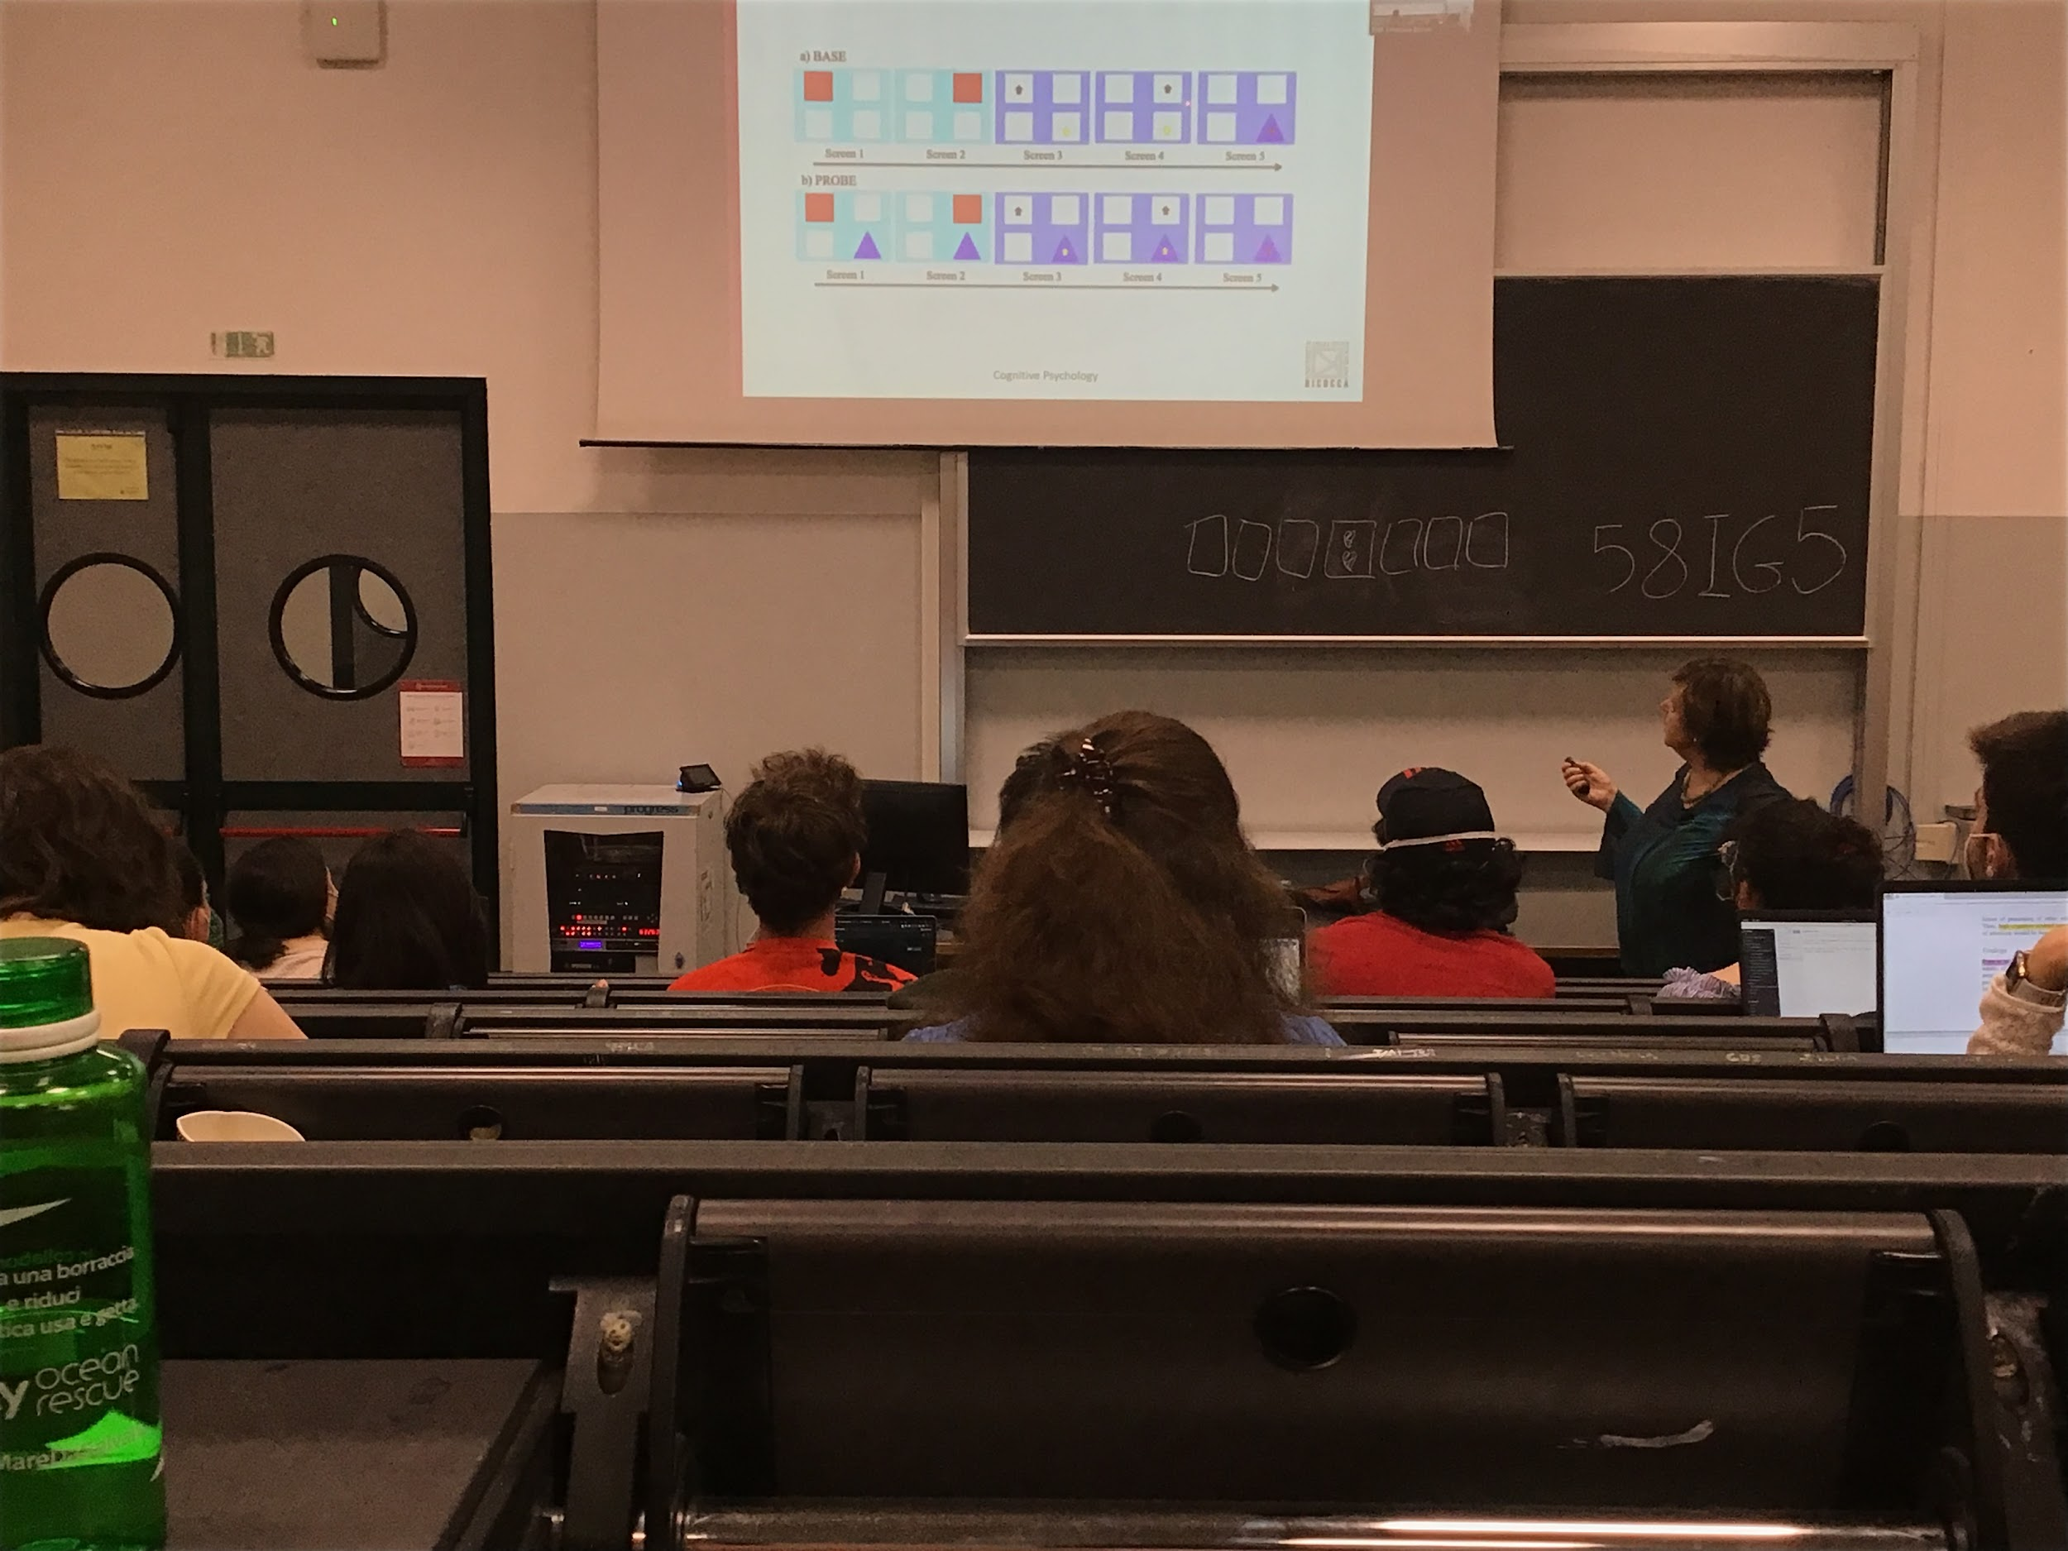

Compare human and boobs condition is that baboons are much better

First task: 4 square, 2 squares lights up and you have to press them in sequence and then a triangular and you have to touch it and you get the reward

If you make a mistake and you press the position where the triangular will actually appear you get a reward in any case (but you don’t know here it would appear)

At a certain point I change the task: the triangular is there all the time

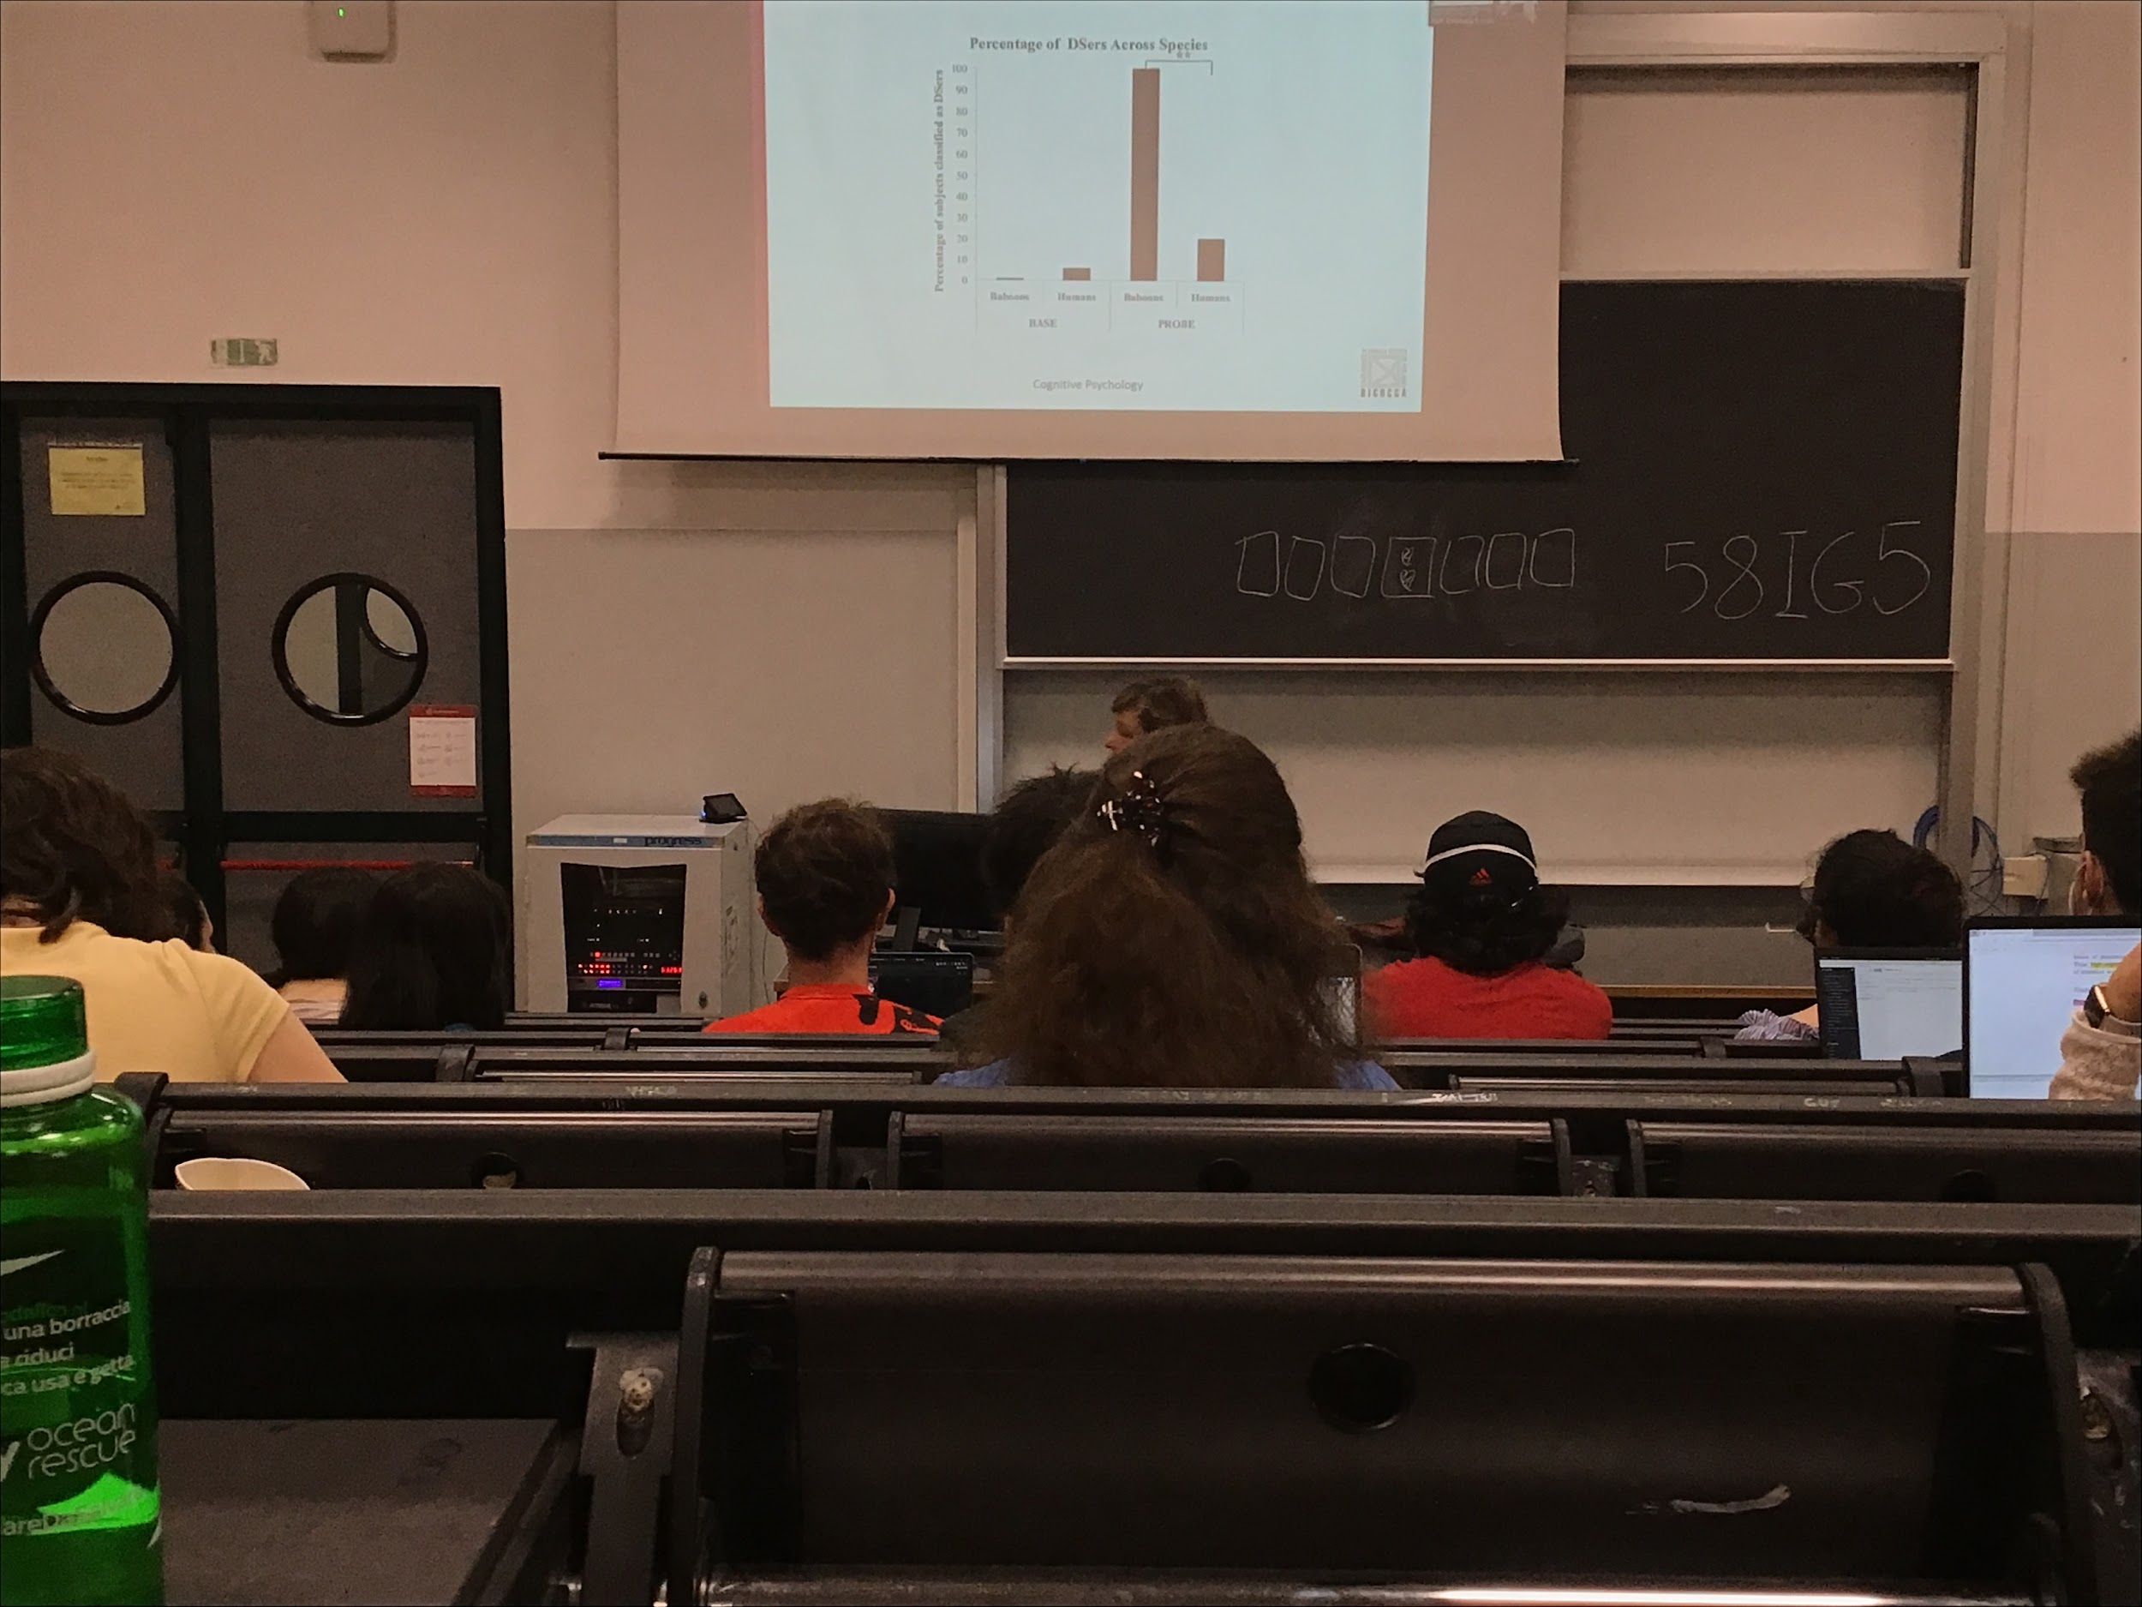

Compare human and baboon behaviour in the second conditions you see that baboons are much better

Baboons know they get the reward as soon as they touch the triangle. Are much better than humans, we do not understand that there was a switch paradigm

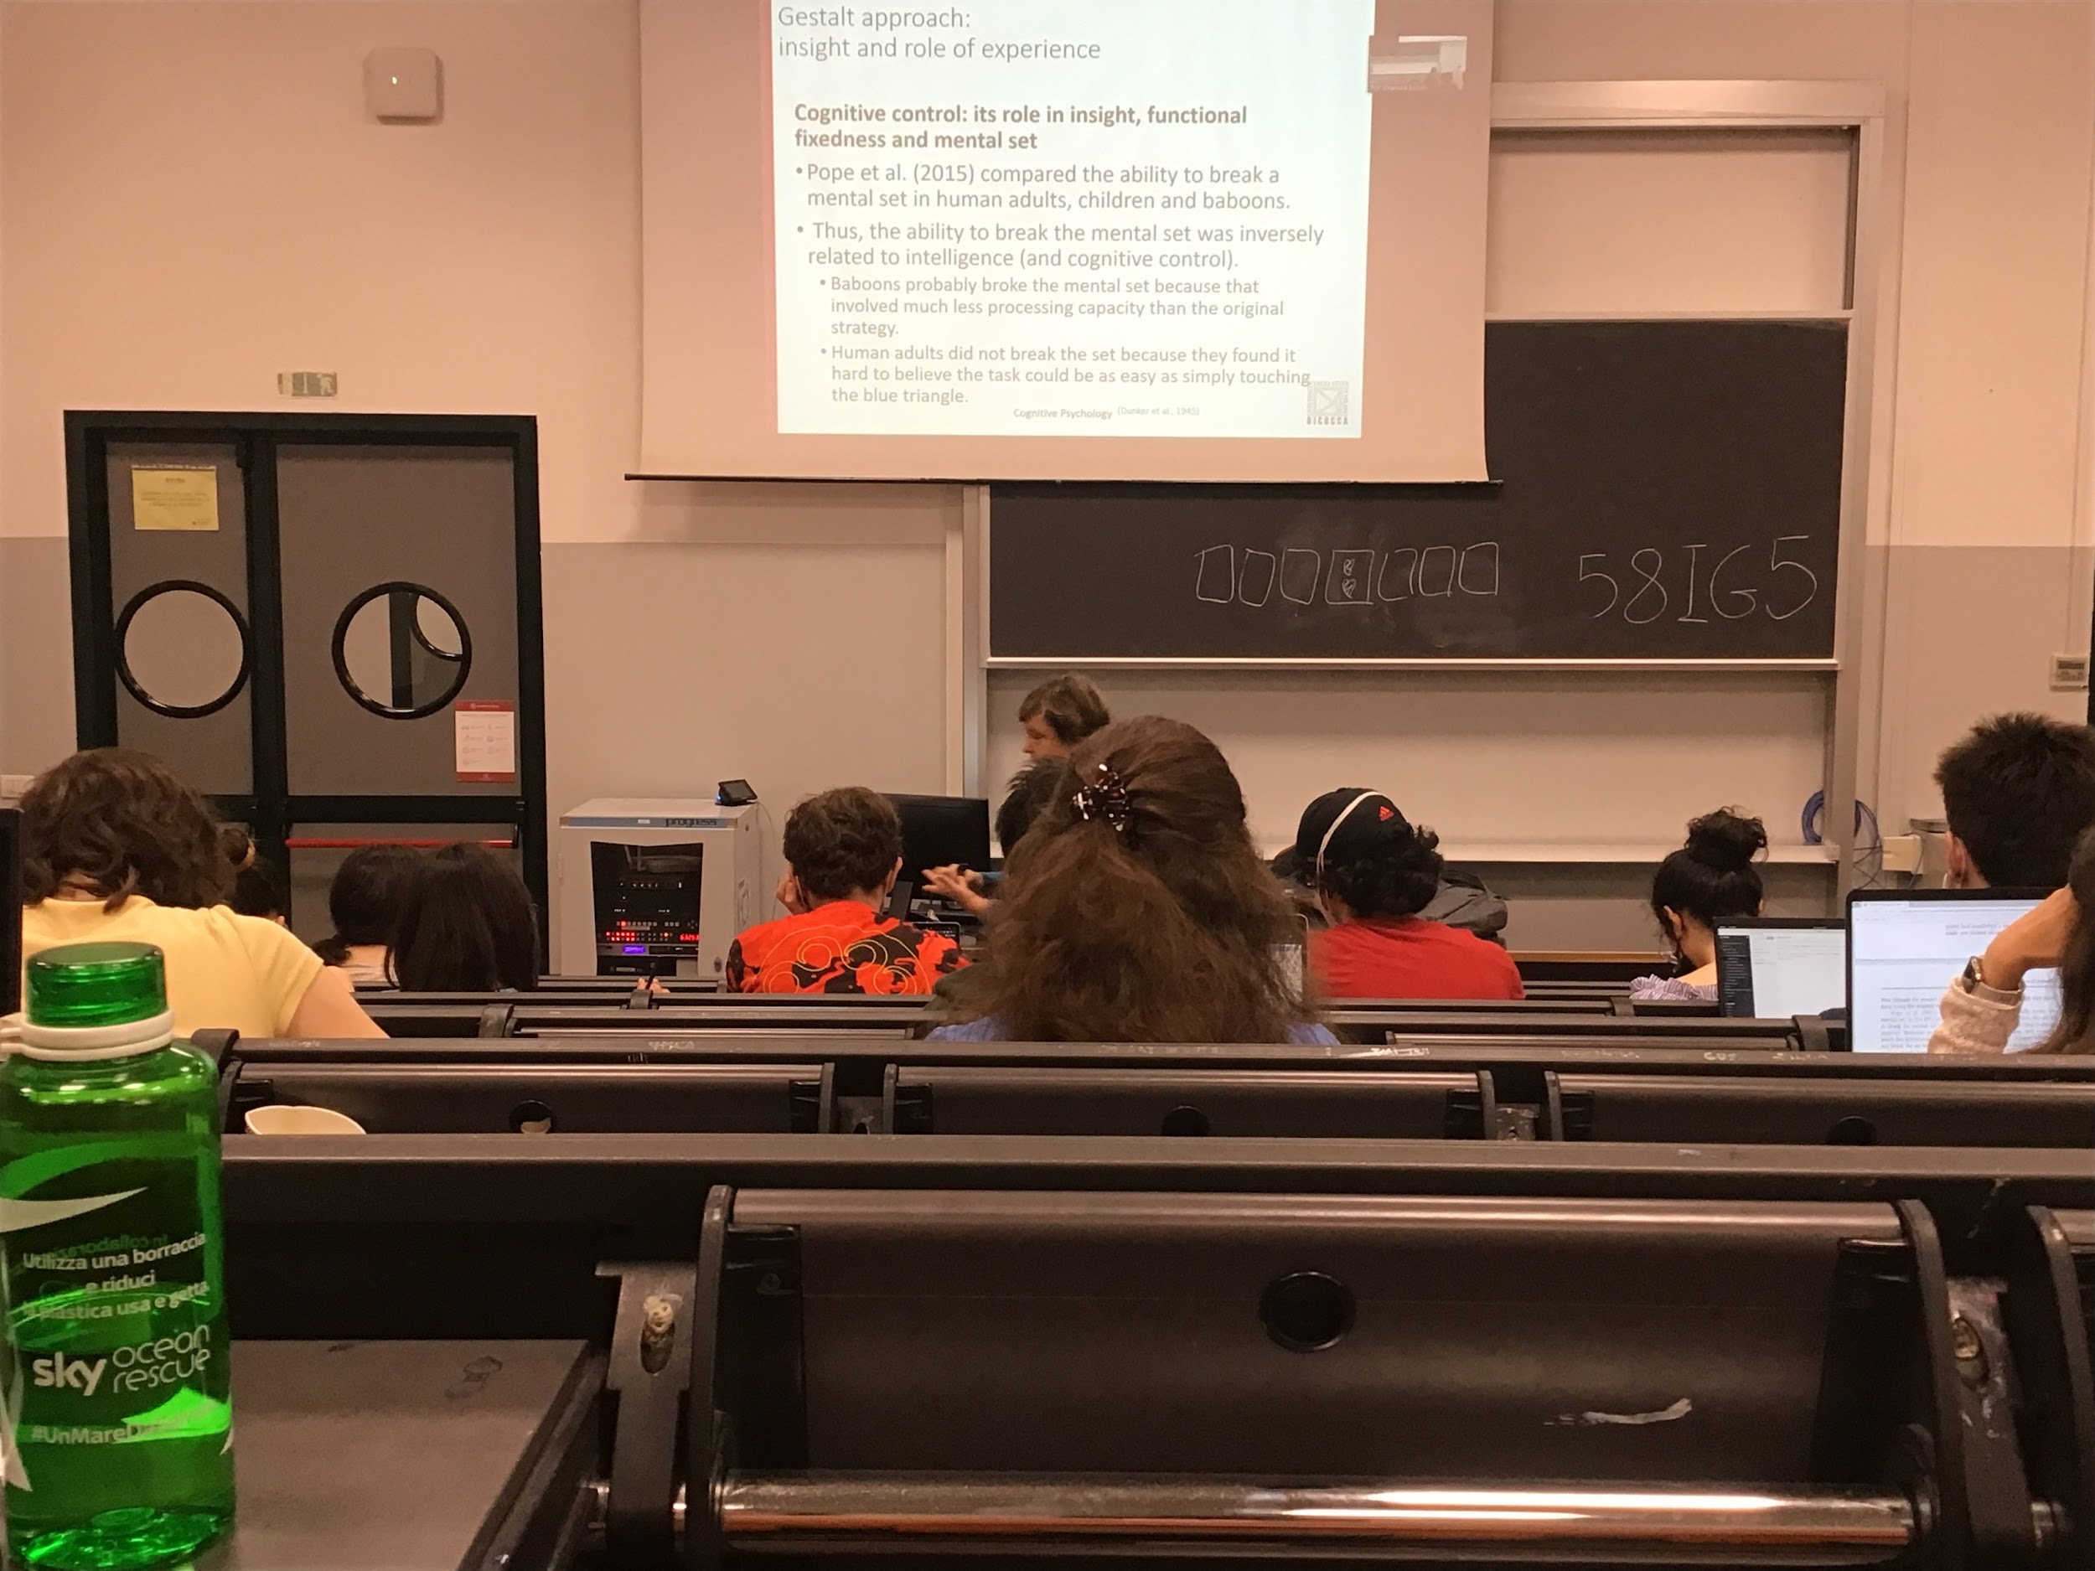

The ability to break the mental set was inversialy propositional to intelligence: baboons were better than children that were better then humans

Baboons break the mental set because for them is much easier and is a faster task

On the other hand humans thinks that the task was too easy, in their mental set they image hat the task was more difficult

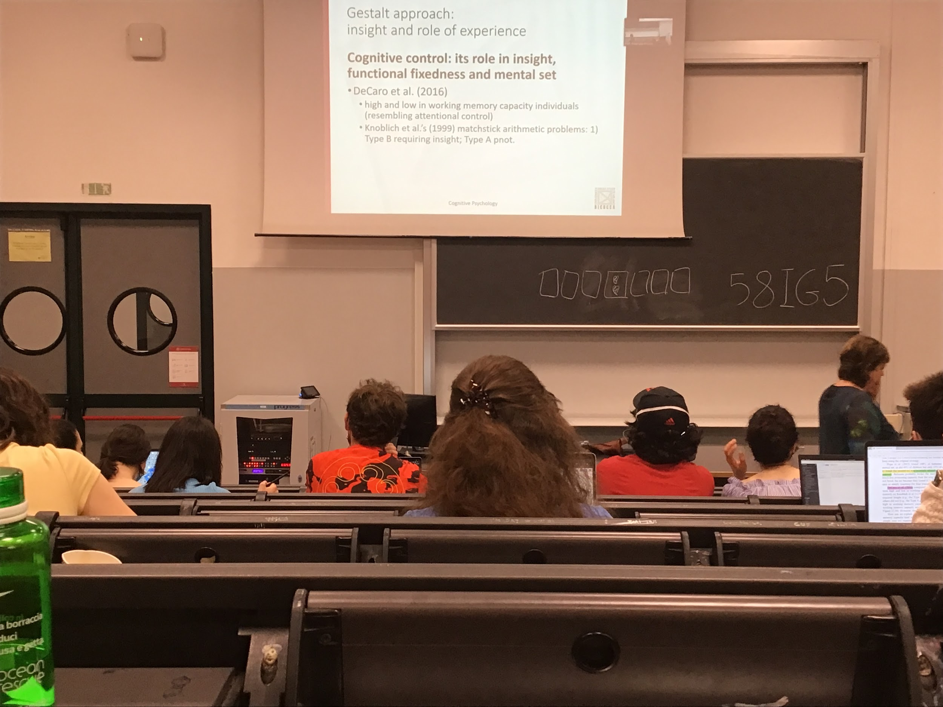

Compare the relationship between intelligence and ability to break the mental set was the paper by DeCaro

Compare people with high and low working memory capacity (it is correlated with attentional attentional controls)

What was expected: people with high working memory capacity are better is some task than lower working capacity people

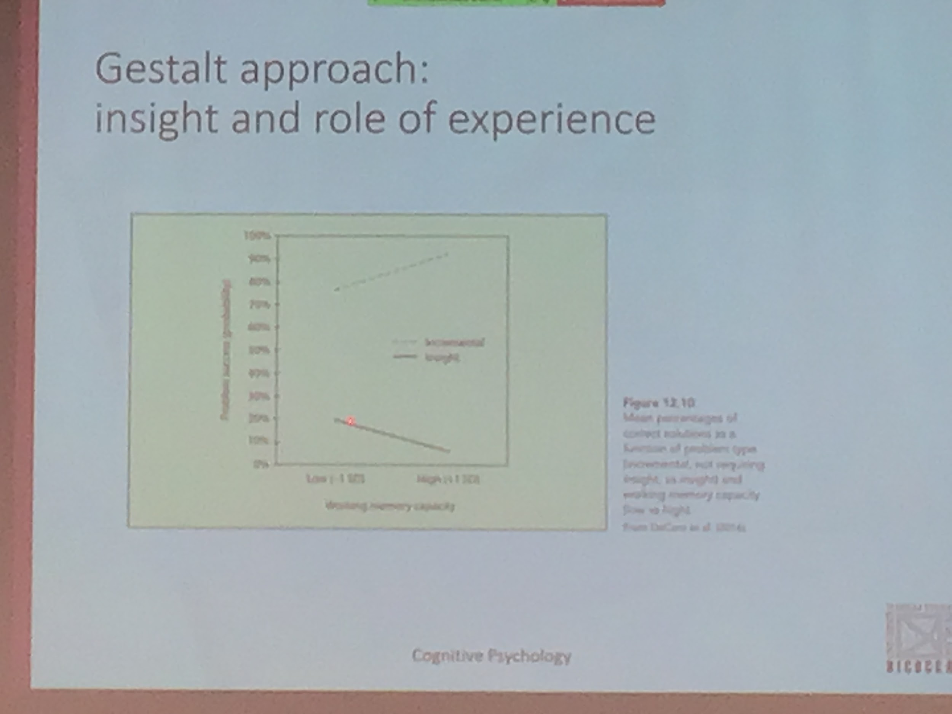

In problem that are solved with insight lower memory capacity are better then high memory capacity. While is the other way around with problems that do not need insight

Insight having a low memory capacity you can not select very well relevant information, you are open up. Low memory capacity solve more problem in insight, high memory capacity you have to solve incrementally

Much better of if you have high working memory

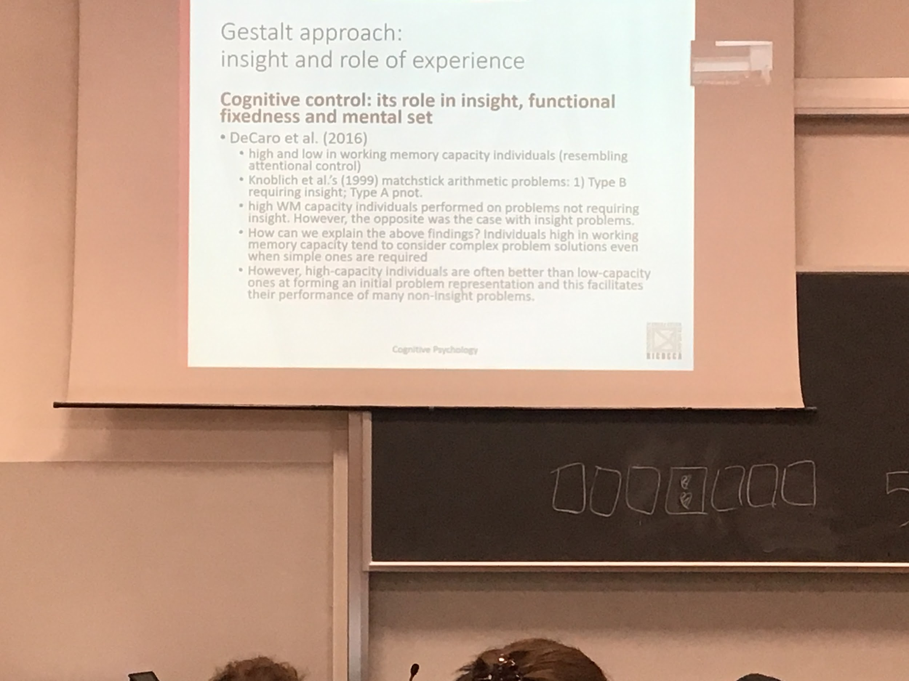

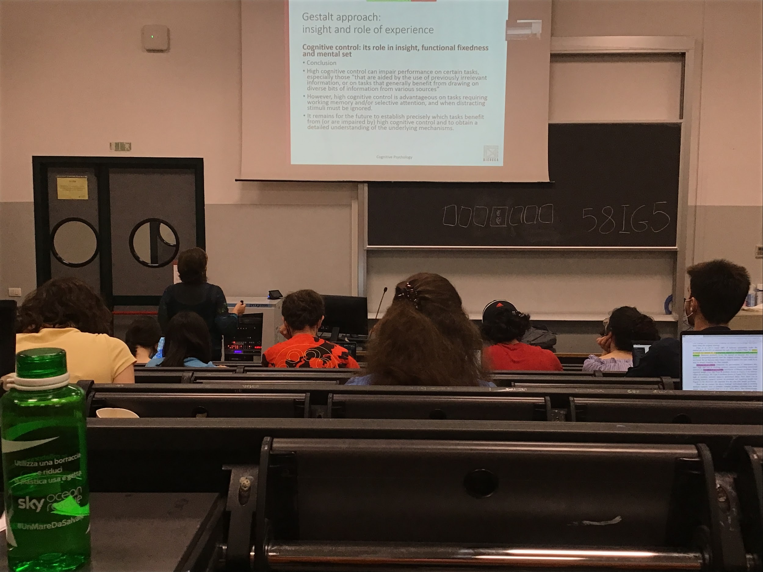

High memory capacity individuals tend to consider complex problem solution even when simple one are require. Are better at difficult problem

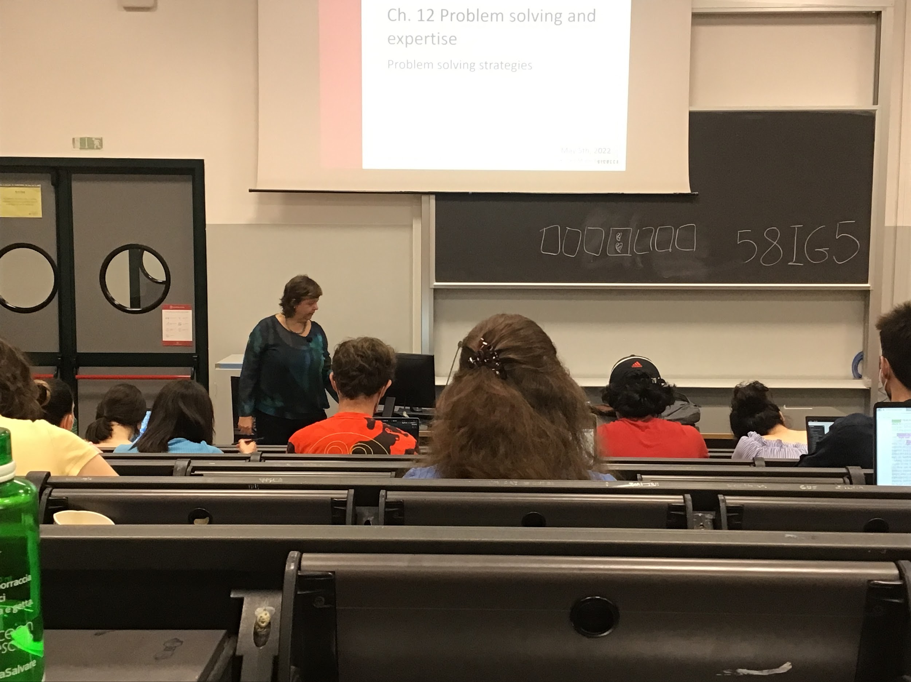

**Problem solving strategies**

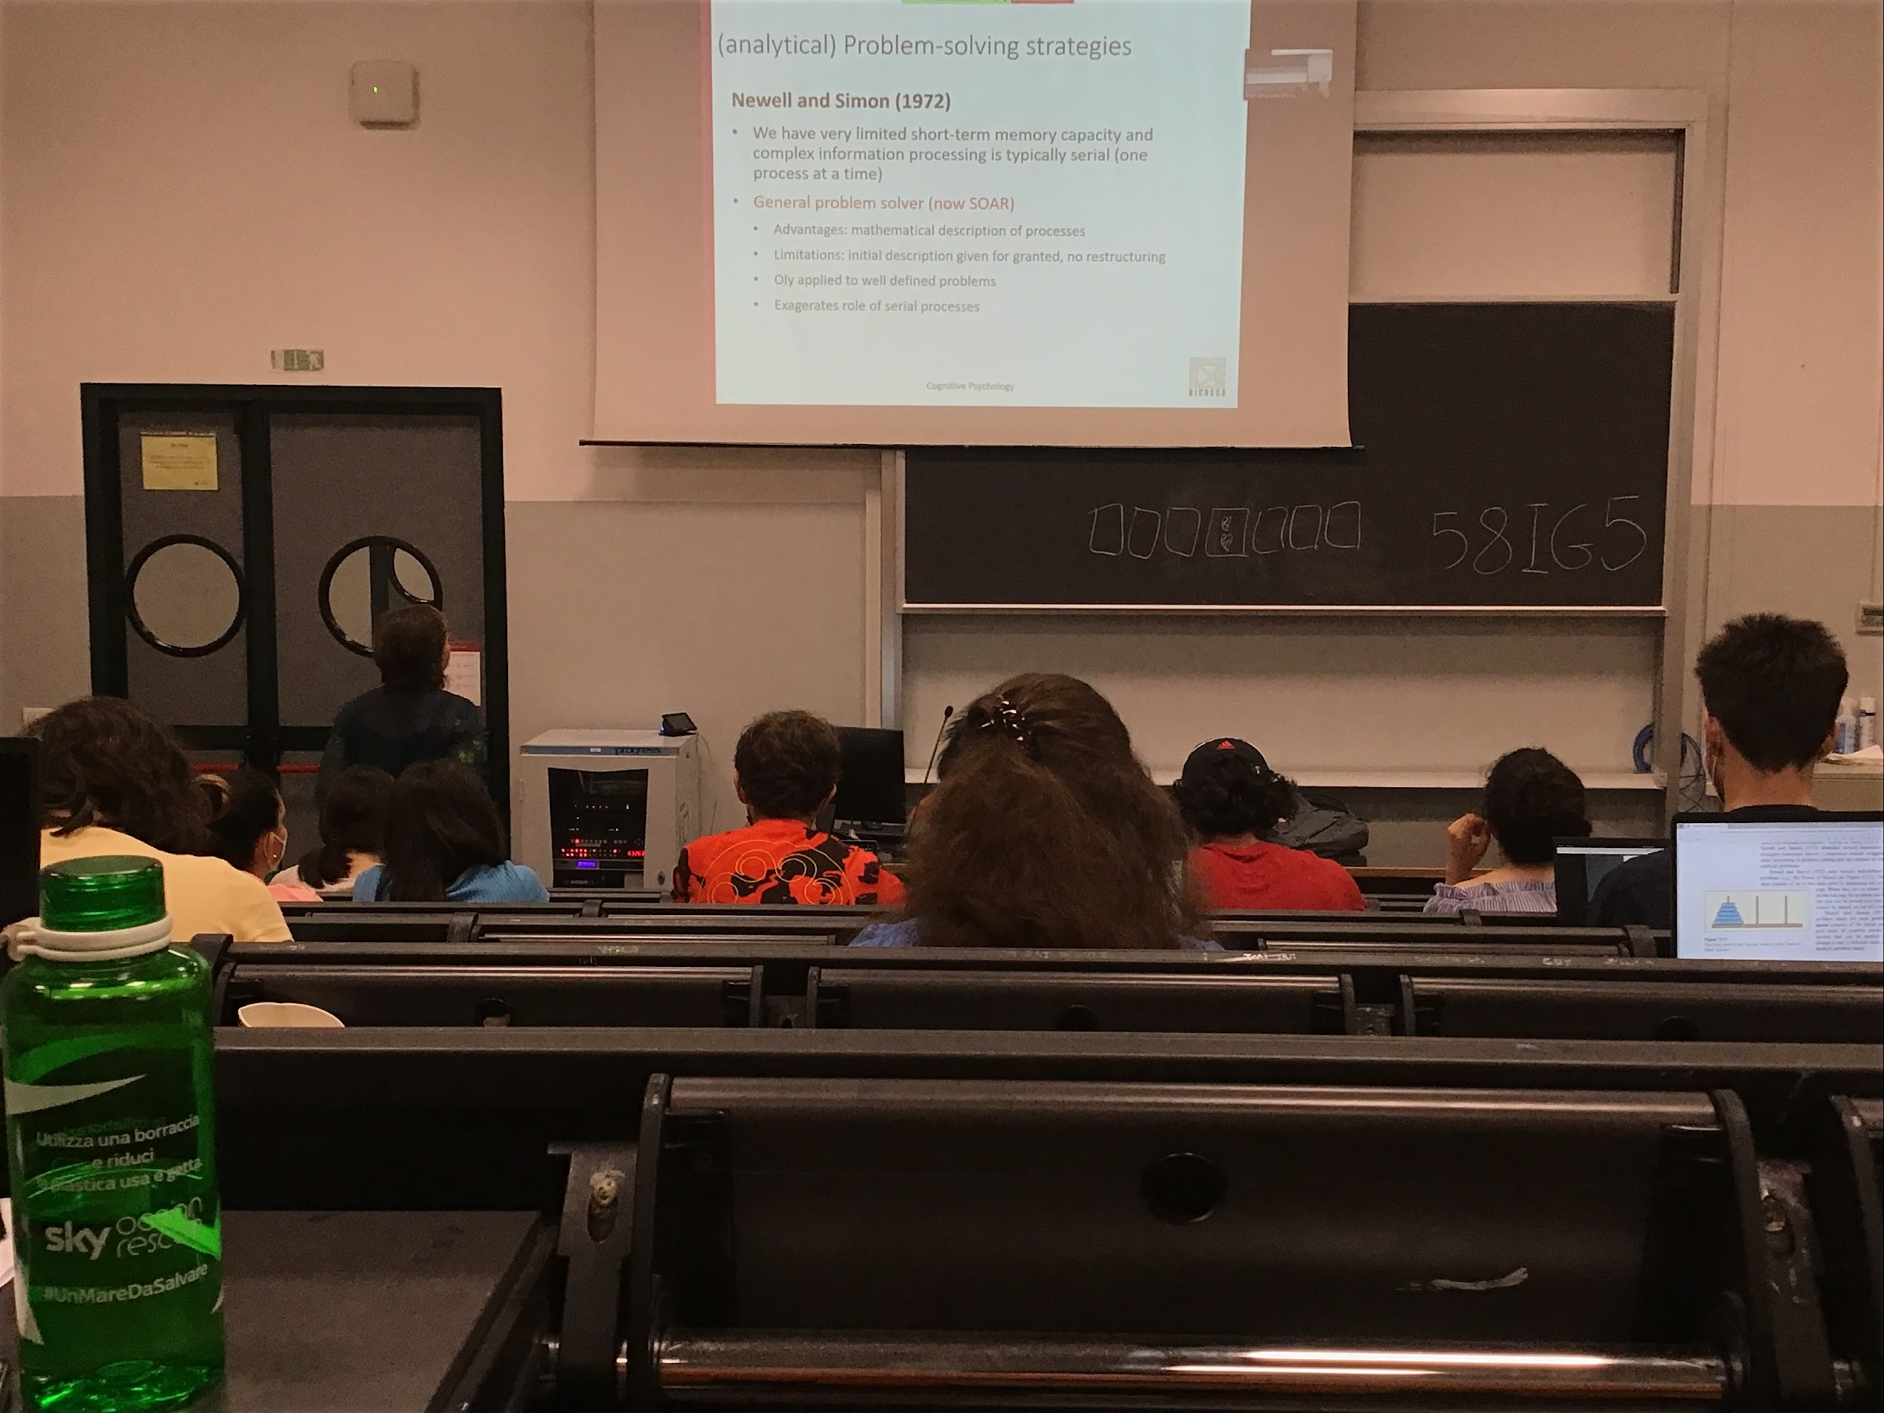

Beginning of AI started with Newell and Simon, studied problem solving strategies and try to implement it in a program

Idea that our short time memory is not very large (7 +-2 items), one process at the time. 1972 proposed a program that actually was able to solve some problems

Advantage: try to solve problems describing them mathematically and use the description to solve it sequentially

Limitation: once the program was describe there was no restructuring

Applied only to well defined problems and it exaggerate the role of serial processing

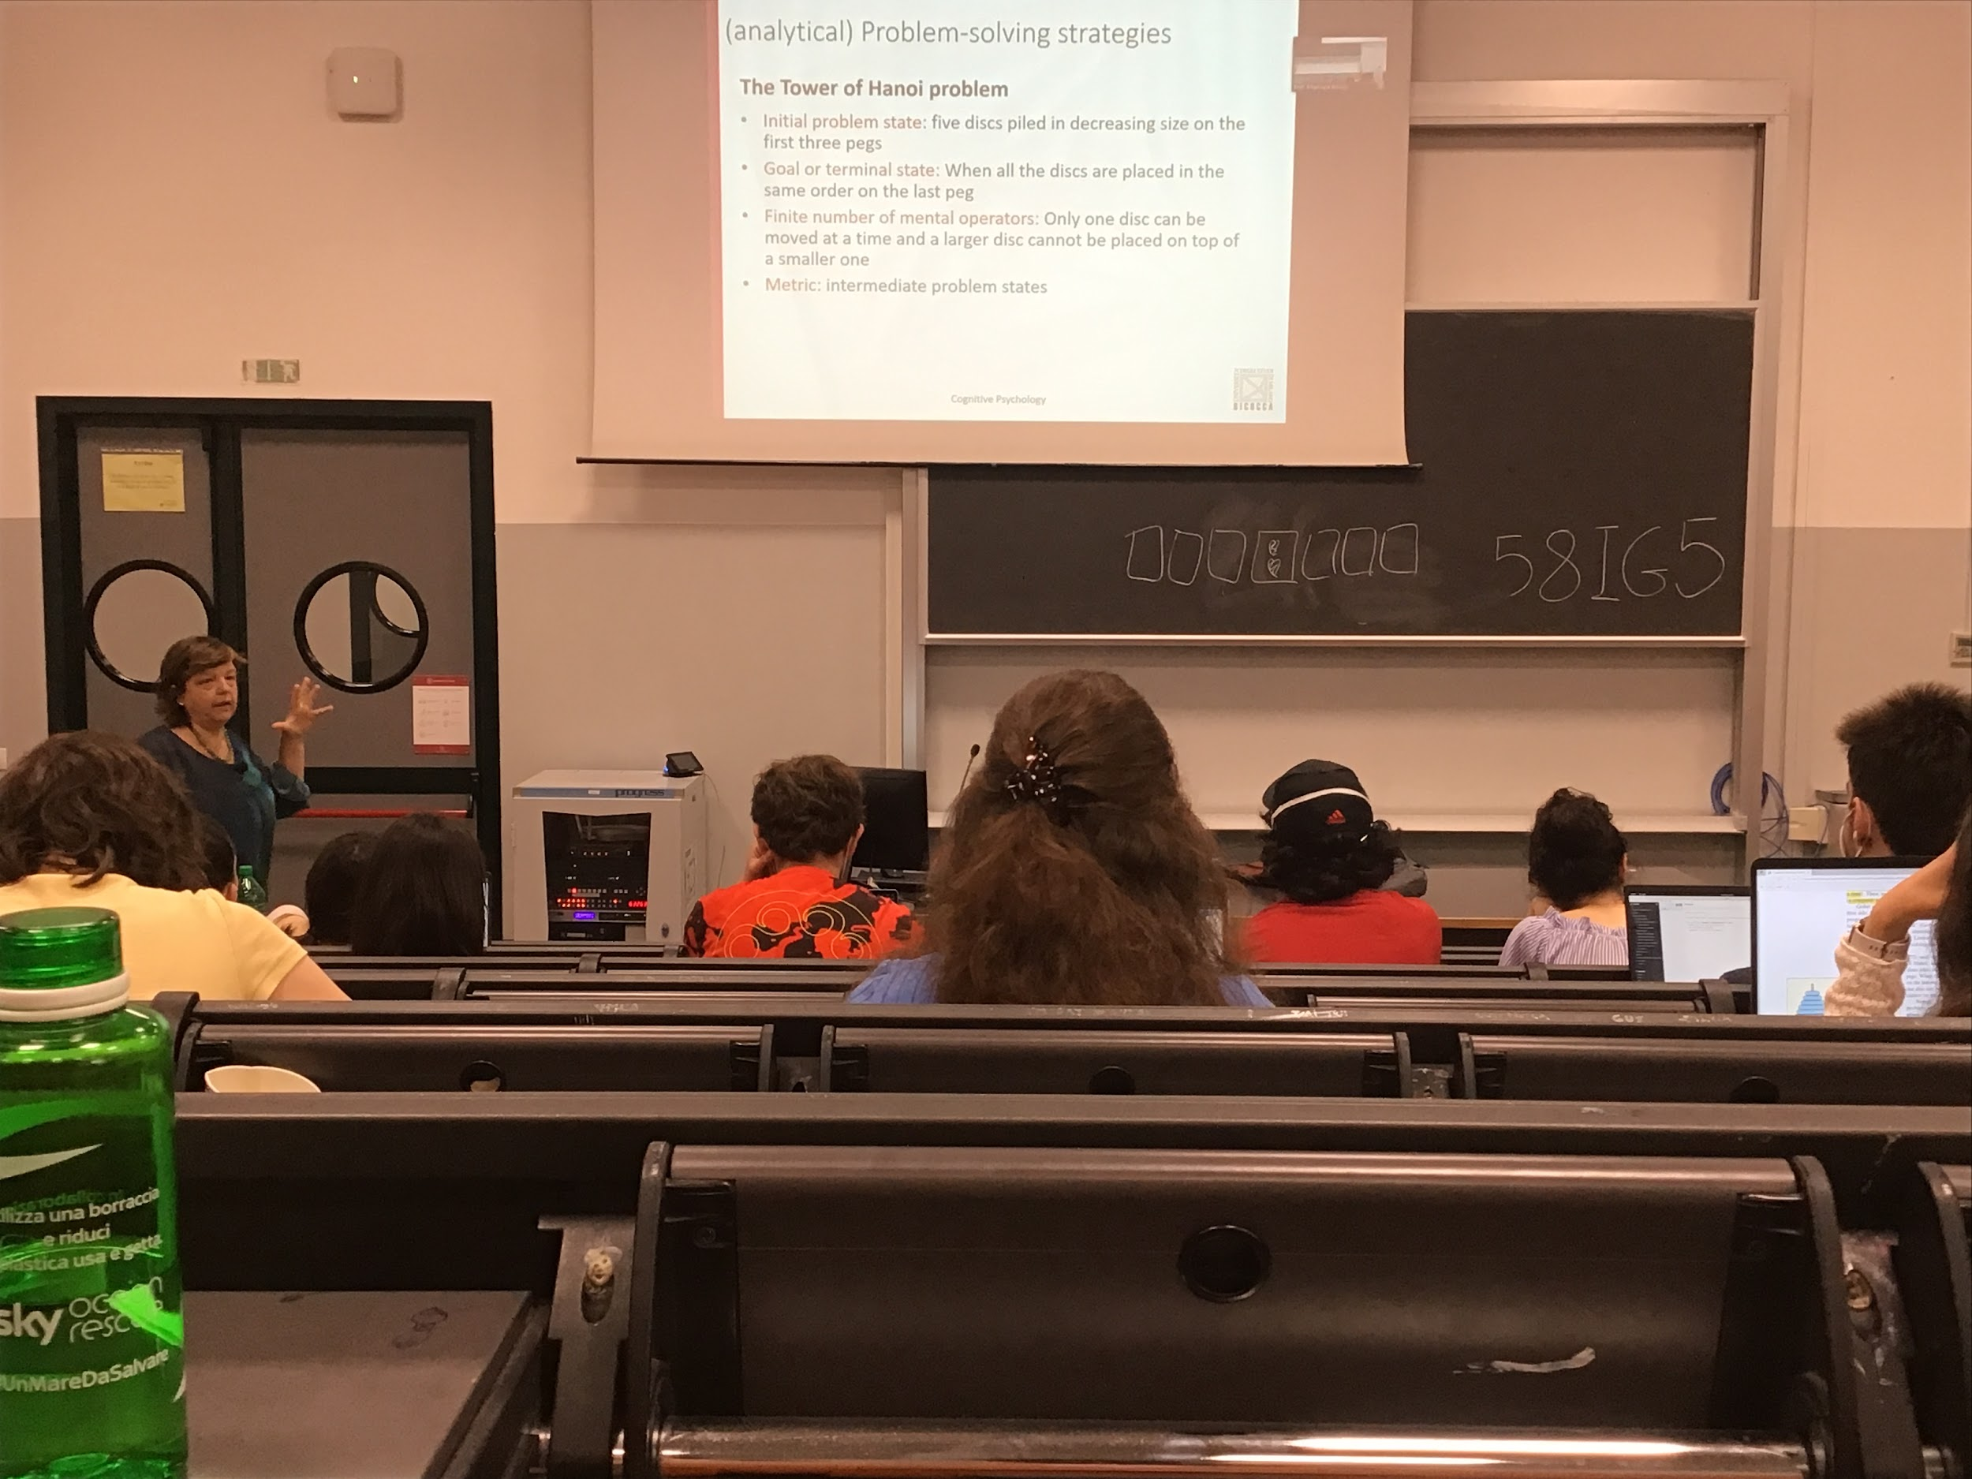

When we have a problem we have to define it.

The identification of a problem implies 4 different definition

1. Initial problem state
2. goal stage
3. Finite number of mental operators
4. Metric: measure on how far away we are from the goal

Tower of Hanoi

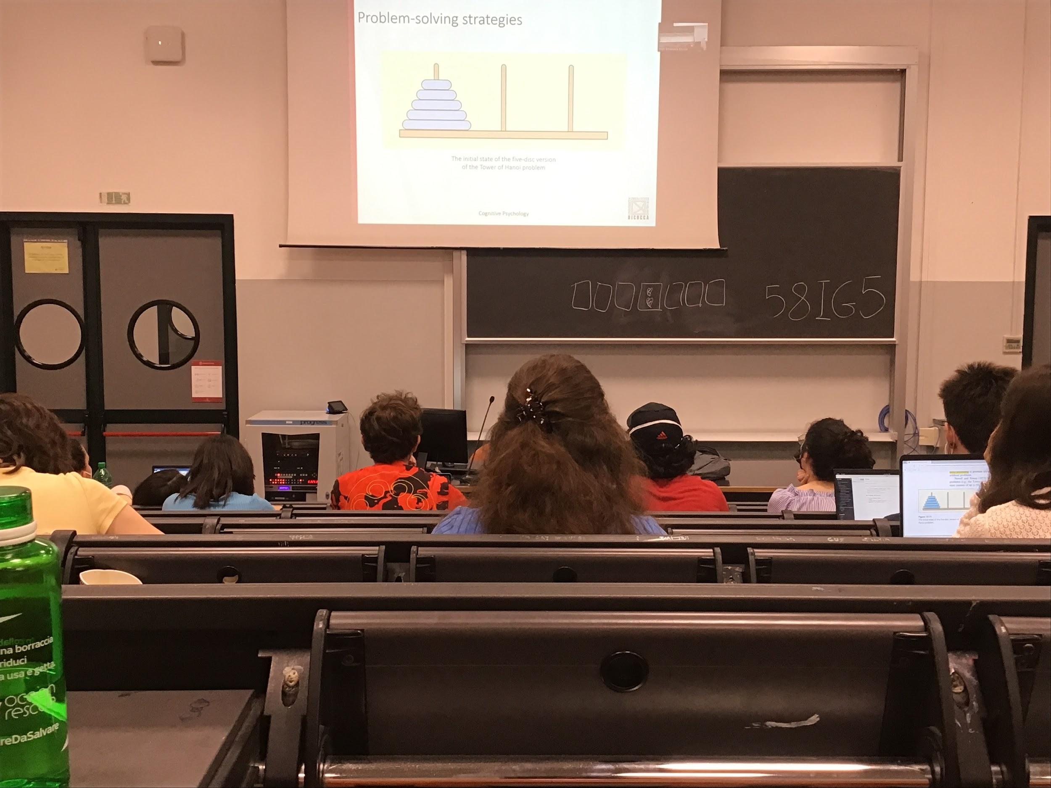

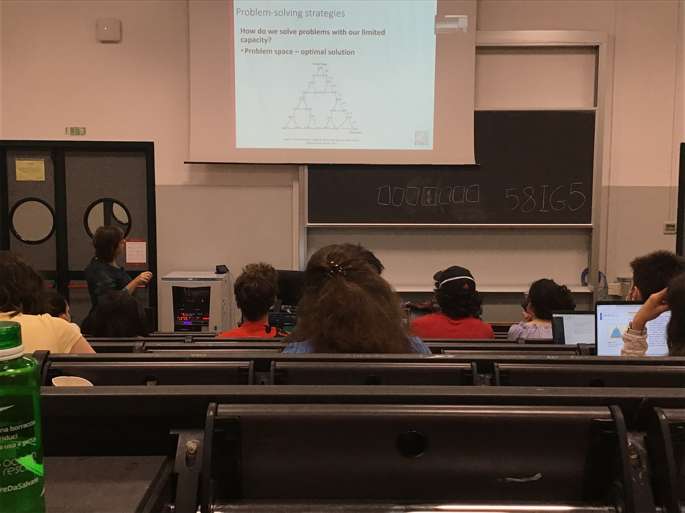

To reach the final state you can move along different dimensions

If you need to solve this problem you can compute all possible combinations and find the shortest path that goes from the initial state to the final state

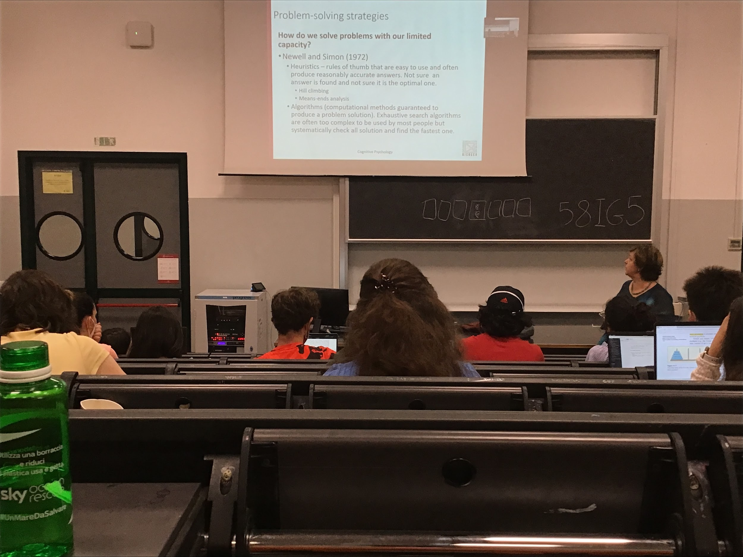

There is a way aroun<(maybe not the best one)

There are 2 way of doing euristic:

* one more general (hill climbing)
* one more focus (means ends analysis)

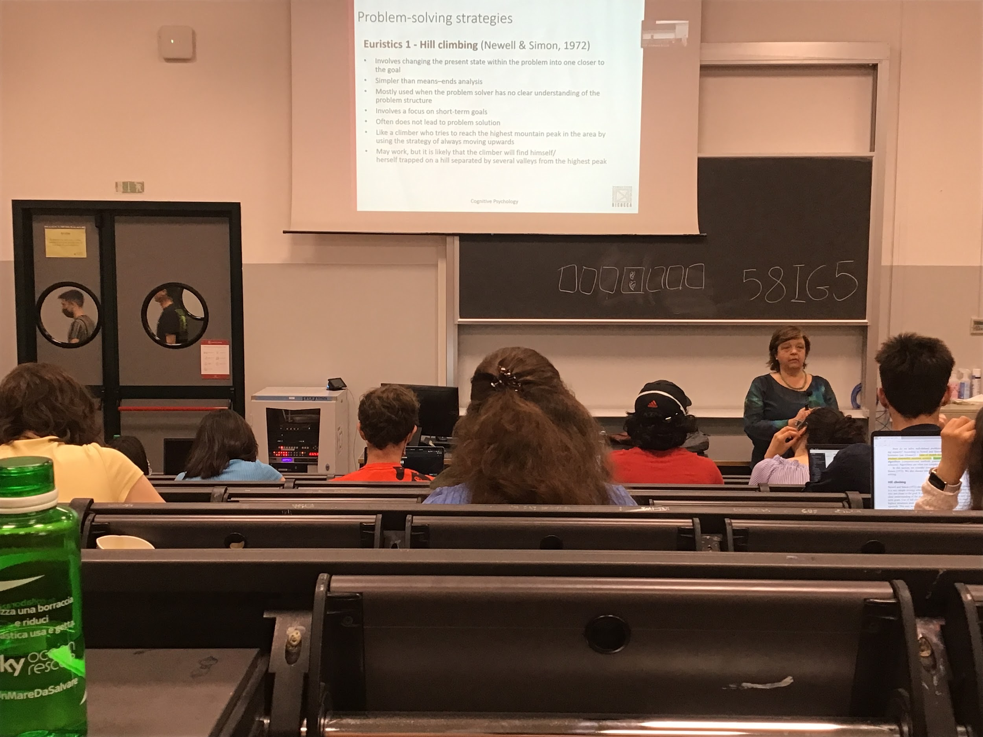

Hll chiming: what neural network does. Try to reach a solution getting closer as possible to the solution

Initial and final, and the metric (how close we are to the goal) we have to make a move that makes us closer to the goal. Make problems short time goals and try to reach them

Sometimes I think I am going closer to the goal but actually I am going further away

We know we have to reach the top and every time we go up the spinet path, but sometimes it takes us to an hill that is not top, and to get to the global top you should go down and up and this heuristic does not work

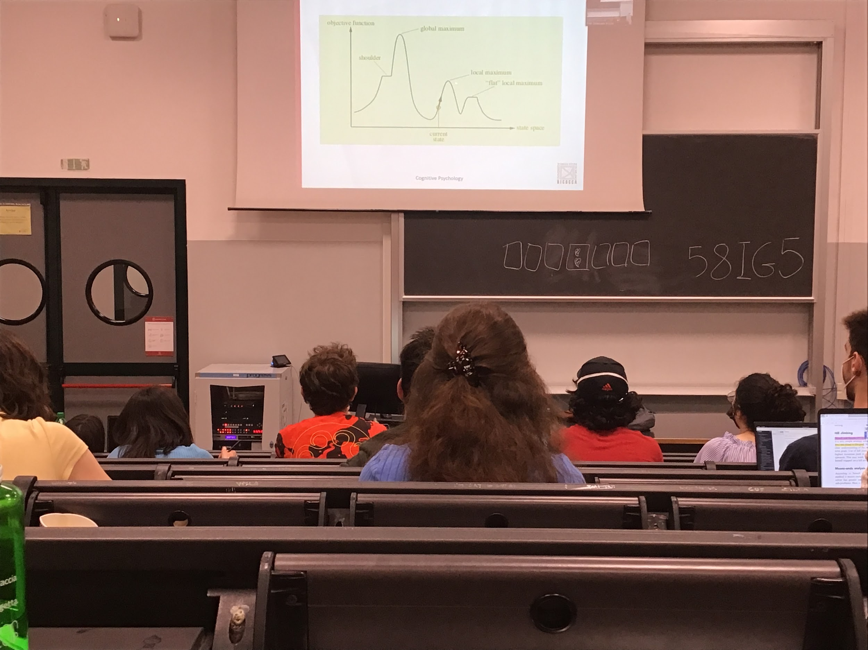

Sometimes heuristic work, but sometimes it does not, and it is better to restart

This is an approximate method, the only goal is to get a little bit closer to the final goal

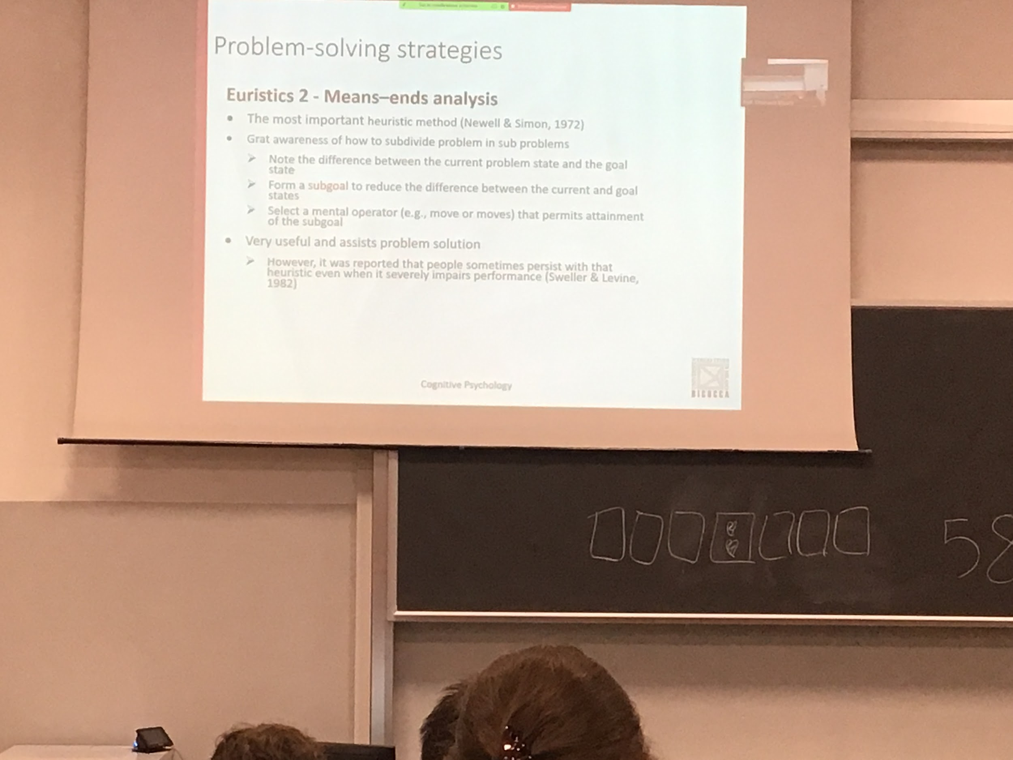

Means-end analysis

We have to subdivide the problem in sub probes we have to know what we want to reach, create subgoals, and move toward that subgoal

It is much easier to get to the solution with the means-end analysis with respect to the hill-climbing, sometimes you get stuck also in this situation

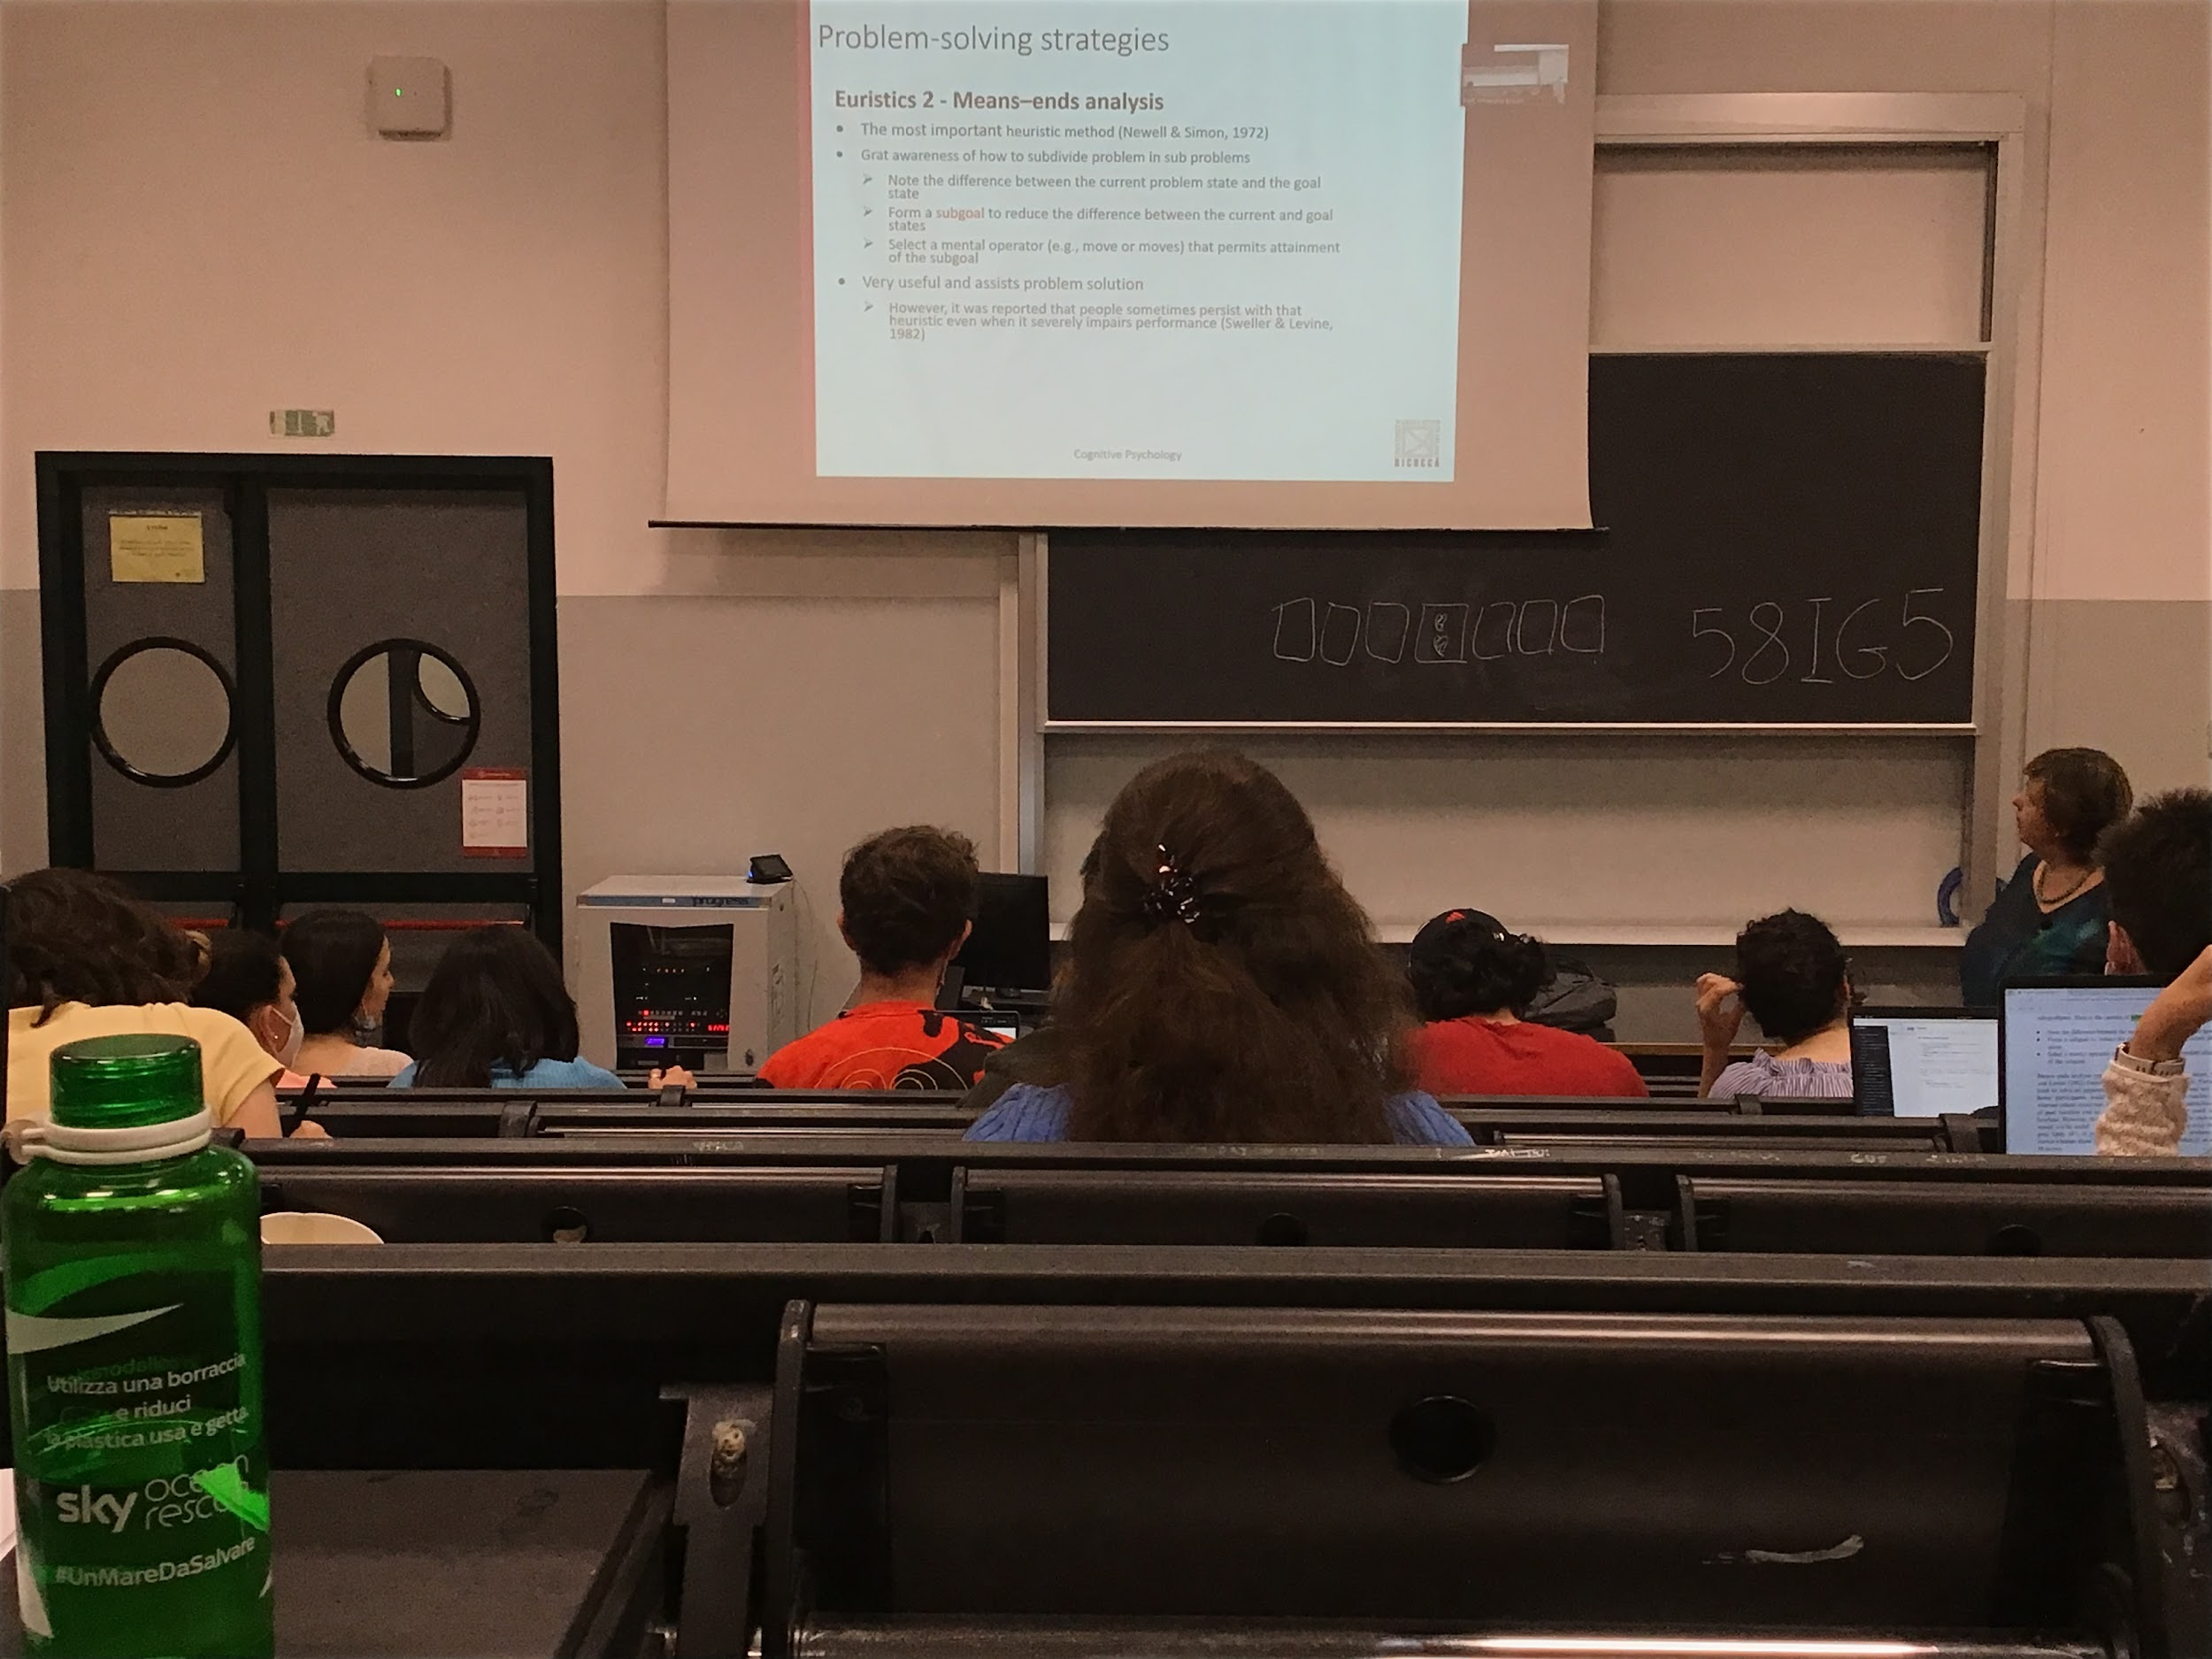

AUDIO 3

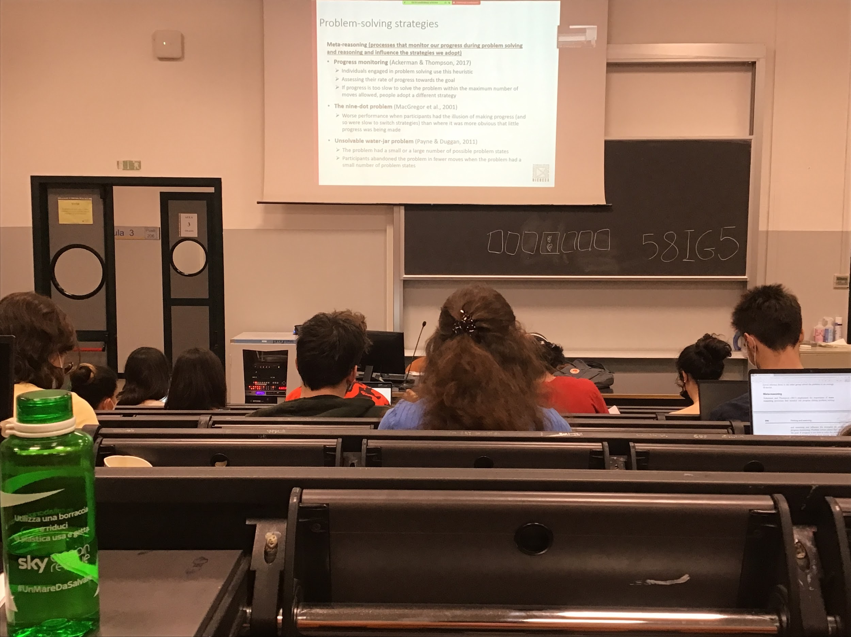

Meta-reasoning we monitor our ability to reach the solution

We not only try to find the solution but check if we are getting closer and closer to the solution

If we realise that the way we are following does not take us where we want, we switch and we try to find the solution

Progress monitoring: checking if we are going closer to the locution

This monitoring enable us to stop wasting time and resources in solutions that are not optimal

If we trick the people that they are actually making process they keep going on that solution even if it not correct

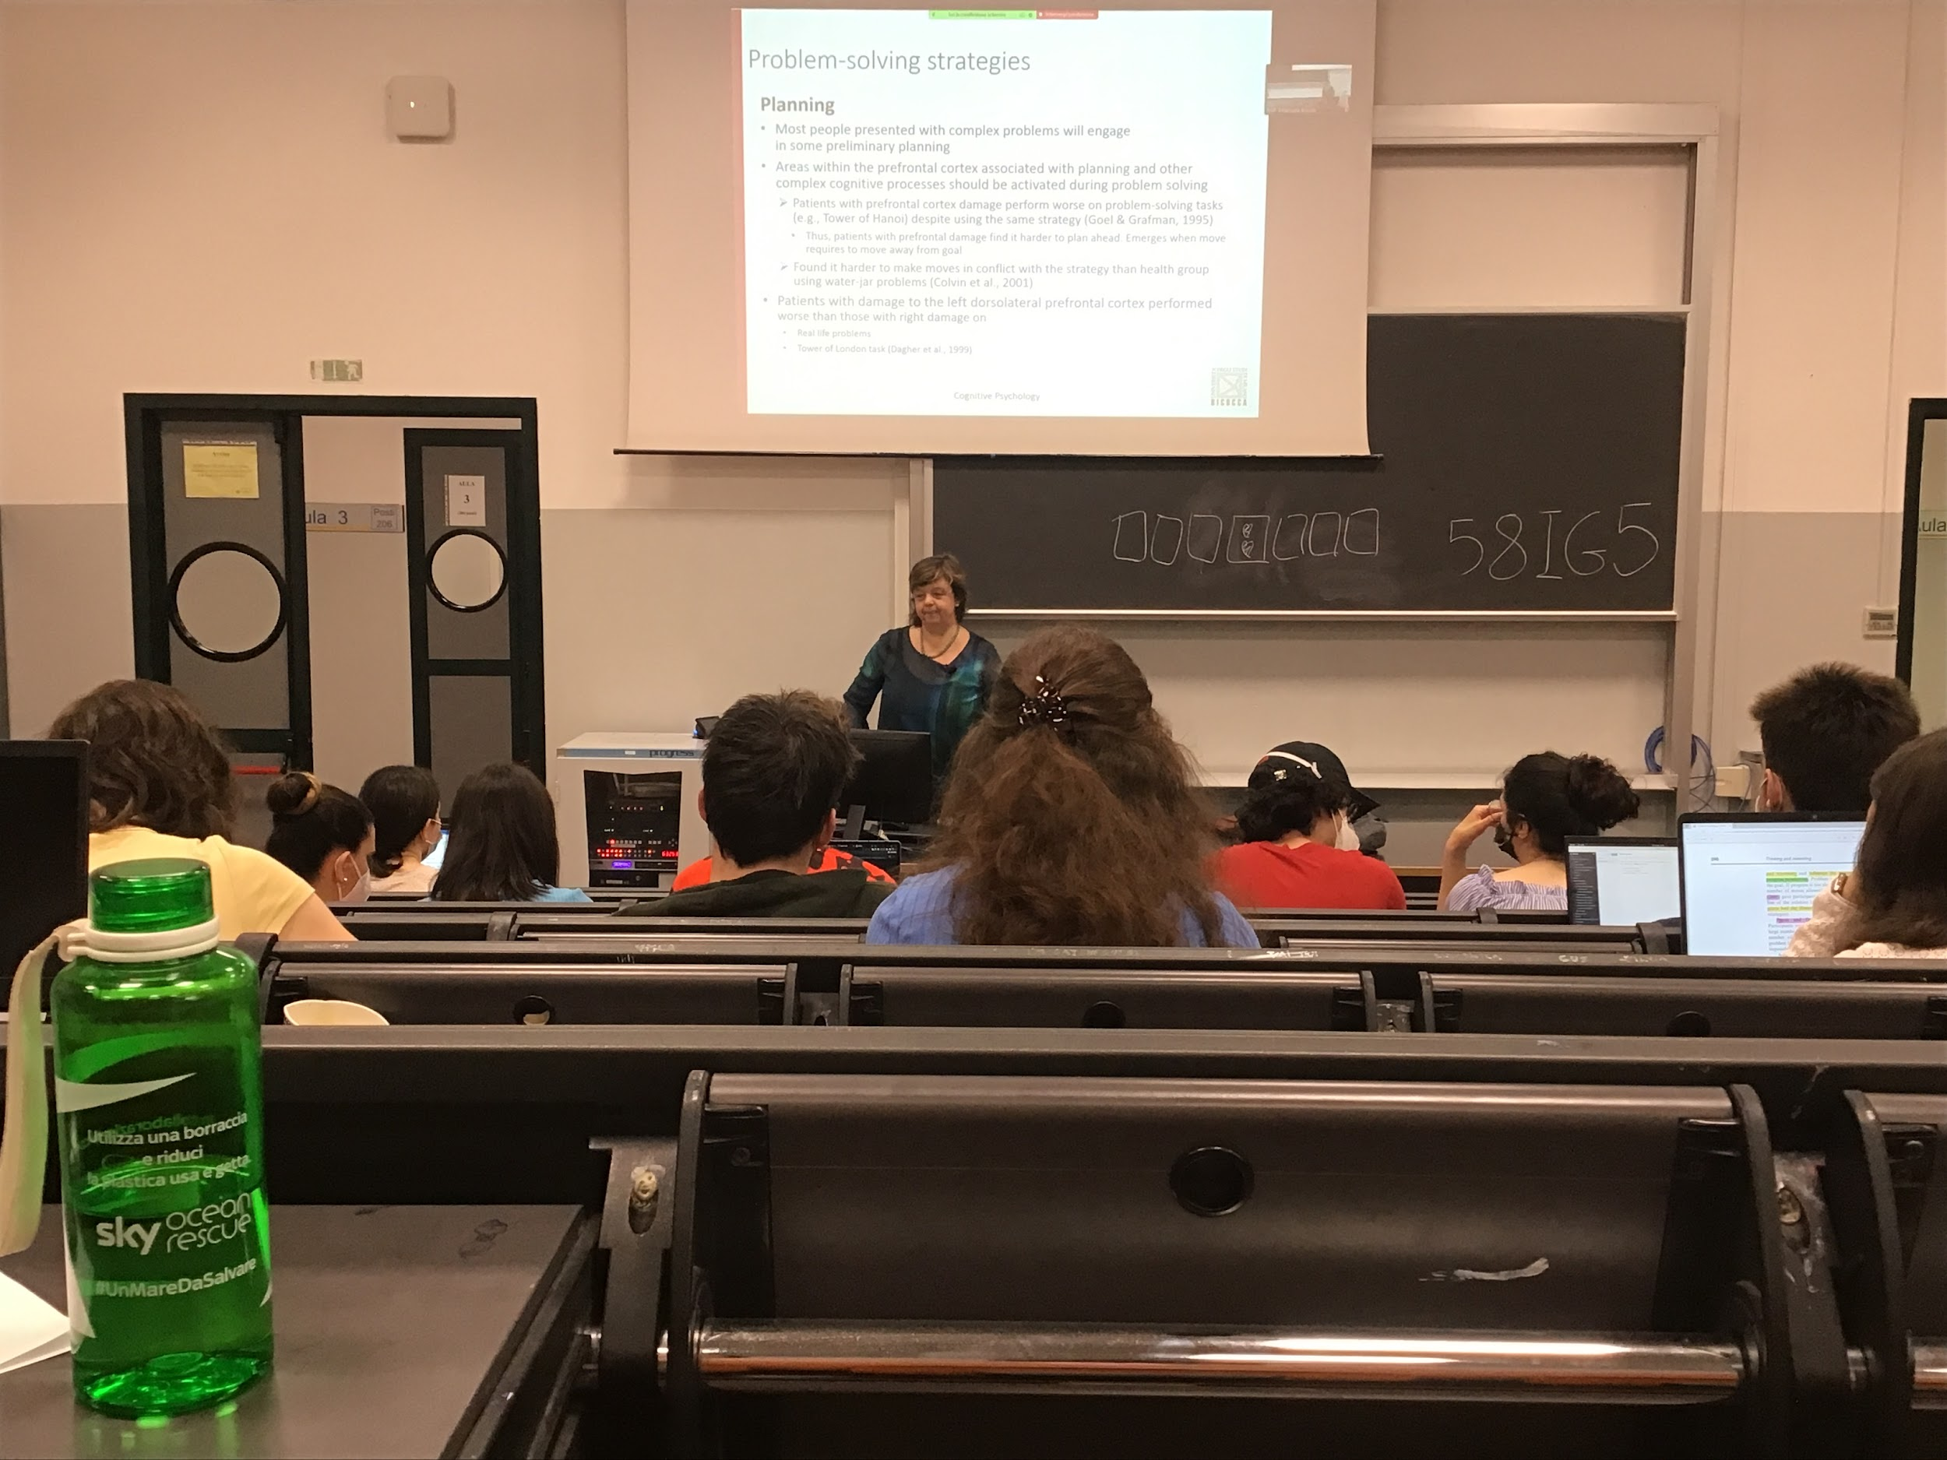

Planning

Most people when they have a complex problem in front of them they do some kind of planning

Planning is associated to prefrontal cortex, people with this damage have much work on problem-solving task, because is harder to them to plan

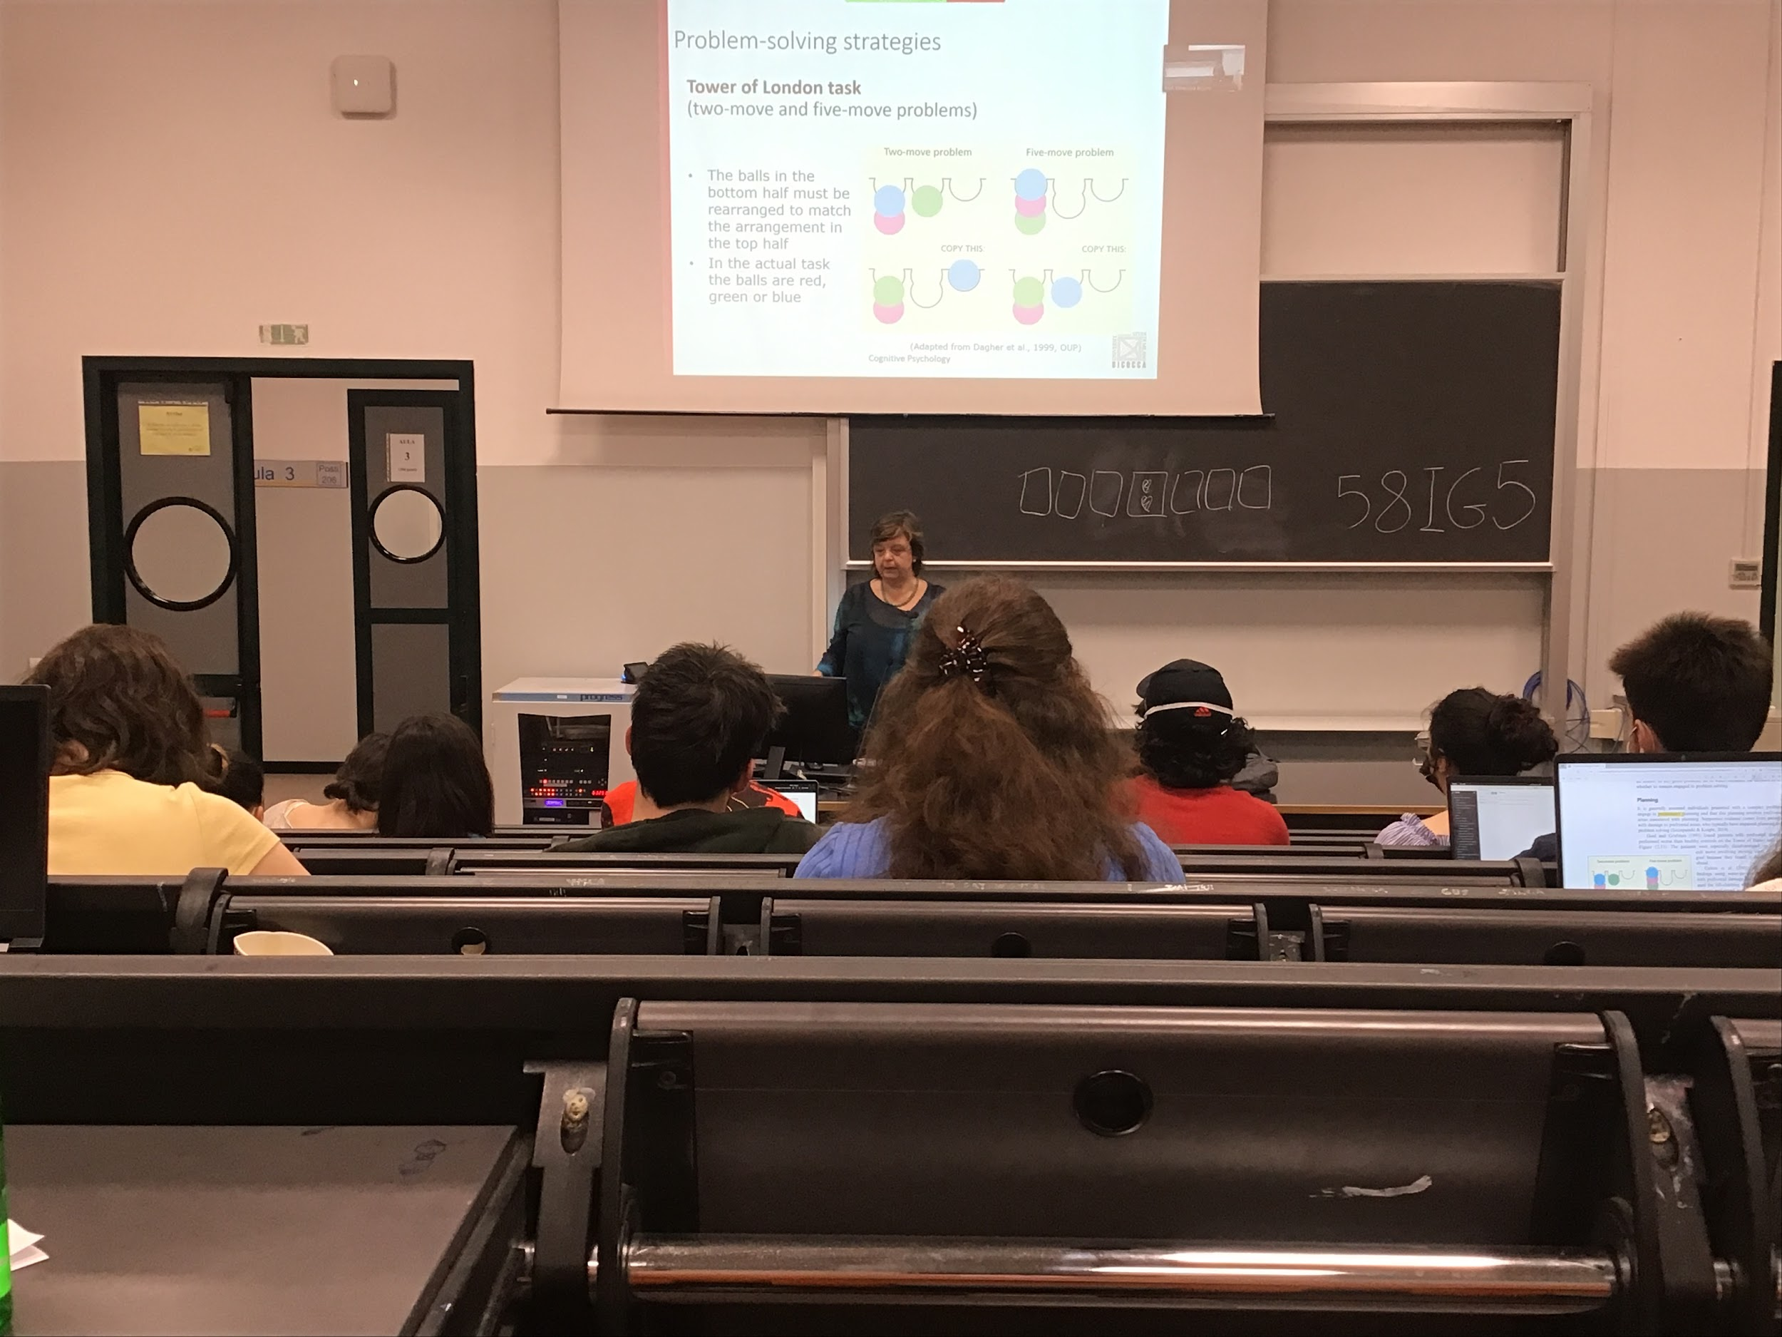

Moving away is going to help you later to reach the goal

Planning is very important especially we the sequence of movement is not obvious

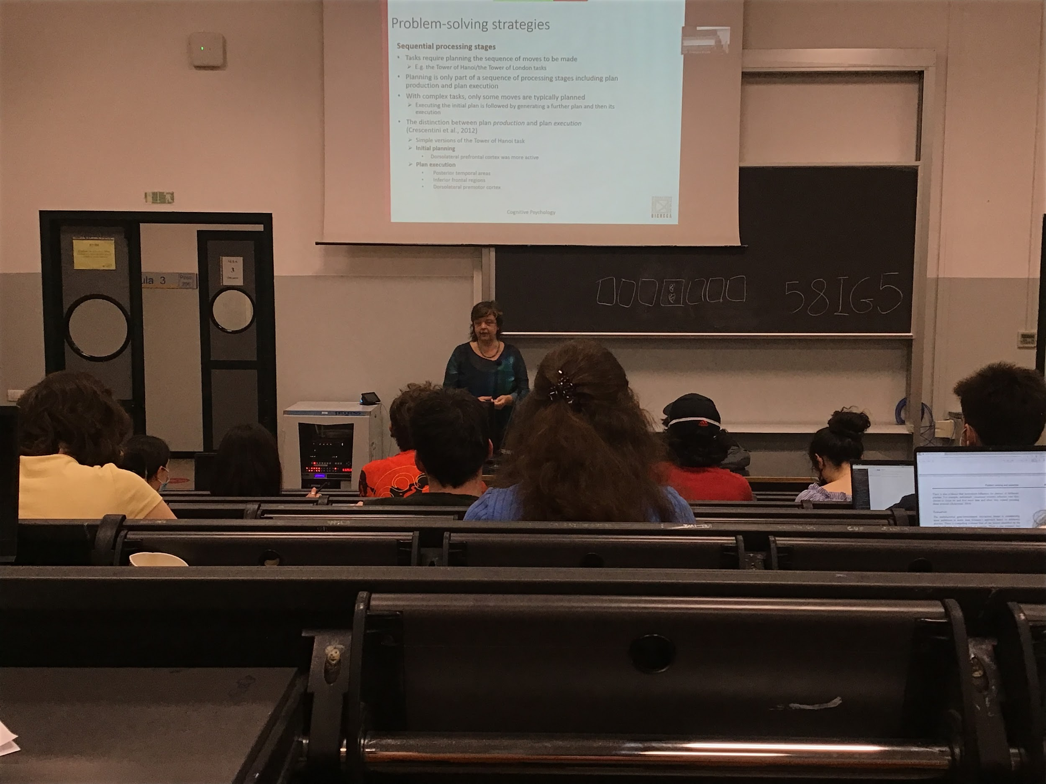

The process can be divided in different steps, we need to plan parts head

Most of the time we plan a little bit, we don’t plan the entire sequence. We have plan production and we do execution, when the program is very big we have to do in different steps because we don’t see the end

For planning and execution we do use different areas

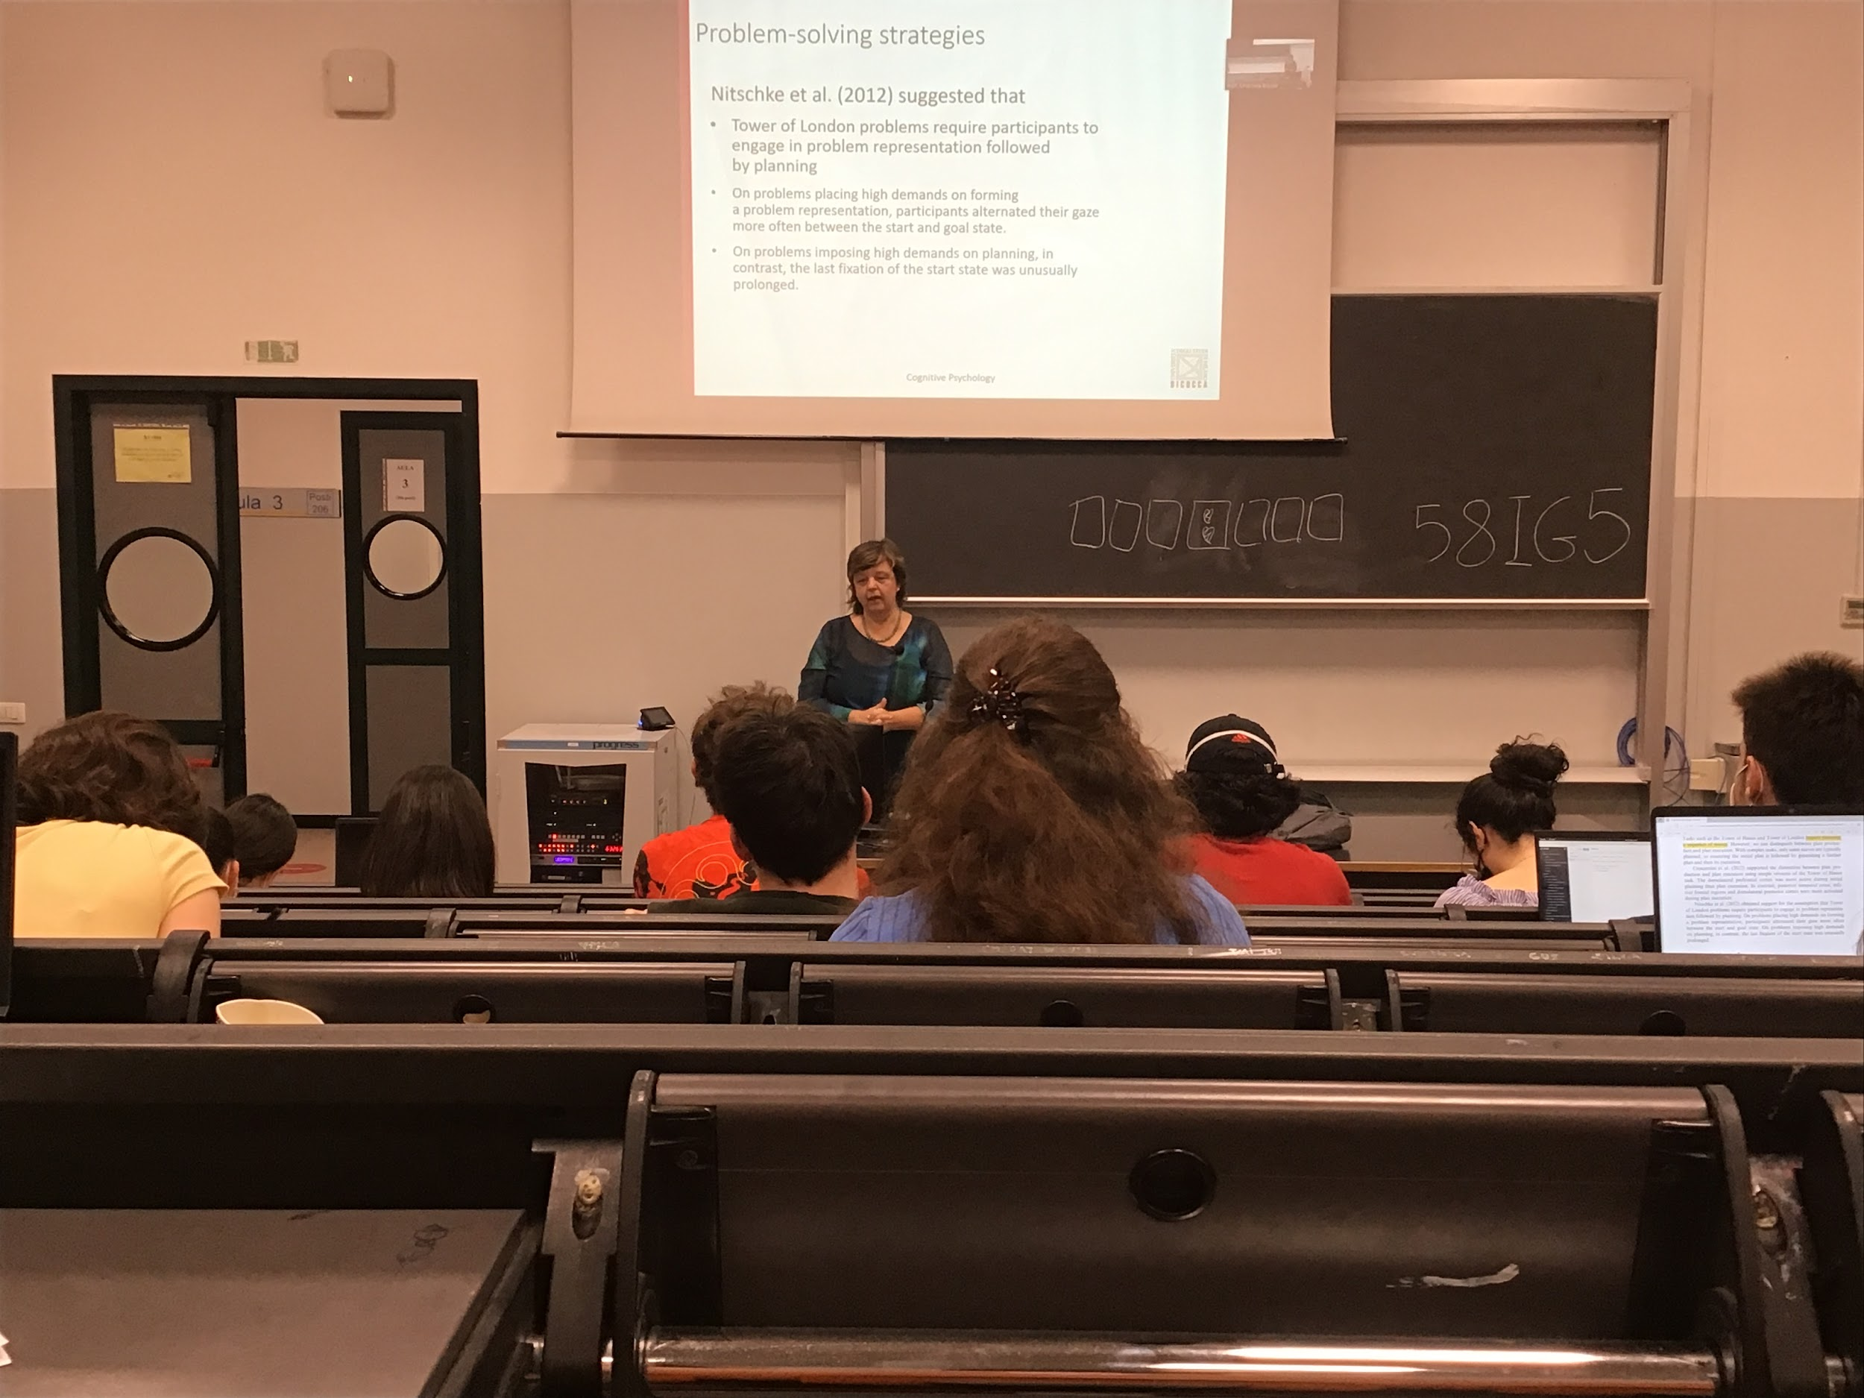

First represent the problem, then planning and then execute it

We have different parts and to try to represent ht the problem is

Keep looking between the start and the end to represent in our mind where we come from and where we are going and when we start doing the execution we fixated our eyes more on the starting phase

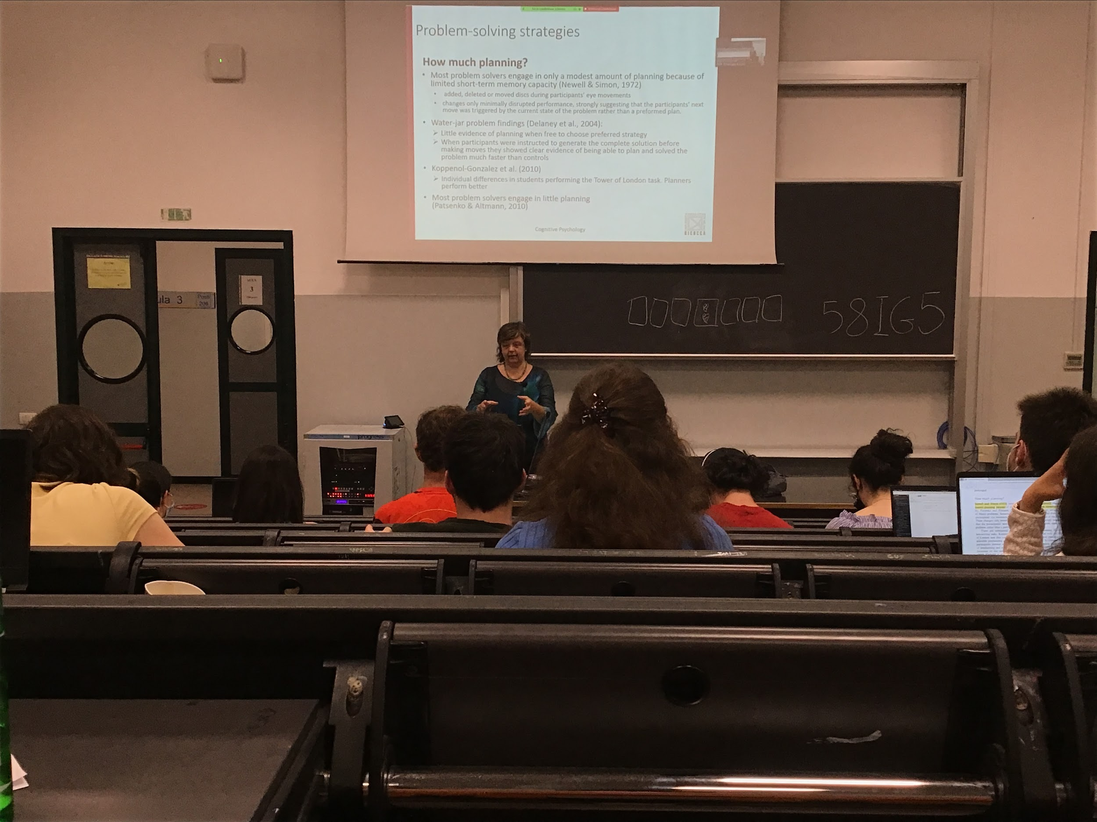

How much planning are we using it? Do we use the same amount of planning?

People with short time memory do not plan much higher, do not store all the steps. Plan a little bit ahead

In vision there is suppression, everything that happened during your movement you don’t see it

If I add a new piece you don’t realise it, don’t program for a long time

Even if you can force people to plan ahead for a long sequence most of the time they don’t use it.

Planning increase the performance but people do not plan much ahead

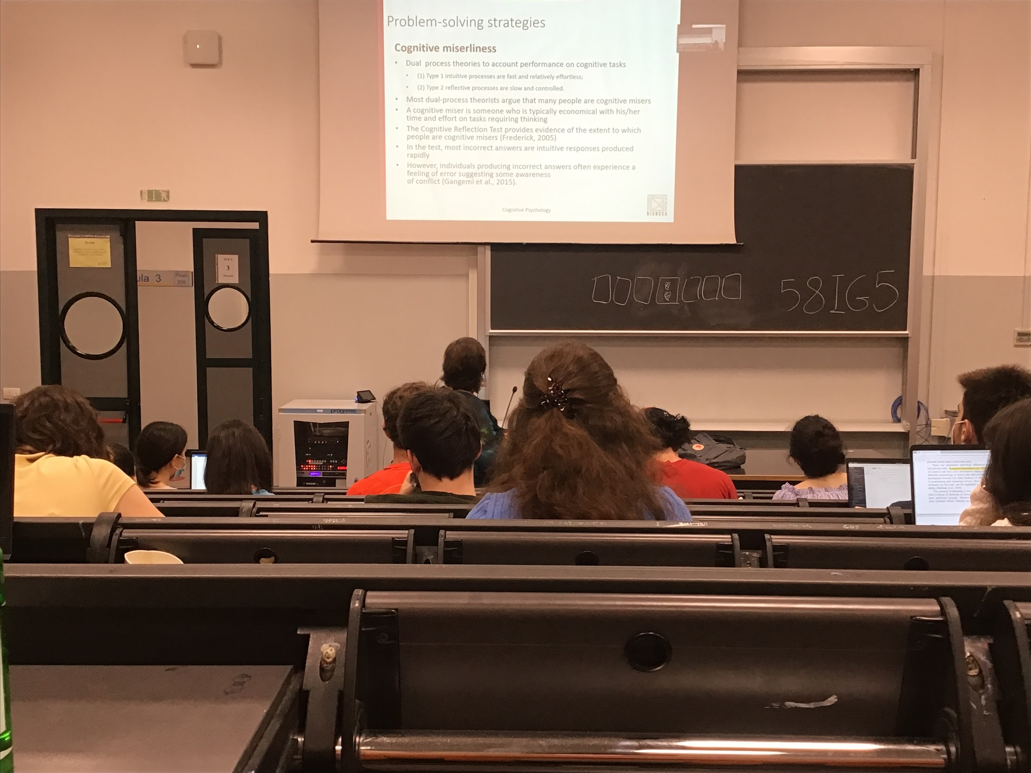

Most people are cognitive miserliness

Do not use the best strategies when have to solve the problem

Try to solve all possible problems using our intuition

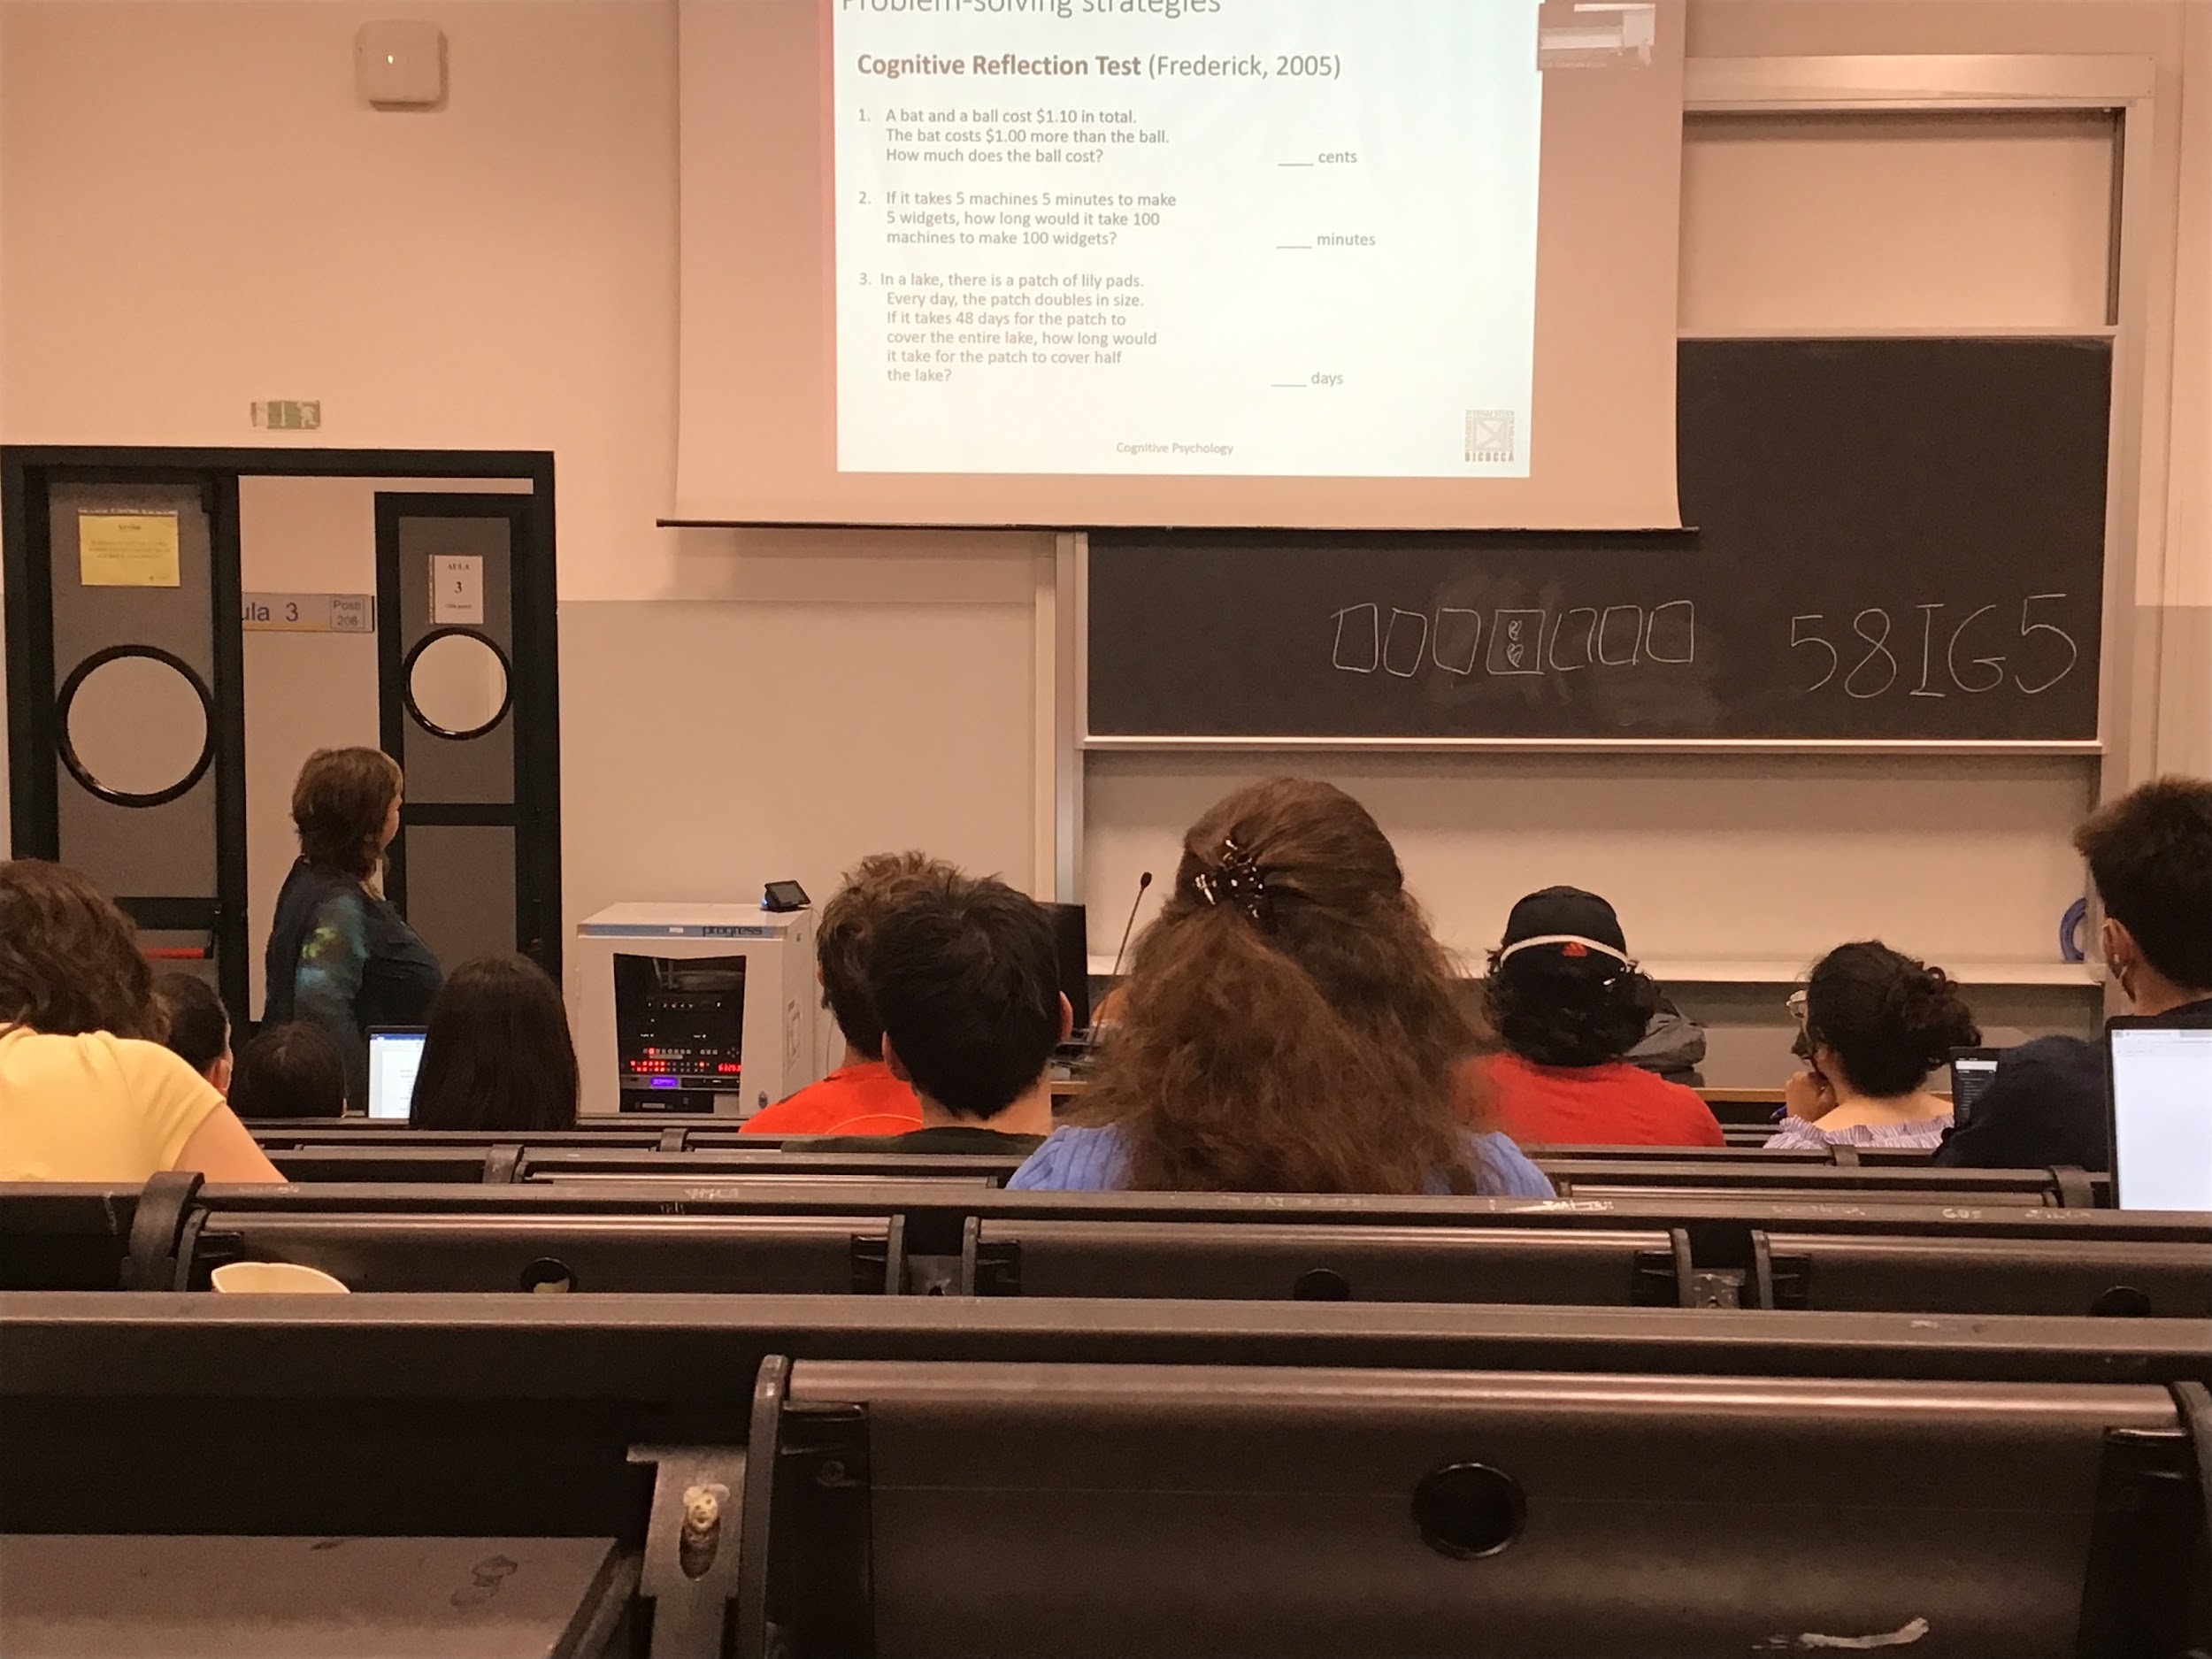

Cognitive reflection test

People that do this task and do not try the slover type-2 or use the type-1 without checking your intuition, they get the incorrect answer

If you check your intuition you realise that this is wrong but most people don’t check it

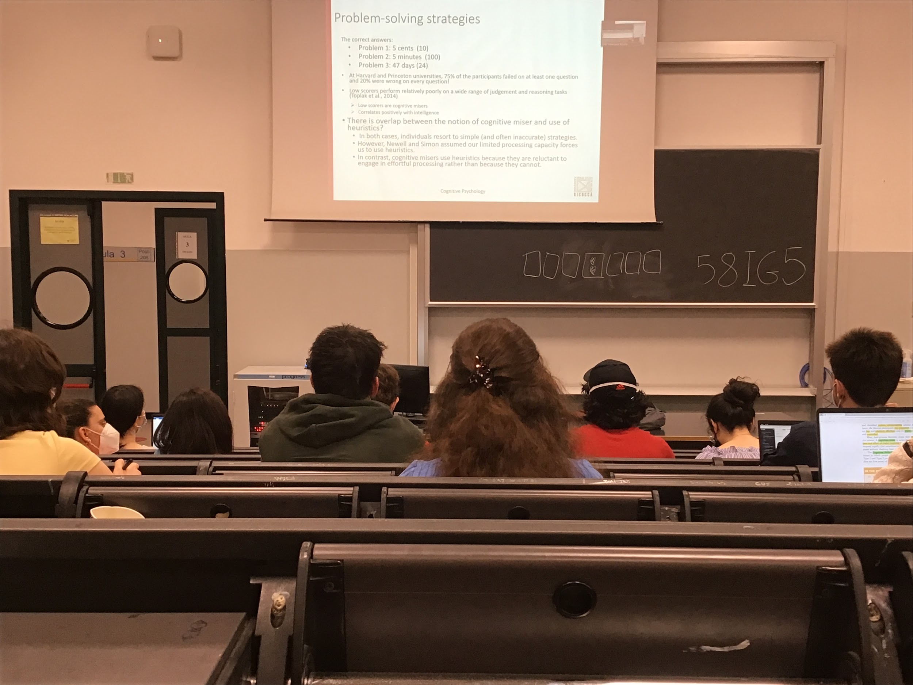

People that have a low score on this test are cognitive miserliness, a low score is correlated having low scores on intelligence, they use the simple fast strategies

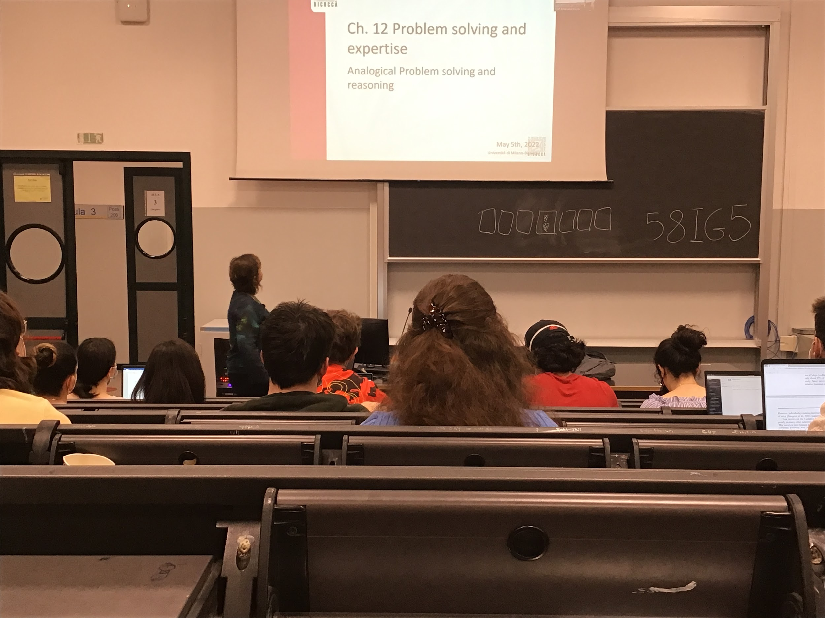

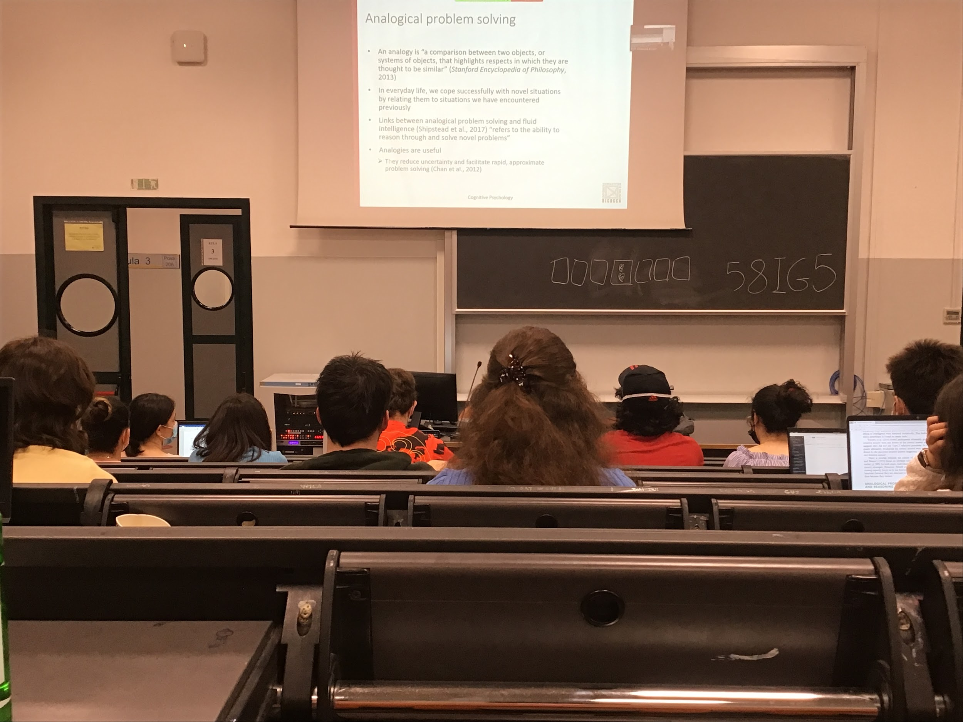

Analogies: compare what we have to something we have seen before, every single day we coop with situation in which we are looking to similar situation in the pat

Analogy helps a lot to understand different conditions

Big connection between analogical problem solving and fluid intelligence (intelligence that help to find a solution of novel problem) if you are good with analogy you are good with fluid intelligence

Analogies helps you find alternatives even if approximate. Guides you to a possible solution of the problem

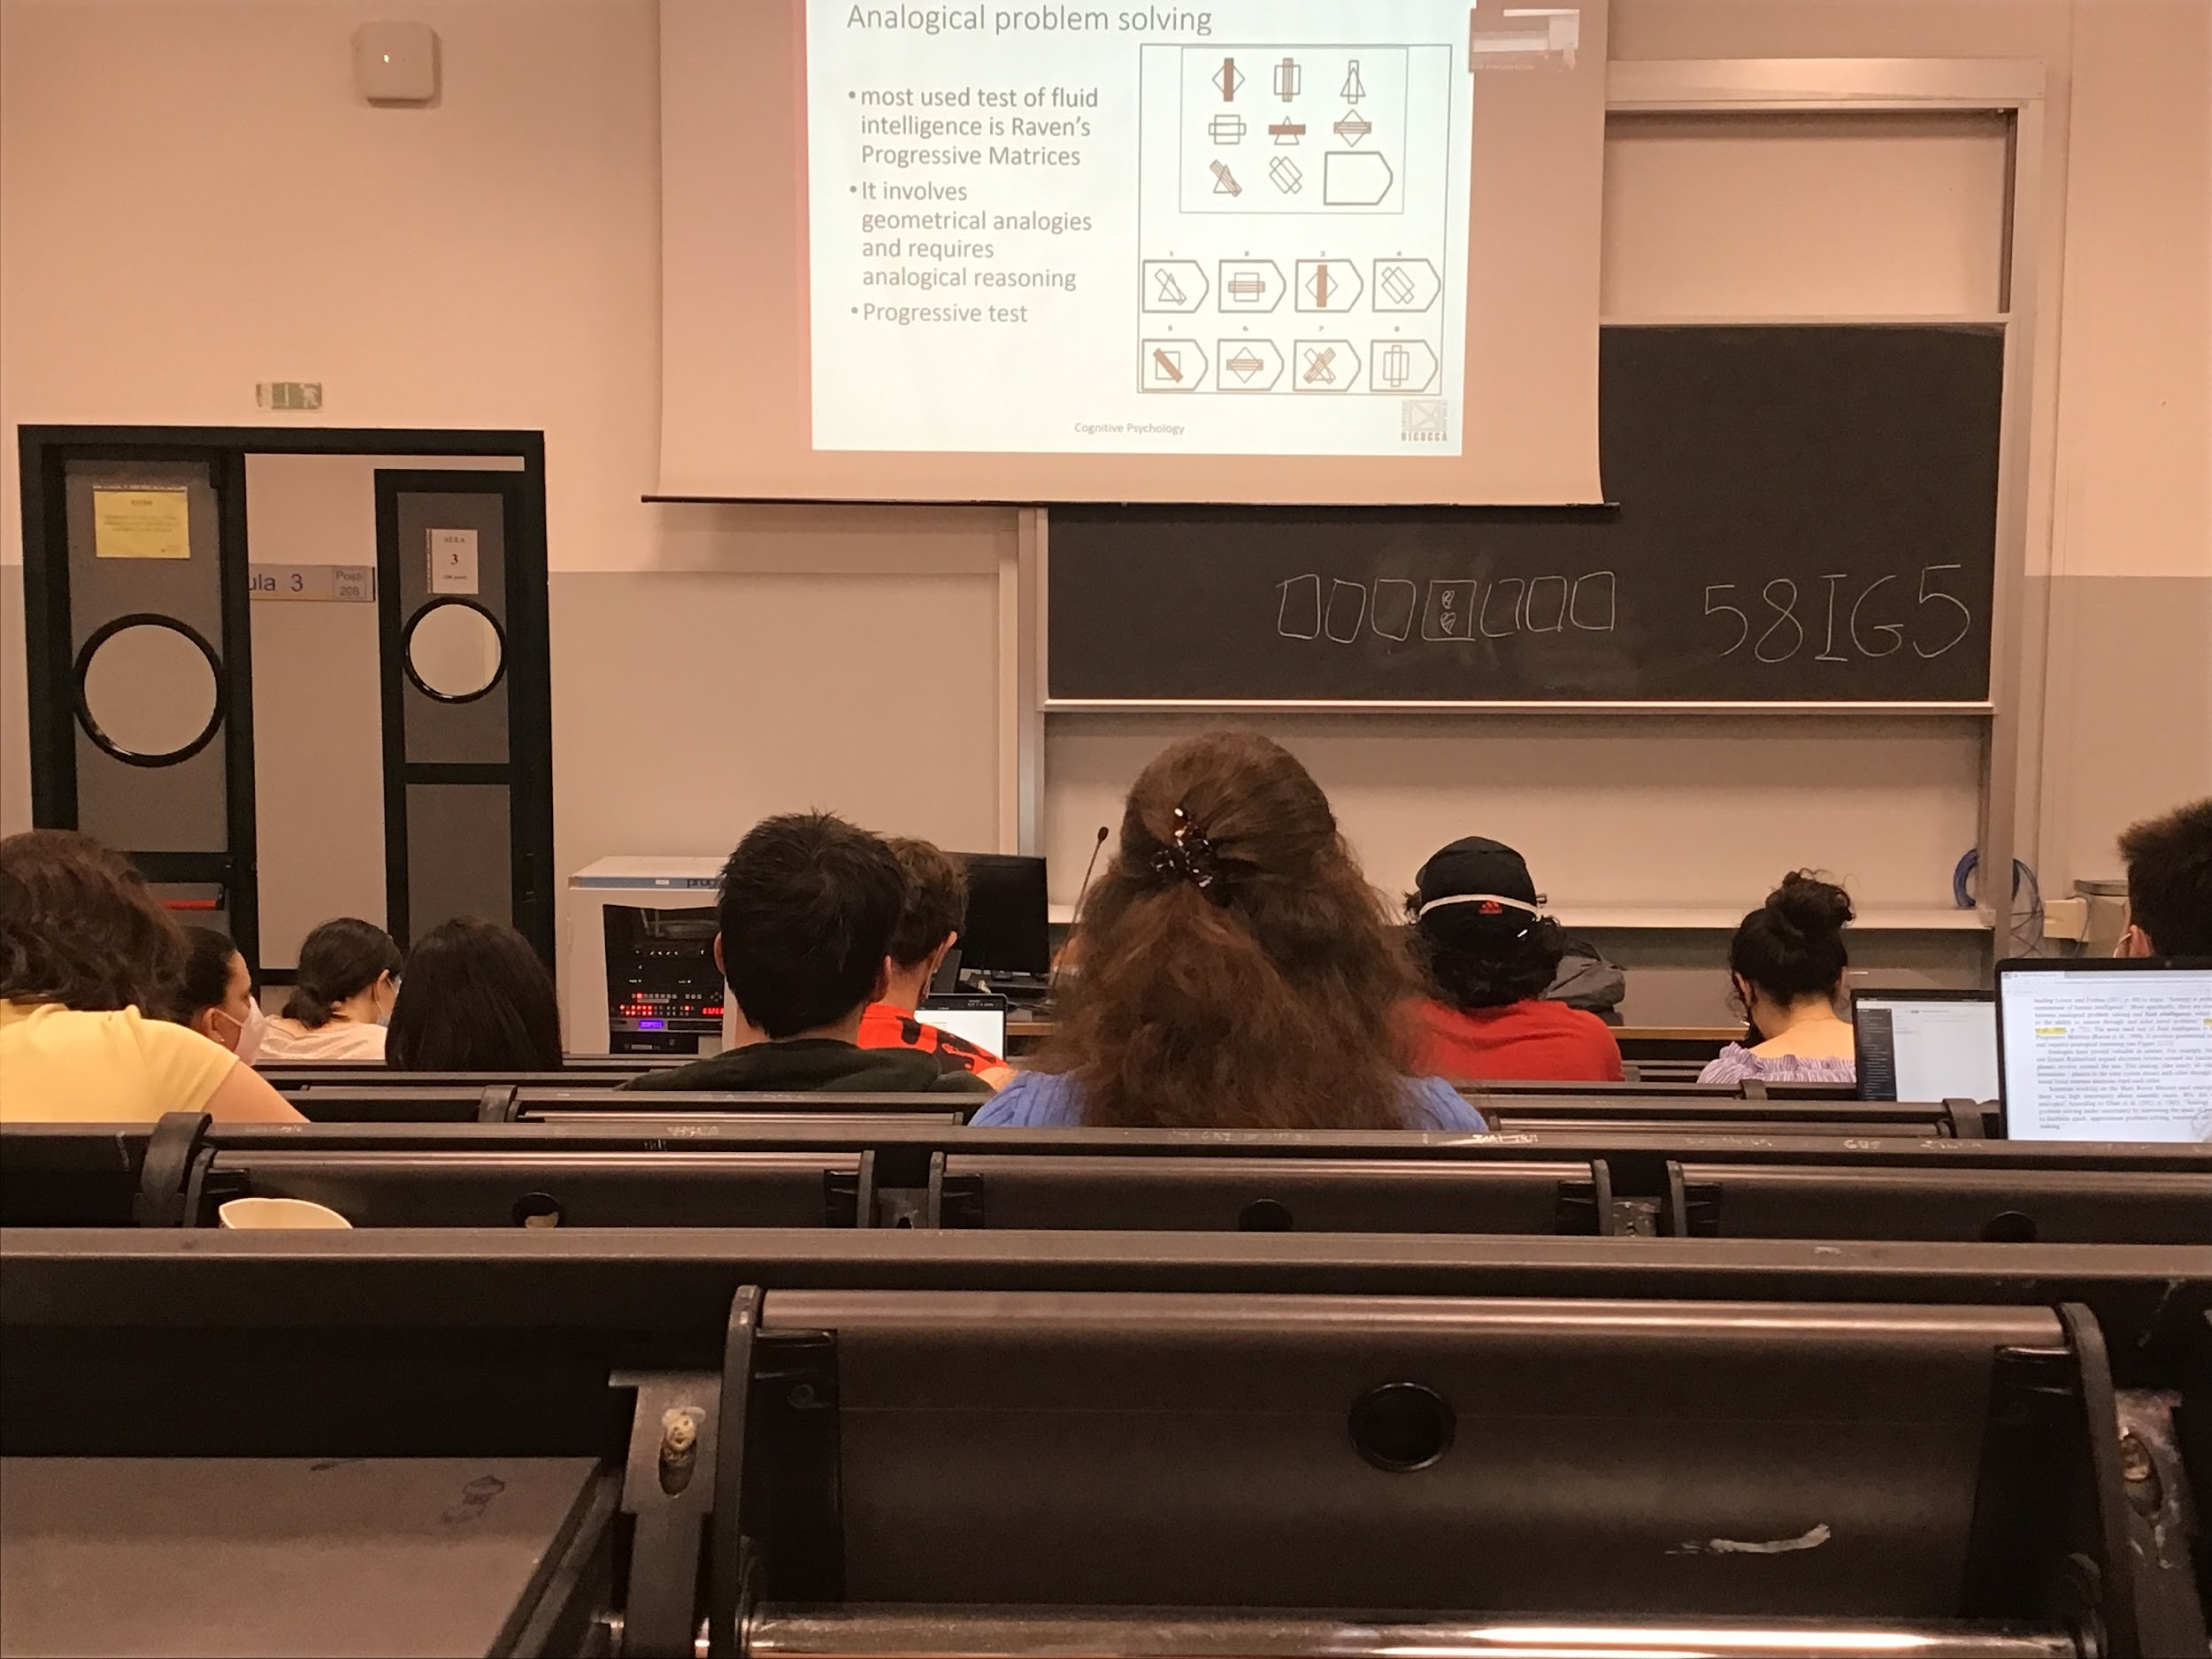

Raven’s progressive matrices: start from very simple example and the you get more complex

Need to do multiple analogies to see what is similar and what is not

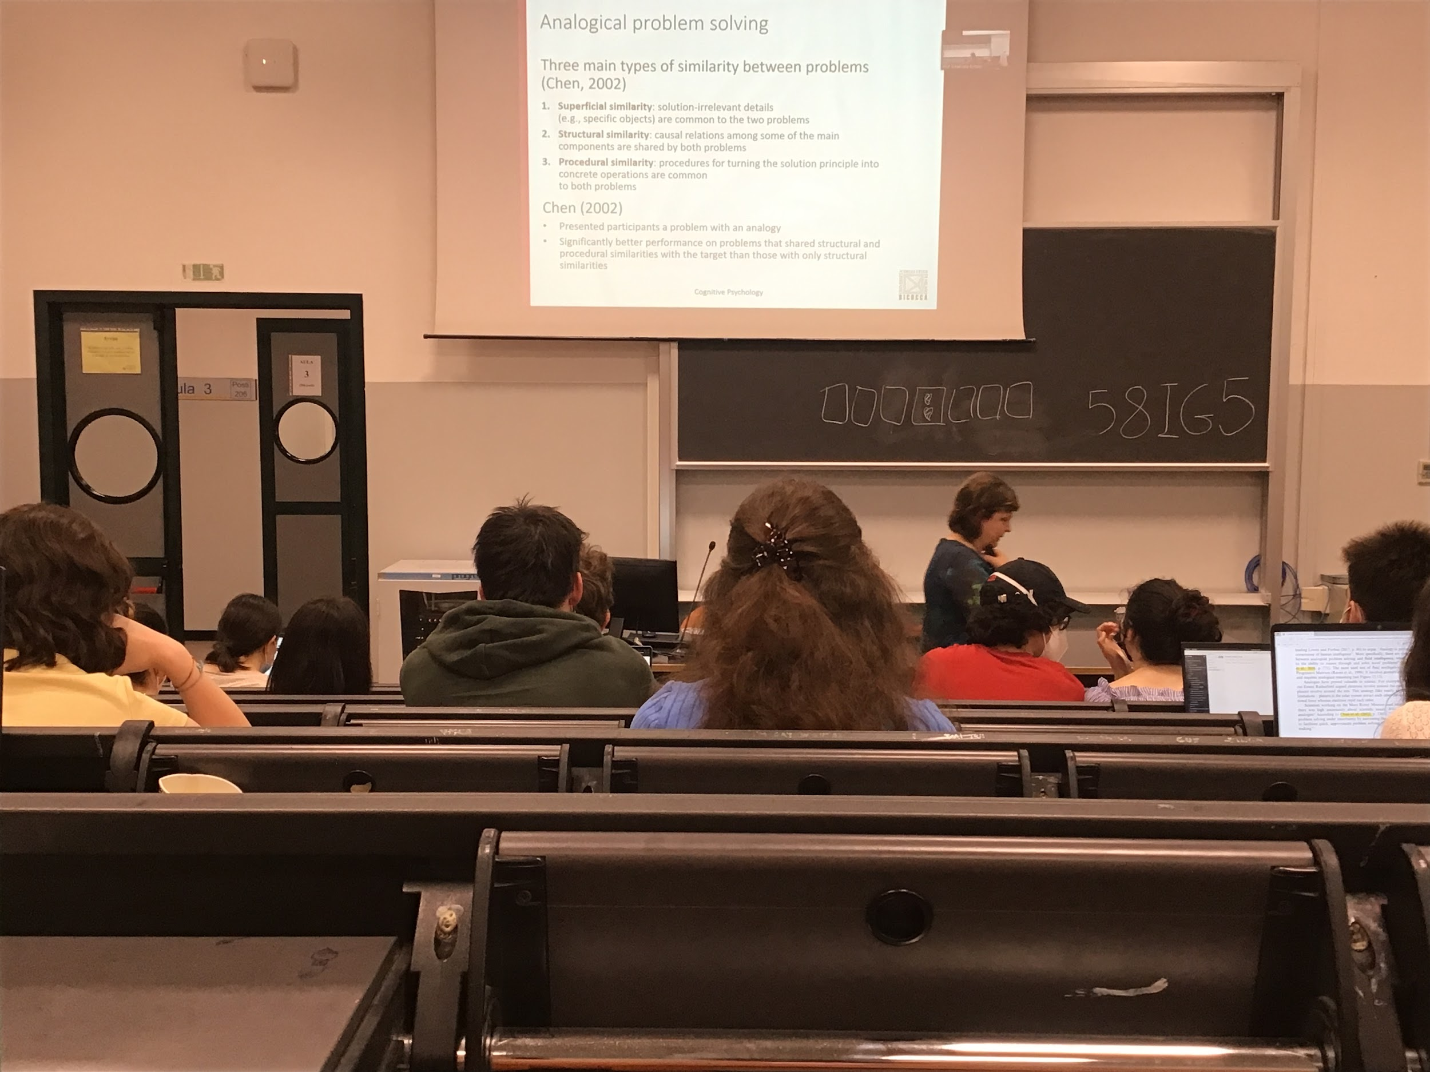

Researched said that there are 3 types of similarities, some are more important to find problems

1. Superficial similarities: an element that can be in 2 problems but the two problems have nothing to do with eachother, don’t help us to solve the problems
2. Structural similarities: relationship about components that are the same in the two problems
3. Procedural similarities: way to find a solution similar to the problem

Superficial similarities does not help very much

Structural and procedural similarities can help a lot

If the second have both structural and procedural similarities you are much better at finding the solution

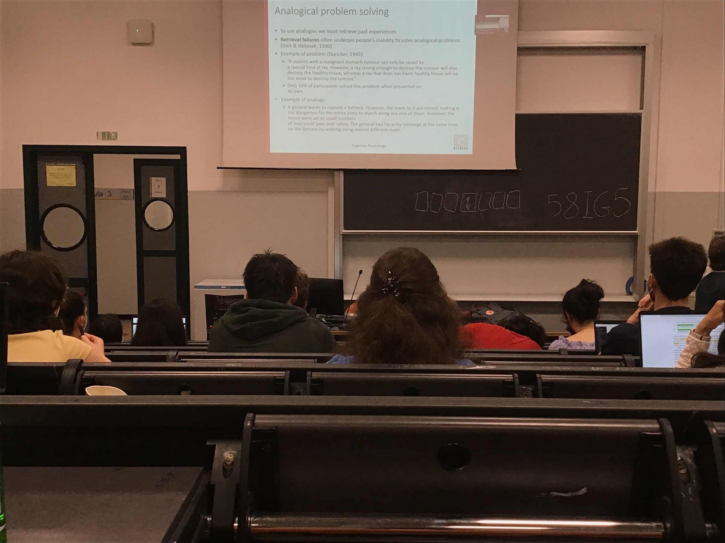

To be able to use analogies we need to take out and retrive past experience. If we are not good at retrieving the original information we can not apply correctly the similarity

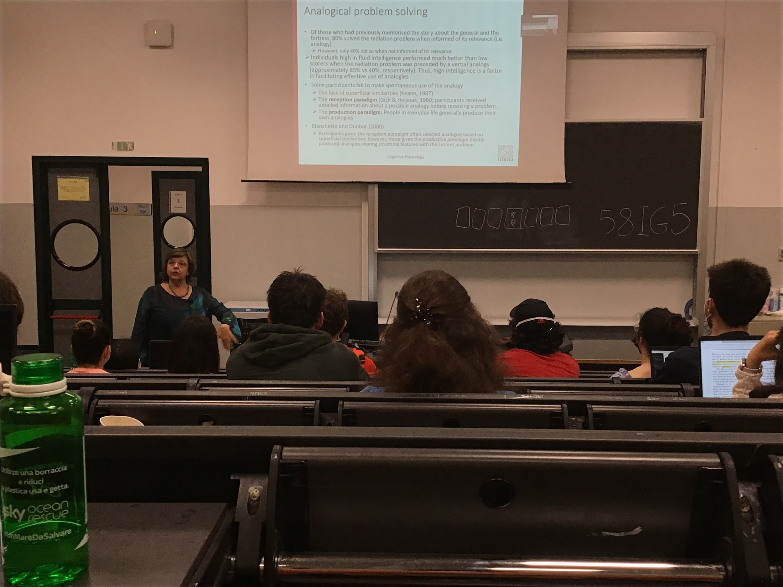

There no superficial similarity. If I ask you to solve the fortress and I tell you to remember it, then people are solving it 80% of the time

If you do not tell that is important and since there is no superficial similarities and you did others things between, it does not comes in your mind and so you lower your performance

People with fluid intelligence were much better as using analogies with the previous problem

If we compare these 2 types of paradigm.You are better of when you do it by yourself

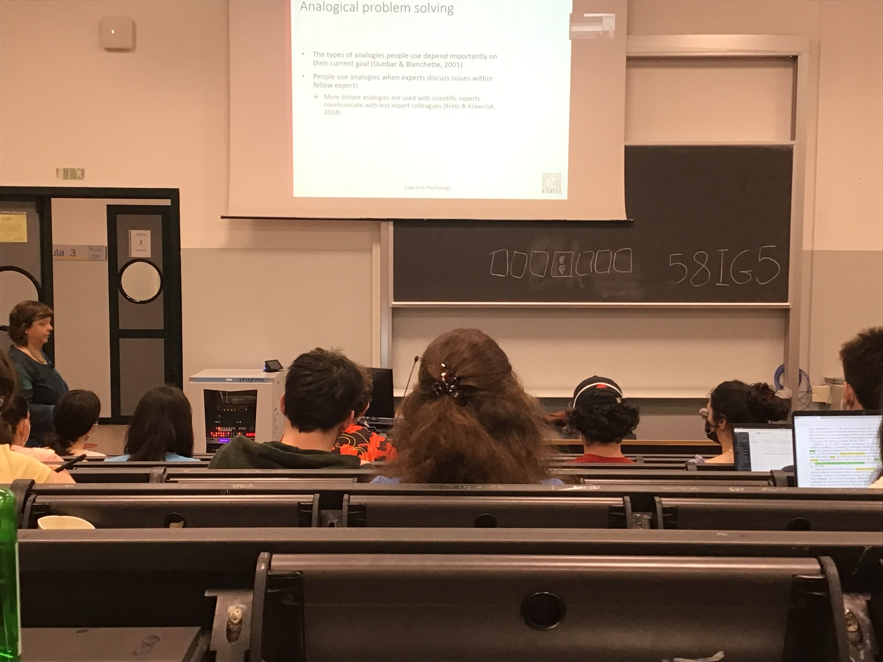

In our life we use a lot analogies

Analogies are important to be able to transfer what we understand to other people

When I try to explain something complex to people from different kind of fields I make more general analogies, while if I talk to people from the same field of I, we made more specific analogies

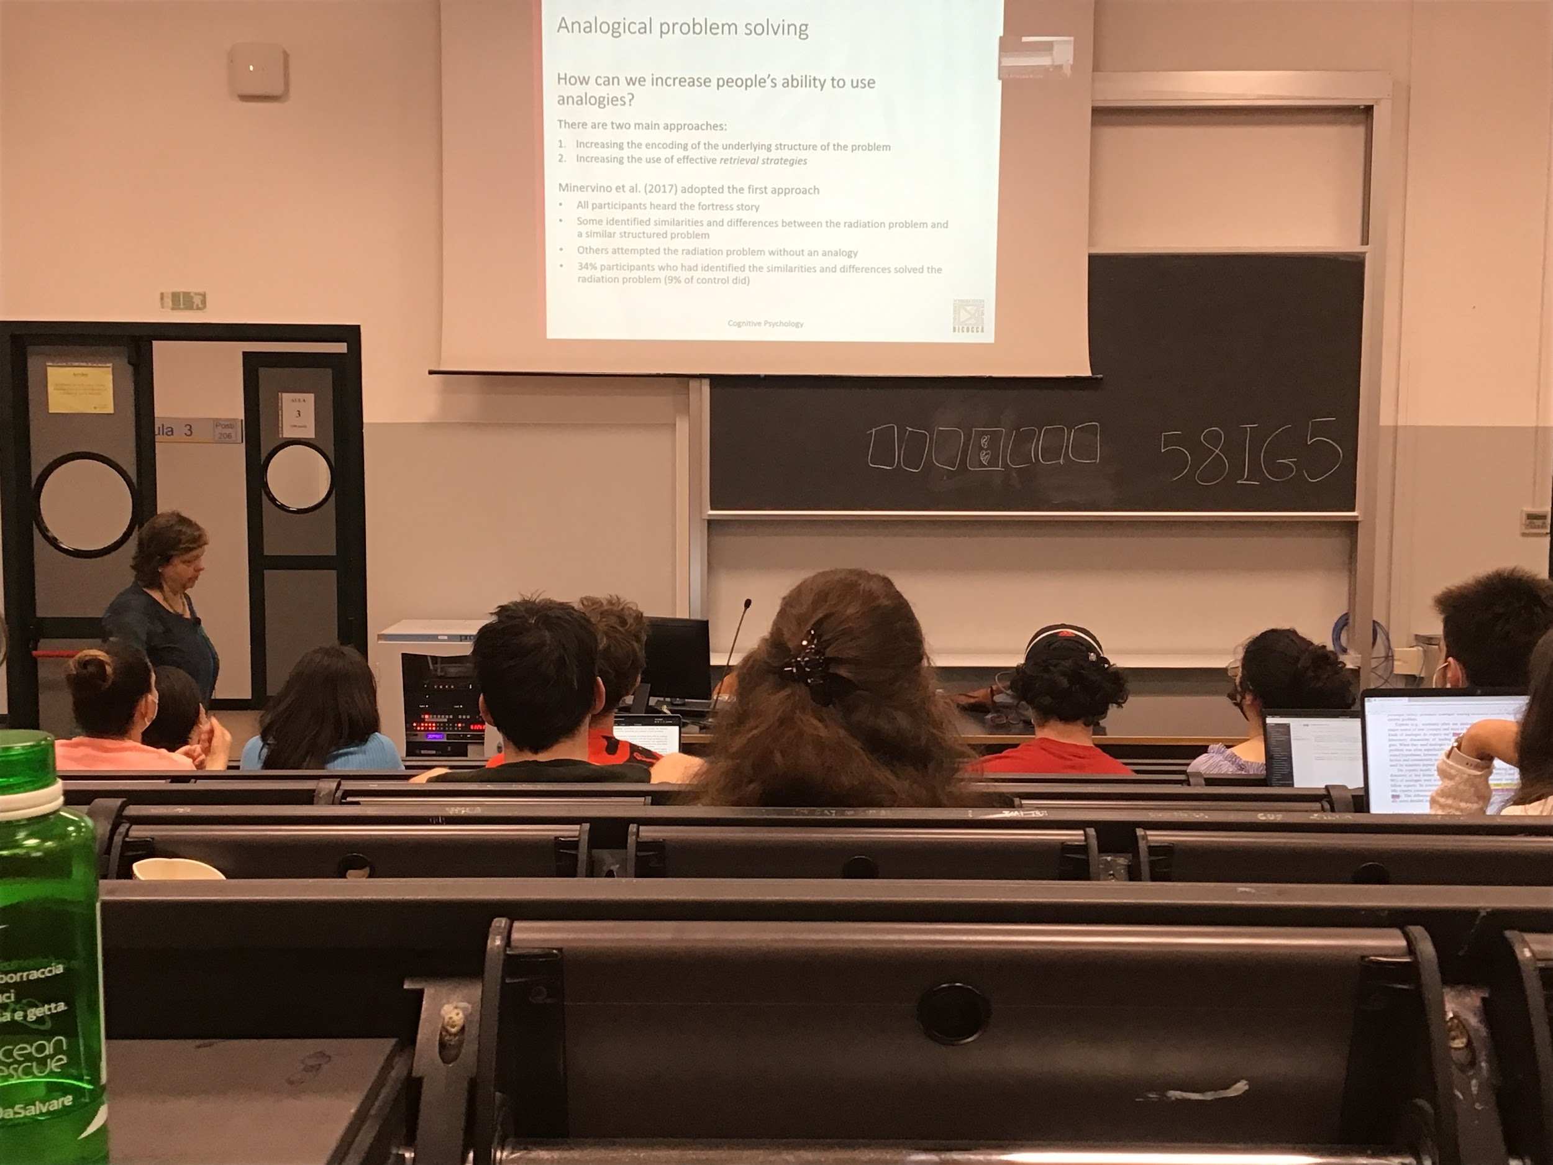

Analogies are easier and help us solve the problem, we can track them to find similarities between problems

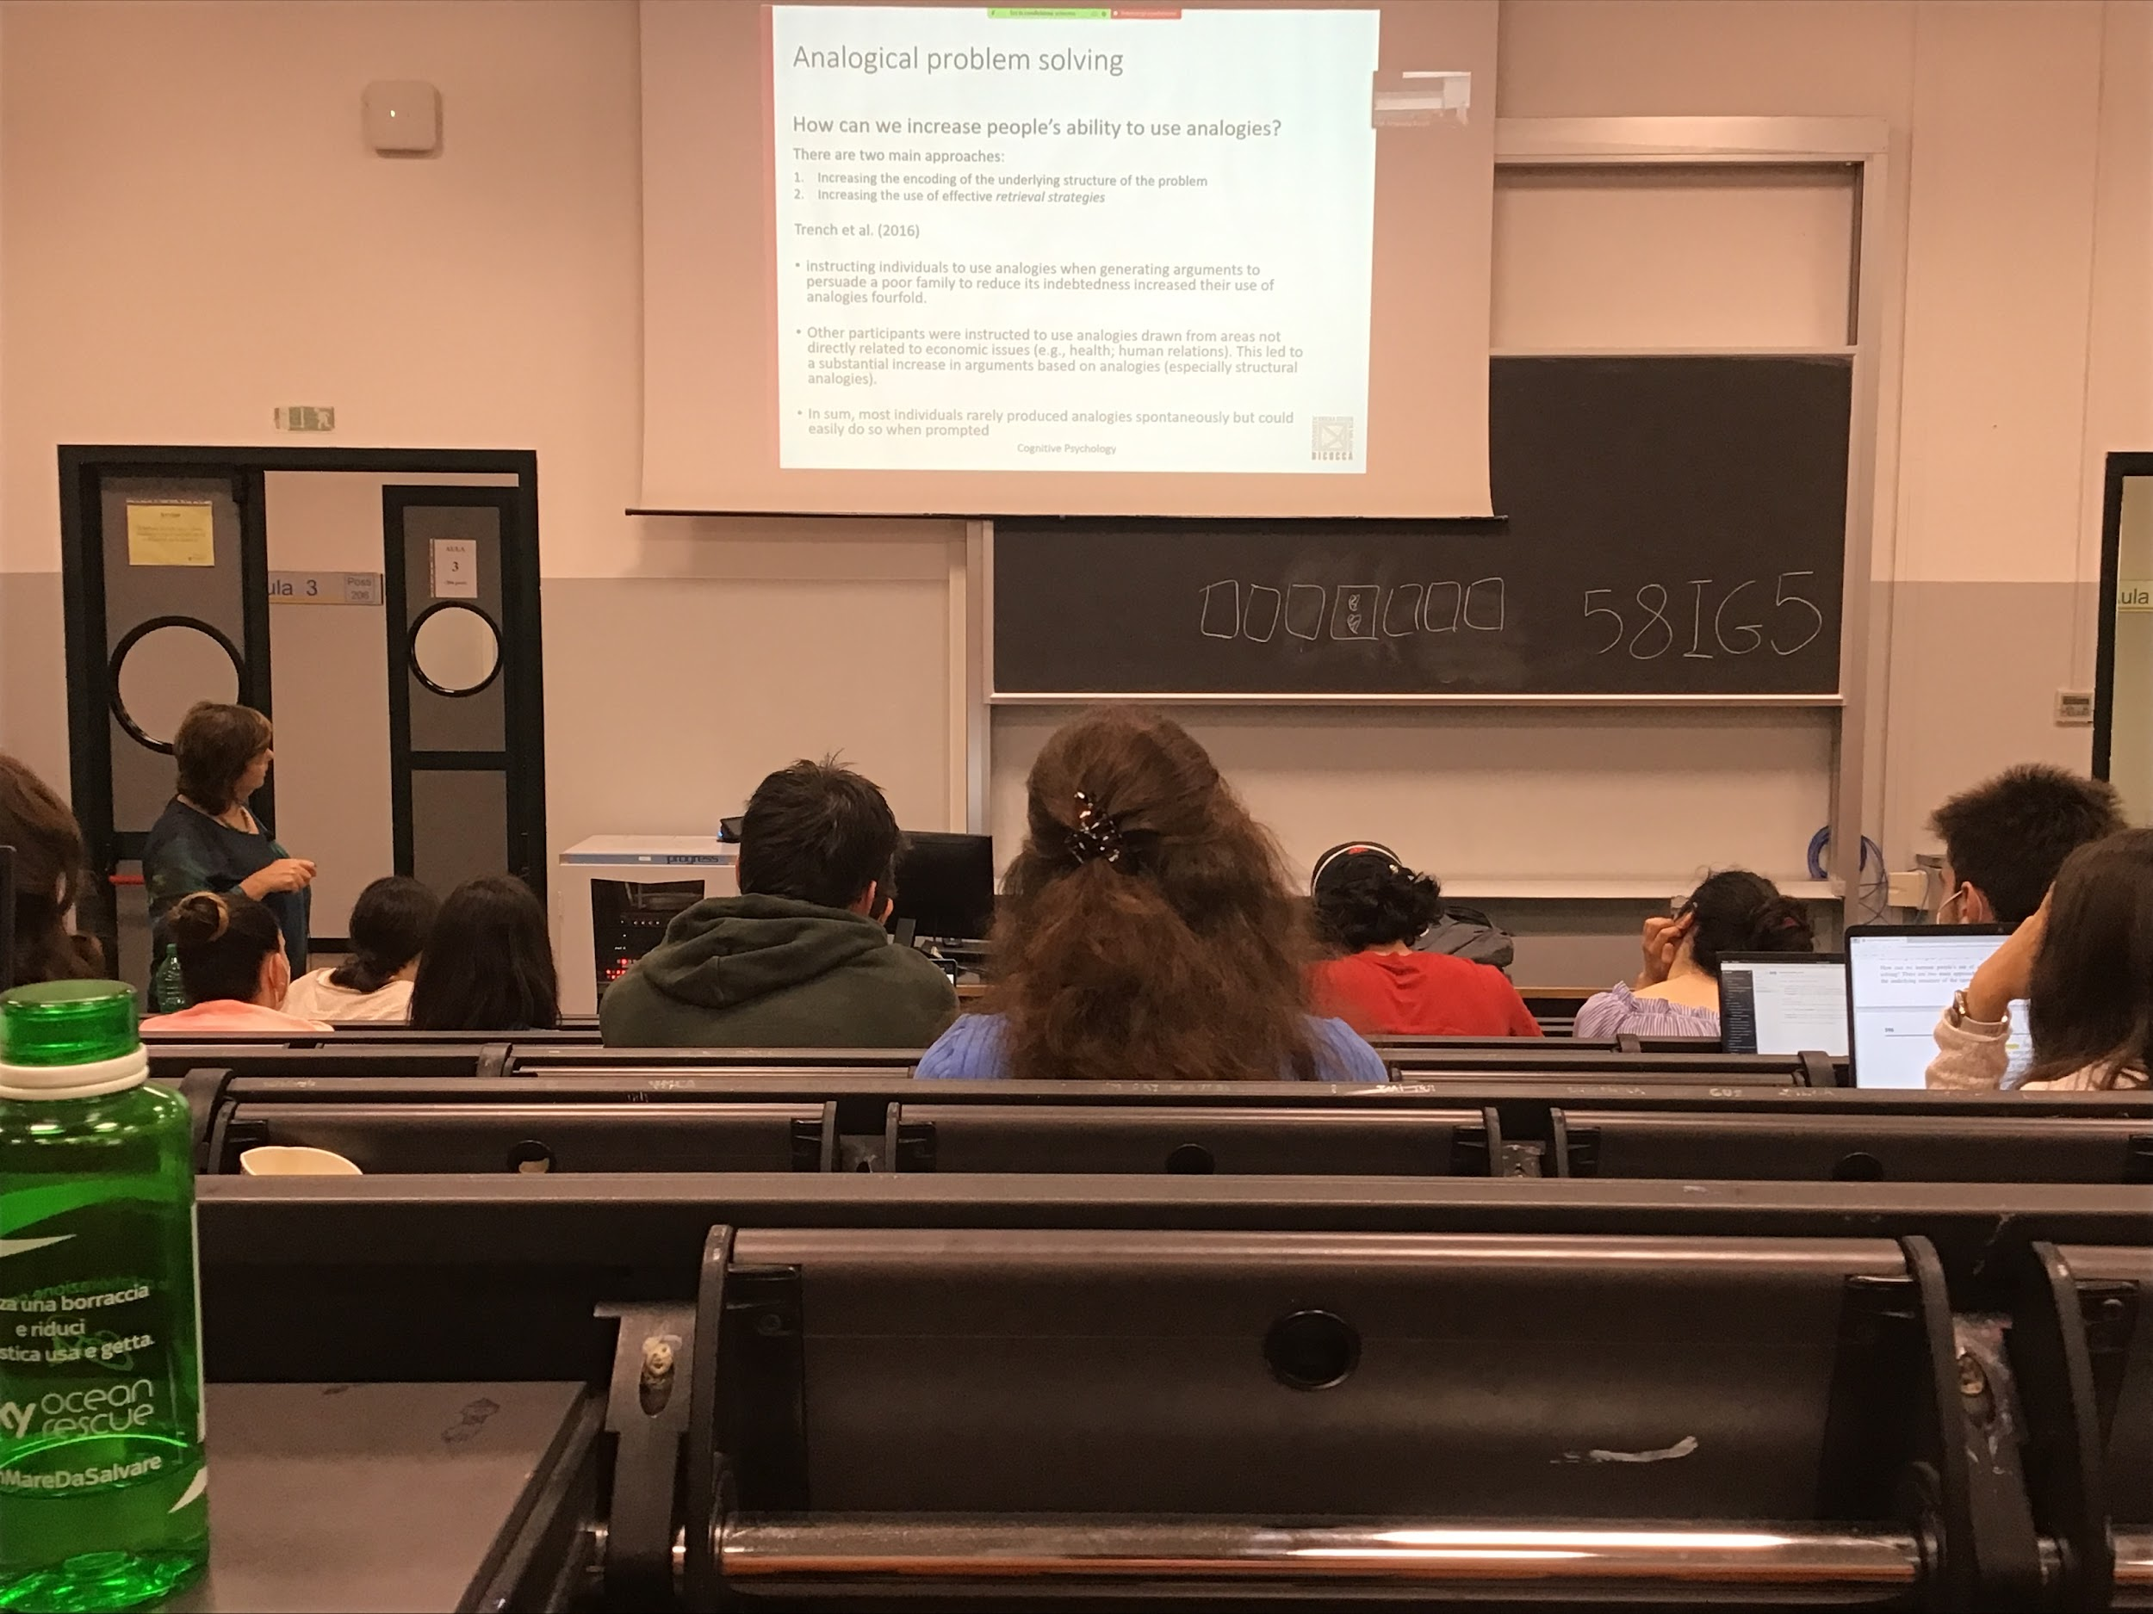

You can produce and use analogies very easly. You can force people to find analysis from completely different areas. We should force ourself to produce more and more because it makes our life easier to solve a lot of problem

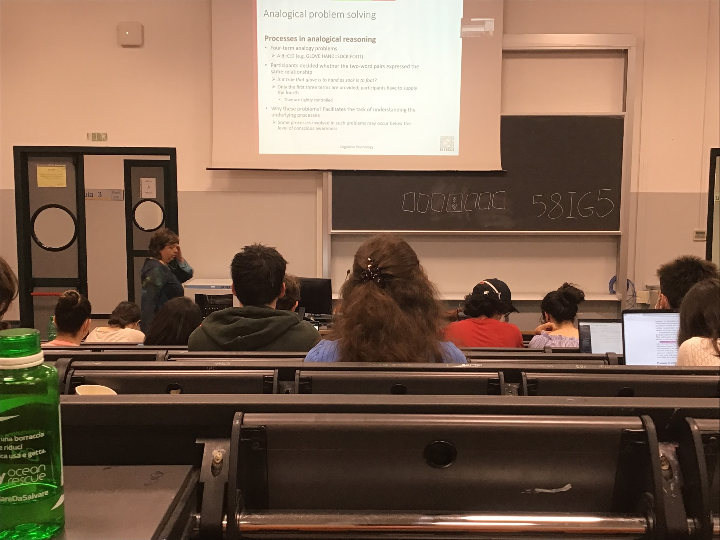

Use specific problem

This types of stimuli are very easy to produce and to test.

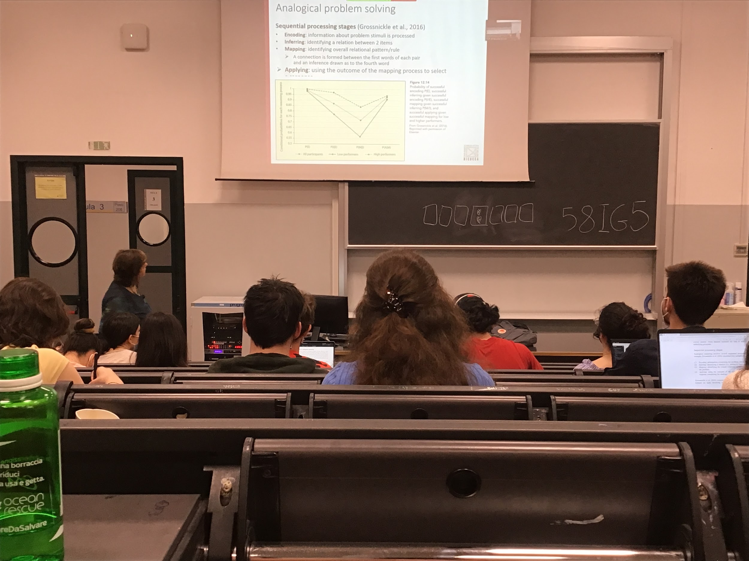

1. Encoding: find what kind of stimuli are in the problem
2. Inferr: look of the first 2 items and try to identify the relation
3. Mapping: map it to a general rule
4. Applying: to see if the solution is correct

Thee 2 different categories of people. High performance ( - - -)and low performance

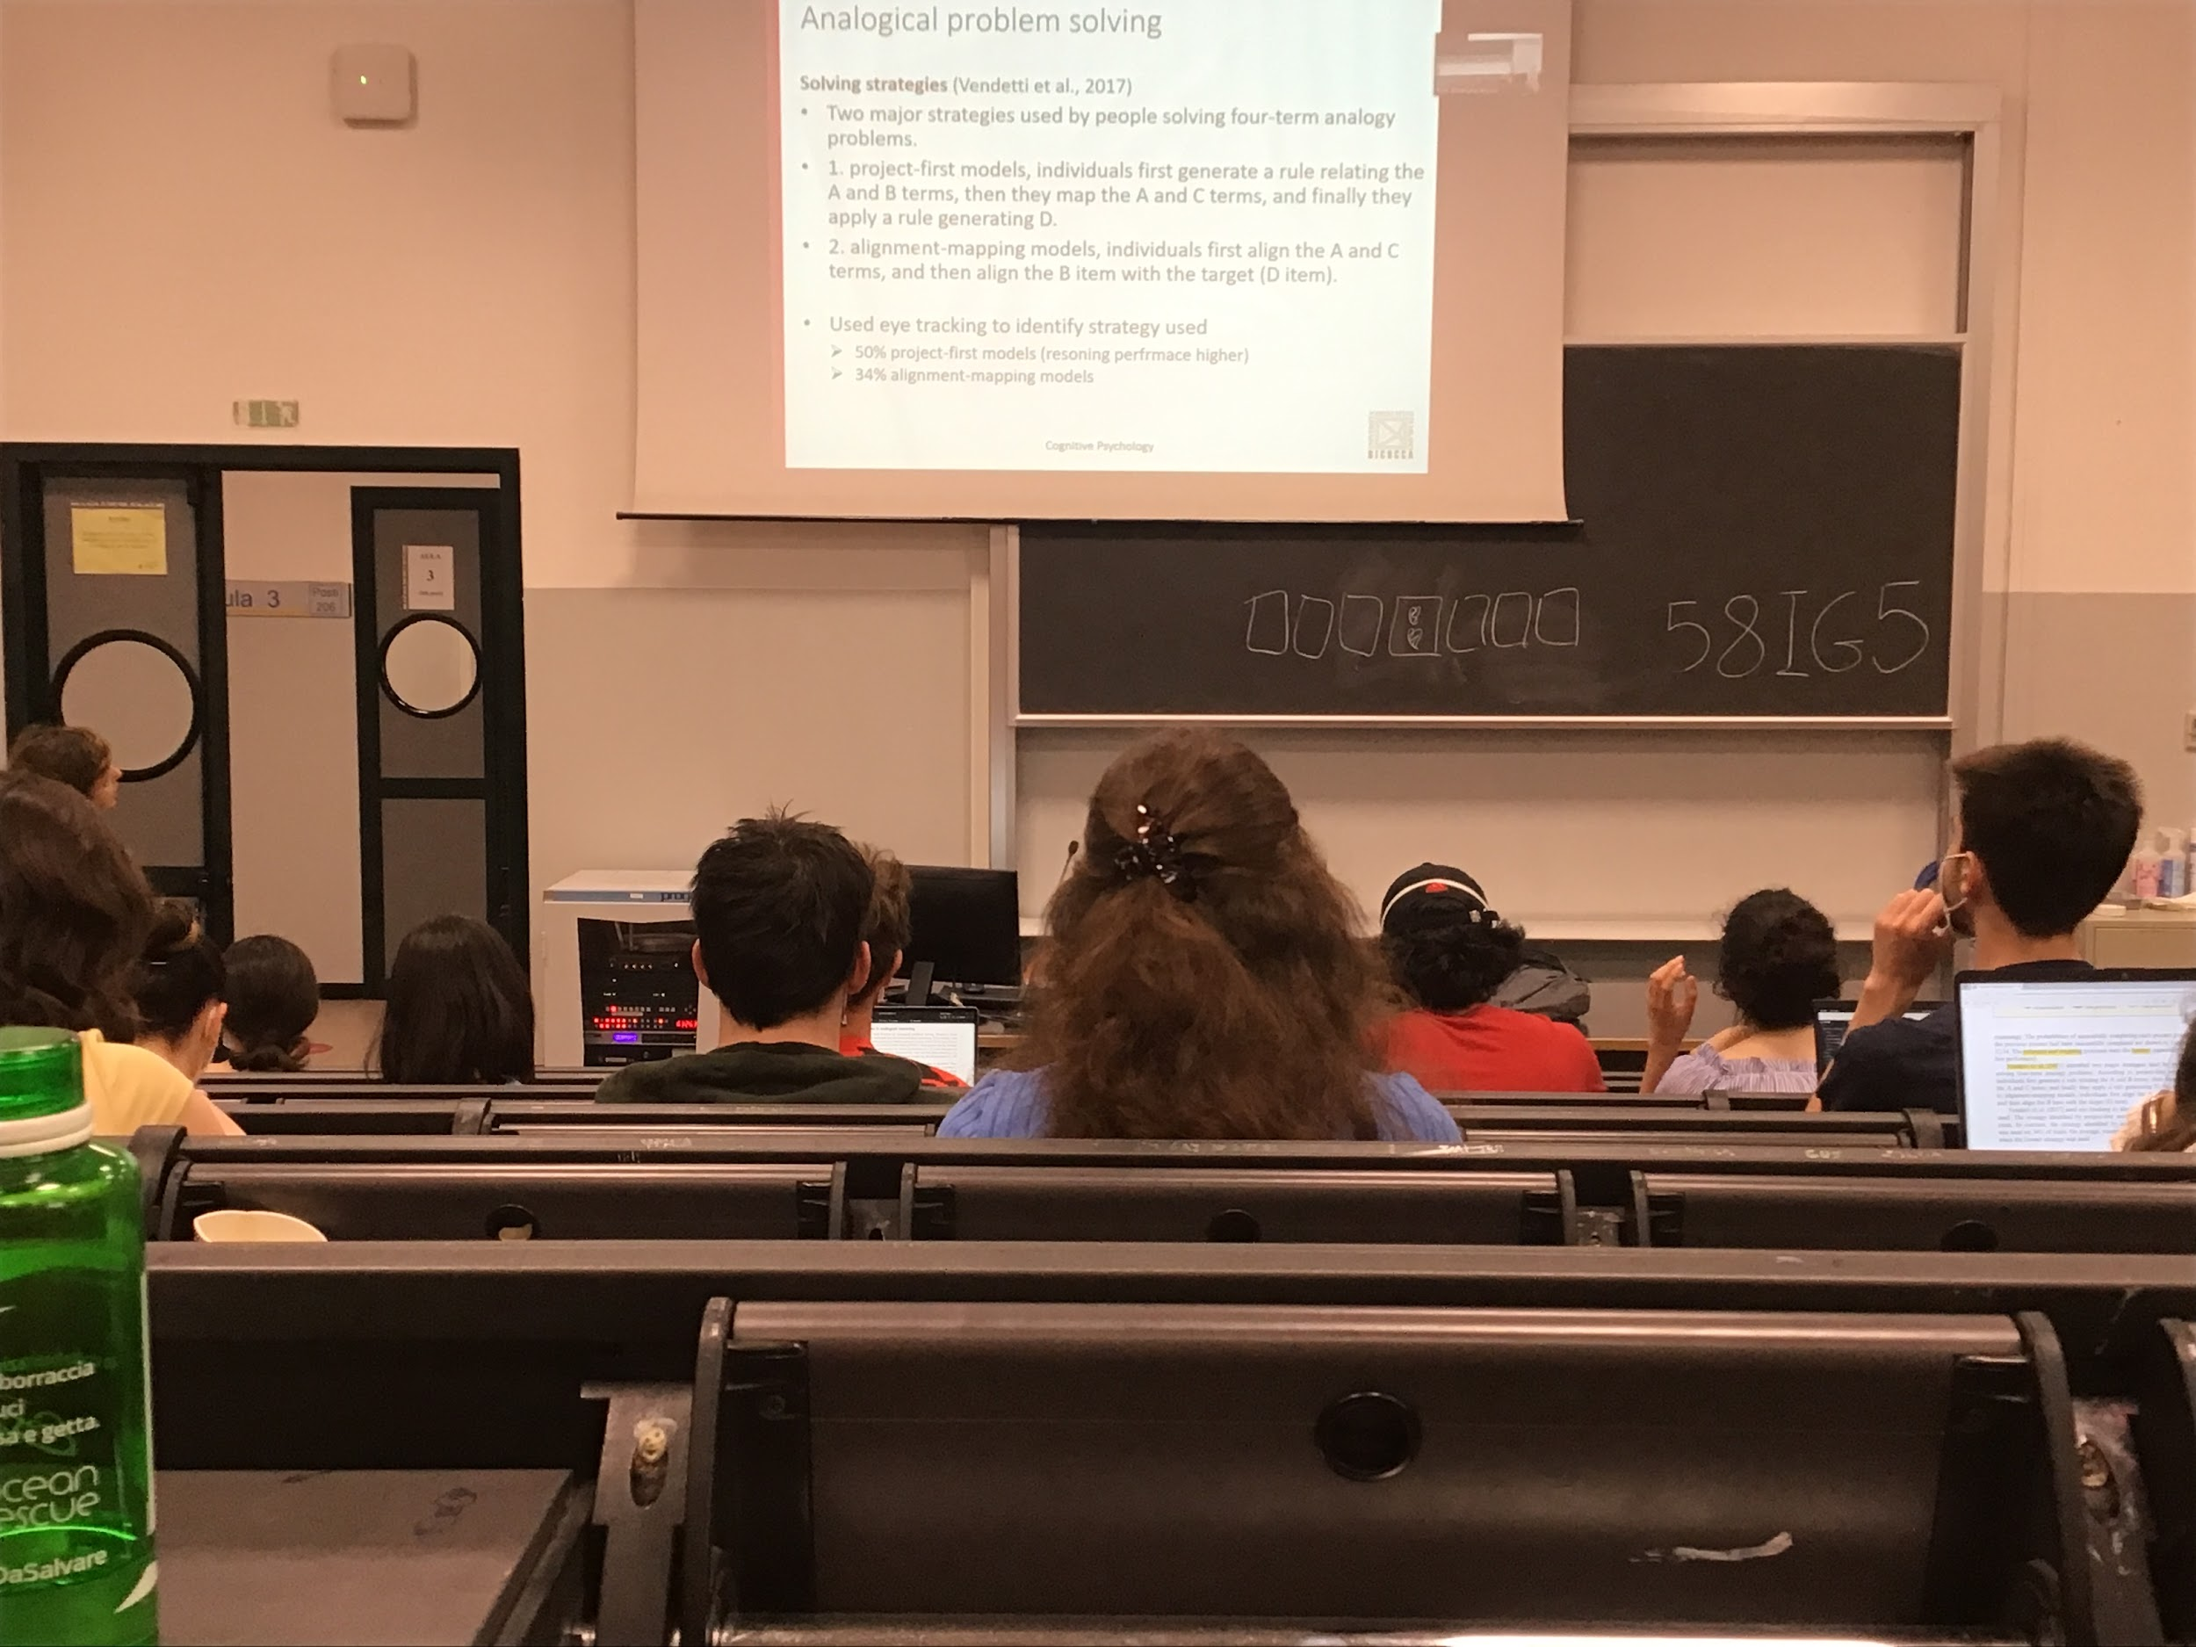

2 general strategies

1. Project first models: find the rule generating A and B
2. Alignment mapping model: first aligned A and C and then B

Most of people use project first models, it brings the best solution

If you are able to understand the relation between in A and B you are much better of at finding the solution